Adapt IT Consulting and Training

INTEGRATOR 4.1 – TRAINING MANUAL

Finance System

Accounts Receivable

Copyright

©All rights reserved

No part of this document may be reproduced or transmitted in any form or by any means, without express written permission from Adapt IT or an authorised representative of Adapt IT. This includes, but not limited to, electronic, electrostatic, magnetic tape or mechanical copying and recording, or use of any information storage and retrieval system.

First edition: February 2018

Disclaimer

Adapt IT makes no representations or warranties with respect to the contents hereof. Although due care and precaution has been taken in the preparation of this manual, Adapt IT assumes no responsibility for errors and omissions or any damages resulting from the use of the information contained in this publication.

Contents

Course Overview 1

Pre-requisite knowledge and skills 1

Course content 1

Learning outcomes 1

Module Structure 2

System Access 3

Logging on to Integrator 3

Landing Page 6

Exiting a form 6

1 System Requirements 8

1.1 Introduction 9

1.2 Maintain Account Type Definition {FCSC-21} 9

1.3 Maintain AR Statement Groups {FARC-4} 10

1.4 Maintain Transaction Type Definition {FCSO-7} 11

1.5 Maintain System Operational Definitions {FCSM-1} 15

1.6 Link Default Statement Groups to Documents {FARM-3} 18

1.7 Update Statement Groups Using Document Defaults {FININS-1} 18

2 Notes 20

2.1 Introduction 21

2.2 Creating a Note 21

2.3 Send Notes Reminder Mail {GOPS-23} 21

2.4 Background Processes {BATCH-9} 23

3 Accounts Receivable Transactions MPM {FARO-14} 25

3.1 Introduction 26

3.2 Invoice {FARO-1} 26

3.2.1 Create Invoice 27

3.3 Cancel Invoice {FARO-5} 39

4 Other Operational Menus 41

4.1 Introduction 42

4.2 Debtor definition pre-requisites 42

4.3 Maintain Debtors {FARO-21} 43

4.4 Query Types of Documents {FCSO-23} 48

4.5 Default text on multiple invoices 49

4.6 Invoices to be Sent {FAROR1-1} 49

4.7 Consolidated External Debtor Statement – NCR Format {FAROR1-12} 52

4.8 Query debtor transactions {FARO-3} 53

4.9 Calculating interest on debtor balances 54

5 Journals 58

5.1 Introduction 59

5.2 Batch journals {FARO-29} 59

5.3 Inter account transfers {FARO-2} 60

5.4 Maintain no show indicators {FARO-4} 62

5.5 Electronic Approval of transactions {FARO-11} 63

5.6 Open item functionality 64

5.6.1 Debtor Transactions {FARI-1} 65

5.6.2 Undistributed Items {FARI-2} 68

6 Reports 75

6.1 Introduction 76

6.2 Print Audit Trail {FARMR1-1} 76

6.3 Print User Work Summary {FARMR1-2} 76

6.4 Balances: Aged {FAROR1-4} 77

6.5 Consolidated Debtor Statement {FAROR1-9} 77

6.6 Consolidated Internal Debtor Statement {FAROR1-11} 78

6.7 Transaction per Type {FAROR1-23} 79

6.8 Print AR Journals in Process {FAROR1-29} 80

Acronyms, Glossary & Terminology 81

Acronyms 81

Glossary 100

Terminology 101

Help us enhance the course 103

# Course Overview

Welcome to the ITS Integrator course for the Accounts Receivable subsystem. This course is designed to equip you with the skills and knowledge you need to administrate sundry debtors. In fact, it is essential for anybody who will be responsible for debt other than student debt.

Course duration

2 days

## Pre-requisite knowledge and skills

Before you can register for this course, you must have attended the interface training so that you have the minimum knowledge of system navigation.

## Course content

The course structure is divided into modules and covers the following:

|  |  |
| --- | --- |
| **Subsystem** | **Modules** |
| Accounts Receivable | * System requirements * Creating notes * Accounts receivable transactions MPM * Other operational menus * Journals * Reports |

## Learning outcomes

On completion of this course, the trainee should be able to:

* Set-up system pre-requisites.
* Create and Maintain notes.
* Utilise the Accounts Receivable Transactions MPM
* Create and maintain journals.
* Generate reports.

## Module Structure

Each module contains the following parts:

**Specific outcomes**

The specific outcomes are very important because they state what is expected of you.

**Introduction**

Each module starts with a statement of the content and learning outcomes for that module in order to introduce you to the subject matter of the module. Suggested time allocation is also indicated. Bear in mind that the time allocation is only a guide and some people will take longer than others to complete the same task. The timeframe can also be longer if you choose to look up content from other resources.

**Content**

Module content consists of information moving from system pre-requisites to operational and menu management issues. The content is subdivided into topics, tasks, procedures and other information arranged in a logical sequence and broken down into small, connected and understandable units. This content can be supplemented by support materials such as PowerPoint presentations, worksheets, hand-outs, etc.

# System Access

## Logging on to Integrator

To access the ITS Integrator system, you need to use the Internet Explorer. Using your browser, use the URL relevant to your institution or link from the institutions’ local Intranet. You will be prompted for your user name and password. Username and passwords are set up in User Access Definitions {USERS-5} and maintained by the institution. A user can have multiple logins with the same user ID. It is dependent on institution rules and policies. Additionally, unsuccessful logging attempts might be limited to a specific number depending on the institution’s policy.

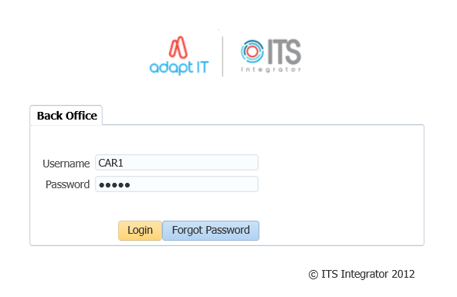

1. Type in your username and password
2. Click on the Login button

**Forgot Password**

If you are having difficulty logging in to Back office or you forgot your password, you can reset your password.

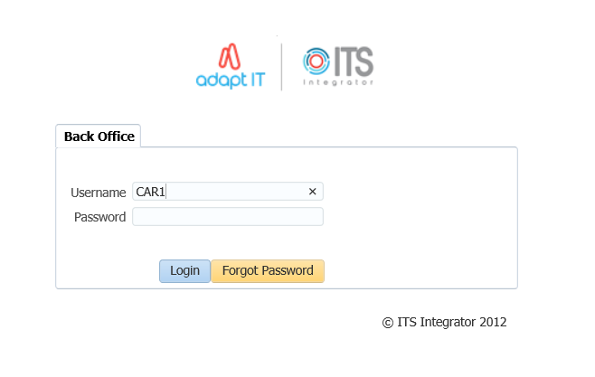

1. Enter your Username
2. Click on the “Forgot Password” button

To be able to reset ITS/OID password, the users email address must be set up on {PBOP-14}/ {GOPS-3} and Primary Indicator for the email must be set to “Y”. If security questions are not set up on {USERS-17}, the user will get login control message to set up password questions and Answers.

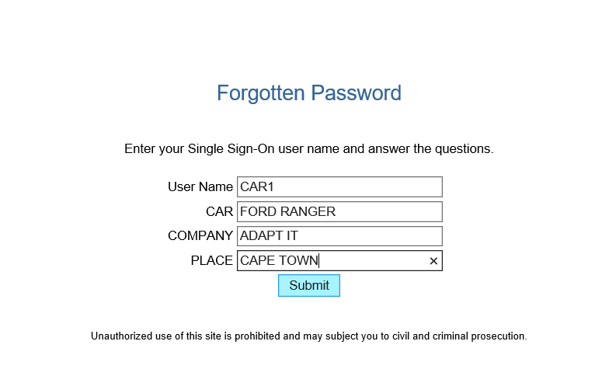

1. Answer the questions as set on {USERS-17}
2. click on “Submit button”

The notification pop up message to be illustrated

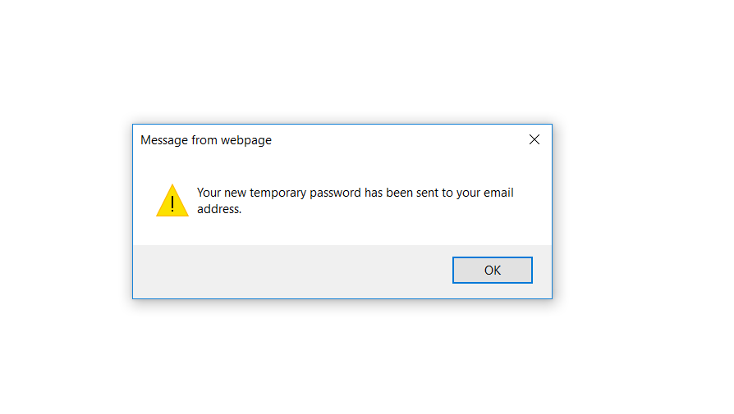

Logging in to ITS Integrator again with the given password on the email



On the main page after logging onto integrator, on the More Tab, the Forgot Password Q and A can be found here and this will direct the user to {USERS-17}

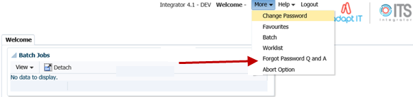

## Landing Page

After logging into the Integrator Back Office System, the Integrator Entry Screen will display. The Integrator Entry Screen is the gateway to the full Integrator Back Office System and consists of four sections: Header, Main Menu Bar, Work Area, Welcome and Footer.

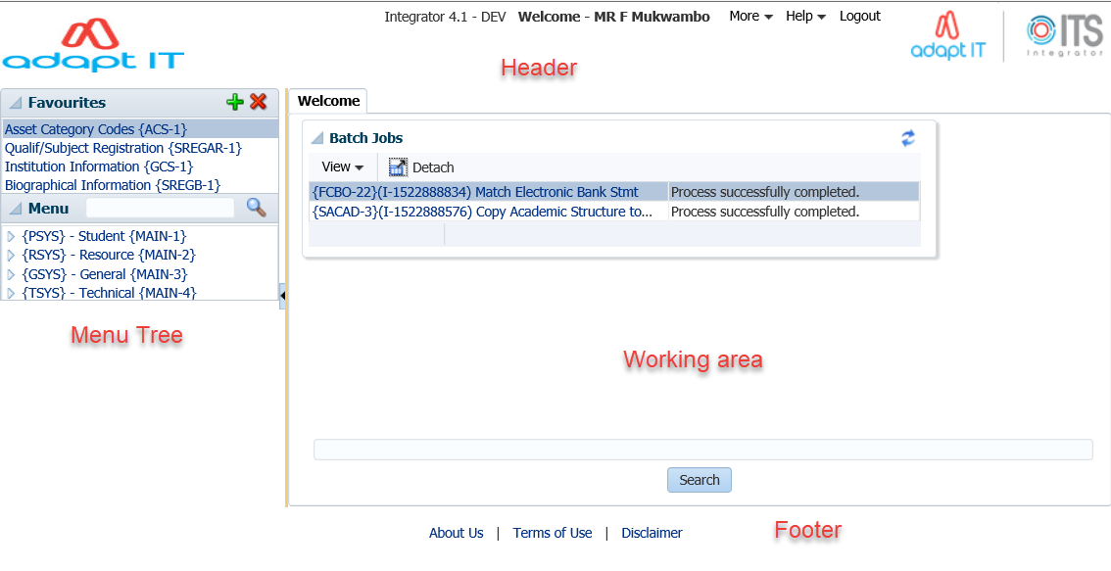

Integrator 4.1 requires that you use the mouse to move from one field to another. In previous versions, the user could navigate between fields using the Tab and Enter keys. However, the new

ADF technology operates in a browser and shortcut keys do not always give the intended output.

## Exiting a form

Use the Green door (old forms) or the black cross (new ADF forms) to exit forms programs in Integrator 4.1.



The Abort Option button is only for emergencies in the event of a menu option hanging.

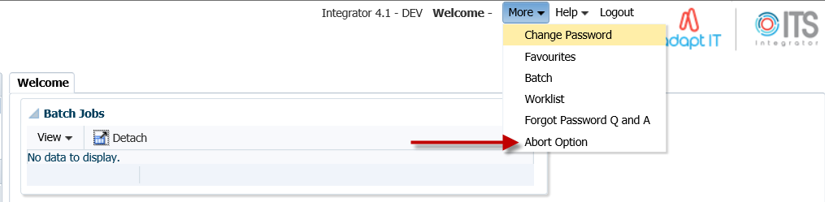

**MODULE 1**

# System Requirements

**Specific outcomes**

On completion of this module, you will be able to:

* Maintain account type definitions
* Maintain accounts receivable statement groups
* Maintain transaction type definitions
* Create new codes and update existing codes
* Link default statement groups to documents
* Update statement groups using document defaults

## Introduction

We are starting from the principle that the necessary cost centres {FCSO-1} and accounts {FCSO-3} have been defined and the necessary GLA’s {FCSO-6} have also been linked.

On completion of the set-up explained in this module, the following types of transactions can be processed in the AR system:

* Invoices, credit notes, journals, inter-debtor corrections, etc., can be created. Invoices can also be processed to be repeated at set intervals. In addition, invoices can be allocated to multiple GL accounts to allow for “distribution” of revenue.
* Invoices and credit notes which are issued manually, e.g. by departments on their own letterheads, can subsequently be recorded on this system by merely entering the transaction to the debtor’s account and the applicable transactions to the GL. Alternatively, the detail of the invoice or credit note can be entered into the system, and the document can be printed on letterhead stationery.
* Payments by debtors to the institution can be recorded in the counter subsystem, where the debtor account will be credited, the GL transactions will be generated and receipts issued. Payments, which are recorded by a non-ITS system and manually made out receipts, can be accommodated by either entering a receipt at a later stage or by a standard journal.
* Interest calculations can be done for debtors and staff debtors and their relation to the personnel and salary systems are catered for.
* Itemised debtor’s statements can be printed, which list the transactions and provide an age analysis of the outstanding balances.
* Income and control account transactions are created automatically, and control totals and audit reports are available.
* A facility is available to administer staff loans. Deductions can be made in the salary system and transferred to the debtor’s system.
* Functionality is available to control and monitor open item documents. The concept “Open Item” refers to the ability to match any relevant transaction to a specific source document. The client has the decision if this functionality will be used or not.

## Maintain Account Type Definition {FCSC-21}

Account types represent the control account in the ledger. This means that it is not an expense/income account. Account types allows you to break down the “account” in smaller manageable sections: thus, allows for better management information. An example would be to have an account type for sundry debtors per campus, or a control account for your rental debtors and your services debtors.

**See Example below {FCSC-21}**

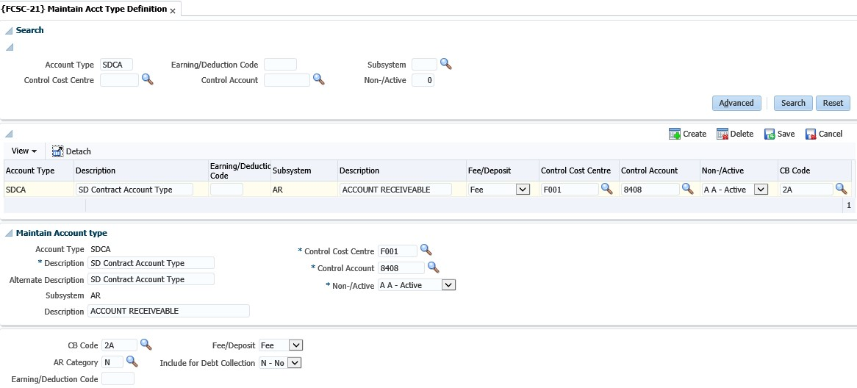

**Account type**: Enter a unique code for the account type.

**Description**: Enter a suitable name to describe the account type.

**Subsystem**: Enter the subsystem where this account type will be used.

**Fee/deposit**: This indicator is ONLY applicable if the subsystem is SD. The user needs to indicate if this account type is a (F)ee or (D)eposit account type.

Control GLA: This account type code is used in the specific subsystem but it will represent a GLA in the GL. Enter the CC and account for the account type.

**CB code**: When the subsystem is PM, the system wants to know from which CB the creditors will be paid. Supply the CB code where you will make the creditor payments.

**AR category**: This field is only applicable if the subsystem is AR. The debtor category is an ITS Integrator defined code and will indicate specific characteristics to be used in the AR system. For example, you can have staff loans, student loans, booking debtors or normal debtors. Enter the debtor category for the specific account type.

**Show Account Type**: This field is applicable for account types that are defined for the SD system and that will be used for contracts. Only if this field is marked as no, you can use it in the contract definition. All the standard SD account types will be set as yes.

**SD Statement Group Code**: This field is used with the SD statements where transactions are grouped and the details are not displayed on the statements.

## Maintain AR Statement Groups {FARC-4}

A statement group is a heading in the statement and all documents linked to the group that will print below the group heading. Statement Groups are mandatory for all AR documents. Integrator standard codes are provided with the install but clients may create their own Group Codes.

**See Example below {FARC-4}**

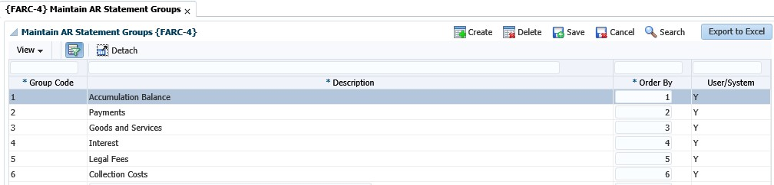

**Group Code**: A code to identify the Statement Group

**Description**: The description of the group code. This description, if used, will print as a heading in the debtor statement.

**Order By**: The order in which the group will be printed in the debtor statement.

## Maintain Transaction Type Definition {FCSO-7}

Transaction types can be seen as a “journal code”, such as registration fees, debit correction, etc. It is defined per subsystem and can only be a debit or a credit, except for the General Ledger and Expense budgeting subsystems. The basic characteristics and advantages of a transaction type are:

* It is specific for each subsystem
* A transaction type is either a debit or a credit transaction for the subsystem. (The GL transaction types are not applicable to this.)
* Where you have TT defined for specific type of transactions, mistakes in respect of GL allocations can be minimized.
* The process of automatic transactions is simplified
* Can make reporting easier where you are looking for type of “journals”, for example just class fees etc.

**Type**: Enter a unique code for your TT.

**Note**: It is recommended that you use number ranges for each subsystem. That way you know that all the CT transaction types are within the range 1000 to 1999 etc.



**Name**: Give a description of the transaction type. Remember that this should be done so that all users would know which transactions will be recorded against this code.

**Active Indicator**: Is the TT active or not? You will make use of this where you may have used a TT for specific purposes, but no longer want the users to use this. So, you query the code and make it non active. This means no user will be able to record transactions against this TT.

**Subsystem**: Enter the subsystem for which the transaction type is valid.

**Default value:** This field will be completed if the transaction type is usually for a specific value. This amount will default when used, but the users can still override the amount.

**Cashbook code**: This field is mandatory if the subsystem is CT and will indicate the cashbook code this TT is relevant to.

Where you have more than one cashbook, but you have the same type of transaction for multiple cashbooks you would create “duplicate” transaction types but indicate in the description for which CB code it will be used.



**Financial field**: This field will indicate what ‘type’ of transaction this TT will record. You have the following options:

* (S)-balance: this is where the system is calculating a brought forward balance.
* (B)udget: this will be for budget transactions as they are reported in different columns in the GL reports.
* (J)ournal: these are the ‘normal’ financial transactions and most of the transaction types will be linked to this field.
* (C)ommitment: these are for the PM system. An example would be where requisitions/order are created. The system will create a transaction in the commitment column of the GL reports.

**See Example below {FCSO-7}**

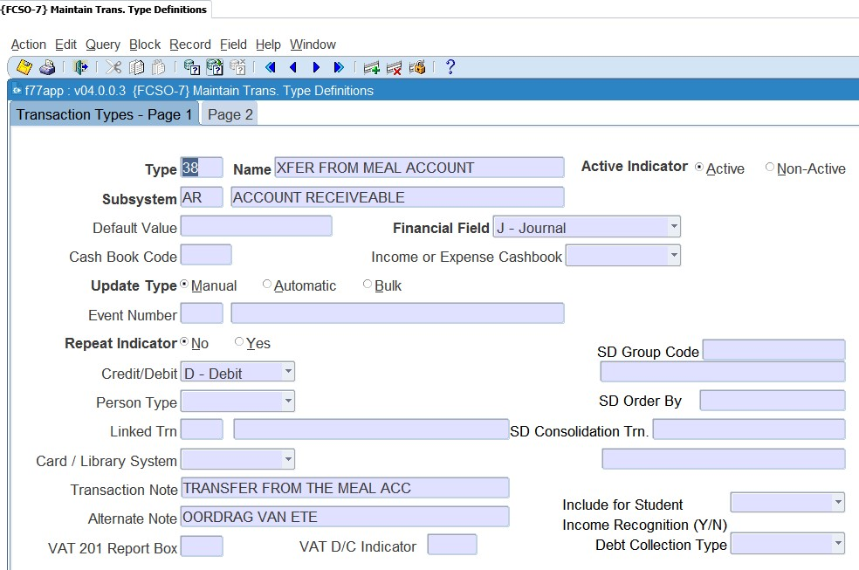

**Income / Expense**: This indicator is only relevant to the CT and CB systems. This is to differentiate between transactions affecting (I)income and (E)xpense on the cashbook.

**Update type**: This field can either be manual or automatic. Most of the TT definitions will be linked to manual. The automatic will be if the TT is linked to an event (see next field).

**Event Number**: This field will list all the predefined events. These events are defined by Adapt IT: Pretoria and you will ONLY link this to the relevant TT code. An event number will be “triggered” by specific programs to use TT automatic without a user selecting them. For the SD fees structure the system have the link between the TT and the events in the option {FSAM-29}.

**Repeat Indicator**: The user may specify repeating transactions in the Procurement Management (PM), Accounts Receivable (AR) and General Ledger (GL) Subsystems. Whenever the applicable screens are used, the system will control that a transaction type with a (Y)es in this field is used. The number of repetitions and the intervals will be specified, and the program will generate transactions accordingly. **Credit / debit**: What must happen to the debtor/creditor account? For example, if it is the SD system, should the student be debited or credited?

**Person type:** This can also be referred to as the debtor/creditor type. This field is applicable where the subsystem is CT or CB. The system wants to know, if this transaction takes place what other ‘subsystem’ must be affected. Remember that where the person type is student, it will also reflect on the students’ account, which means the SD system.

The ‘other’ person type is used where you have sundry transactions that are not for a debtor or creditor account.

**Linked transaction**: This field will be completed if this TT that you are busy defining can have VAT. The VAT portion will be recorded against the TT entered in this field.

**Card/Library system?**: If you are using the meals (card) or library system, then TT can be defined to receipt money in those specific ‘accounts’. The field will be used where the subsystem is CT. This field must be set to yes if you want to use it for those types of receipts.

**Transaction note**: This field is the note field that will default when the TT is used when a transaction is processed. Enter a note that will best describe the transaction to the debtor/creditor as this will display on their statements.

**Alternate note**: This field is the same as the transaction note field. This description will be used if you have indicated on the debtor/creditor biographical detail their preferred language is not ‘English’ but ‘Alternate’.

**VAT 201 box report**: This field is applicable if you are registered for VAT and do VAT reporting through the system. The box numbers with their information can be obtained from the receiver of revenue. **VAT D/C indicator**: This field is applicable if you are registered for VAT. It will be used to indicate if it is a debit or credit to the VAT transactions.

The following fields are all display fields and the detail is defined in the SD system*.*

* SD group code
* SD order by
* SD consolidation transaction
* Include for consumption report Y/N?

**See Example below {FCSO-7}**

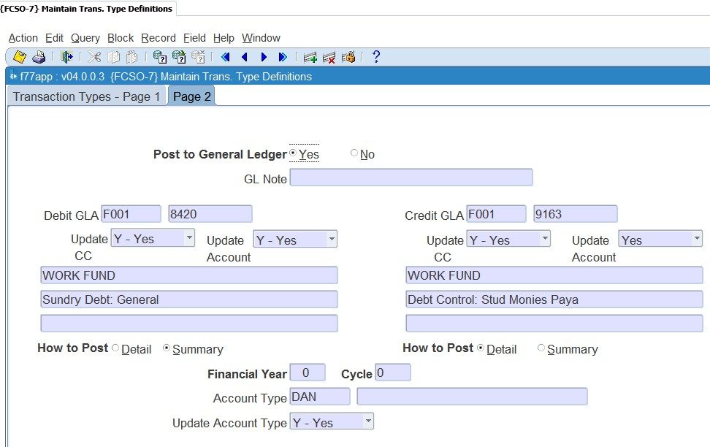

**Post to general ledger**: You will usually set this field to yes. This indicates if the transaction should be posted to the GL. This field is not applicable to the GL system as the transaction is already ‘in’ the GL system.

**Debit GLA**: Enter the GLA to be debited. This field will be completed if there is a specific GLA that must be used or where the GLA can’t be blank when automatic (TT linked to an event) transactions take place.

**Credit GLA**: Enter the GLA to be credited. This field will be completed if there is a specific GLA that must be used or where the GLA can’t be blank when automatic (TT linked to an event) transactions take place.

**Update CC**: Is the user allowed to change/update the CC? This field can only be set to NO if the “Update Type” field is set to (M)anual.

**Update Account**: Is the user allowed to change/update the account? This field can only be set to NO if the “Update Type” field is set to (M)anual

How to Post: Do you want to post the transactions in detail or summary to the GL? If set to summary, the system will accumulate all transactions (since the last posting) for the specific account which has not yet been posted, and post one transaction.

**Note**: It is recommended that you make the debit GLA indicator ‘summary’ for all debit transactions and the credit GLA indicator summary for all credit transactions. This will mean your GL reports are not that cluttered. Should you wish to see how the summary posting is made up you can request a report from the menu {FGLP}.



**Financial year**: This field is only relevant for TT linked to the GL system. This is where you wish to process transactions for a financial year that is different to the financial year of the system as indicated in {FCSM-2}. For all the other subsystems this field will have a value of zero, as the transactions will use the financial year as indicated in {FCSM-2} for the relevant subsystem.

**Financial cycle**: This is only valid for the GL system, for the rest of the subsystems set this value to "00". If a transaction type is meant to be valid only during a specific cycle, the user may enter a value equal to or greater than the present financial cycle, or in all other cases "00" (zero). If zero, the system will default to the cycle of the subsystem. Transaction Types linked to sub-system GL are subject to the setting of rule GH, of the system operational definitions, on menu option {[FCSM-1}](http://wlint4.adaptit.co.za:7221/itshelp/faces/helppages/config.OHW+Servlet+1/vtAnchor.Block_2/topics/navSetId.itshelp/itshelp/documents/fcsm-1.html#Block_2), TAB - System Operation Definitions.

* Rule [GH](http://wlint4.adaptit.co.za:7221/itshelp/faces/helppages/config.OHW+Servlet+1/vtAnchor.GH/topics/navSetId.itshelp/itshelp/documents/fcsm-1.html#GH) provides the facility to prevent the update of the financial year and cycle for Ledger journals. Whenever the user supplies a transaction type on any of the GL journal screens, may the user update the financial year and cycle, (Y)es or (N)o? This rule must also be read in conjunction with rules GC and GY.
* Rule [GC](http://wlint4.adaptit.co.za:7221/itshelp/faces/helppages/config.OHW+Servlet+1/vtAnchor.GC/topics/navSetId.itshelp/itshelp/documents/fcsm-1.html#GC) provides the facility to allow Ledger journals to be processed in previous cycles and rule GY provides the facility to allow Ledger journals to be processed in previous years.

**Account Type**: Supply the default Account Type to be used. This is not a mandatory field. A <LIST> function is available and where the subsystem, is AR, the <LIST> function will only contain active Accounts Types defined for AR.

**Update Account Type**: Can the User update the Account Type (Y)es/(N)o. When this Transaction Type is used, may the user update the Account Type?

## Maintain System Operational Definitions {FCSM-1}

The system operational parameters are all pre-defined codes and cannot be removed or changed by the user. The user can only decide how the specific rule should be applied to the system.

**See Example below {FCSM-1}**

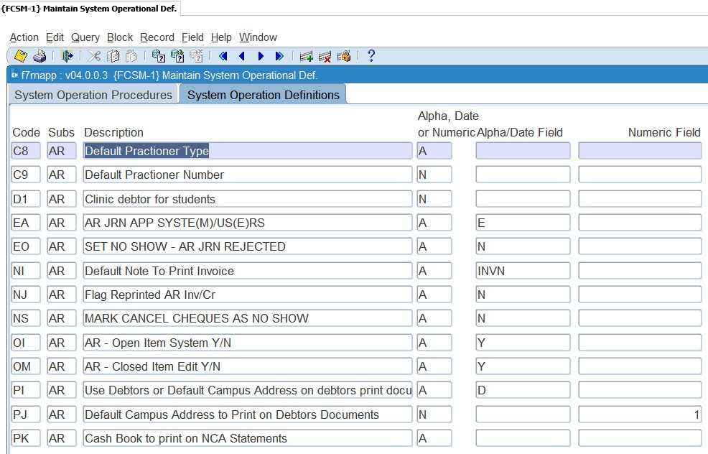

**EA**: AR journal approval by syste(M) or us(E)r

If you make use of electronic document approval the parameter should be set as us(E)r. If not it means that all transactions that are recorded on the AR system has been approved manually.

**EO**: Set no show when AR journal rejected Y/N

This parameter is used in conjunction with ‘EA’. If you have indicated that users need to approve the AR document/transactions and this code is set to (Y)es:

* The system will set the rejected transaction and its contra transaction to 'no-show' {FARO-11} and it will not print on statements.
* The AR statement program {FAROR1-3} will not print transactions set to 'no-show’.

**NI:** Default note to print on the invoice

Should you wish to add a note when printing an invoice, you can set up a ‘letter’ code in {FDCO-1} and the text linked to the code will print at the bottom of the invoice if ‘add default note to document’ is Yes when you run {FAROR1-1}.

**NJ:** Flag reprinted AR invoice/credit note

The valid values are (Y)es or (N)o. Where you set the value to (Y)es you will be able to print the invoice/credit note as often as you like and the printout will ‘look’ the same. If you set the value to (N)o the words “Copy Only” will be printed on all invoices {FAROR1-1} or credit notes {FAROR1-2} when reprinted.

**NS:** Mark cancelled cheques as no-show

Valid values are (Y)es or (N)o. If ‘Y’es, the system will mark the payment and the cancellation with a now-show indicator to not print when generating a statement for the debtor.

**OI:** Open Item system in use

Are you making use of the facility to allocate credit transactions to specific debits?

**OM:** Closed item edit Y/N

Do you allow the users to remove the link between debits and credits?

**PI:** Use Debtors or Default Campus Address on debtors print documents

Values are C/D (Campus/Debtor). The parameter indicates the campus to be used to derive the address to be printed on an AR Debtor Statement using option {FAROR1-12} as he the Institutions Physical and Postal Address. If Debtor, the campus address of the campus linked to the debtor (person) is used, else the campus address or the default campus linked to system operational parameter PJ is used.

**PJ:** Default Campus Address to Print on Debtors Documents

Must be a valid Campus Code from option {SPCS-1}. If System Operational Parameter PI of subsystem AR is set to Campus, then this campus address will be used as the Institution Physical and/or Postal Address. <List of Values> is available.

**PK:** Cashbook to print on NCA Statements

Must be a valid Cashbook Code from option {FCSC-5}. The banking information printed on an AR Debtor Statement is derived from the Cashbook Code entered. The program Debtor Statement, option {FAROR1-12}, gets the Bank Name, Branch Code and Account Number tags from the cashbook linked here. <List of Values> is available.

**PP:** AR Statement Number Sequentially per Debtor or Unique Statement Numbers

If set to unique statement numbers, the system operational definition code 'S2' for subsystem 'SD' must also be considered. If both, 'S2' and 'PP' are set to unique statement numbers, a unique statement number will be allocated throughout the two systems whenever a statement is generated. No two statements will have the same number, but statement numbers for a debtor, SD and AR, will also not follow on each other. If either one is set to generate unique statement numbers, only statement numbers in that system will be unique. Statement numbers for the other will follow sequentially one after the other per debtor.

**Note**: Remember that where you allow this it means that if a statement has been generated and changes are made after that you will not be able to “reproduce” the statement.



## Link Default Statement Groups to Documents {FARM-3}

It is mandatory that each AR Document must be link to a Statement Group. To assist the user, this menu option defined the default statement group for each Type of Document in AR. When the user creates a document, the system will default this definition and in some cases the user is allowed to change it to a different statement group, if required. The following combination will be installed:

**See Example below {FARM-3}**

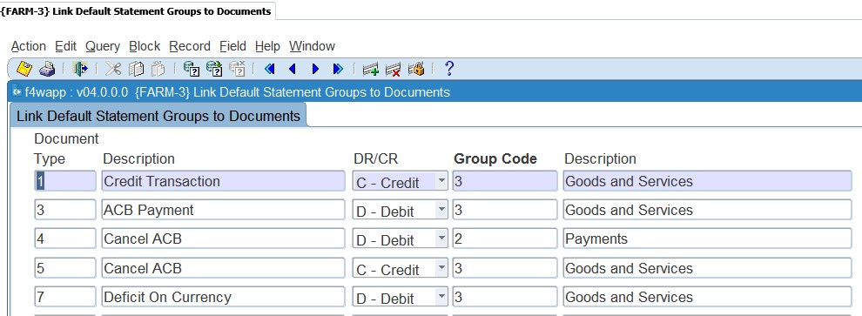

**Type**: A unique character as allocated by Integrator for the different AR Documents.

**Description**: Description of the Document.

**Debit/Credit**: The debit or credit indicator of this Type of Document.

**Group Code**: The default statement group code linked to the document type a defined in option {FARC-4}. A <List of Values> is available.

**Description**: The description of the statement group code.

If the client created their own statement groups, link them to the required Type of Documents if applicable and updateable and you may update these changes to your current year Debtor Document not linked to a statement number using option {FININS-1}.

## Update Statement Groups Using Document Defaults {FININS-1}

If the user change the Integrator install statement group codes on option {FARM-3} and need to apply the changes to AR documents that were not printed on/linked to a statement number, then this option will do those updates.

**See Example below {FINNIS-1}**



**MODULE 2**

# Notes

**Specific outcomes**

On completion of this module, you will be able to:

* Create a note.
* Set-up note reminders.
* Send manual and automatic emails.

## Introduction

Users do not have automatic access to “notes” that were created. Access must be given to users to access notes and they can be restricted to only view, add, query and view existing notes. This will be done in the user restriction option for the specific subsystem. An example is {AMNT-8} for assets, {SMNT-5} for students, {FCSM-4} for finance and {PAMT-1} for personnel etc.

Notes can also be used if there is a need to make notes to specific qualification or subject information. If the user did not have any notes training before, we suggest the user attend this training or the super users to set up these applications. The user can also refer to the Notes training document if more information is needed.

## Creating a Note

Proceed to the applicable option where you would like to use the functionality of adding a note, for example: {FARO-21}. You can query any debtor in this option and type general notes in the Notes panel box. Type-in the note and save.

**See Example below {FARO-21}**

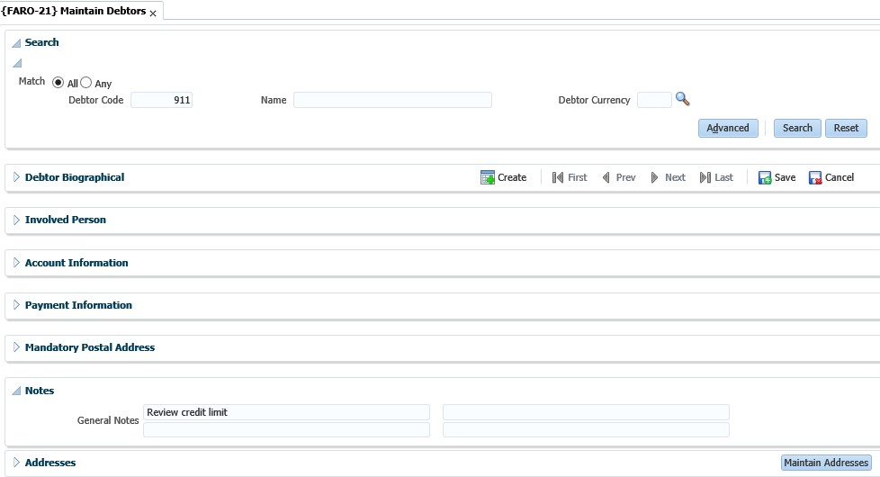

## Send Notes Reminder Mail {GOPS-23}

This is a report a user can run at any time to start the e-mailing process for certain selection criteria.

**See Example below {GOPS-23}**

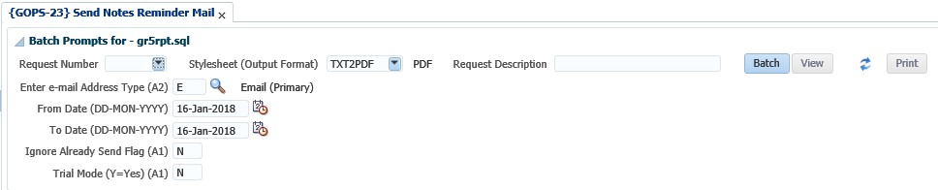

The LOV on the e-mail address type will list only address types where the type is defined as a type email. The mail will be sent to this selected e-mail address, if this address is specified for the personnel. If the mail address type does not exist for a person, the mail will not be sent. All mail where the date/time of the reminder fall between the 'From Date' and 'To Date' will be selected.

If the user selects trial mode = ‘Y’es, only a report will be produced to list all the possible e-mail reminders that will be send, but the actual mail will not be send. When specifying the trial mode as ‘N’o, a report will be produced and the e-mail will be send.

**See Example below**

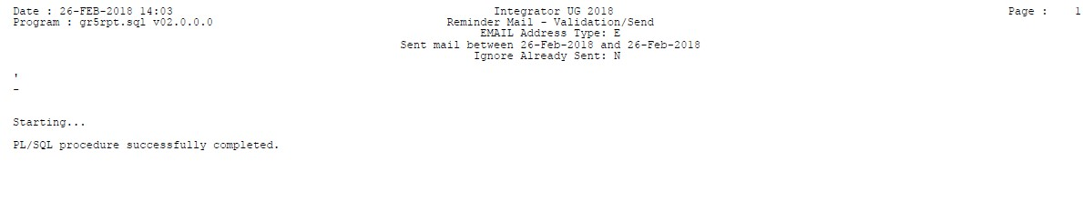

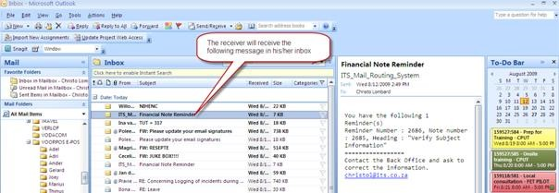

Once the mail reminder is sent to the selected user, the reminder note will be marked as sent.

**See Example below {FCTO-10}**

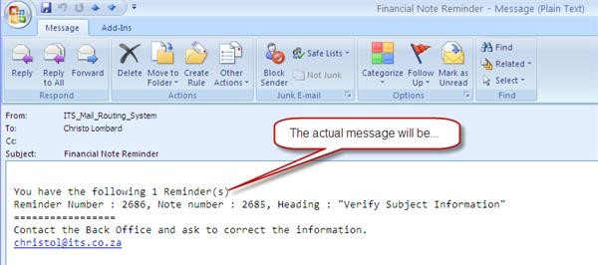

## Background Processes {BATCH-9}

This option will send notes reminder e-mail every **X** minutes automatically for a specific date as specified by the user. Go down to the 'gen.gr5pkg. Send_Reminder*;'* procedure. Specify the 'Interval' in minutes when the mail must be sent. Change the 'Status' to Running.

**See Example below {BATCH-9}**

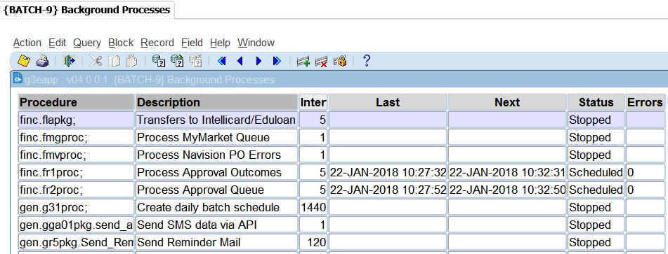

This option will send all reminder notes for system date to the selected users. It will automatically send to the person's primary active e-mail address. Once the mail was successfully sent, the reminder note will be marked as per the above manual option.

**MODULE**

**3**

# Accounts Receivable Transactions MPM {FARO-14}

**Specific outcomes**

On completion of this module, you will be able to:

* Create invoices and credit notes.
* Duplicate invoices.
* Print / mail invoices and credit notes.
* Cancel invoices.
* Maintain no show indicators.

## Introduction

This is Multi Process Management (MPM) for accounts receivable. The aim of an MPM is to empower the user to work with an entity (in this case, a debtor) using only one menu option. This will provide a 360-degree view of the debtor, the transactions linked to the debtor, details of the transactions, as well as allow the user to create new transactions or edit existing ones. If no debtor is searched for in the 'Debtor Details' panel box, the options listed in the 'Tasks" panel box will either open with no details prefilled (Invoice, Credit Note, Maintain No Shows) or will not open at all (Maintain GLA, Copy Invoice, Cancel Invoice).

**See Example below {FARO-14}**

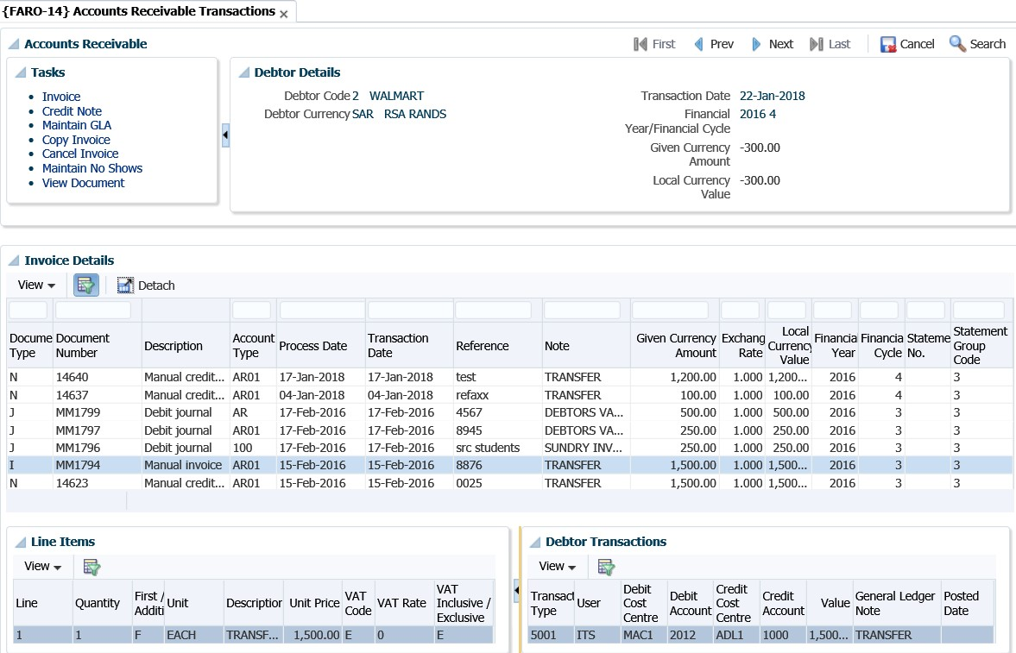

## Process Debtor Transactions {FARO-1}

This is the option where you will process invoices for a debtor. The option allows you to also print the invoice after processing it. This option is also used to process other “types” of debit and credit transactions for a debtor. When you access the option a list of available transactions will be displayed according to the sequence in {FCSO-23}. The user must highlight the specific process that he/she would like to do. Once you have selected the type of document you would like to process there is an additional functionality that will allow you to copy data (detail) from a previous document. That means you can copy detail instead of retyping everything.

This option is made up of 3 panel boxes, 'Search', 'Debtor Account Type Balances' and 'Debtor Transactions' and is used for the following:

* Creating an Invoice
* Creating a Credit Note
* Maintaining the GLAs of an unposted Invoice or Credit Note
* Creating a Copy of an existing Invoice or Credit Note

When you search for a debtor in {FARO-1}, the following screen displays, and you can choose to either “Create Invoice” or Create Credit Note”.

**See Example below {FARO-1}**

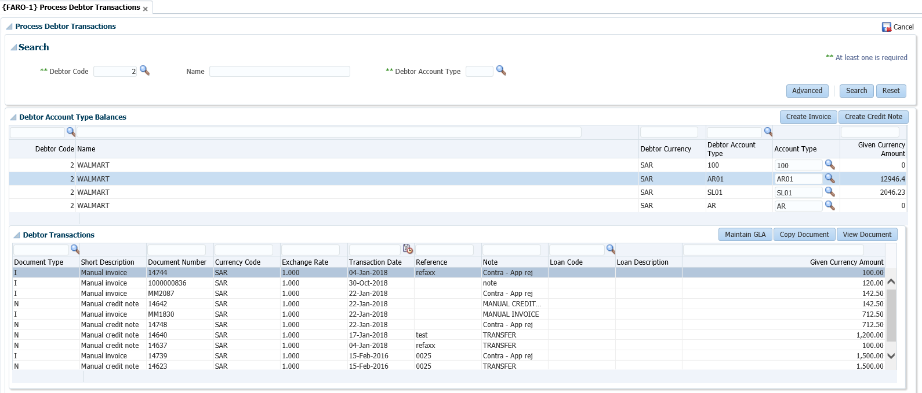

### Create Invoice

**See Example below {FARO-1}**

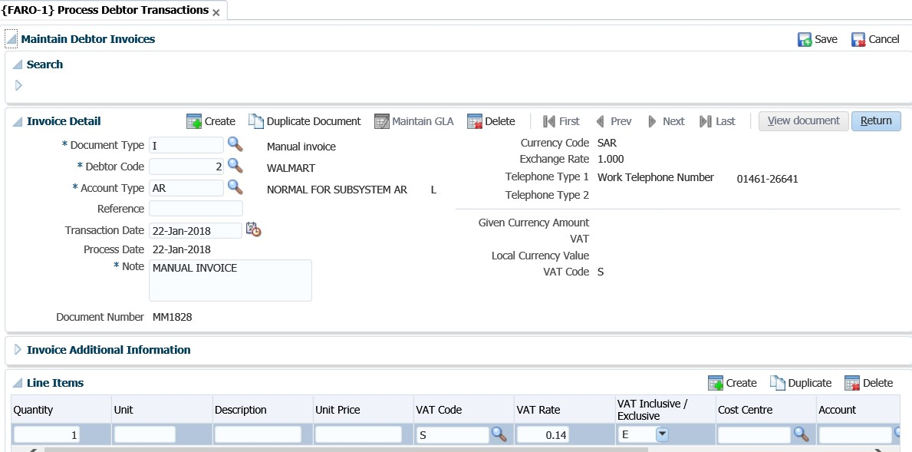

**You can also utilise the Accounts Receivable EP.**

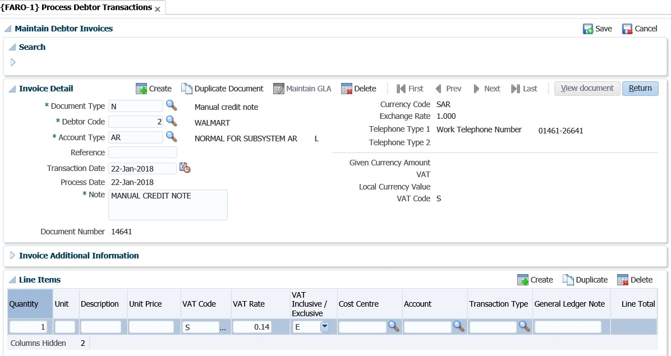

**See Example below {FARO-14}**

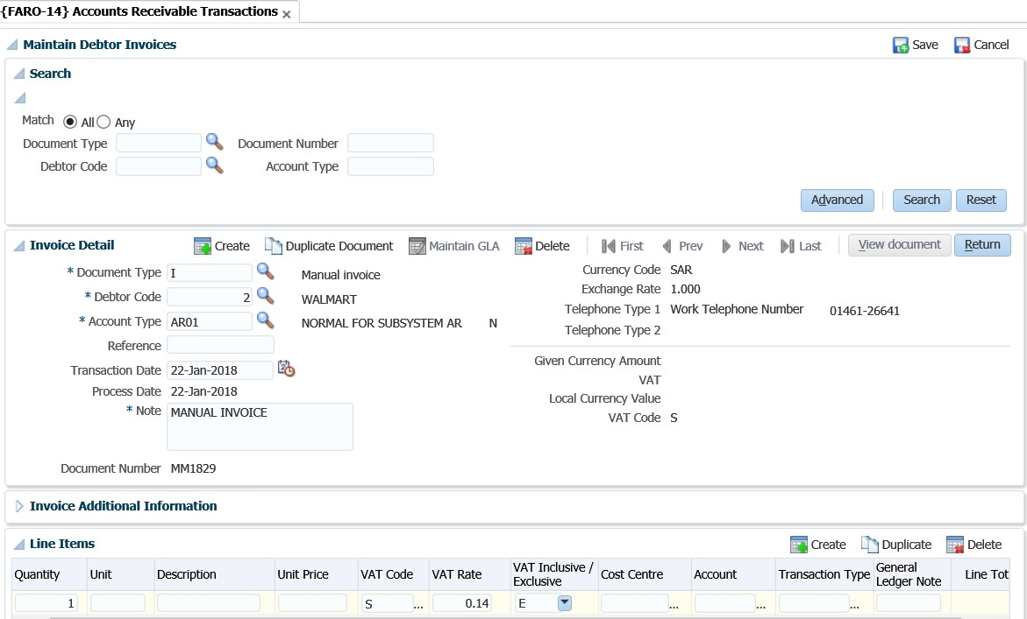

**See Example below {FARO-14}**

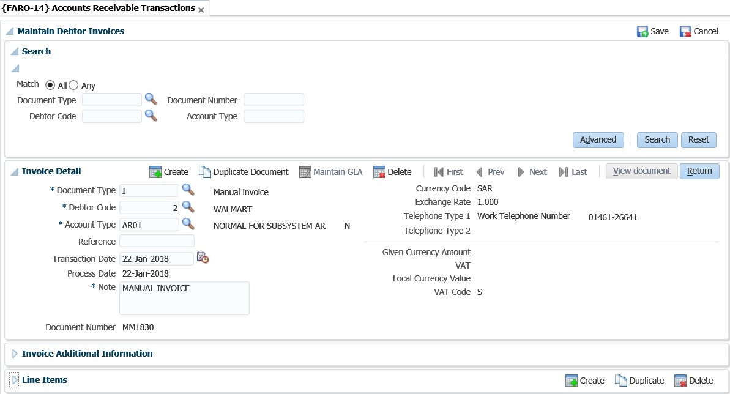

The user can enter the 'Debtor Code', 'Name' and/or 'Account Type' and click on the 'Search' button to view existing transactions for the 'Debtor Code', 'Name' and/or 'Account Type' combination. If the search functionality is used, then all processes thereafter will default with the search criteria.

**Panel box 2: Invoice Detail**

**Document Type**: This field will default to an 'I' when the user clicks on the 'Create Invoice' button and an 'N' when the user clicks on the 'Create Credit Note' button.

**Debtor:** The debtor code against which the document is to be processed. Will default to the debtor that was searched for in the search panel. If no debtor was selected, then the user will have to type in a debtor code or select a debtor by clicking on the <LIST> command.

##### Account Type: The 'Account Type' will default to the account type for the line that was selected in the 'Debtor Account Type Balances' panel box. The user can select a different account type by clicking on the <LIST> command. This will list all the account types for the ‘AR’ system, as defined on {FCSC-21}. Reference: An optional first documentation support reference, e.g. reference to an Order Number, Invoice, Credit Note or another Journal. This reference number is more meaningful for credit notes and/or payments.

##### Transaction Date: The date that should appear on the transaction. System date is used as the default date. This date must be greater than the last statement number's statement date.

##### Process Date: This is the date on which the transaction was processed i.e. the system date.

##### Note: This will default from the description of the document type, however, the user can type in their own note.

##### Document Number: A system generated unique number for this document that is maintained on {FCSM-3}.

##### Currency Code: This is a display field only and cannot be updated by the user. The currency code will default from the debtor detail as set up in {FARO-21}.

##### Exchange Rate: This value will default from {FCSO-21} for the given currency as in the Currency Code Field above. This field can only be updated if the indicator for subsystem ‘AR’ is set to (Y)es in option {FCSO-21}. Also refer to the Code Structure manual for a complete explanation of option {FCSO-21}. Telephone Type 1: This is a display only field and will default from the 'Telephone Type 1' field in the 'Invoice Additional Information' panel box.

##### Telephone Type 2: This is a display only field and will default from the 'Telephone Type 2' field in the 'Invoice Additional Information' panel box.

##### Given Currency Amount: Displays the value of the document in the debtor’s currency.

**VAT:** Displays the VAT for the document.

**Local Currency Value**: Displays the value of the document in Local Currency. The value is obtained by multiplying the Given Currency value with the exchange rate.

**Panel box 3: Invoice Additional Information**

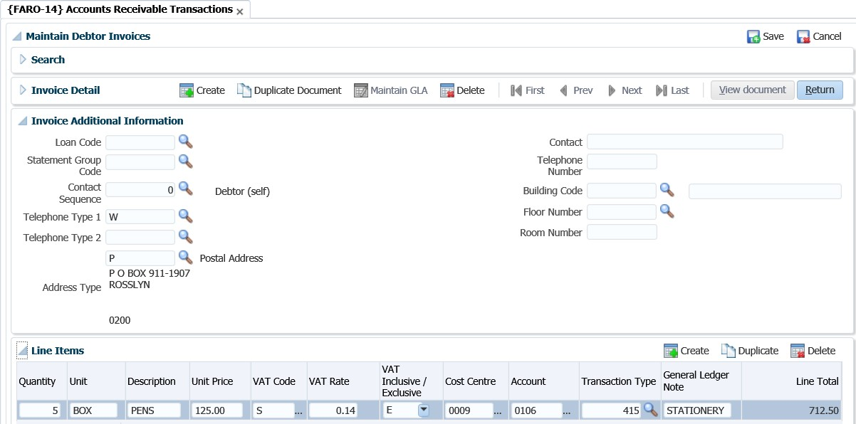

**Loan Code**: This field is not mandatory but allows the user to enter a loan code if an adjustment is to be made to a Staff loan or Student loan. The user will only be able to access this field if the account type used in Account Type on the document is linked to a category of S or L on the account type definition {FCSC-21}. The link between the loan and account type can be found on {FARS-1}. The staff loan will be updated when the user commits the document.

**Statement Group Code**: Statement Group Codes is defined in option {FARC-4} and linked to AR Document Types in option {FARM-3}. Statement Group is only updateable if the Statement Number is null. The system will default the Group Code linked to the document as defined in option {FARM-3} and if is updateable, then the user may change it on this screen. The group code is updateable until a statement number is linked to the document.

**Contact Sequence**: This number is used for identifying the addresses and/or telephone detail for the contact in question. Contact sequence = '0' always refers to the debtor himself - Primary contact. This field is mandatory for documents that must printed. The document types referred to are Invoices (Normal or Repeating) and Credit Notes (Normal or Repeating).

**Telephone Type 1**: Telephone number for contact in the Contact Sequence field as above. A list of valid types is available.

**Telephone Type 2**: Telephone number for contact in the Contact Sequence field as above. A list of valid types is available.

**Address Type**: Address type for contact sequence referred to in the above Contact Sequence Field. A list of valid address types is available. This field is mandatory for documents that must be printed.

**Contact**: The name of the person who requested the document.

**Telephone Number**: The contact person’s telephone number.

**Building Code**: The code of the building in which the contact person resides. If the building is in the Space Inventory, its name will be displayed. The <LIST> command will show valid building codes. If the building is not in the space inventory, this field may be left blank and the building name entered in the following field.

**Floor Number**: The floor number of the contact person.

**Room Number**: The room number of the contact person. (Refer to Space Inventory {SPOPS-1} for information regarding the room-numbering convention).

**Panel box 4: Line Items**

**Quantity:** The number of units that have been supplied.

**Unit:** An eight-character descriptor, e.g. Unit, Kg, Litre, etc.

**Description**: Description of the item.

**Unit Price**: The unit price in the debtors’ currency. Unit price must be entered exclusive of VAT as VAT will be added by the program if a VAT rate with a value greater than 0.00 is entered on the line. **VAT Code**: Is VAT payable on this item? Reply with an existing VAT code as defined in option {FCSC-1} and the system will display the value in the “VAT RATE” field. The system will use the VAT rate to calculate the total at the top of the "Transaction Detail tab. The user will have to link a default VAT code to SOD 'VA' in {FCSM-1}.

**VAT Rate**: The VAT rate that should be applied to the line. Selecting the VAT code on the VAT field will default the rate linked to the VAT code. For further details regarding this field, see VAT.

**VAT Inclusive/Exclusive**: If VAT is Inclusive (i.e. The VAT is part of the 'Unit Price'), then the system will calculate the VAT amount by deducting the VAT from the 'Unit Price'. If the VAT is Exclusive (i.e. The 'Unit Price' does not have any VAT added to it), the system will add the VAT by calculating it from the 'Unit Price'.

**Cost Centre**: Invoice - The cost centre for the credit leg of the transaction

Credit Note - The cost centre for the debit leg of the transaction

**Account**: Invoice - The account for the credit leg of the transaction

Credit Note - The account for the debit leg of the transaction

**Transaction Type**: Supply a valid, appropriate transaction type code, as defined in option {FCSO-7}. The transaction type codes are to a certain extent, restricted per screen. However, it is still possible to make mistakes and users should be careful in defining transaction types: staff should be thoroughly trained and aware of the dangers of using incorrect types. The system will however validate that the Dr/Ct indicator on the type of document is the same as that on the transaction type. Events 'VC' (Invoices) and 'VD' (Credit Note) were created to default the transaction type of the transaction if the user leaves the transaction type field blank. The system will control that a VAT transaction (“linked”) is used if a non-zero VAT rate was used. The test is executed only when the credit GLA is entered. If not, the system will respond with: “VAT linked transaction is required for transaction with non-zero VAT value”

**General Ledger Note**: An optional note to accompany the transaction. On entering the transaction type, the system will insert the short name of the debtor and the reference number as specified on the Document. The user is allowed to update these values.

**Create button**

A new line to enter the Financial Item Detail is created.

**See Example below {FARO-14}**

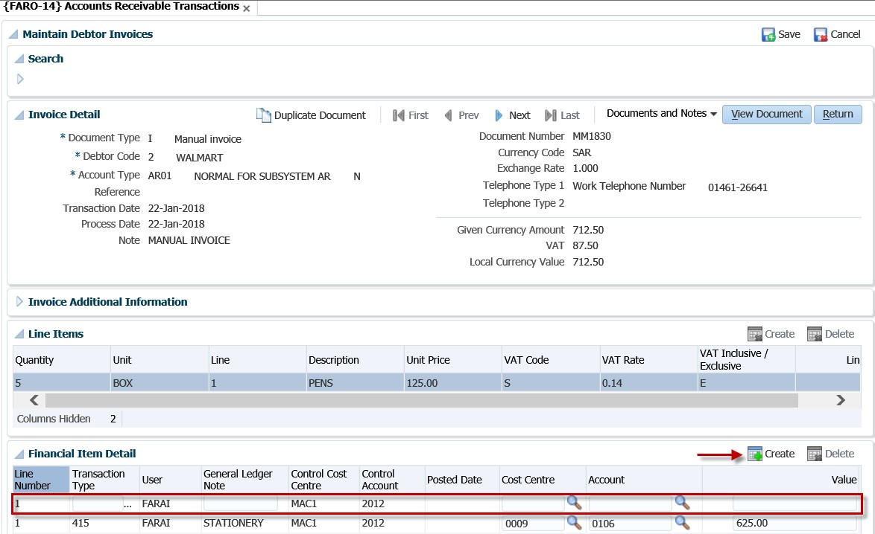

**Save button**

The invoice is created when you click on the “Save” button.

**See Example below {FARO-14}**

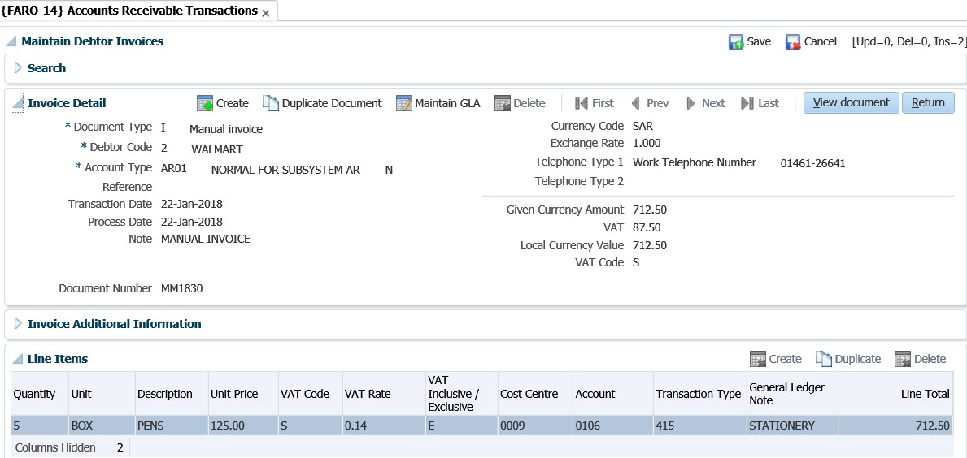

**View Document button**

By clicking on the 'View Document' button, the option will open the Invoice or Credit Note as well as the batch prompter. The batch prompter will enable the user to view, mail or print the document.

**See Example below {FARO-14}**



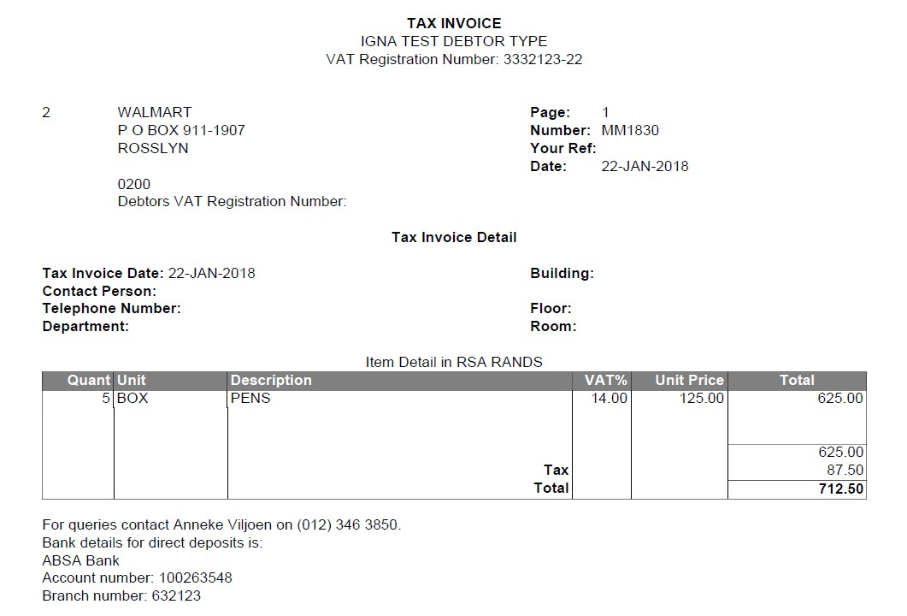

**Duplicate Document**

Allows the user to copy the details of an existing invoice. By clicking on the 'Copy Invoice' button, the system will create a duplicate of the invoice selected, but with a different invoice number. The fields that are updateable are the same fields as when the user creates a new invoice, except for the invoice number field.

**See Example below {FARO-14}**

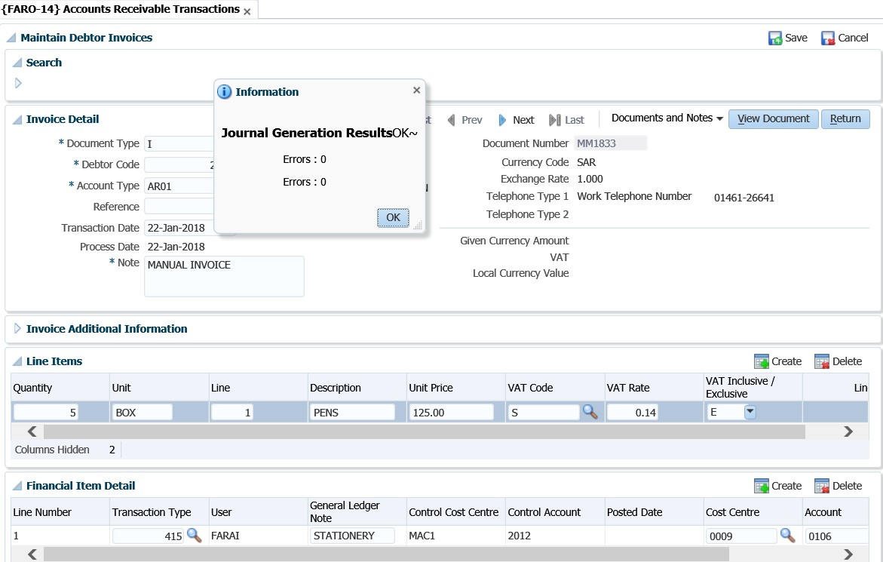

**Maintain GLA**

**See Example below**

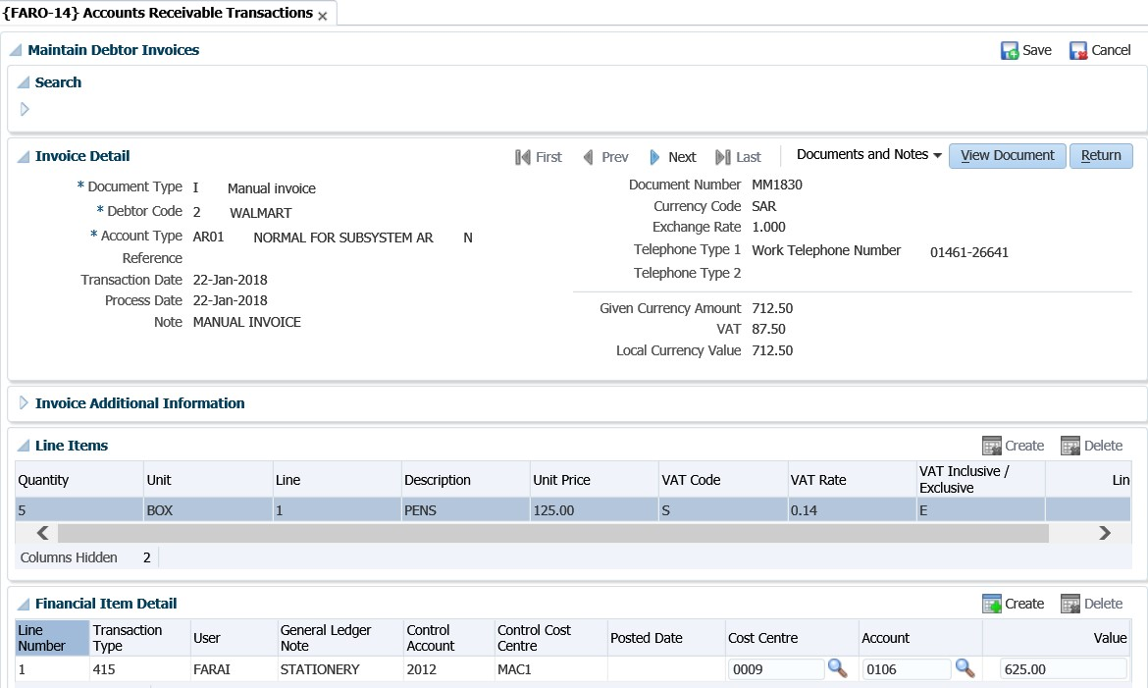

The user can maintain the GLA of a debtor transaction with this task. The GLA can only be changed if the transaction has not yet been posted to the General Ledger.

**Documents and Notes LoV**

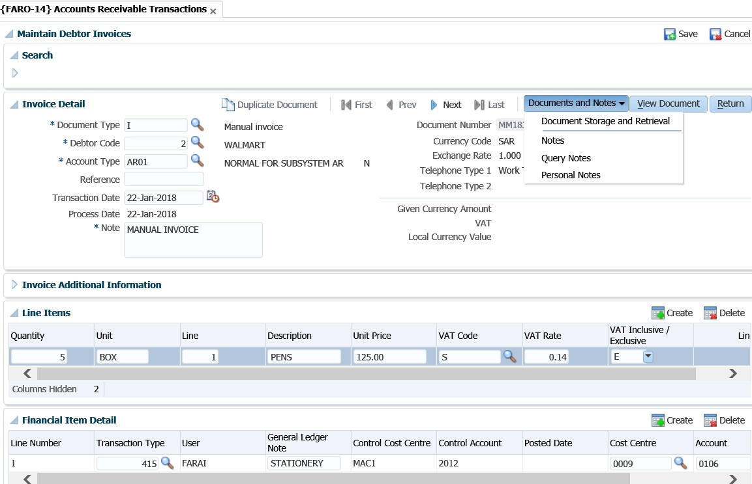

(Refer to the information on “Invoice” for a detailed explanation of the fields)

**Save button**



**See Example below**

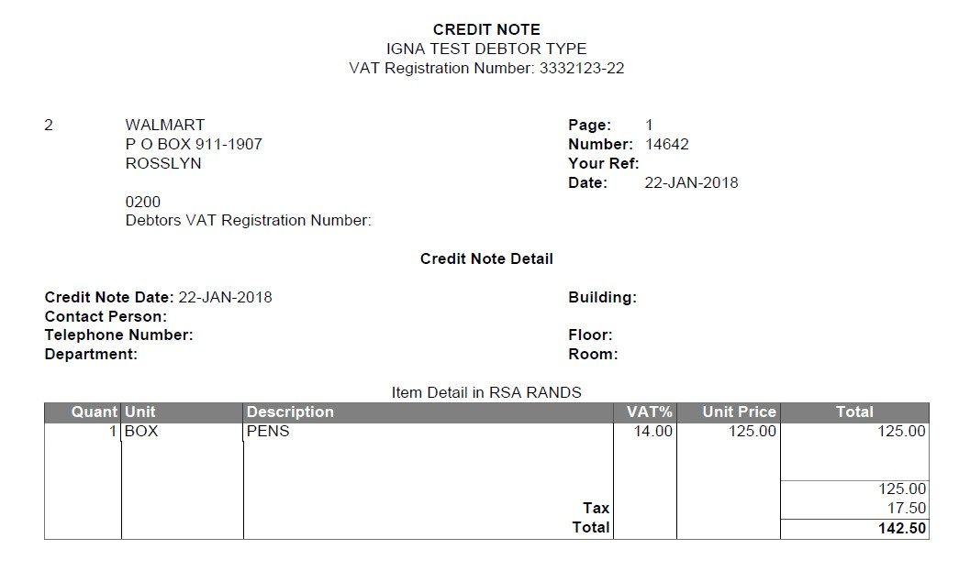

**See Example below {FARO-14}**

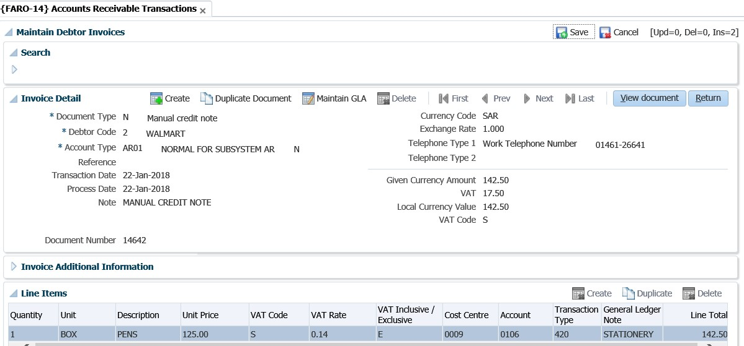

**Duplicate Document**

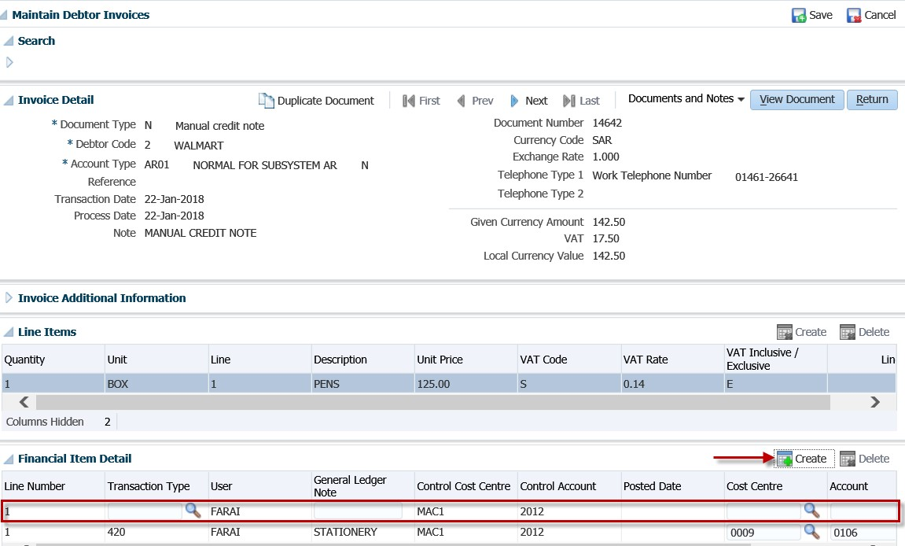

**Copy Invoice**

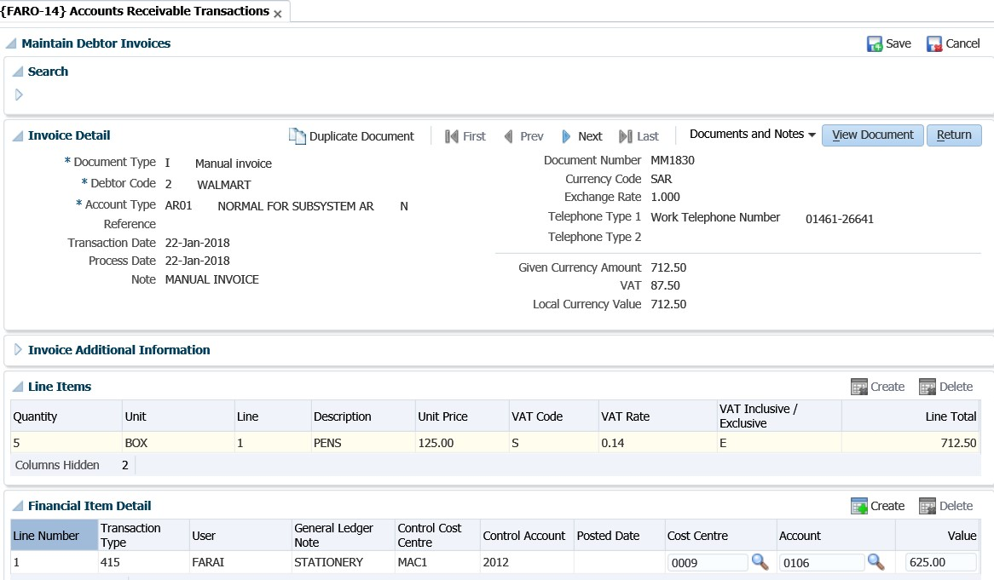

## Cancel Invoice {FARO-5}

Allows the user to cancel single or repeating invoices.

**See Example below {FARO-14}**

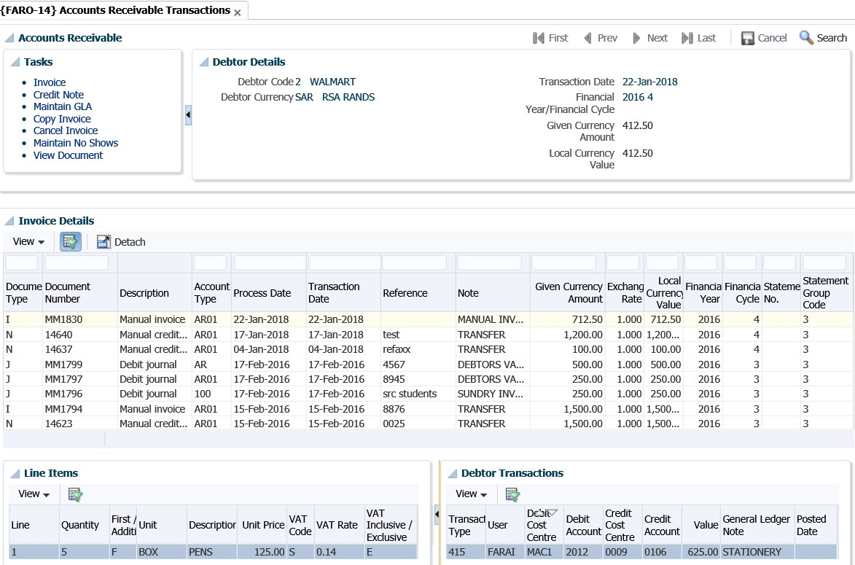

Allows the user to suppress the printing of contra entries on a specific debtor’s statement for a specific account type. This could be useful for suppressing multiple erroneous entries that crowd the statement.

**See Example below {FARO-14}**

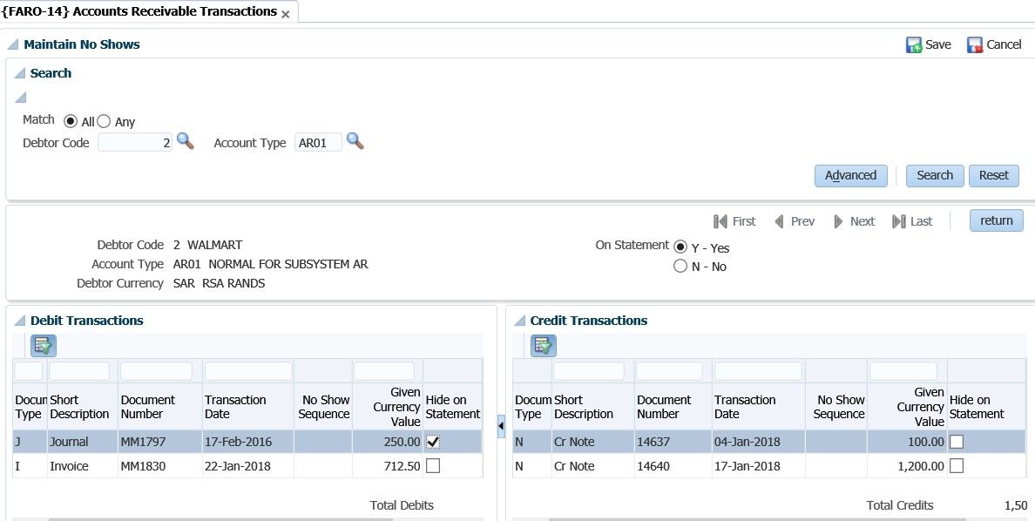

Transactions for an account type are displayed and only the 'Show on Statement' indicator can be updated. A blank field means that the item will be printed.

**MODULE**

**4**

# Other Operational Menus

**Specific outcomes**

On completion of this module, you will be able to:

* Maintain debtors.
* Query types of documents.
* Default text on multiple invoices.
* Query debtor transactions.
* Calculate interest on debtor balances.

## Introduction

Debtors may be divided into two groups, namely student debtors and other debtors such as central government, sponsors, personnel and organisations from commerce who use the facilities and/or expertise of academics. Student debtors are fully catered for within the student accounts subsystem (refer user manual for student debtors), whereas this module allows for keeping record of the other debtors.

## Debtor definition pre-requisites

**Step 1**: Account types must be defined for the AR subsystem in {FCSC-21} and linked to the relevant debtor categories (see next step for available categories).

**See Example below {FCSC-21}**

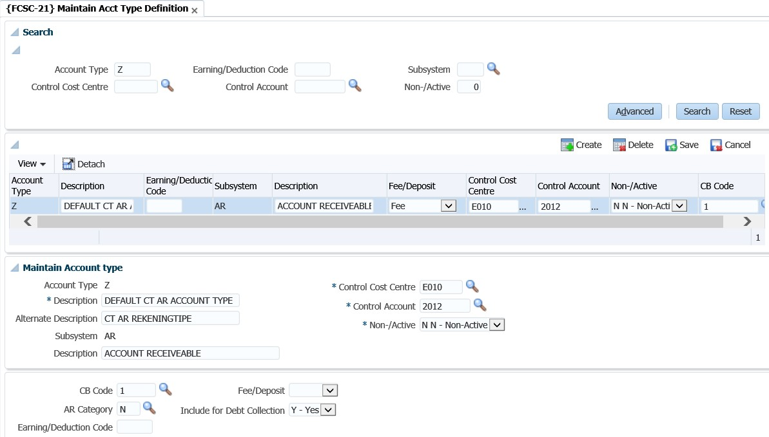

**Step 2:** The debtor categories are pre-defined and cannot be changed. The debtor category will determine the use of the specific account type for a type of transaction. Decide what type of sundry debtors will be maintained in the system so that the right account types can be created. The different types of sundry debtor transactions are, (N) normal transactions, (S) staff loans, (H) clinic system, (L) student loans, (C) contact debtor or (B) booking transactions.

**Step 3:** Create at least one debtor type in {FARC-1}. This debtor type will be linked to the debtor on the debtor definition. Reports can be requested per debtor type.

**See Example below {FARC-1}**

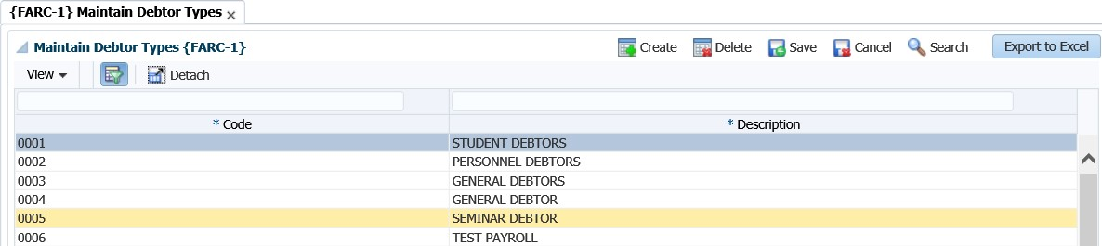

**See Example below {FCSC-21}**

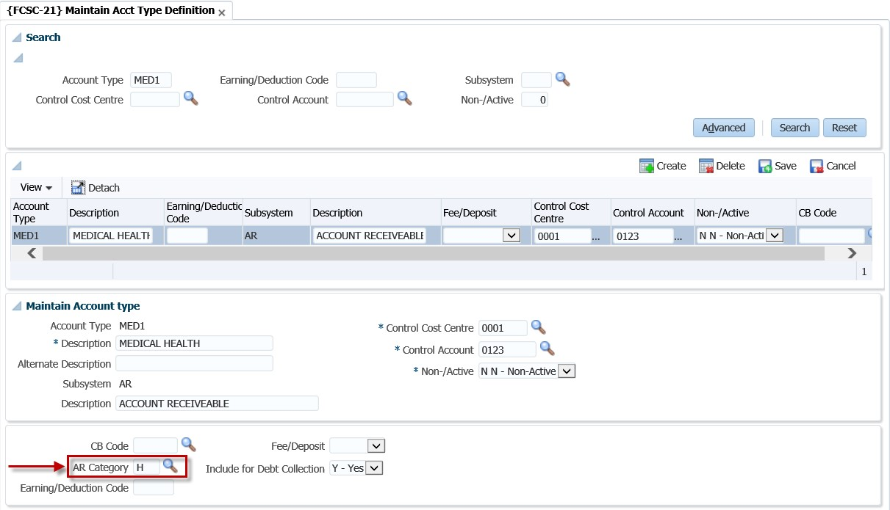

## Maintain Debtors {FARO-21}

Before you will be able to process any transactions in the AR system, the debtor must be defined or allocated a number that will be used when any reports are requested, or transactions are processed for the debtor. This is the option where the debtor will be defined, and the detailed information of the debtor is kept. Access to this option will be restricted and caution must be taken when new records.

**See Example below {FARO-21}**

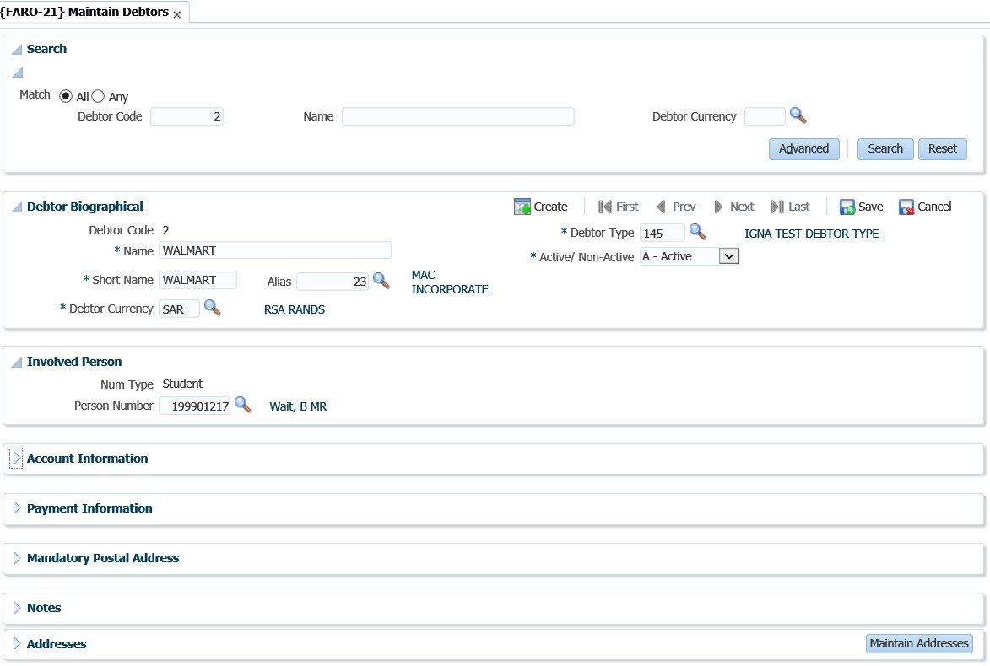

The user can enter the 'Debtor Code', 'Name' and/or 'Debtor Currency' and click on the 'Search' button to view existing transactions for the 'Debtor Code', 'Name' and/or 'Debtor Currency' combinations.

**Panel box 2: Debtor Biological**

**Debtor Code**: The debtor’s unique account number.

**Name**: The name of the debtor

**Short Name**: The first 10 characters of the above name default into this field, but may be altered by the user to be more meaningful. This short name is used for quick reference, display purposes and on some reports.

**Alias**: The alias code (if any) to be used with this debtor, as defined in option {FARO-22}. The alias name will be displayed.

**Debtor Currency**: In which currency should the debtor transactions take place? Use the list function to view the valid currency codes, as created on {FCSO-21}, TAB - Fixed Foreign Currencies.

**Debtor Type**: The code of the debtor type as defined in option {FARC-1}.

**Active/ Non-Active**: Is this account Active or Non-Active? If this indicator is set to Non-Active, the system will not allow any transactions from any subsystems to be entered for this Debtor.

**Panel box 3: Involved Person**

**Num Type**: This field will be completed if the debtor that you are creating, is also used on another sub-system in ITS. This is where you can link the debtor to a Student, Alumni, Personnel or Other. **Person Number**: This is the number for the Person Type selected. The name will be displayed as defined in the sub- system of origin. The list function can be used to display all the valid numbers on the system.

**See Example below {FARO-21}**

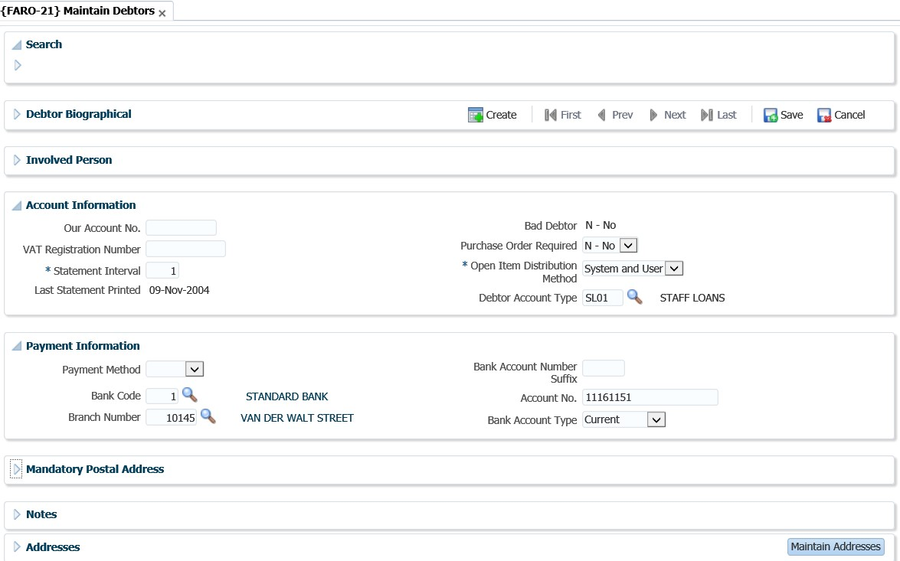

**Our Account No.**: This is the institution's account number with the debtor.

**VAT Registration Number**: The registration number of this debtor, if any. This number will be displayed on a number of reports.

**Statement Interval**: The number of months between printing statements for this debtor. Only 1 to 12 allowed.

**Last Statement Printed**: This field is not accessible to the user but will be updated by the system each time a statement is printed for this debtor.

**Bad Debtor**: Is the debtor a bad debtor Y - Yes or N - No. This indicator is also important for deletion of a debtor. The system will control that a debtor is inactive for at least the number of cycles set as the retaining period of transactions, before deletion is allowed.

**Purchase Order Required**: When using the Student Debtor Contract system, is a Purchase Order required when the student applies or registers for a qualification where the registration or application is linked to a contract that is linked to this debtor. Valid values are Y - Yes or N - No.

**Open Item Distribution Method**: An indicator to show the Open Item distribution method allowed for the debtor. User distribution allowed or System and User distribution allowed.

* System and User distribution allowed:

The System Batch Distribution program will distribute credit documents (receipts etc) to invoices automatically in sequence of the oldest to latest invoices.

* User distribution:

Credit documents must be linked to specific invoices by the User via online maps. (System distribution will not look at these transactions).

**Account Type**: This is the default account type for the debtor as setup in {FCSC-21}.

**Panel box 5: Payment Information**

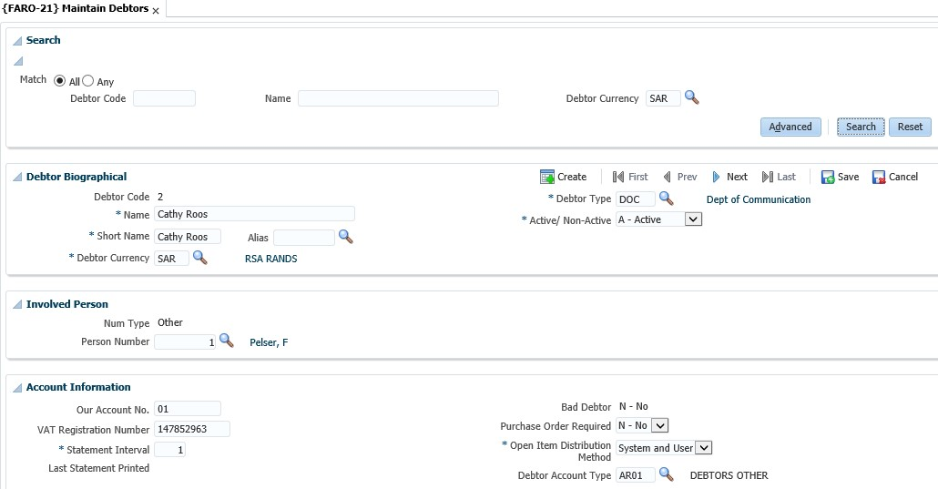

**Payment Method** –This field indicates the debtor’s method of payment; it can be EFT or Cheque.

**Bank Code**: The Bank Code of the debtor’s banking institution.

**Branch Number**: The branch code of the debtor’s bank.

**Bank Account Number Suffix**: Enter a 4-digit number suffix for the Bank Account. Only applies to clients in New Zealand.

**Account No**.: The debtors’ bank account number.

**Bank Account Type**: The debtor's account type. Values are Current, Savings or Transmission.

Displays the postal address of the debtor. You click on the “Maintain Addresses” button in the Addresses panel box to add the postal address of the debtor.

**Panel box 7: Notes**

General notes for the debtor can be added.

**Panel box 8: Addresses**

Displays the address and communication details of the debtor. The Maintain Address button will take you to a form where the addresses can be maintained.

**See Example below**

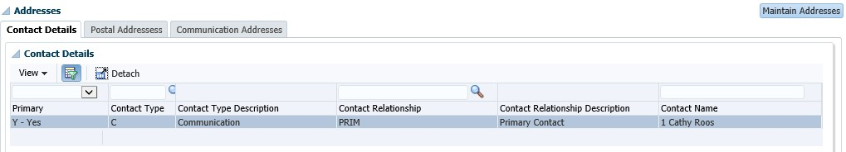

When you click on the “Maintain Addresses” button, the following screen will display and you can click on the “Create” to add an address.

**See Example below**

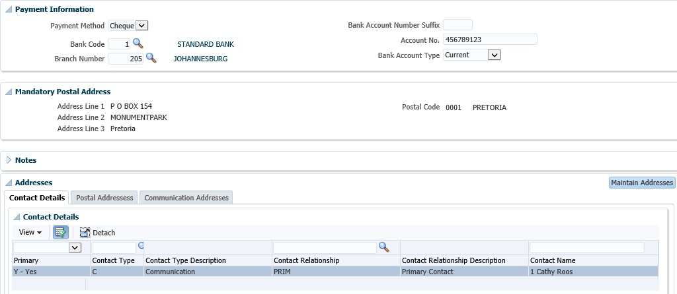

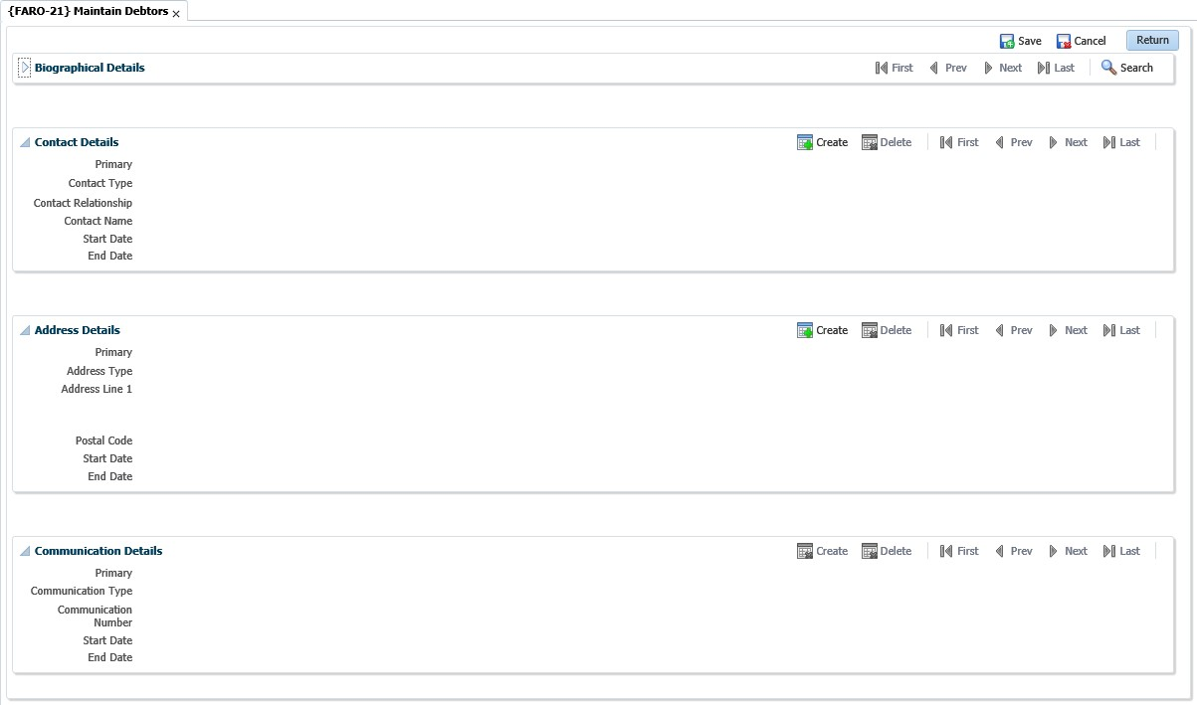

**See Example below {FARO-21}**

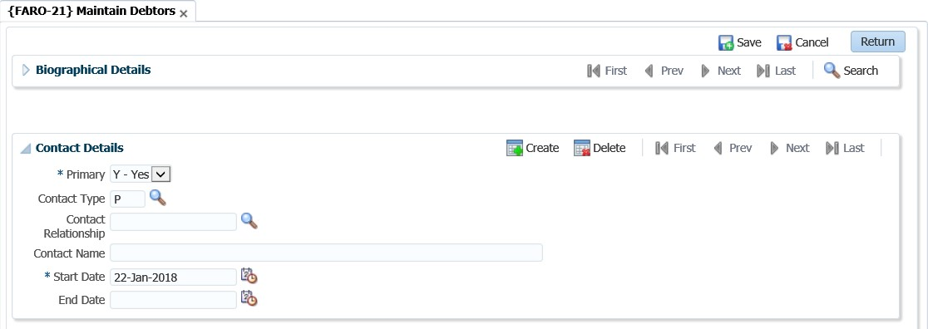

Once you save, the address details will appear in the table.

## Query Types of Documents {FCSO-23}

There are a number of transactions that can be processed on a debtors’ account. The institution must however indicate on this option, which transactions are allowed. Query for ‘AR’ on the field that reads “subsystem”. All the types of transactions will be displayed. There are 8 types of transactions where the user can indicate if this type of transaction is allowed. The 8 types are:

* 1: Credit Transaction
* B: Repeating invoice
* F: Repeating credit note
* I: Invoice
* J: Debit journal
* N: Credit note
* S: Credit Balance
* T: Debit Balance

If the “display sequence” field is left blank, the type of process will not be available. The sequence number allocated will indicate the in which sequence the options will display on



{FARO-1}. The number sequence you allocate does not matter, you can start at 1 and

increment the numbers or allocate numbers as you please. The important thing to look at is the display sequence. The smallest number will display that “document type” first.

**Field in this option**:

**Type**: A unique character as allocated by ITS for each subsystem involved.

**Description**: Description of the Document.

**Short Description**: The English description of the type will be displayed.

**Alternate Description**: The Alternate description of the type will be displayed.

**Debit/Credit**: The debit or credit indicator of this type of Document.

**Subsystem**: The subsystem that uses this type of Document.

**Display Sequence**: The sequence in which the document must appear on the <LIST> function. Referring to the previous image, it would mean the sequence in which the documents would be displayed in {FARO-1} is:

**See Example below {FCSO-23}**

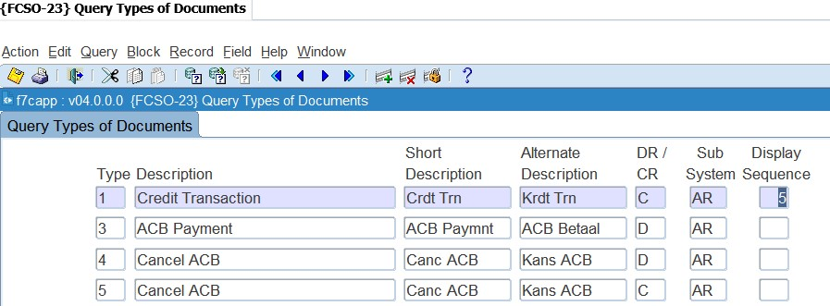

* Manual invoice
* Repeating invoices
* Credit transaction
* Repeating credit note

## Default text on multiple invoices

Should you like to print generic text on the invoices you print for the debtors, you have to access menu option {FAROR1-1} or {FAROR1-12}.

## Invoices to be Sent {FAROR1-1}

This is the option that allows you to print (or re-print) invoices. Styles sheet are added to the option to include header and footer as part of the invoice. The program can include a note as part as the Invoice. The note is obtained either from a note created in the Debtors Correspondence {FDCO-1} or a paragraph where a note is created in an RTF format and loaded into the system and converted to a style sheet {GMNT-14}.

The default note is the note code or paragraph include linked to the SOD code NI subsystem AR. To create a paragraph, include type note, create the note in MSWord, save the note as RTF. In {GMNT-14} enter a note code, description (description may note contain spaces) and document classification (paragraph include class is PINC) and date, load and convert the RTF document (Retrieve from Client button).

Access the option {FAROR1-1}. Enter the values as requested from the different parameters. The parameter that asks “add default note” you will indicate yes. The note that you have created and linked to the parameter in {FCSM-1} will print with the invoice.

**See Example below {FAROR1-1}**

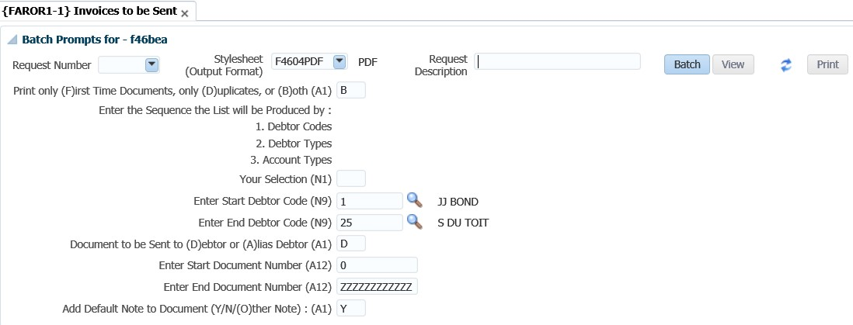

**Print only (F)irst Time Documents, only (D)uplicates, or (B)oth:** First time documents have not yet been printed and therefore have not been flagged as printed. When documents are printed for the first time these documents are flagged as printed by the program. Duplicate documents will reprint documents that have previously been printed. These documents are flagged as printed. Both will reprint previously printed documents as well as first time documents.

**Add Default Note to Document:** When you select (Y)es, the note is obtained from a note created in the Debtors Correspondence {FDCO-1}. The default note is the note code linked to the SOD code NI subsystem AR. You go to the option “Maintain system operational definitions”: {FCSM-1} tab 2. Query the code “NI” and link the document code created above to the “Default Note to Print Invoice” code.

**See Example below {FCSM-1}**

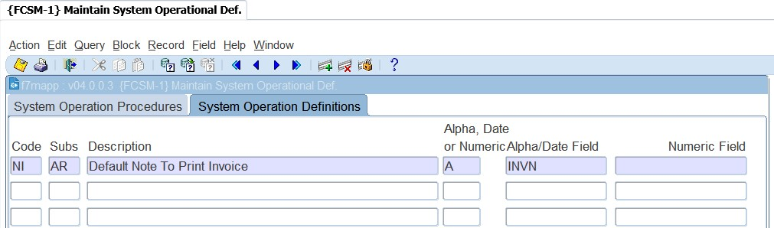

To create a paragraph, include type note, create the note in MSWord, save the note as RTF. In {GMNT14} enter a note code, description (description may note contain spaces) and document classification (paragraph include class is INC) and date, load and convert the RTF document (Retrieve from Client button).

You can also select to not to use the default note i.e. on the parameter that requests “add default note” you will indicate “O”ther.

**See Example below {FAROR1-1}**

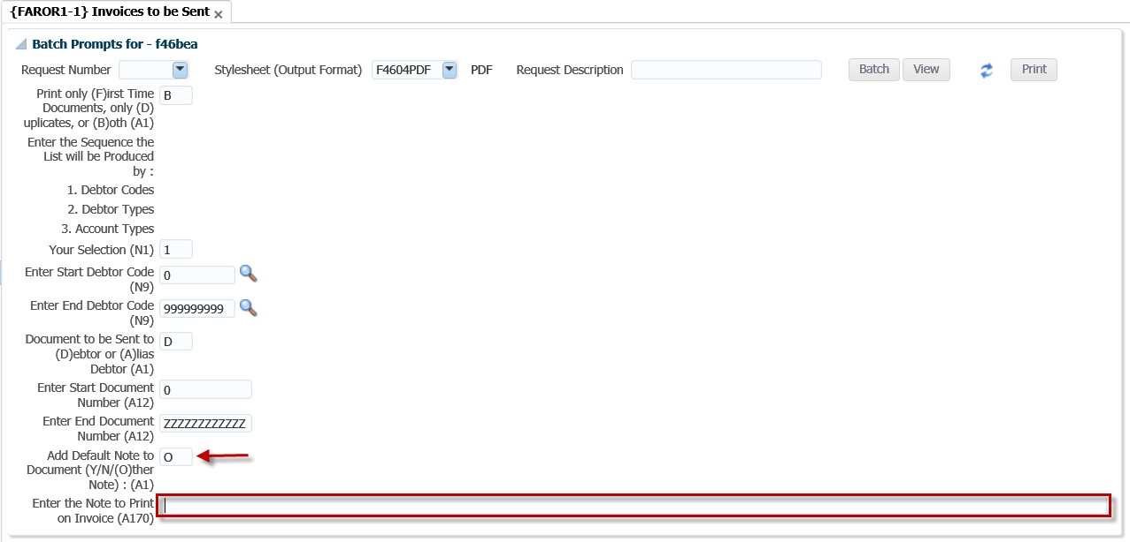

**Add Default Note to Document:** If the answer is O, then enter the note to print on invoice in the field that follows.

**Enter the Note to Print on Invoice**: The actual text that you want to appear on the invoice.

**Batch button**

You can proceed in immediate or deferred batch mode and the View / Print buttons will become active.

**See Example below {FAROR1-1}**

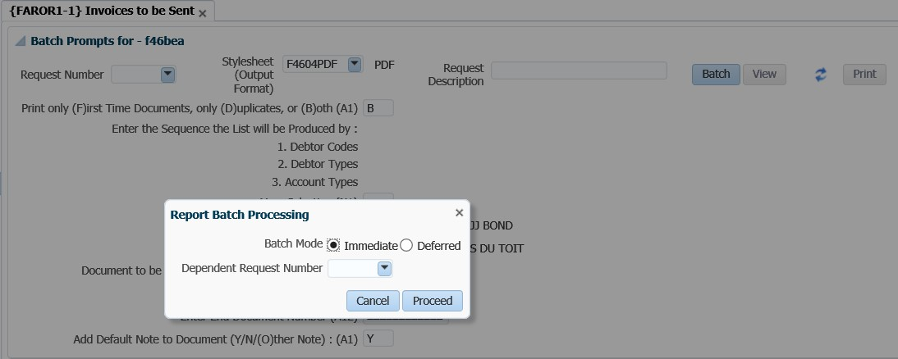

The user can opt to view or print the report generated.

**See Example below**

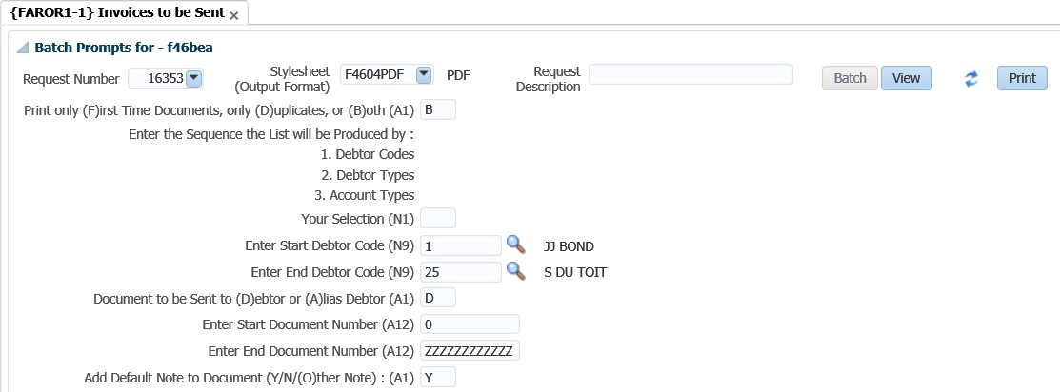

## Consolidated External Debtor Statement – NCR Format {FAROR1-12}

This option is based on the selections criteria of previous debtor statements and it is designed for external use. The output is based on the iComms concept and users may design their own layout. Statements can be generated sequentially per debtor or unique statement numbers. A new option based on the selections criteria of previous debtor statement and it is designed for external use. The output is based on the iComms concept, users may design their own layout.

Notes that are recorded against a debtor can be printed on the statement. The note category 'ZPDN' is and ITS category called Public Domain Notes and cannot be restricted. The note category 'ZPDN' and note code 'ITSSTMD' must specifically be used when notes are created that must print on the Debtor Statements. Only notes linked to this category will print on statements. All notes that are linked to this category where the note status is null will print on the student statement

**Enter Comment Line 1 to print on Statement**: The actual text that you want to appear on the invoice.

**See Example below {FAROR1-12}**

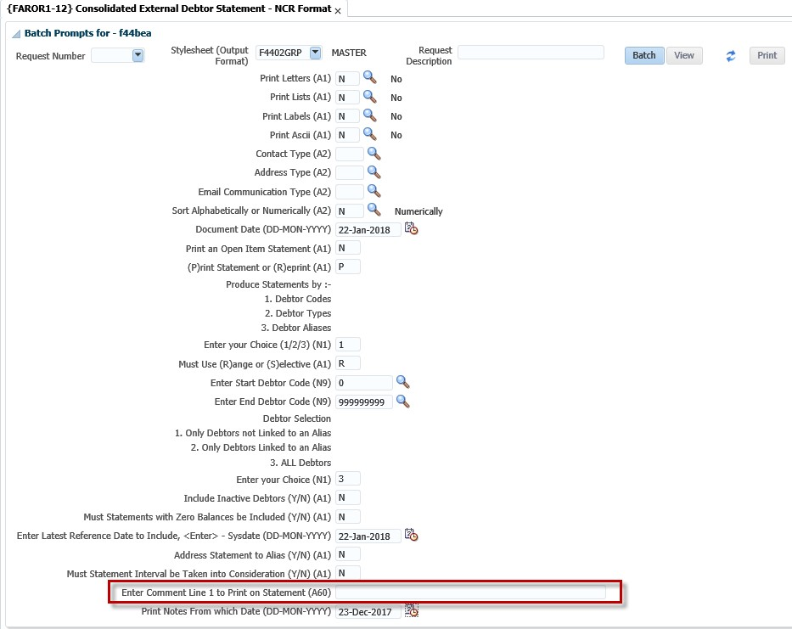

## Query debtor transactions {FARO-3}

This option is not only used to query all transactions of the debtor, but also has the functionality

available to drill down to detailed transaction.

**See Example below {FARO-3}**

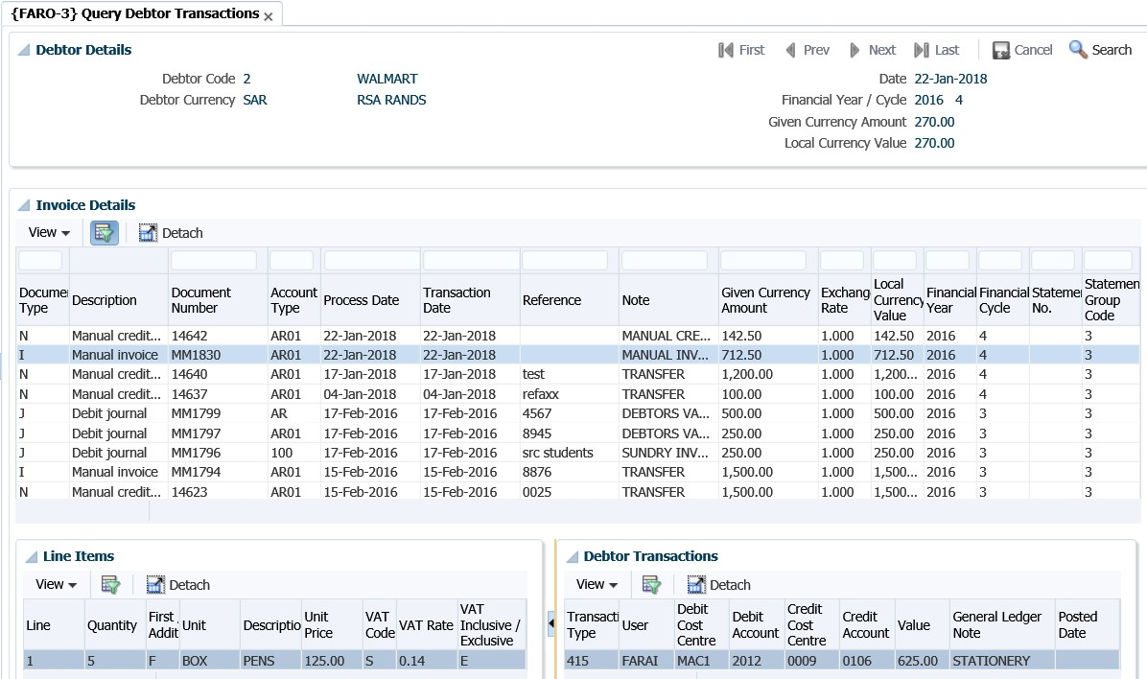

When the user selects a debtor from a search, the details of the debtor are displayed in this panel box.

**Invoice Details**

This panel box will display all the documents for the debtor selected in Debtor Details. The invoices of the debtor display in the table and are not updatable. If you wish to see the detail of a specific transaction in this panel box, you click on the transaction and the financial details will display in the Line Items and Debtor Transactions panel boxes.

**Line Items**

All the line items of the document selected in the Invoice Detail panel box are displayed here.

**Debtor Transactions**

The general ledger allocation details of the document selected will display here.

Transactions will be displayed from the latest transaction date to the oldest. The type code is the same codes that are used in {FARO-1}.



## Calculating interest on debtor balances

Interest is calculated per debtor type linked to the account type. The debtor type will be linked to the debtor as well as to the account type. Interest can be calculated on a monthly basis. Below are the steps to follow should you wish to charge interest to the debtor accounts.

**Step 1: Maintain debtor types {FARC-1}**

The debtor type will be linked to the debtor in {FARO-21}. The debtor type is primarily used to “group” the debtors. The reports do make provision for requesting per debtor type. An example of debtor types that can be used are, “Normal debtors”, “Student debtors” and “Sundry debtors”.

**See Example below {FARC-1}**

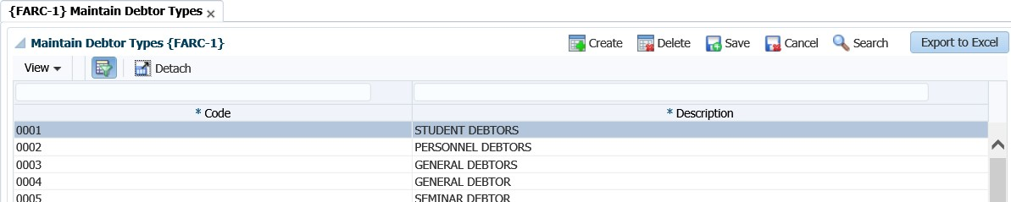

**Step 2: Maintain interest parameters {FARM-1}**

The system makes provision to charge interest for different debtor types per account type. This means that different interest can be charged for sundry debtors than for SRC debtors. You will specify the interest rate applicable per debtor type for transactions recorded on a specific account type. Interest rates can be specified for current, 30-60 days, 60-90 days and 90 days plus. Remember that the transaction date will be used to do the ageing when calculating interest. If you don’t want to charge interest you will set the fields to zero.

**See Example below {FARM-1}**

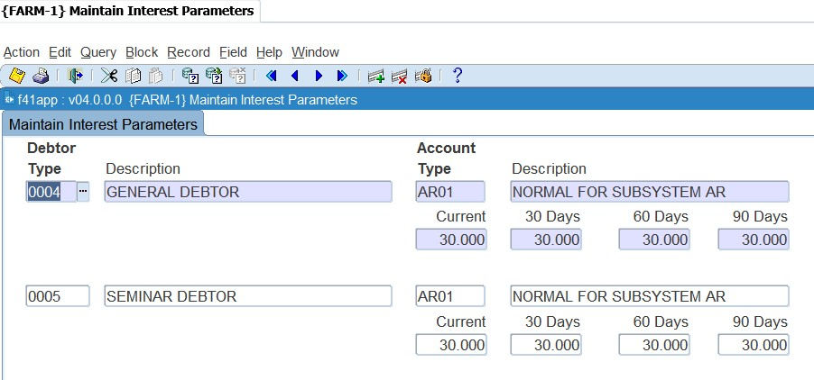

**Step 3: Calculate interest {FARO-6}**

Before this can be used for the first time, the user should link a transaction type to event ‘FU’. (see section on example of transaction types above on what GLA’s should be used.) For debtors that are flagged as an Open Item usage debtor, aging will be done for each invoice. The functionality of Open Item enables the system to do aging of outstanding amounts for debtors at invoice level. The option is in a “report format” and the system will ask the following parameters:

**See Example below {FARO-6}**

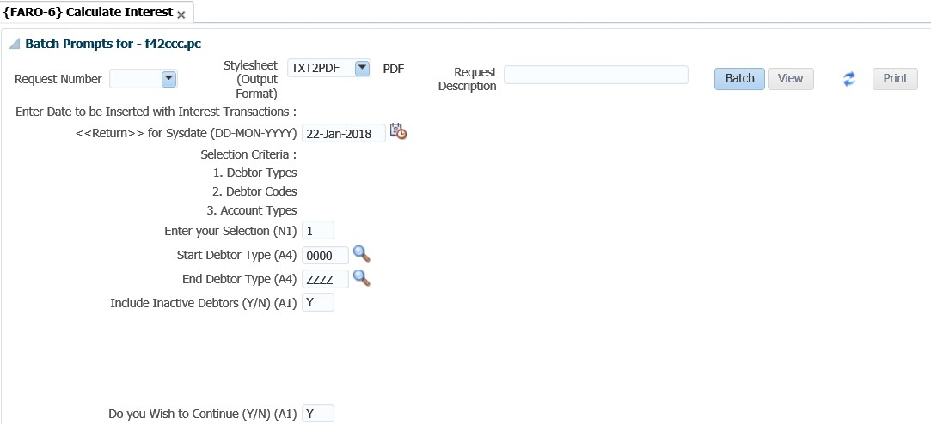

**Enter Date to be inserted with interest transactions**: <RETURN> will default to system date: This date will be used for ageing of the interest transaction.

**Previous Interest transactions to be included**: Note that a (Y)es will result in interest being calculated on interest. If your institution does not follow this compound interest policy, always reply (N)o to this question.

**Step 4: Rollback interest calculation {FARO-7}**

This option allows for the rollback of interest as calculated in {FARO-6}. The option will control that the transactions have not yet been posted to the GL. If it was posted, the system will abort with a message.

**See Example below {FARO-7}**

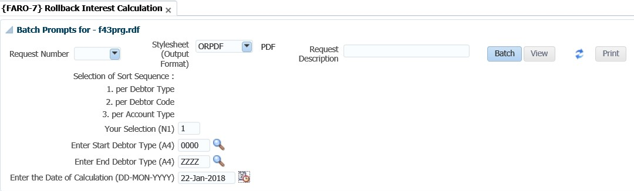

The selection allows selective rollbacks per debtor type for interest calculations done on the same date.

**MODULE**

**5**

# Journals

**Specific outcomes**

On completion of this module, you will be able to:

* Generate batch journals.
* Execute inter-account transfers.
* Maintain no-show indicators.
* Perform electronic approval of transactions.
* Utilise the open item functionality.

## Introduction

In the previous section we had a look at individual transaction processing. That means where you would either process an invoice or journal for an individual debtor. In this section we will look at the functionality available where you can process journals for more than one debtor simultaneously.

## Batch journals {FARO-29}

This is used to process transactions/journals for different debtors with one journal/voucher number. The option can also be used to process transactions for individual debtors. This option allows the user to capture batch journals manually or to duplicate a previously captured journal by searching for the journal and then clicking on the 'Duplicate Journal' button, as well as importing a journal from a csv template.

The 'Create CSV template' button allows the user to download a journal template from the option. The user can then fill in the template with the journal details, then upload the file back into the option. This is useful where staff recoveries (for example telephone usage) must be made. If a list of staff members and the cost to be recovered is available, the application allows for quick capture of such a list.

**See Example below {FARO-29}**

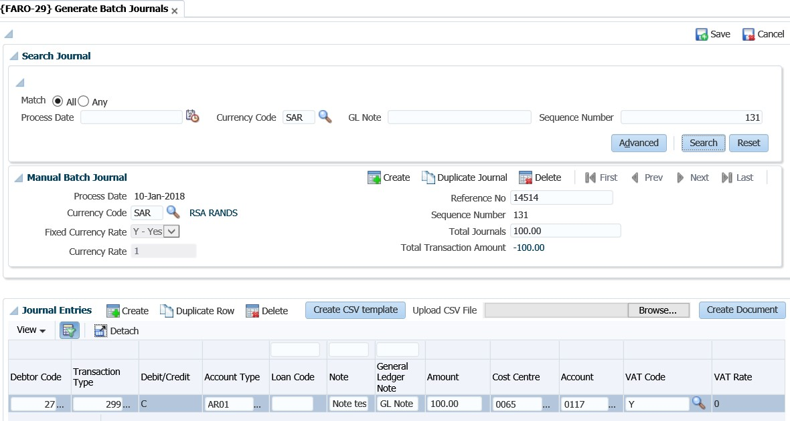

**Process Date:** Processing date of the journal.

**Currency Code:** Currency code for this journal.

**Currency Rate:** Currency rate for this journal.

**Fixed Currency Rate:** Is the exchange rate fixed? Values are Y - Yes and N – No.

**Reference No:** This is a user defined reference number used to reference the batch journal to its supporting documents.

**Sequence Number:** This is a system generated number.

**Total Journals:** Total amount of the journal to be processed. (If it is for foreign purposes, enter the amount in foreign currency). If this is a credit Journal, the amount must be captured as a negative e.g. -10000.00.

**Total Transaction Amount:** The total of the transactions in the Journal Entries panel box will be displayed.

**Journal Entries**

**Debtor Code**: The code of the debtor as defined in {FARO-21}.

**Transaction Type**: Transaction type to be used for this journal. Created in {FCSO-7}.

**Debit/Credit:** Is this transaction a (D)ebit / (C)redit? This field is populated systematically from the debit/credit indicator of the transaction type.

**Account Type:** Account type for the debtor transaction. Created in {FCSC-21}.

**Loan Code:** The loan code from which the staff recovery will be made if applicable. The link between the loan and account type can be found in {FARS-1}.

**Note:** The transaction note to print on debtor statement for this journal.

**General Ledger Note:** The note that will appear in the general ledger.

**Amount:** The transaction amount for this debtor.

**Cost Centre:** Cost centre for this transaction. Created in {FCSO-1}.

**Account:** Account for this transaction. Created in {FCSO-3}.

**Vat Code:** Vat code for this transaction.

**Vat Rate:** This field is populated from the VAT Code.

**Transaction Group Code:** Transaction Group Codes are defined in option {FARC-4} and linked to AR Document Types in option {FARM-3}. The system will default the Group Code linked to the document as defined in option {FARM-3} and if it is updateable there, then the user may change it.

**Note**: Saving a journal will not write it to the debtor’s account, regardless of whether the Total Transaction Amount balances to the Total Journals amount. In order to have the journal reflect on the debtor accounts, the user will have to click on the 'Create Document' button.



## Inter account transfers {FARO-2}

Should you have processed journals/transactions to the wrong debtor account, you can always make use of the inter account transfer option to process transactions between debtors. This option simplifies the process by capturing one transaction instead of different journals on option {FARO-1}. The option also allows you to transfer amounts between different subsystems.

**See Example below {FARO-2}**

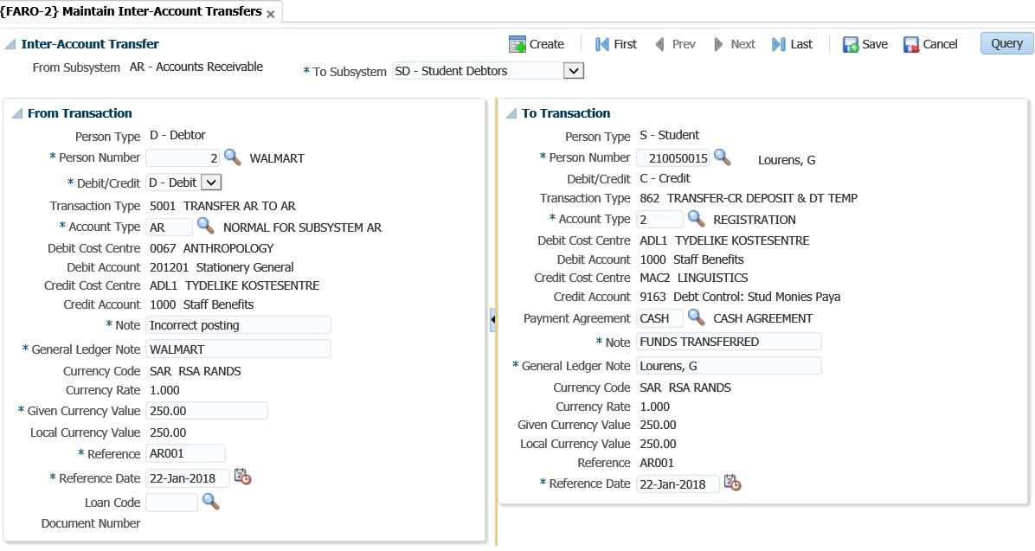

**Main Inter-Account Transfers**

**From Subsystem**: The user must select the subsystem where the information must be transferred from. You have the option to select between AR, SD or CM.

**To Subsystem:** The user must select the subsystem where the information must be transferred to. **Date:** Defaults from the system date.

**“From Transaction”**

**Person Type**: This field will default depending on the subsystem that was selected in the previous tab. Where the subsystem AR is selected, this field will display a D for the debtor.

**Number:** Complete the debtor code from which account the transfer must take place.

**C/D:** What must happen to this debtor? Would you like to debit or credit his account? The system will simultaneously enter the opposite indicator on the next tab.

**Transaction type**: The system will insert the TT automatically. This is because the option works with a transaction event that is linked in {FCSO-7}.

**From account type**: Specify the account type that the amount must be transferred from.

**Note**: This is the description that will appear on the statement for the transaction. It is advised that it is descriptive enough so that the debtor would understand what happened.



**Value given currency**: Enter the amount that should be transferred.

**Reference date**: The system date defaults into the reference date but can be updated by the user.

**“To Transaction”**

The panel box is similar to the adjacent panel, the only difference is that the former contains the ‘To’ information. The user will complete the debtor code for the other person to be updated with this transaction. Other fields are not updatable as they default from the “From Transaction” panel box.

## Maintain no show indicators {FARO-4}

Should you have made a mistake when processing a transaction against the wrong debtor, you can use this option to “hide” the mistake. In the previous section it was explained how to transfer between debtors’ accounts. If statement number is in use, then the system will only display records that are not linked to a statement number. The reason: Once a document is linked to a statement the user is not allowed to change no-show indicators.

**See Example below {FARO-4}**

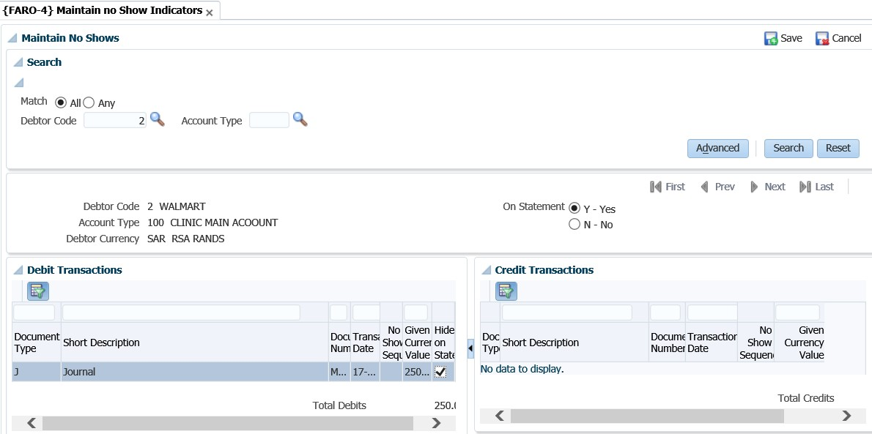

The user will have to enter the debtor code and the account type (optional) as search criteria.

**TAB 2**

You can either select “Yes” to view all transactions on the statement or “No” to view transactions that have already been ticked and thus do not appear on the statement.

**Debit / Credit Transactions**

Will display all the debit / credit transactions for an account type and only the 'Hide on Statement' indicator can be updated. A blank field means that the item will be printed.

**Note**: The system will validate that the no-show transactions balance. That means that the debits and credits are equal. So, before you can save the transaction the option will show the totals in the control tab at the bottom of the screen.



## Electronic Approval of transactions {FARO-11}

This option will be used if the system operational parameter (in {FCSM-1 b2}) ‘EA’ (AR journal approvals) is set to us(E)rs. Only users that are defined as staff members on the personnel system can be linked on {FCSM-5} to “approval privilege”. In addition, the users can also be restricted in {FCSO-4} to approve only certain amounts, cost centres or departments.

**See Example below {FARO-11}**

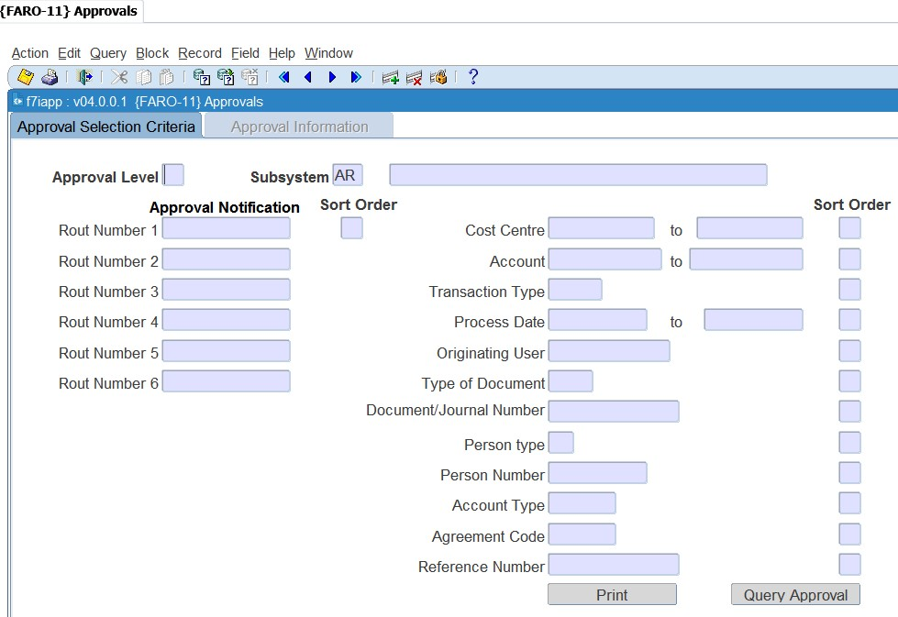

Multiple criteria can be used to query transactions and sort priorities can be given to selection criteria. In tab 1, the user will enter the criteria for the system to query the transactions to be approved. It is optional to indicate what the sort order must be for the transactions to display on the second tab.

**Note**: You must at least indicate in one of the fields what the sort order is before continuing to the next tab. All the transactions that have not been approved yet, will display on the next screen according to the criteria specified.



**Approval Information**

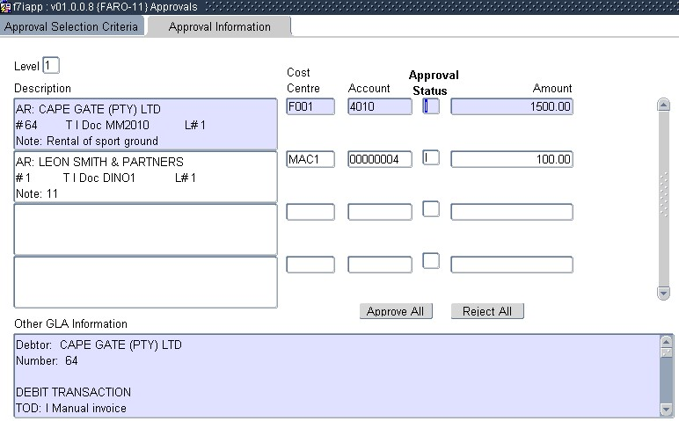

In this screen you can:

* Approve or reject individual transactions. You will select the specific transaction and change the status to A or R or I.
* Approve or reject all the transactions in batch. Click the applicable button at the bottom of the screen.

**Note**: Should you wish to see more detail of the transaction, the detail of the transaction is displayed at the bottom of the screen. When you use the scroll bar on the right of the screen you can view all the transaction detail.



## Open item functionality

“Open Item Distribution” is the functionality to link credit transactions (receipts, cheques, credit notes etc.) to a debit transaction (or invoice). Multiple credit transactions can be distributed to one invoice, or one credit transaction can be linked to multiple invoices. A debit transaction (invoices etc.), where the full document amount is not linked to credit transactions, is referred to as an open item. A debit transaction (invoice etc.), where the document amount is fully linked to credit transactions is referred to as a closed item.

**Note:** By using this functionality, you will be able to not just show the specific outstanding invoices, but also to age the debtor more accurately. When the open item functionality is not used, receipts are “allocated” to the oldest debt first.



### Debtor Transactions {FARI-1}

This option will select and display all the debtors in the open item control table for distribution or maintenance. From this screen the user can access the "Open Item Distribution" and "Open Item Maintenance" options.

The menu option will only be able to be used if the system operation definition ‘OI’ (AR - Open Item Y/N) for sub-system ‘AR’ is set to (Y)es in the menu {FCSM-1 }Tab 2.

**See Example below {FARI-1}**

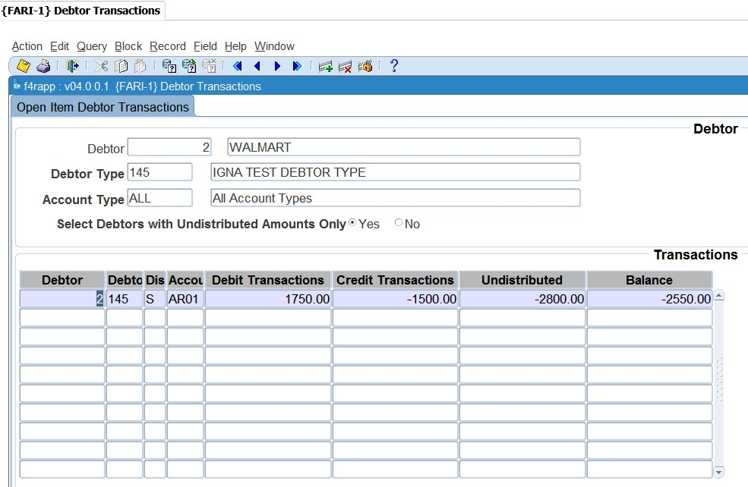

**Open Item Debtor Transaction Selection**

This tab will be used to determine which debtors, debtor types and account types will be selected for processing in the next tab. Debtor / Debtor Type / Account Type will determine the transactions that will display in the next tab. Select Debtors with undistributed amount only (Y/N) will determine if all debtors or only those with undistributed amounts outstanding will display.

**Open Item Debtor Transaction Detail**

The detail data will be selected from the open Item control table according to the selection criteria from tab1. The debit, credit and undistributed transactions will be summarized, and the balance calculated for each debtor and account type combination.

**See Example below {FARI-1}**

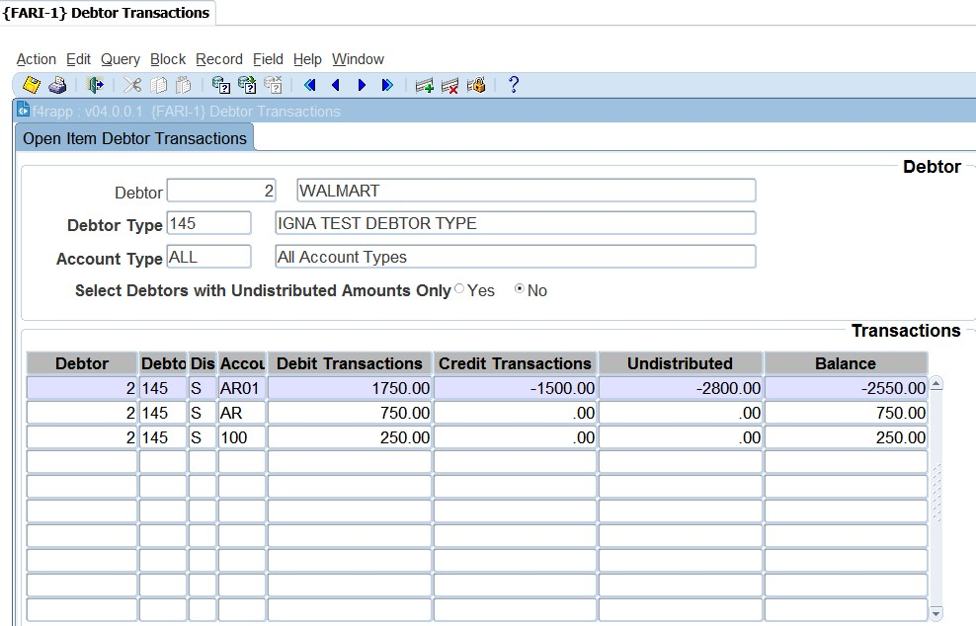

When you right click on the debtor code, you will be able to drilldown to the following menus:

* Maintain Debtor {FARO-21}: update the debtor details
* Query Debtor Transactions {FARO-3}: check the debtor’s transactions and balance
* Open Item Distribution {FARI-2}: distribute credit transactions to a source document (invoice)
* Open Item Maintenance {FARI-4}: unlink a credit transaction from an invoice

**Open Item Distribution**

Open Item Distribution refers to a process of allocating distribution records for credit transactions in the Open Item table for selected debit transactions (payments / receipts to invoices etc.) and two methods of distribution will be available:

* **Batch System distribution**: This is the distribution of all or a selection of undistributed credit transactions. The system will allocate the credits to debit transactions that are still available (open items) from the eldest to latest date for a specific or all debtors. The distribution may be performed in one of the following ways:
  + Full System Distribution: This is the distribution of all undistributed credit transactions for selected debtors to all open invoices for the same debtor
  + System Distribution: This is the distribution of selected undistributed credit transactions for a selected debtor to all open invoices to be cleared from the eldest to latest date.
* **Manual User distribution**: This method distributes selected undistributed credit transactions for a selected debtor to selected debit transactions (invoices etc.) for the debtor.

**See Example below {FARI-1}**

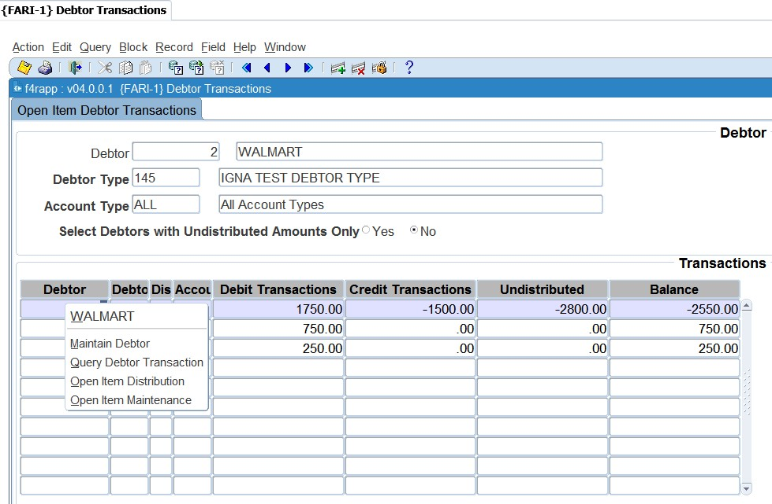

**Open item Maintenance**

If you made a mistake with the linking, you can edit this by using {FARI-4}. This will however depend on the system operation definition indicator ‘OM’ is set to ‘YES’.

**See Example below {FARI-1}**

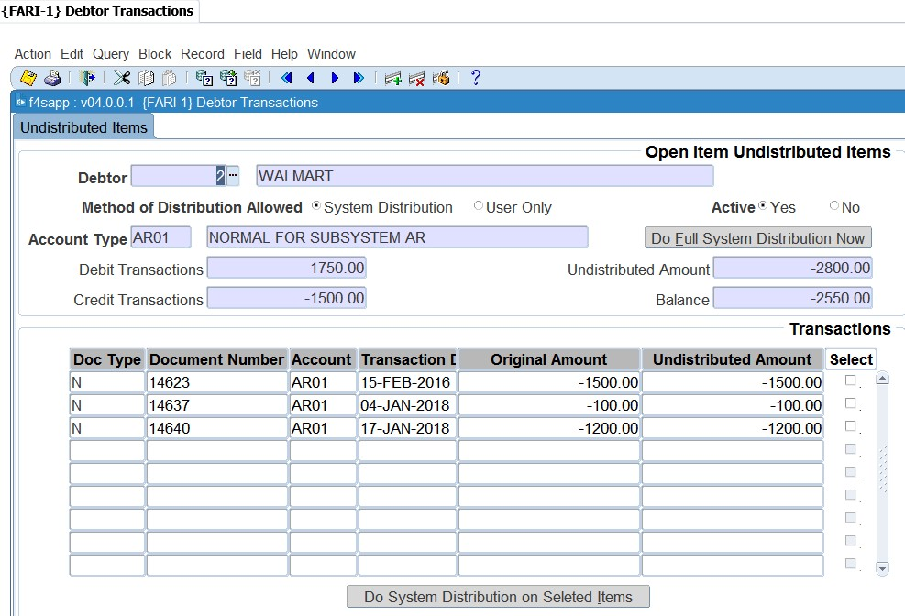

### Undistributed Items {FARI-2}

Open item distribution is the functionality of linking credit trans. (receipts, cheques, credit-notes etc.) to an invoice with an outstanding balance. Various credit transactions can be distributed to 1 invoice or 1 credit transaction can be distributed to various invoices. An invoice with no outstanding balance will be, with its linked credit trans., flagged as a closed item.

**See Example below {FARI-2}**

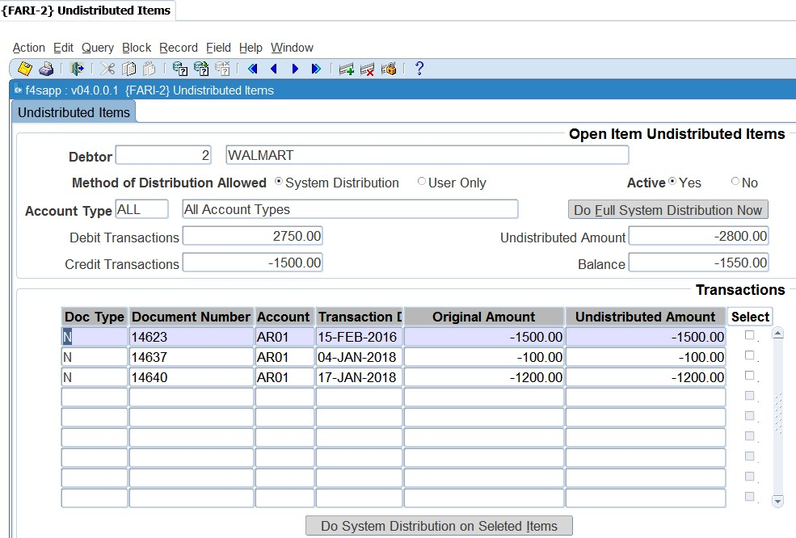

Select the debtor for which the distribution will be done. The transactions that will display in the next tab are dependent on the account type. If ALL is specified, all transactions for all account types will display. The Do Full System DistributionNow button will distribute all undistributed credit transactions to invoices with outstanding balances for the specific debtor and account type.

**Transactions**

All undistributed transactions for the debtor and account type combination will be displayed and available to use for distribution. Select the transactions that must be distributed with a tick in the check box. As soon as the ‘Do System Distribution’ button is hit, all flagged credit transactions will be distributed to the invoices with outstanding balances. The selection and processing of the credit transactions and invoices will be in date sequence from the earliest to the latest date.

**6.6.3** **Distribution Items {FARI-3}**

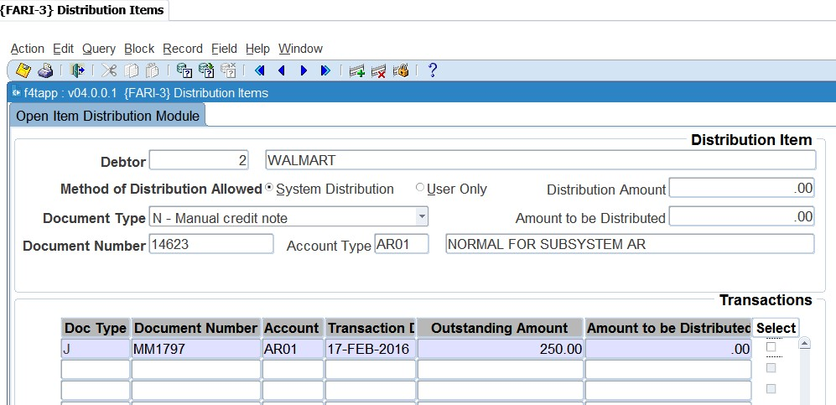This option will distribute any undistributed transactions to invoices with outstanding balances. The option will be available if the system operational parameter ‘OI’, AR: Open Item Y/N, is set to ‘Y’es in {FCSM-2}Tab. One the document amount is fully linked to credit transactions is referred to as a closed item.

**Distribution Item**

This tab will be used to determine which debtor and account types will be selected for distribution processing in the next tab.

**Debtor:** The debtor code entered into this field will determine which debtor transactions will be displayed in the next tab.

**Name:** The debtor name will be displayed in this field.

**Method of Distribution Allowed:** The method of distribution allowed as defined on the debtor, "Maintain Debtors" {FARO-21}.

**Document Type:** The document type of credit transaction available for distribution.

Document Number: The document number of credit transaction document available for distribution.

**Account Type:** Displays the account type of the document selected for distribution.

**Description:** Account type description. (Display Item). The account type description will be displayed in this field.

**Distribution Amount:** An undistributed amount available for distribution for the debtor and document.

**Amount to be Distributed:** A calculated total of all the amounts selected in tab 2 to be used for distribution. This is a running total, which will be updated continually as invoices are selected to be cleared in Tab 2. This value cannot exceed the Distribution Amount or be less than zero.

**Note**: +It is recommended that a specific document type is selected from the drop-down menu to make it easier to find the “document number” in the next field. Enter the document number of the document that must be distributed to the relevant documents in the next tab.



**Transactions**

The transactions that are displayed in this tab will be determined by the selection criteria from the first tab. All invoices that are displayed are invoices that are still outstanding, thus not yet linked to a payment or credit transaction. All the fields are display fields only; the only updateable field is the ‘Amount to be Distributed’. This amount cannot exceed the ‘Amount Available’ and can be altered by the user. The ‘Select’ field can be “clicked” on. When the users click/tick the box the system will display the ‘outstanding amount’ in the ‘Amount to be distributed field’. As the user clicks, the ‘Distribution Amount’ in the first tab will be updated till the full amount is distributed.

**See Example below {FARI-4}**

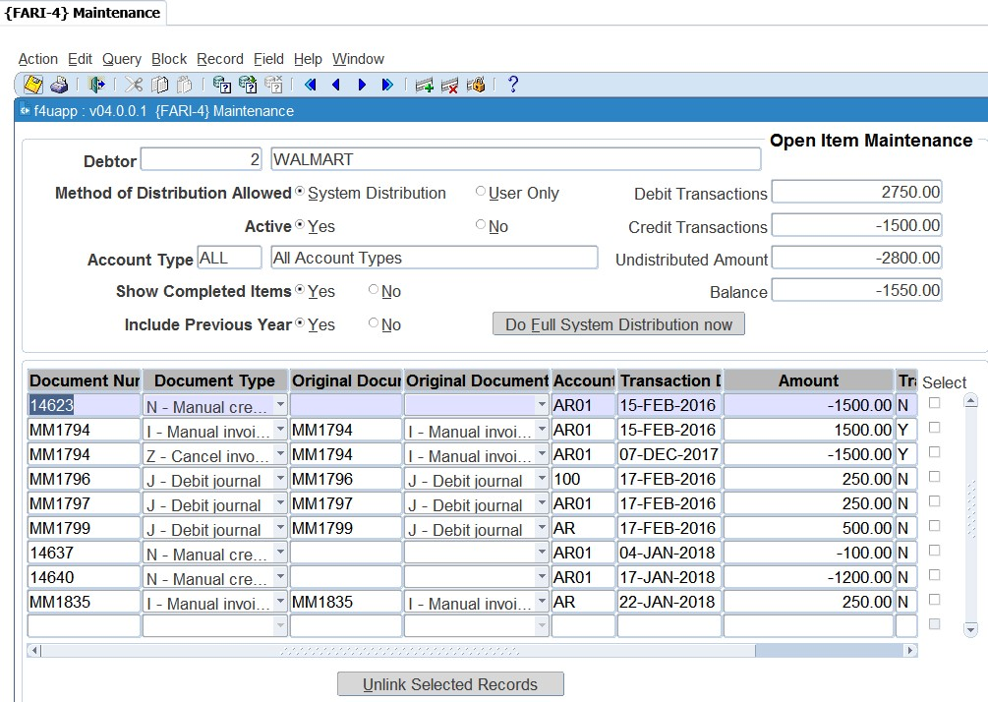

**See Example below**

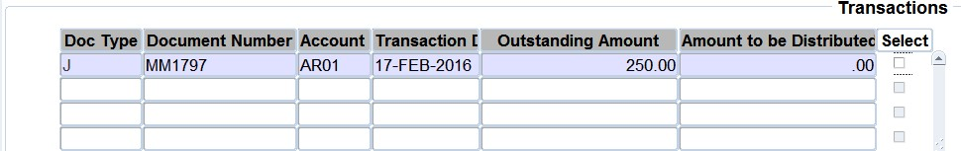

**Document Type:** The document type of the document with an outstanding balance that can be linked to an undistributed transaction.

**Document Number:** The document number of the document with an outstanding balance that can be linked to an undistributed transaction.

**Account Type:** The account type of the document with an outstanding balance that can be linked to an undistributed transaction.

**Transaction Date:** The date of the document with an outstanding balance that can be linked to an undistributed transaction.

**Outstanding Amount:** The outstanding amount of the invoice that can be linked to an undistributed transaction.

**Amount to be Distributed:** This is the amount selected, or entered, that will be distributed to the Invoice. This amount cannot exceed the outstanding amount, nor be less than zero.

**Select:** This check box will allocate the value of the outstanding amount field to the amount to be distributed field. It will also deduct this value from the amount to be distributed field in tab 1. The user will be able to continue distributing the available distribution amount to various invoices until the total amount to be distributed is zero.

**Note:** Once you have selected the right documents, you can save the record. The system will then link these documents to the credit document from the first tab 1. If you made a mistake with the linking, you can edit this by using {FARI-4}. This will however depend on the system



operation definition indicator ‘OM’ is set to ‘YES’.

**See Example below {FARI-4}**

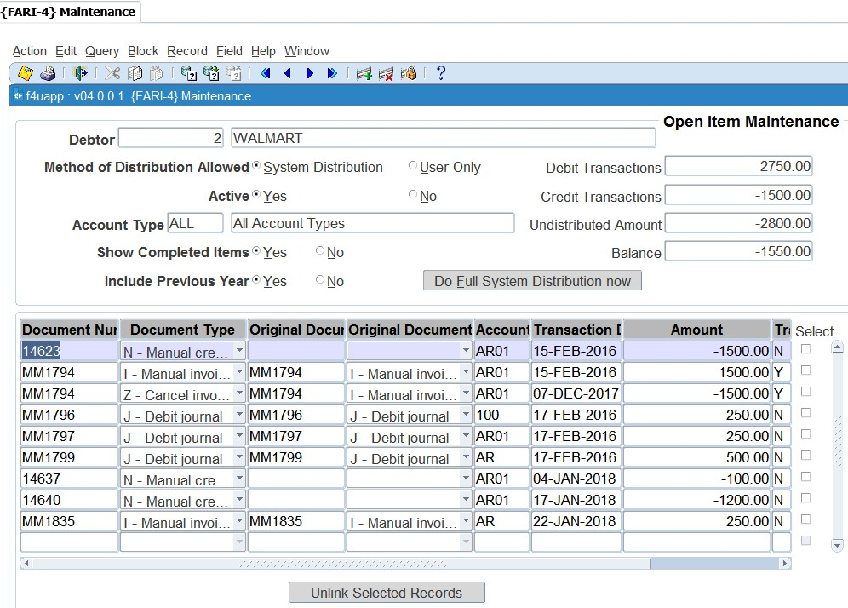

The option will display all ‘open items’ for maintenance. This option can also be accessed from {FARI1}. The option will only available if the system operational parameter ‘OI’ in {FCSM-1 b2} was set to ‘Y’es. Where option {FARI-3} was used to link credit transactions to an invoice this option is to “unlink” the credit transaction from the invoice. This means the credit transaction will be available again to use in {FARI 3}.

This tab will be used to determine which debtor and account types will be selected for distribution processing in the next tab.

**See Example below {FCSM-1}**

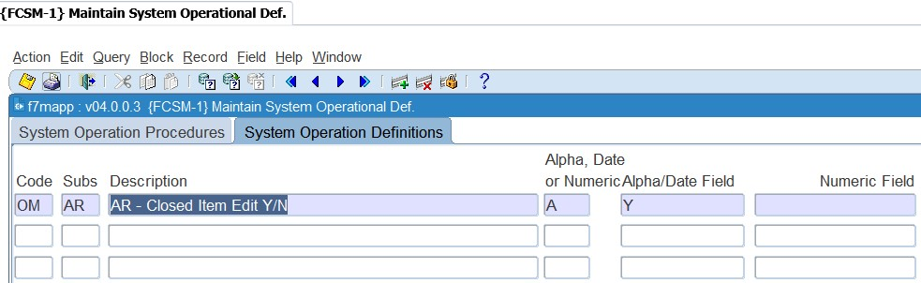

**Debtor:** The debtor code entered into this field will determine which debtor transactions will be displayed in the next tab. LoV displays one record for each debtor found on the Open Item control table, with their names.

The following exist in the pop-up menu:

* Maintain Debtor {FARO-21}
* Query Debtor Transactions {FARO-3}

**Method of Distribution Allowed**: The method of distribution allowed that is linked to the above debtor.

**Active Yes / No:** Indication of whether the debtor is currently flagged as active or inactive.

**Account Type:** The account type entered in this field name will determine which debtor transactions will be displayed in the next tab. If ‘All’ is entered, transactions for all account types will be displayed. LoV displays all the account types and their descriptions that are available for distribution for this specific debtor.

**Show Complete Items Y/N**: The indicator will determine if transactions marked as complete will be displayed and available for maintenance in the next tab. Completed transactions are also referred to as Closed Items. An invoice and its related transactions will be considered as Completed transactions (the invoice can also be referred to as a Closed Item) when the outstanding invoice has a zero-calculated balance (the sum of all the debit and credit documents linked to an invoice is zero). Once an invoice is considered as a Closed Item, the invoice together with its related documents, will be flagged as a completed transaction.

**Include Previous Years Y/N:** The indicator will determine whether only the transactions relating to (the current financial year or all the transactions) will be displayed and available for maintenance in the next tab.

**Debit Transactions:** A total of all the debit transactions for the debtor and account type.

**Credit Transactions:** A total of all the credit transactions for the debtor and account type.

**Undistributed Value:** A total of all the undistributed values for the debtor and account type.

**Balance:** The calculated outstanding balance for the debtor and account type.

**Do Full System Distribution now:** The functionality of this push button is to distribute, in background, all undistributed credit transactions to invoices with outstanding balances for the specific debtor and account type. The credit transactions, and similarly the invoices, will be selected and processed in date sequence from the earliest to latest date.

**See Example below**

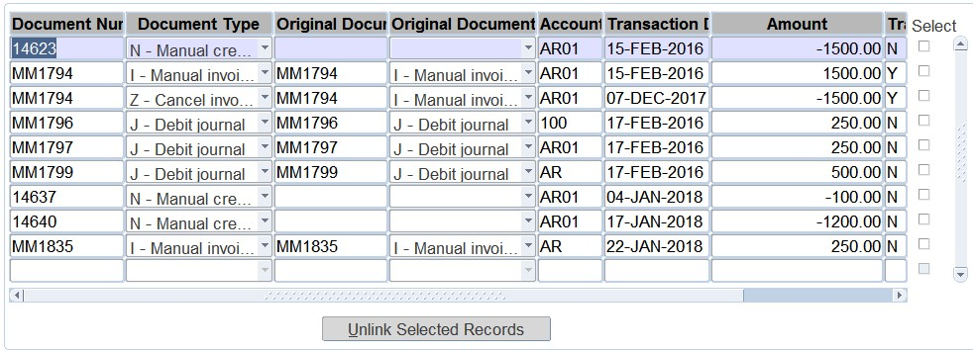

**Document Number:** The document number of the document selected document. The following is available on the pop-up menu:

* Transaction Note
* User Distribution. This menu item will only be available for use if the transaction can be used for distribution.

**Document Type:** The document type of the document.

**Originating Document Number:** This is the document number of the originating invoice to which distribution has taken place. (For the invoice transactions, the document and originating document information are the same).

**Originating Document Type:** The document type of the above originating document.

**Account Type:** The account type of the document that can be distributed. The following is available in the pop-up menu:

* Account Type Description

**Transaction Date:** The date of the document that can be distributed.

Transaction Amount: This is the amount used for the transaction.

**Select:** This check box works together with the following Push-Button. The originating document type and number cleared for all the transactions flagged with this check box will be processed by the Pushbutton.

**Unlink Selected Records:** The functionality of this push button is to clear the originating document type and number of all the flagged (Check Box) transactions. This will result in all the transactions being cleared as undistributed and available for re-distribution. Maintenance to Closed Items will only be allowed if the System Operational Definition ‘OM’ (Maintenance allowed for Closed Items Y/N) for Sub-system ‘AR” is set to (Y)es.

**MODULE 6**

# Reports

**Specific outcomes**

On completion of this module, you will be able to generate at least the following reports:

* Audit trail.
* User work summary.
* Audit Log: Financial.
* Invoices to be sent.
* Accounts receivable balances (aged).
* Consolidated debtor statements.
* Consolidated internal debtor statements.
* Consolidated external debtor statements.
* Transactions per type.
* Accounts receivable journals in process.

## Introduction

The running of reports correctly will enable users to get accurate information from the ITS students accounts receivable system. There are several reports available. The reports can be divided in three major areas (with the menu option applicable to that area):

* Code structure {FARCR1}

The code structure reports will provide you with lists of codes that were created in the {FARC} menu. These reports could be used where you would like to have a list of the codes that were created in {FARC}.

* Maintenance {FARMR1}

The maintenance reports will be used more frequently than the {FARCR1} reports. It includes important log files.

* Operational {FAROR1}

The operational reports will be used most frequently. The reports will be used for management reporting and also to perform reconciliations between the subsystem and the GL.

## Print Audit Trail {FARMR1-1}

This report will show all transactions that were processed for a specific period in the AR system.

**See Example below {FARMR1-1}**

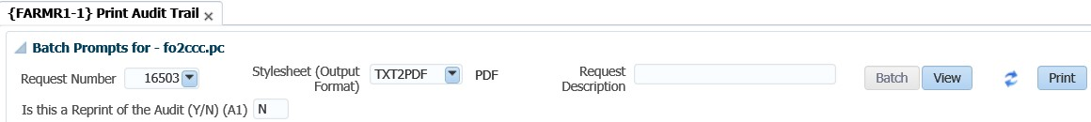

## Print User Work Summary {FARMR1-2}

This report can be used to reconcile input documents with the transactions processed by users in the system for a specific period.

This is the option that will be used to determine who made changes to code structures in the AR system. It will not only show who made changes but also the date and time changes were made.

**See Example below {FARMR1-2}**

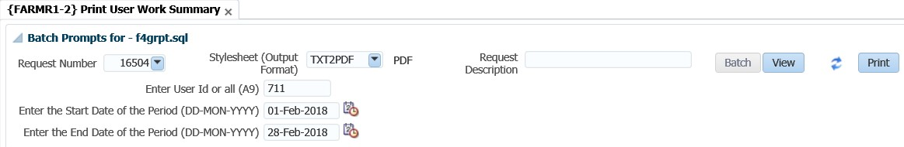

**See Example below {FARMR1-21}**

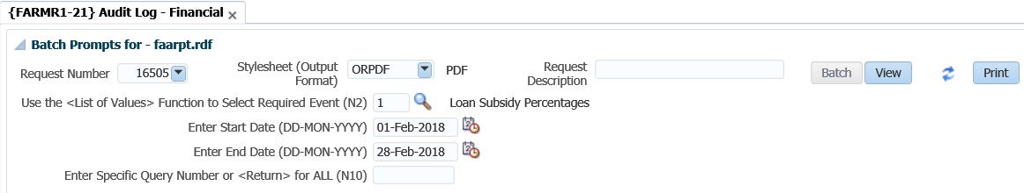

## Balances: Aged {FAROR1-4}

This report will be used to get a list of debtors balances up to a specific date (or year and cycle).

**See Example below {FAROR1-4}**

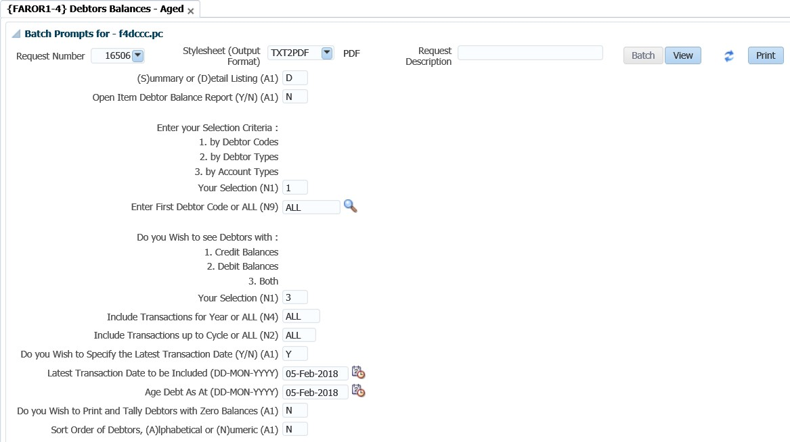

## Consolidated Debtor Statement {FAROR1-9}

This option is used to run consolidated statements. Where the open item functionality is used, you can print a statement that will indicate only the outstanding transactions.

**See Example below {FAROR1-9}**

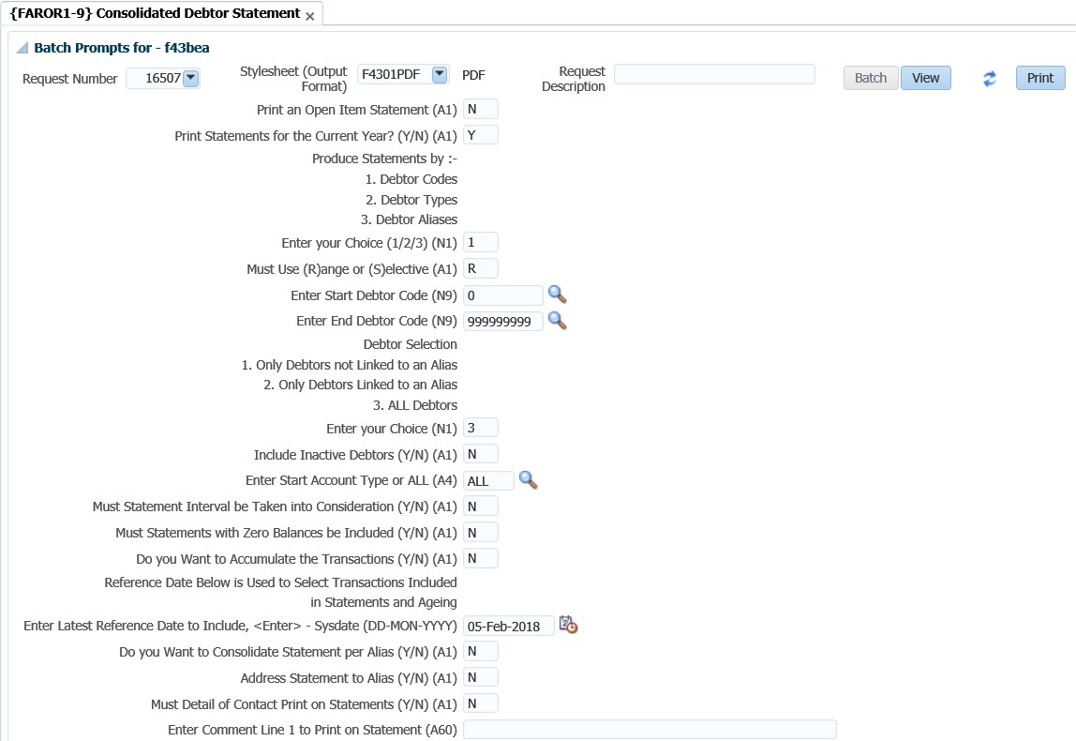

## Consolidated Internal Debtor Statement {FAROR1-11}

This option is based on the selections criteria of previous debtor statements. It is designed for internal use only and the output is based on the iComms concept. The users may design their own layout.

**See Example below {FAROR1-11}**

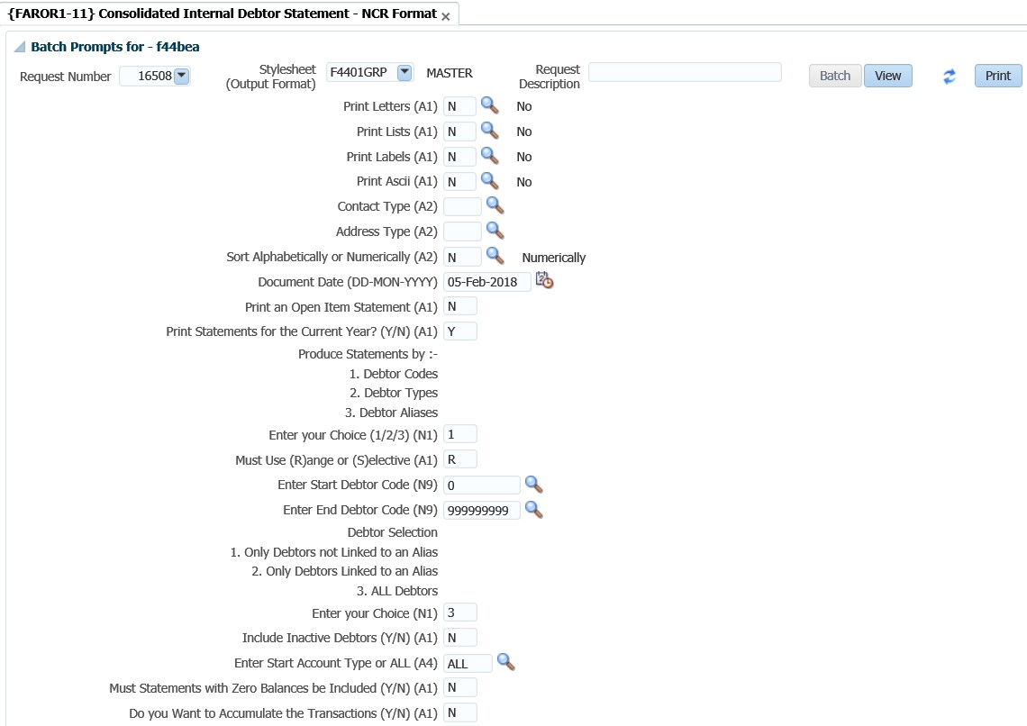

## Transaction per Type {FAROR1-23}

This report is used to retrieve all transaction per transaction type, which had an impact on the AR system. It will typically be used when you reconcile the subsystem with the GL and you need to compare the transactions per TT between the subsystem and the GL.

**See Example below {FAROR1-23}**

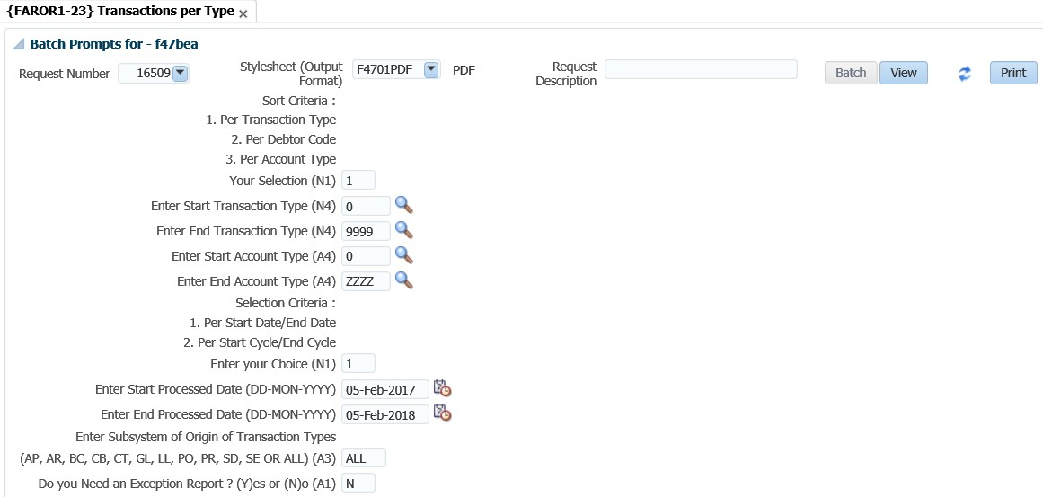

## Print AR Journals in Process {FAROR1-29}

This report is used to view specific completed batch journals processed on {FARO-29}. (i.e A journal where the total on the first tab balanced with the individual transactions on the second tab).

**See Example below {FAROR1-29}**

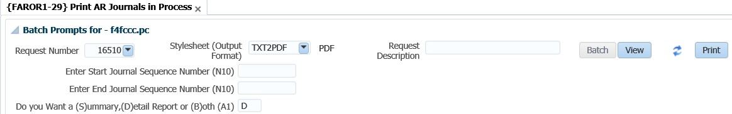



Adapt IT Consulting and Training

**INTEGRATOR 4.1 – TRAINING MANUAL**

**Finance System**

**Cashbook**

Copyright

©All rights reserved

No part of this document may be reproduced or transmitted in any form or by any means, without express written permission from Adapt IT or an authorised representative of Adapt IT. This includes, but not limited to, electronic, electrostatic, magnetic tape or mechanical copying and recording, or use of any information storage and retrieval system.

First edition: February 2018

Disclaimer

Adapt IT makes no representations or warranties with respect to the contents hereof. Although due care and precaution has been taken in the preparation of this manual, Adapt IT assumes no responsibility for errors and omissions or any damages resulting from the use of the information contained in this publication.

**Contents**

**Course Overview** 1

**Course duration** 1

**Pre-requisite knowledge and skills** 1

**Course content** 1

**Learning outcomes** 1

Module Structure 2

**System Access** 3

**Logging on to Integrator** 3

**Forgot Password** 4

**Landing Page** 6

**Navigation** 6

**Exiting a form** 6

**1** **System Requirements** 7

1.1 Introduction 8

1.2 Links to Other Subsystems 8

1.3 Maintain Cashbooks {FCSC-5} 9

1.4 Maintain Account Categories {FCSC-7} 11

1.5 Maintain Transaction Type Definitions {FCSO-7} 12

1.6 Maintain User Restrictions {FCSP-2} 16

1.7 Control Issue of Receipts/Payments {FCTM-1} 17

1.8 Maintain Cashier ID and Password {FCTM-2} 18

1.9 Cashier Sign-on {FCTO-1} 20

**2** **Cashbook MPM** 22

2.1 Introduction 23

2.2 Cashier login 23

2.3 Maintain Statement Journals {FCBO-1} 24

2.4 Manage Manual Bank Statements {FCBO-2} 28

2.5 Bank Statement Reconciliation {FCBO-4} 31

2.6 Manage Cheque Matching 32

2.7 Cashbook Transfers {FCBO-5} 32

2.8 Maintain Electronic Bank Statement {FCBO-21} 33

2.8.1 Match Bank Statement 36

2.8.2 Edit Bank Statement 36

2.8.3 Payments 37

2.8.4 Deposits 38

2.8.5 EFT 38

2.9 Process Incoming Bank Files {FACMR1-2} 38

2.10 Maintain Electronic Statement- Standalone {FCBO-28} 39

2.11 Query Unreconciled Cheques {FCBO-6} 40

**3** **Query Menus (not in MPM)** 42

3.1 Introduction 43

3.2 Query Budget GLA {FCBO-9} 43

3.3 Query Statement Journals {FCBO-10} 44

**4** **Reports** 46

4.1 Introduction 47

4.2 Receipt / Payment Transactions per Type {FCTOR1-1} 47

4.3 Bank Statement {FCBOR1-1} 48

4.4 Bank Reconciliation {FCBOR1-2} 48

4.5 Receipt Payments Not Deposited {FCBOR1-5} 49

4.6 Deposit Validation Report {FCBOR1-7} 50

4.7 Bank Reconciliation as at a Specific Date {FCBOR1-10} 51

**Acronyms, Glossary & Terminology** 52

**Acronyms** 52

**Glossary** 53

**Terminology** 54

**Help us enhance the course** 56

**Need help?** 57

**Course Overview**

Welcome to the ITS Integrator course for the Cashbook subsystem. This course is designed to equip you with the skills and knowledge you need to be a cashbook administrator. In fact, it is essential for anybody who will be responsible for the cashbook at an institution.

**Course duration**

1 day

**Pre-requisite knowledge and skills**

Before you can register for this course, you must have attended the interface training so that you have the minimum knowledge of system navigation.

**Course content**

The course structure is divided into modules and covers the following:

|  |  |
| --- | --- |
| **Subsystem** | **Modules** |
| Cashbook | * System requirements * Cashbook MPM * Query menus * Reports |

**Learning outcomes**

On completion of this course, the trainee should be able to:

* Set-up system pre-requisites.
* Utilise the cashbook MPM.
* Query cashbook information.
* Generate cashbook reports.

## Module Structure

Each module contains the following parts:

**Specific outcomes**

The specific outcomes are very important because they state what is expected of you.

**Introduction**

Each module starts with a statement of the content and learning outcomes for that module in order to introduce you to the subject matter of the module. Suggested time allocation is also indicated. Bear in mind that the time allocation is only a guide and some people will take longer than others to complete the same task. The timeframe can also be longer if you choose to look up content from other resources.

**Content**

Module content consists of information moving from system pre-requisites to operational and menu management issues. The content is subdivided into topics, tasks, procedures and other information arranged in a logical sequence and broken down into small, connected and understandable units. This content can be supplemented by support materials such as PowerPoint presentations, worksheets, hand-outs, etc.

**Acronyms, Glossary and Terminology**

As far as possible, the workbook uses clear and non-technical language. However, it is inevitable that you will be introduced to new terminology or be faced with the use of acronyms to describe or explain the contents of this manual. All terminology and/or acronyms used will be explained in the content, but you will also find separate structured tables at the end of this manual.

**System Access**

**Logging on to Integrator**

To access Integrator, you need the use of Internet Explorer. Using your browser, use the URL relevant to your institution or link from the institutions’ local Intranet. You will be prompted for your user name and password. Username and passwords are set up in User Access Definitions {USERS-5} and maintained by the institution. A user can have multiple logins with the same user ID. It is dependent on institution rules and policies. Additionally, unsuccessful logging attempts might be limited to a specific number depending on the institution’s policy.



1. Type in your username and password
2. Click on the Login button

**Forgot Password**

If you are having difficulty logging in to Back office or you forgot your password, you can reset your password.



1. Enter your Username
2. Click on the “Forgot Password” button

To be able to reset ITS/OID password, the users email address must be set up on {PBOP-14}/ {GOPS-3} and Primary Indicator for the email must be set to “Y”. If security questions are not set up on {USERS-17}, the user will get login control message to set up password questions and Answers.



1. Answer the questions as set on {USERS-17}
2. click on “Submit button”

The notification pop up message to be illustrated



Logging in to ITS Integrator again with the given password on the email



On the main page after logging onto integrator, on the More Tab, the Forgot Password Q and A can be found here and this will direct the user to {USERS-17}



**Landing Page**

After logging into the Integrator Back Office System, the Integrator Entry Screen will display. The Integrator Entry Screen is the gateway to the full Integrator Back Office System and consists of four sections: Header, Main Menu Bar, Work Area, Welcome and Footer.



**Navigation**

Integrator 4.1 requires that you use the mouse to move from one field to another. In previous versions, the user could navigate between fields using the Tab and Enter keys. However, the new ADF technology operates in a browser and shortcut keys do not always give the intended output.

**Exiting a form**

Use the Green door  (old forms) or the black cross   (new ADF forms) to exit forms programs in Integrator 4.1.

The Abort Option button is only for emergencies in the event of a menu option hanging.



**MODULE**

**1**

# **System Requirements**

Specific outcomes

On completion of this module, you will be able to:

* Link the cashbook to other subsystems
* Maintain cashbooks
* Maintain account categories
* Set subsystem statuses
* Maintain cashier ID and password
* Log on and off the cashbook

## Introduction

The system provides the facility to administrate cashbooks, perform bank reconciliations as well as financial reporting. This facility makes provision for the creation of multiple cashbooks, updating of cashbook journals, and the entering of bank statements followed by a reconciliation process. The cashbook consists of 2 sets of tables, namely cheque tables and journal tables. The cheque tables contain the detail of all the individual cheques generated, irrespective of the subsystem of origin. The journal table contains 3 types of transactions:

* Transactions with the total value of an ACB tape or bank draft payment every time that type of payment is generated. They can originate from any subsystem.
* Whenever a deposit list is generated, a transaction reflecting that deposit is created in this table. Deposits are driven by event “CB” and a transaction type should be linked to this event. Separate deposit lists can be produced for credit card, drafts and all other types of payments received.
* Transactions that originate from the bank statement, e.g. bank charges, interest paid or received, etc. are also stored in this table.

A specific cashbook must be associated with all transactions involving a bank account. This is done in two ways:

* For all cheque and receipt transactions a transaction type must be used. The specific bank account is identified by the cashbook code field on the specific transaction type. This implies that there must be different transaction types for the same type of transaction but for different cashbooks.
* The cashier must identify a specific cashbook before journal transactions can be entered. The specific cashbook is not identified on the transaction type. This implies that the same transaction type can be used for the same type of transaction for different cashbooks, e.g. bank charges or interest.

## Links to Other Subsystems

The ITS systems are designed to eliminate the entering of duplicate information in different subsystems. The subsystems are thus integrated and interdependent. Consequently, the implications for the cashbook subsystem are:

* All payments received and cheques made out by this system should be posted to specific General Ledger Allocations, which must be predefined in the Financial Code Structure subsystem.
* User-defined transaction types drive the Financial system. For the cashbook subsystem, receipt transaction types and payment transaction types must be defined in option {FCSO-7} in the Financial Code Structure subsystem.
* Different Cashbooks are maintained in option {FCSC-5}, and these are then linked to the different subsystems in which cheques are generated
* Validation is done against student, debtors, creditors and personnel numbers.

The debit/credit indicator on the transaction type for CB has the same meaning as in the Counter Subsystem, that is:

* “D” means it is a debit in the “Other” subsystem involved and a credit in the cashbook as identified by cashbook code and the relevant debit GLA must be supplied. The credit GLA will default from the cashbook definition.
* “C” means it is a credit in the “Other” subsystem involved and a debit in the relevant cashbook and a credit GLA must be supplied. The debit GLA will default from the cashbook definition.

Given that the GL-Allocations are already set-up in the Financial Code Structure subsystem, the user should also set-up the cashbooks, account categories, subsystem status and login credentials in the Cashbook subsystem.

## Maintain Cashbooks {FCSC-5}

The user will first have to create a cashbook and if necessary the ACB users. The cashbook, ACB users and subsystems must then be linked. In option {FCSC-5}, the user can define a cashbook for each of the institutions bank accounts or search for existing cashbooks.

**See Example below {FCSC-5}**

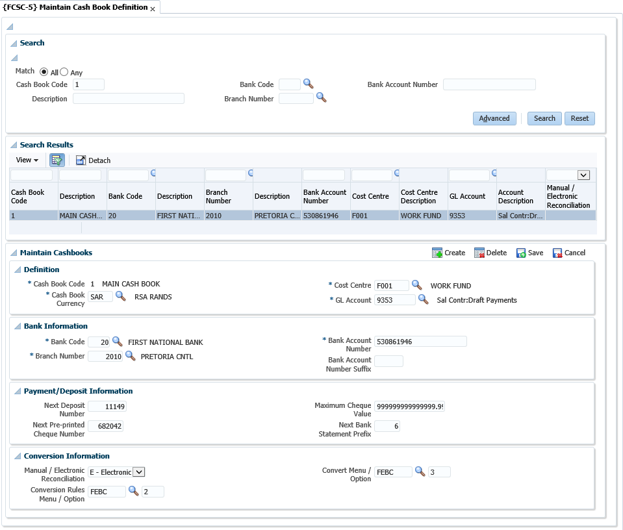

**Search panel box**

The search panel allows the user to search using a cashbook code, description, bank code, branch number or bank account number and the records returned are displayed in a table. Records in the table are not updateable and the user must use the form layout (panel box 2) to enter or edit cashbook definition details.

**Definition panel box**

**Cashbook Code**: Supply a unique code for this Cashbook.

**Cashbook Description**: Supply a suitable description for the code.

**Cashbook Currency**: Supply the currency for this Cashbook. Currencies are defined in option {FCSO-21}

**Cost Centre**: Supply the cost centre for this cashbook.

**GL Account**: Supply the Account which together with the Cost Centre represents the general ledger allocation (GLA) for this Cashbook. The system will use this GLA whenever transactions are created for this Cashbook. Cost Centre is defined in option {FCSO-1}, Account {FCSO-3} and GLA {FCSO-6}

**Bank Information panel box**

**Bank Code**: Supply the code of the Bank relevant to this Cashbook defined in menu option {FCSM-4}.

**Branch Number**: Supply the number of the Bank branch relevant to this Cashbook defined in option {FCSM-4}.

**Bank Account Number**: Supply the number of the Bank account number relevant to this Cashbook. This is the number as allocated by your bank. This account number usually appears at the foot of a cheque. The format may vary between banks, the most common format being 334945: 0610.511.645" 26.

**Payment and Deposit Information panel box**

**Next Deposit Number**: Whenever a Bank Deposit is generated, the system will automatically allocate a deposit number to the document. The number will be retrieved from this field and the next number will be allocated.

**Next Pre-printed Cheque Number**: Whenever a cheque is generated, the system will automatically allocate a number to the cheque. The number will be retrieved from the table in option {FCTM-1}, resulting in only one range of internally generated numbers for cheques. It is however, true that different series of cheque numbers (refer pre-printed number on the cheque) will be used for the different subsystems or cashbooks. The number maintained in this field, is the next pre-printed number. When cheques are printed in options {FCTO-22}, {FPMOPD-27} and {FPRN-6} or {FPRN-21}, the system will request the next pre-printed number. The system will then increment the number for the number of cheques generated and this field will be updated.

**Maximum Cheque Value**: This is the maximum amount for which the ITS system may generate a cheque. This value will be used in the Finance subsystem as well as the Payroll subsystem.

Where the ITS system generates a cheque with an amount greater than the maximum cheque amount a fatal error will occur.

**Next Bank Statement Prefix**: Some banks restart there bank statement number at 1 when a max statement number was reached. To make provision for more than one bank statement range, same range, add a numeric prefix in this field before starting the second, third… etc. ranges

**Conversion Information panel box**

**Manual / Electronic Reconciliation**: Indicate whether the cashbook is being reconciled manually or electronically. The conversion codes for electronic reconciliation are defined in {FCSC-23}. This menu option is maintained by Adapt IT and users cannot execute any updates.

**See Example below {FCSC-23}**

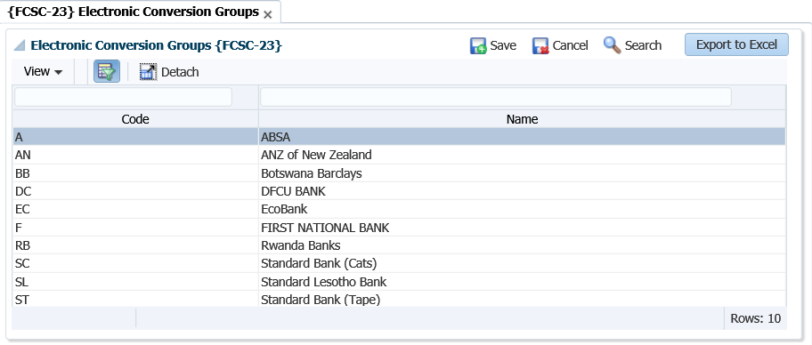

**Conversion Rules Menu / Option**: The menus and the option for the setup of the bank’s conversion rules.

**Convert Menu / Options**: The menu and the option to convert the statement for the cashbook.

**Note:** The cashbooks, ACB users and subsystems must then be linked. The cashbook can be affected by transactions from the Counter (CT), Procurement Management (PM), Payroll (PR), Cashbook (CB) and Long -Term Loans (LL) subsystems. The cashbook must therefore, be linked to each of these in {FCSC-26}.

**See Example below {FCSC-26}**

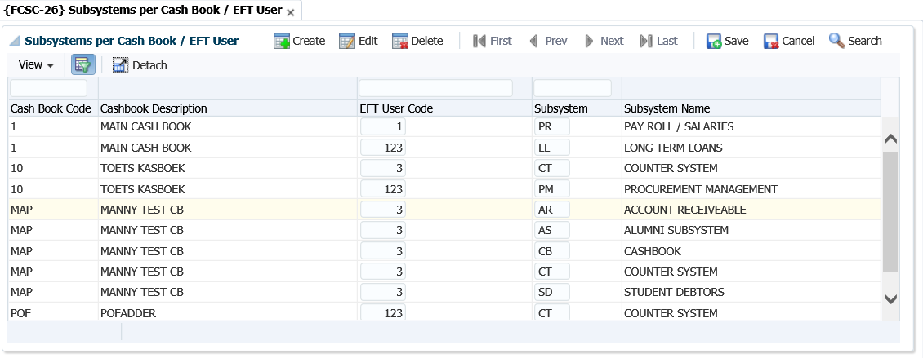

## Maintain Account Categories {FCSC-7}

The valid account categories that can be used in the Cashbook subsystem must be declared. Under this option, the user can define account categories and restrict the access of individual subsystems per account category. A standard set of account categories required for STATS reporting is supplied with the system. The numbering of the standard set of account categories allows the users to create new categories (user defined) with the understanding that newly created account categories will be accumulated into the preceding standard one.

**Note**: The user should not only understand that the table may be updated by the user and that categories can thus be deleted, but also that the supplied account categories are pre-defined into some programmes and therefore that deletions of the supplied account categories could cause problems in the STATS reporting. Deletion of a category is only allowed if there are no accounts linked to that specific category.

**See Example below {FCSC-7}**

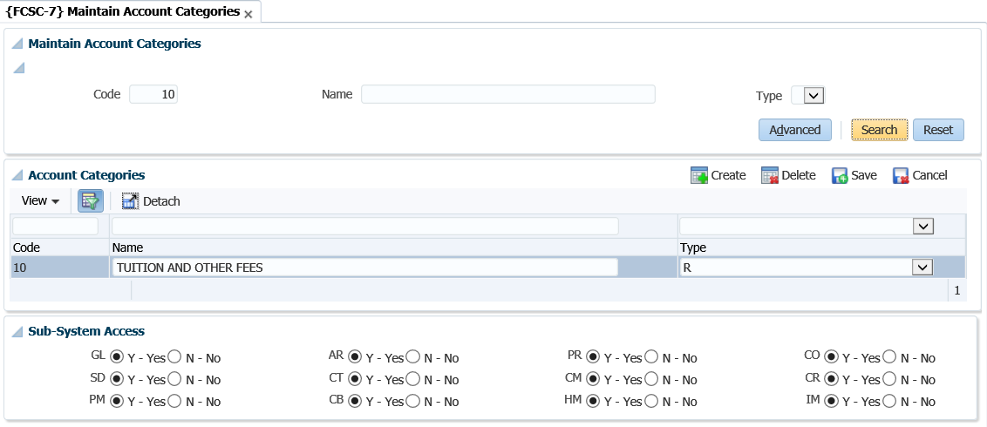

**Code**: Supply a unique number for this category.

**Name**: Supply a suitable description for this category.

**Type:** Choose the relevant type for this category. Categories are divided into 4 types, namely:

* Revenue
* Expense
* Assets
* Liability

**Sub-system Access**: Columns are displayed with the codes of the different subsystems as headings, and the user can indicate with a radio button whether this category is accessible to the specific subsystem.

## Maintain Transaction Type Definitions {FCSO-7}

A transaction type can be described as a “pre-defined journal type”. All financial transactions must be recorded against a transaction type. The basic characteristics and advantages of a transaction type are:

* It is specific for each subsystem.
* A transaction type is either a debit or a credit transaction for the subsystem (this is not applicable to GL transaction types)
* Where you have TT defined for specific type of transactions, mistakes in respect of GL allocations can be minimized.
* Decisions on accounting principles are taken away from juniors.
* The process of automatic transactions is simplified.
* Makes reporting easier where you are looking for type of “journals”.

Each cashbook needs a debit, credit and a VAT transaction type which will be used in menu options {FCTO-3} and {FCTO-6}. Very important is to remember that the indicator “Income or expense cashbook” must be set to ‘Income’, otherwise the user will not be able to use these in {FCTO-3}.

Credit transaction type {FCSO-7}.

**See Example below {FCSO-7}**

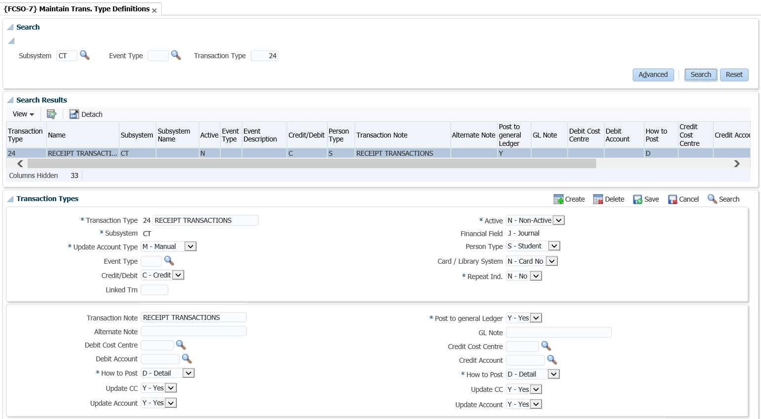

**Field in this option:**

**Type**: Enter a unique code for your TT. It is recommended that you use number ranges for each subsystem. That way you know that all the CT transaction types are within the range 1000 to 1999 etc.

**Name**: Give a description of the transaction type. Remember that this should be done so that all users would know which transactions will be recorded against this code.

**Active Indicator**: Is the TT active or not? You will make use of this where you may have used a TT for specific purposes, but no longer want the users to use this. So, then you query the code and make it non- active. This means no user will be able to record transactions against this TT.

**Subsystem**: Enter the subsystem for which the transaction type is valid.

**Default value:** This field will be completed if the transaction type is usually for a specific value. This amount will default when used, but the users can still override the amount.

**Financial field**: This field will indicate what ‘type’ of transaction this TT will record. You have the following options:

* (S)-balance: this is where the system is calculating a brought forward balance.
* (B)udget: this will be for budget transactions as they are reported in different columns in the GL reports.
* (J)ournal: these are the ‘normal’ financial transactions and most of the transaction types will be linked to this field.
* (C)ommitment: these are for the PM system. An example would be where requisitions/order are created. The system will create a transaction in the commitment column of the GL reports.

**Cashbook code**: This field is mandatory if the subsystem is CT and will indicate the cashbook code this TT is relevant to. Where you have more than one cashbook, but you have the same type of transaction for multiple cashbooks you would create “duplicate” transaction types but indicate in the description for which CB code it will be used.

**Income / Expense**: This indicator is only relevant to the CT and CB systems. This is to differentiate between transactions affecting (I)ncome and (E)xpense on the cashbook.

**Update type**: This field can either be manual or automatic. Most of the TT definitions will be linked to manual. The automatic will be if the TT is linked to an event (see next field).

**Event Number**: This field will list all the predefined events. These events are defined by Adapt IT: Pretoria and you will ONLY link this to the relevant TT code. An event number will be “triggered” by specific programs to use TT automatic without a user selecting them. For the SD fees structure the system have the link between the TT and the events in the option {FSAM-29}.

**Repeat Indicator**: The user may specify repeating transactions in the Procurement Management (PM), Accounts Receivable (AR) and General Ledger (GL) Subsystems. Whenever the applicable screens are used, the system will control that a transaction type with a (Y)es in this field is used. The number of repetitions and the intervals will be specified, and the program will generate transactions accordingly.

**Credit / debit**: What must happen to the debtor/creditor account? For example, if it is the SD system, should the student be debited or credited?

**Person type:** This can also be referred to as the debtor/creditor type. This field is applicable where the subsystem is CT or CB. The system wants to know, if this transaction takes place what other ‘subsystem’ must be affected. Remember that where the person type is student, it will also reflect on the students’ account in the SD system.

The ‘Other’ person type is used where you have sundry transactions that are not for a debtor or creditor account.

**Linked transaction**: This field will be completed if this TT that you are busy defining can have VAT. The VAT portion will be recorded against the TT entered in this field.

**Card/Library system?** If you are using the meals (card) or library system, then TT can be defined to receipt money in those specific ‘accounts. The field will be used where the subsystem is CT. This field must be set to yes if you want to use it for those types of receipts.

**Transaction note**: This field is the note field that will default when the TT is used when a transaction is processed. Enter a note that will best describe the transaction to the debtor/creditor as this will display on their statements.

**Alternate note**: This field is the same as the transaction note field. This description will be used if you have indicated on the debtor/creditor biographical detail their preferred language is not ‘English’ but ‘Alternate’.

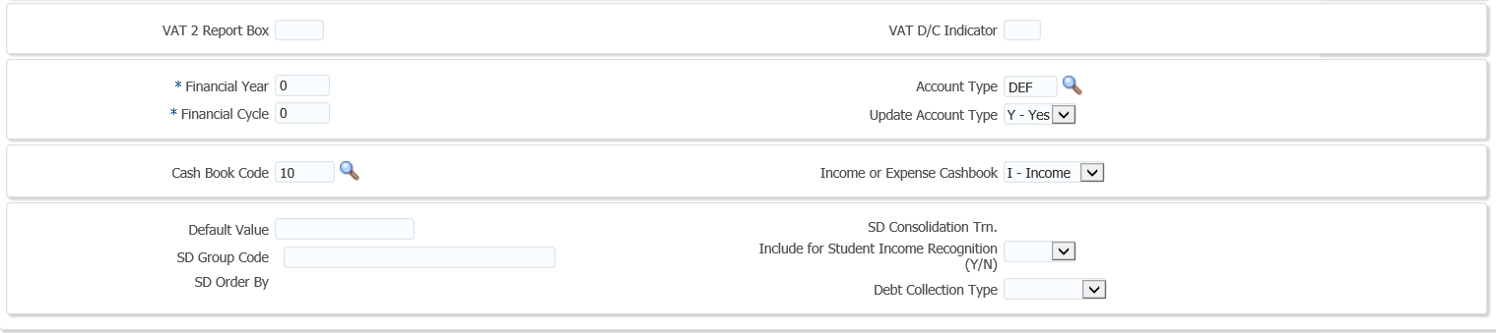

**VAT 201 box report**: This field is applicable if you are registered for VAT and do VAT reporting through the system. The box numbers with their information can be obtained from the receiver of revenue.

**VAT D/C indicator**: This field is applicable if you are registered for VAT. It will be used to indicate if it is a debit or credit to the VAT transactions.

The following fields are all display fields and the detail are defined in the SD system:

* SD group code
* SD order by
* SD consolidation transaction
* Include for consumption report Y/N?

**Post to general ledger**: You will usually set this field to yes. This indicates if the transaction should be posted to the GL. This field is not applicable to the GL system as the transaction is already ‘in’ the GL system.

**Debit GLA**: Enter the GLA to be debited. This field will be completed if there is a specific GLA that must be used OR where the GLA can’t be blank when automatic (TT linked to an event) transactions take place.

**Update CC**: Is the user allowed to change/update the CC? This field can only be set to NO if the “Update Type” field is set to (M)anual.

**Update account**: Is the user allowed to change/update the account? This field can only be set to NO if the “Update Type” field is set to (M)anual

**How to Post**: Do you want to post the transactions in detail or summary to the GL? If set to summary, the system will accumulate all transactions (since the last posting) for the specific account which has not yet been posted, and post one transaction.

It is recommended that you make the debit GLA indicator ‘summary’ for all debit transactions and the credit GLA indicator summary for all credit transactions. This will mean your GL reports are not that cluttered. Should you wish to see how the summary posting is made up you can request a report from the menu {FGLP}.

**Financial year**: This field is only relevant for TT linked to the GL system. This is where you wish to process transactions for a financial year that is different to the financial year of the system as indicated in {FCSM-2}. For all the other subsystems this field will have a value of zero, as the transactions will use the financial year as indicated in {FCSM-2} for the relevant subsystem.

**Financial cycle**: This is only valid for the GL system, for the rest of the subsystems set this value to "00".  If a transaction type is meant to be valid only during a specific cycle, the user may enter a value equal to or greater than the present financial cycle, or in all other cases "00" (zero). If zero, the system will default to the cycle of the subsystem. Transaction Types linked to sub-system GL are subject to the setting of rule GH, of the system operational definitions, on menu option {[FCSM-1](http://wlint4.adaptit.co.za:7221/itshelp/faces/helppages/config.OHW+Servlet+1/vtAnchor.Block_2/topics/navSetId.itshelp/itshelp/documents/fcsm-1.html#Block_2)}, TAB - System Operation Definitions.

* Rule [GH](http://wlint4.adaptit.co.za:7221/itshelp/faces/helppages/config.OHW+Servlet+1/vtAnchor.GH/topics/navSetId.itshelp/itshelp/documents/fcsm-1.html#GH) provides the facility to prevent the update of the financial year and cycle for Ledger journals. Whenever the user supplies a transaction type on any of the GL journal screens, may the user update the financial year and cycle, (Y)es or (N)o? This rule must also be read in conjunction with rules GC and [GY](http://wlint4.adaptit.co.za:7221/itshelp/faces/helppages/config.OHW+Servlet+1/vtAnchor.GY/topics/navSetId.itshelp/itshelp/documents/fcsm-1.html#GY).
* Rule [GC](http://wlint4.adaptit.co.za:7221/itshelp/faces/helppages/config.OHW+Servlet+1/vtAnchor.GC/topics/navSetId.itshelp/itshelp/documents/fcsm-1.html#GC) provides the facility to allow Ledger journals to be processed in previous cycles and rule GY provides the facility to allow Ledger journals to be processed in previous years.

**Account Type**: Supply the default Account Type to be used. This is not a mandatory field. Account Types may only be defined for sub-systems AR, CM, PM and SD. Account Type definitions are defined on menu option {[FCSC-21](http://wlint4.adaptit.co.za:7700/itshelp/faces/helppages/config.OHW+Servlet+1/topics/navSetId.itshelp/itshelp/documents/fcsc-21.html)}:

* Where the [subsystem](http://wlint4.adaptit.co.za:7221/itshelp/faces/helppages/config.OHW+Servlet+1/vtAnchor.Subsystem/topics/navSetId.itshelp/itshelp/documents/fcso-7.html#Subsystem), is PM, the <LIST> function will only contain active Accounts Types defined for PM.
* Where the [subsystem](http://wlint4.adaptit.co.za:7221/itshelp/faces/helppages/config.OHW+Servlet+1/vtAnchor.Subsystem/topics/navSetId.itshelp/itshelp/documents/fcso-7.html#Subsystem), is AR, the <LIST> function will only contain active Accounts Types defined for AR.
* Where the [subsystem](http://wlint4.adaptit.co.za:7221/itshelp/faces/helppages/config.OHW+Servlet+1/vtAnchor.Subsystem/topics/navSetId.itshelp/itshelp/documents/fcso-7.html#Subsystem), is CM, the <LIST> function will only contain active Accounts Types defined for CM.
* Where the [subsystem](http://wlint4.adaptit.co.za:7221/itshelp/faces/helppages/config.OHW+Servlet+1/vtAnchor.Subsystem/topics/navSetId.itshelp/itshelp/documents/fcso-7.html#Subsystem), is SD and [Card System](http://wlint4.adaptit.co.za:7221/itshelp/faces/helppages/config.OHW+Servlet+1/vtAnchor.Card/topics/navSetId.itshelp/itshelp/documents/fcso-7.html#Card), is (Y)es, the <LIST> function will only contain active Account Types for the CM.
* Where the [subsystem](http://wlint4.adaptit.co.za:7221/itshelp/faces/helppages/config.OHW+Servlet+1/vtAnchor.Subsystem/topics/navSetId.itshelp/itshelp/documents/fcso-7.html#Subsystem), is SD and [Card System](http://wlint4.adaptit.co.za:7221/itshelp/faces/helppages/config.OHW+Servlet+1/vtAnchor.Card/topics/navSetId.itshelp/itshelp/documents/fcso-7.html#Card), is (N)o, the <LIST> function will only contain active Account Types for the SD.
* Where the [subsystem](http://wlint4.adaptit.co.za:7221/itshelp/faces/helppages/config.OHW+Servlet+1/vtAnchor.Subsystem/topics/navSetId.itshelp/itshelp/documents/fcso-7.html#Subsystem), is CT or CB, the <LIST> function is dependent on the values of [Debtor/Creditor type](http://wlint4.adaptit.co.za:7221/itshelp/faces/helppages/config.OHW+Servlet+1/vtAnchor.Person_Type/topics/navSetId.itshelp/itshelp/documents/fcso-7.html#Person_Type), and, if applicable, [Card System](http://wlint4.adaptit.co.za:7221/itshelp/faces/helppages/config.OHW+Servlet+1/vtAnchor.Card/topics/navSetId.itshelp/itshelp/documents/fcso-7.html#Card).

**Update Account Type**: Can the User update the Account Type (Y)es/(N)o. When this Transaction Type is used, may the user update the Account Type?

## Maintain User Restrictions {FCSP-2}

Before a cashier can start entering transactions, user restrictions can be set up to restrict the cashiers to only have access to specific cashbooks.

**See Example below {FCSP-2}**

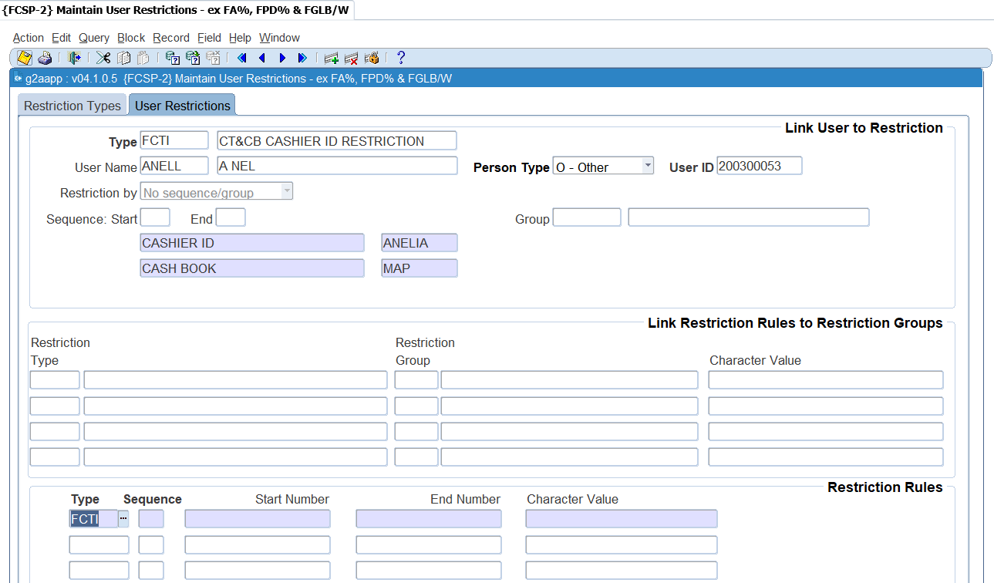

**Importance of user restrictions**

* This would, for instance, allow each faculty/school to see and update only its part of the financial data.
* This facility, combined with the normal access control with "updating" and "read only" privileges {USERS-2}, provides for powerful and flexible access and update control. This option should be under the control of one or two senior financial users.
* Restrictions form part of the Routing Set-up {GROU-1} to {GROU-4}. When the user is restricted to a specific cost centre, limit or account category, the routing as set-up in {GROU-1} will pick-up who to notify for doing the approval on a specific document, etc.

## Control Issue of Receipts/Payments {FCTM-1}

In this option, the user (normally the finance officer) may query the status of the subsystem, activate and de-activate it, and control transaction, receipt, cheque and payment numbers. For example, in the morning the system will normally be activated for receipts only.  At a specific time of day this status could be changed to payments, or receipts and payments, thus allowing the user to produce daily payments.  If a function (receipts or payments) is “inactive”, updating of the applicable screen will be impossible.

**See Example below {FCTM-1}**

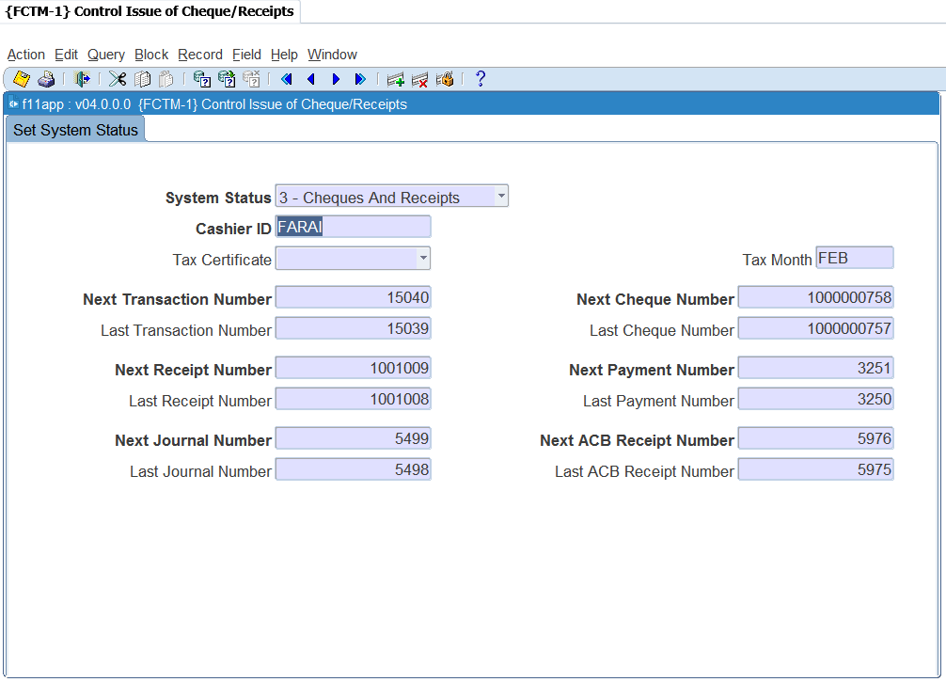

**System Status**: Select from the list of values for the appropriate activation and the list contains the following:

* Inactive
* Only receipts
* Only cheques
* Cheques and receipts

**Cashier**: The name of the Control Officer/Cashier, with powers between 80 and 99, who is resetting the status and updating receipt, cheque, payment or transaction numbers.

The next two fields refer to Receipt Transactions:

**Tax Certificate**: The default for the Tax Certificate Indicator on {FTXO-1} when the debtor type of the debtor code is of the category (C)ontact. Value that can be inserted is Yes, No or Null from the list of values.

**Tax Month**: The Tax Certificate year end month e.g. JAN, FEB, MAR, etc.

**Last/Next Transaction Number**: The last and next transaction numbers used and to be used.

**Last/Next Receipt Number**: The last and next receipt numbers used and to be used.

**Last/Next Cheque Number**: The number of the last cheque used and the next number to be issued.

**Last/Next Payment Number**: The last payment number used and the next number to be used.

**Last/Next ACB Number**: The last ACB receipt number used and the next ACB number to be used.

**Last/Next Journal Number**: The number of the last Journal used and the next number to be issued.

**Note**: The user may change these numbers but may only increase them.

## Maintain Cashier ID and Password {FCTM-2}

The financial system requires a high level of security, which should be controlled by financial staff. This system provides a facility whereby a senior finance officer can create and maintain cashiers’ ID’s and passwords. In effect, the user will appoint cashiers, grant powers, assign a printer to the cashier and control the passwords.

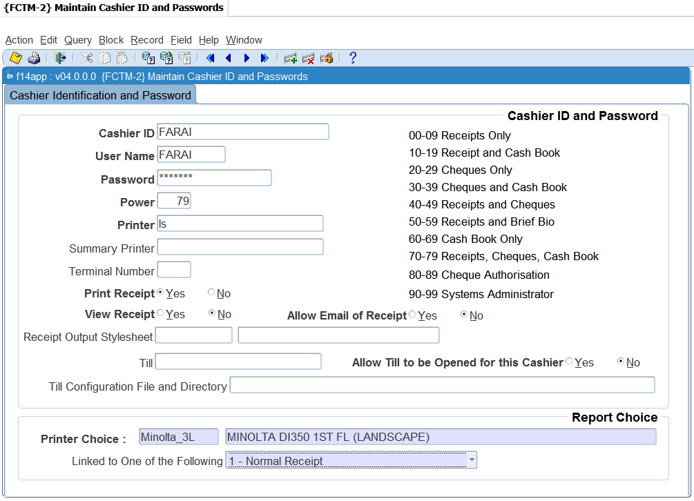

**Cashier ID and Password**

**Cashier ID**: Enter the name to uniquely identify the cashier in the system. This ID will accompany all transactions generated by this cashier.

**User Name**: Enter the user name of the same person for whom the cashier ID is being created. All programs where a cashier ID is required will validate that the person logged onto the system and the cashier ID being used correlates to the cashier ID and user linked in this option. A user will then only be able to use the cashier ID linked to his or her user code.

**Password:** Enter the secret password of the cashier. This field is encrypted, which means that the text cannot be seen on the screen. The finance officer will create a password that is easy to remember, notify the cashier of the password and request the cashier to change it immediately using option {FCTO-1}, Cashier Sign-On. This changed password cannot be seen on any report or screen, and only the cashier will know what it is.

**Power**: Powers will normally range between 00 and 79 which represent normal cashiers, powers between 90 and 99 being reserved for systems managers. The system manager can thus grant activating powers to other senior people. The codes and meaning of the powers are explained on screen.

**Printer:** The UNIX or other O/S printer name of the destination printer for receipts issued by this cashier. If no printer is specified, the system will queue the receipt internally in spooler files. In block 2 the user can specify the type of stationery which will be in a specific printer.

**Summary Printer**: This field is used to enter a name of a printer that will allow you to print the summary of the receipt information on a document e.g. the back of a cheque. In order to do this, the printer of the cashier should be linked to report choice 7 - Normal and Summary Receipt. A summary printer must also be defined as part of the cashier ID definition.

**Terminal Number**: When this screen is queried, the system will display the number of the terminal that was used when the cashier signed on.

**Print Receipt**: The system can be set to allow or to suppress the printing of receipts per cashier. This is only a default value that will be used for the cashier when receipts are processed on {FCTO-3}. It can be changed by the cashier for individual receipts.

**View Receipt**: The system can be set to allow the cashier to view a receipt before printing or emailing it. This is only a default value that will be used for the cashier when receipts are processed on {FCTO-3}. It can be changed by the cashier for individual receipts. The printer that is linked to the cashier, is linked to the choice of receipt 9

**Allow Email of Receipt**: The system can be set to allow or to suppress the emailing of receipts per cashier. If set to no, the cashier will not be able to mail receipts at all. If set to yes, the cashier can email the receipts when it is captured on {FCTO-3}. It can be changed to NO by the cashier for individual receipt.

**Receipt Output Style Sheet**: the style sheet that will be used to view and email receipts. For printer choice 9, this will be the same layout as the printed receipt. For all other printer choices, the layout differs from the printed receipt.

**Note:** If you have pre-printed stationery, or you are using line printers and you want to use the ‘old’ format of the receipt printing, then this field must be left null. If you want to make use of the new format of printing, you must insert the style sheet code f1101pdf and link the printer to receipt choice 9.

**Till**: this field will only be used when the equipment used allows the till drawer to be opened electronically. This is typically where the computer is linked to a drawer that is like a cash register. Enter the UNIX or other O/S name of the till to be opened for this cashier. The till name must be defined as a printer in {GPRT-1}

**Allow Till to be opened by this Cashier**: If equipment is used that allows the till drawer to be opened electronically, the functionality can be restricted to specific cashiers only. A cashier can only open a till drawer electronically if this field is set to 'Y'

**Till Configuration File and Directory**: this field contains the configuration file and location that will determine the communication parameters passed to activate the port linked to the physical printer.

**Report Choice**



**Printer Choice**: the printer to be used is queried and selected from the list of pre-defined printers. After selection of the printer, the type of stationery can be selected. The following is available from the list of values:

1. Normal Receipt
2. Receipt and ID Combination
3. Multiple Receipts per Page
4. L/S Normal Receipt
5. L/S Receipt and ID Combination
6. L/S Multiple Receipts per Page
7. Normal and Summary Receipt
8. L/S/ Normal and Summary Receipt
9. Style Sheet Format

After selecting the stationery type, <SAVE> the information in order to link the printer to the stationery type.

**Note:** That when selecting option (2), if an unregistered student pays, a receipt will be printed in the format of option (3) above with ***STUDENT NOT REGISTERED*** on the receipt. Option (3) can be selected if the user wishes to print receipts on official letterheads and print multiple receipts per page.

In the event of local software stationery, select the appropriate local software applicable to the printer selected above.

## Cashier Sign-on {FCTO-1}

The Finance Officer creates a password in option [{FCTM-2](http://wlint4.adaptit.co.za:7700/itshelp/faces/helppages/config.OHW+Servlet+1/locale.en/topics/navSetId.itshelp/itshelp/documents/fctm-2.html)}, notify the cashier of the password and request him/her to change it immediately through option {FCTO-1}.  This password is encrypted and can thus not be seen on any report or screen, i.e. only the cashier will know his/her own password. Once an ID and password have been granted to a specific cashier, the cashier becomes operational. Before a cashier can start entering transactions, s/he will be prompted to “sign-on” as a user in the menu option they will be working in.



**Note:** When allocating the cashier's ID and password, the controlling officer will also assign the printer to which this cashier's printing will be directed. The user has a choice regarding the format of receipt to be printed. Receipt formats are selected in {FCTM-2}.

If the cashier wants to change his/her password, the following two fields will be used. The system displays text, “To Change Password". The password cannot be “updated” on the “sign-on” screen, and cashiers must first sign-off and then sign-on again to change the password.

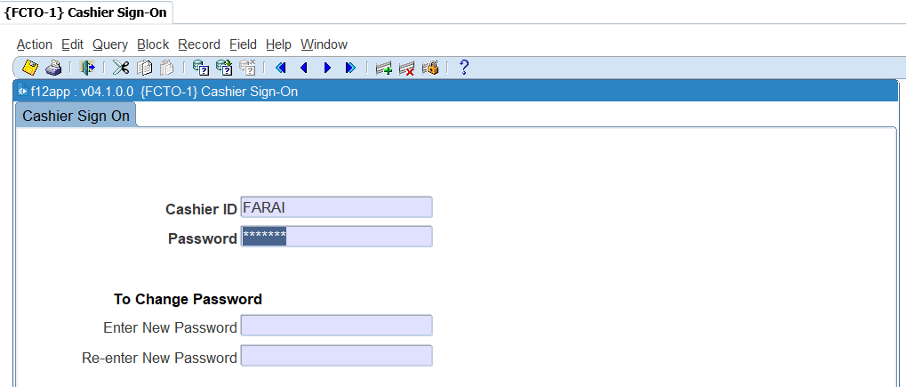

This screen cannot be queried.

**Cashier ID:** Enter the name of the cashier.

**Password:** Cashier must enter the secret password.

**Enter New Password:** Enter new password

**Re-enter New Password:** Re-Enter the new password and <SAVE>.

**MODULE**

**2**

# **Cashbook MPM**

Specific outcomes

On completion of this module, you will be able to:

* Create cashbook journals.
* Duplicate cashbook journals.
* Reverse cashbook journals.
* Manage manual bank statements.
* Perform bank statement reconciliations.
* Execute cashbook transfers.
* Maintain electronic bank statements.

## Introduction

This option is the Multi Process Management (MPM) for cash book and is consists of the following panel boxes: Search, Bank Statements for, Transactions for Statement and Tasks. The aim of an MPM is to empower the user to work with an entity (in this case the cash book) using only one menu option. This will provide a 360-degree view of the cash book, the transactions linked to the cash book, details of the transactions, as well as allow the user to create new transactions or edit existing ones. A cash book code must be entered in the 'Search' Panel Box in order to use this option and will default to all the tasks that the user accesses.

**Cash Book MPM {FCBO-11}**

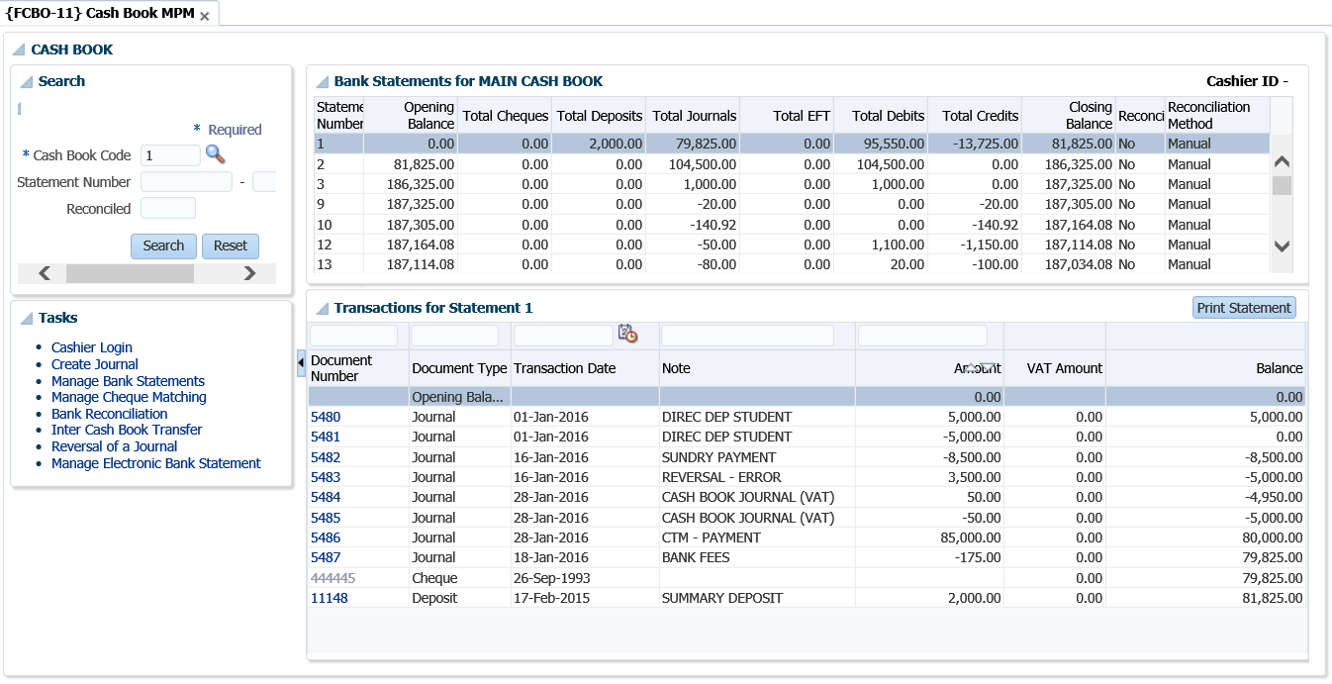

## Cashier login

Users with access to cash book options can query cash book transactions but to process a transaction, the user must be a cashier that is logged on i.e. cashier must have a valid ID and password. The program will validate that the user logged onto the system and the cashier ID entered refer to the same person. It does this by checking if the cashier ID is linked to the user in {[FCTM-2](http://wlint4.adaptit.co.za:7700/itshelp/faces/helppages/config.OHW+Servlet+1/topics/navSetId.itshelp/itshelp/documents/fctm-2.html)}.

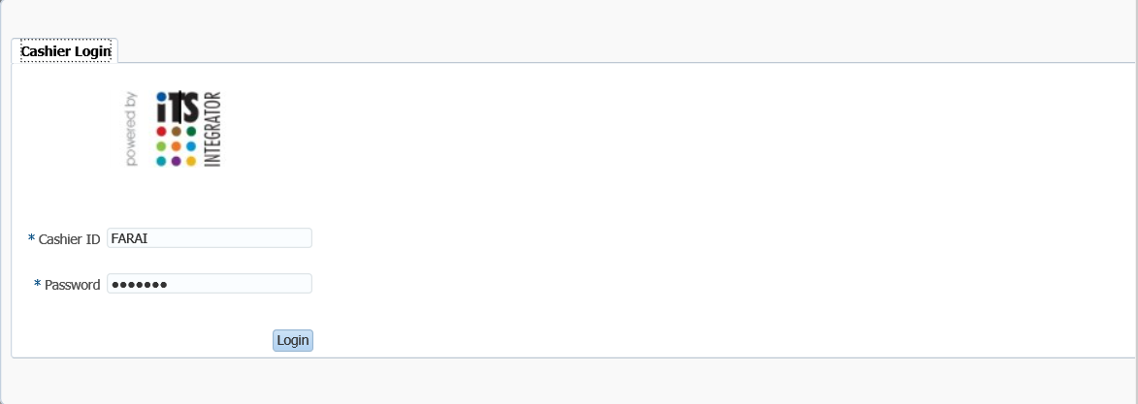

## Maintain Statement Journals {FCBO-1}

The purpose of this menu option is to enable processing of bank statement transactions and subsequently post them to the general ledger. When this option is selected, the system requests the ID and password of the cashier as defined in {FCTM-2} in block 1, and the cashbook code the user intends to work on in block 2. Additionally, system operational definition '[C7](http://hawkapp.its.co.za:7772/itshelp/help/state/content/navId.2/navSetId.itshelp/vtTopicFile.itshelp%7Cdocuments%7CC7CB/)' for subsystem 'CB' (Receive money for student with action 'S') exists in {[FCSM-1](http://hawkapp.its.co.za:7772/itshelp/help/state/content/navId.2/navSetId.itshelp/vtTopicFile.itshelp%7Cdocuments%7Cfcsm-1%7Ehtml/)} to determine if the user may accept money for a student with a status with action 'S' linked. If (N)o, the user will not be able to receive money for a student linked to a status with action 'S'. If (Y)es, the user will only receive a warning that the student is linked to a status code with action 'S'.

**Create Journal**

The Create button allows the user to create a manual cashbook journal.

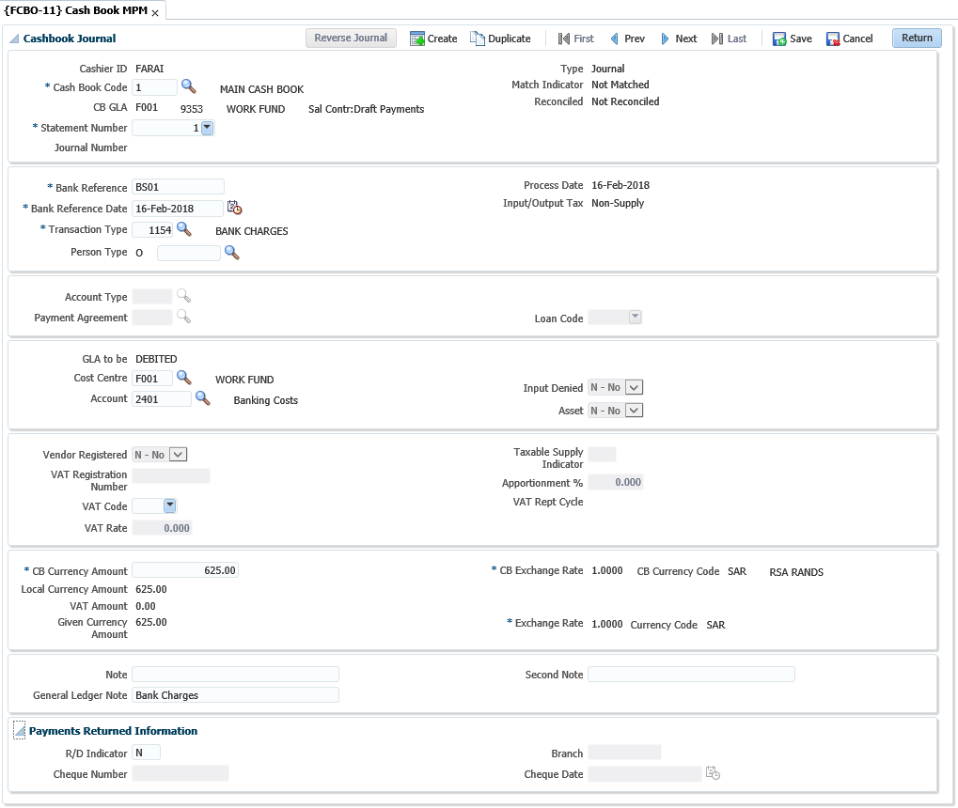

**Note:** All transactions entered here are treated as normal journals and will be posted to the general ledger if indicated as such, irrespective of whether they are matched or not. Transactions will also be generated in the other relevant subsystem.

**Cash Journal panel box**

**Cashier ID**: The cashier ID will display as created for the user on {FCTM-2}.

**Cashbook**: Enter the cashbook code. A list of values is available displaying all the valid cashbooks with their code and description.

**CB GLA**: Displays the cashbook GLA as defined in {[FCSC-5](http://wlint4.adaptit.co.za:7700/itshelp/faces/helppages/config.OHW+Servlet+1/topics/navSetId.itshelp/itshelp/documents/fcsc-5.html)} "Maintain Cashbook Definition".

**Statement Number**: Enter the statement number. A list of values is available displaying all the statement numbers for the cashbook.

**Journal Number**: This is a unique transaction number which is allocated programmatically to every transaction

**Bank Reference**: The reference number of the transaction as it appears on the bank statement.

**Bank Reference Date**: The reference date of the transactions as it appears on the bank statement.

**Process Date**: The process date will default to system date and is not updateable.

**Transaction Type**: Enter the transaction type defined on {FCSO-7}.

**Person Type**: Depending on the transaction type definition, one of the following values will be displayed: (S)tudent, (D)ebtor, (C)reditor, (A)lumnus, (O)ther or (P)ersonnel. The adjacent person number field is mandatory if the person type of the transaction is (S)tudent, (D)ebtor, (C)reditor, (P)ersonnel and (A)lumni. For person type (O)ther, this field is not mandatory, but a number can be used if the person was created on the system.

**Account Type**: the account type will default from the transaction type, but will be updateable by the user if it is defined on the transaction type definition.

**Note:** The account type field is mandatory if the person type of the transaction is (S)tudent, (D)ebtor or (C)reditor. A list of valid account types for that person type will be available. For (P)ersonnel and (O)ther, this field is also mandatory if the card indicator on the transaction type definition is (Y)es.

**Payment Agreement**: Whenever a transaction is processed for person type (S)tudent, the user will have to enter a payment agreement for the transaction. If the transaction is processed against the default account type, this field will be null.

**Loan Code**: The staff loan code or student loan code can be entered here.

**GLA to be**: Indicates if the GLA will credited or debited.

**Cost Centre**: Displays the cost centre for the transaction. The cost centre is not updateable if the person type is Student, Creditor or Debtor or where an account type is used.

**Account**: The account to be debited or credited. The account is not updateable if the person type above is Student, Creditor or Debtor or where an account type is used.

**Input Denied**: The indicator defaults from the account definition. If the journal relates to a taxable supply on the input side and the indicator is (Y)es, GST / VAT will not be processed when the journal is saved. The journals will be marked as input denied.

**Asset:** If the journal relates to the sale or purchase of an asset the indicator should be set to (Y)es. The indicator will be used to identify capital items for GST / VAT reporting purposes. The value defaults according to the asset categories as defined on the SOD codes AV and AW.



**Vendor Registered**: Vendor registered only applies to SA clients registered for VAT, where the journal relates to input. In order to claim the input VAT on the journal the field vendor registered must be set to (Y)es. If the field is "Y" the cashier will be required to enter the vendors VAT registration number. This forces the cashier to enter a VAT registration number where input tax will be claimed.

**VAT Registration Number**: If the field vendor registered is set to (Y)es, the cashier must enter a VAT registration number. The program will validate that the number is a valid VAT number applying the SARS modules check.

**Vat Code**: For money received, the VAT Code defaults from the credit GLA cost centre definition. For payments, it defaults from the Cost Centre of the debit GLA.

**Vat Rate**: The VAT percentage linked to the VAT code will default but can be updated by the user. It is the user's responsibility to ensure the VAT rate is correct on commit of the transaction.

**Taxable Supply Indicator**: Taxable supply indicator is used to classify a transaction in terms of its treatment for VAT / GST purposes. The taxable supply indicator is linked to the GST / VAT code and by selecting a GST / VAT code, the taxable supply indicator is set. The following indicators are available:

* Taxable Supplies
* Standard Rated Supplies
* Zero Rated Supplies
* Exempt Supplies
* Deemed Supplies
* Change in Use
* Bad Debts
* Non-Taxable Supplies

**VAT Apportionment**: Where a journal is directly attributed to the making of a taxable supply there is no apportionment and the apportionment is 100% rate = 1. However, if the journal relates mixed supplies, apportionment applies and only a portion of the input tax can be claimed. The portion that can be claimed is referred to as an apportionment. Apportionment rates to be applied should be obtained from the local tax authority.

**Note:** Apportionment is only applicable if the journal relates to input. The apportionment rate defaults from the rate definition but it is the cashier’s responsibility to ensure the GSWT / VAT apportionment is correct on commit of the transaction. The rate is entered in decimal notation.

**VAT Report Cycle**: Displays the VAT Report Cycle. When a transaction is reported in a VAT report, the transaction is flagged with the report year and cycle it was reported in.

**CB Currency Amount**: The transaction value in cashbook currency i.e. the amount as it appears on the bank statement.

**Local Currency Amount**: The CB currency amount converted in the currency of the institution.

**Vat Amount**: The VAT amount, if VAT is applicable will display.

**Given Currency Amount**: The value of the transaction, in each currency. Given currency value is the value of the transaction in the currency of the Debtor / Creditor after converting the Cashbook amount received to local currency and the local currency value to the debtor / creditor currency.

**CB Rate**: The cashbook currency exchange rate.

**CB Currency Code**: The currency code of the cashbook. The cashbook currency defaults from the cashbook definition and cannot be updated.

**Given Currency Rate**: The exchange rate of the currency the Debtor / Creditor is defined in.

**Currency Code**: The currency code of the currency the person, Debtor / Creditor, is defined in. The code defaults from the person’s biographical definition and cannot be updated.

**Note**: A note for the subsystem transaction may be entered. If the debtor / creditor is a (S)tudent, the note will default from the transaction type note, but may be updated.

**General Ledger Note**: The debtor number and name will default to this field but may be updated by the user. This note will be entered in the General Ledger.

**Second Note**: A second note field can be entered for the transaction. This field can be updated after the transaction is saved. If the field is entered, it will print on the transaction list. If null, the GL Note will print on the transactions list {FCBOR1-6}.

**Payments Returned Information panel box**

**Set R/D Indicator**: If an R/D cheque is processed, this indicator may be set to (Y)es.

**Cheque Number**: If a cheque was returned from the bank, the cheque number of the returned cheque can be entered here.

**Branch:** The branch code of the returned cheque can be entered here.

**Cheque Date**: The date of the returned cheque can be entered.

**Reverse Journal**

The Reverse Journal button allows the cashier to reverse a cashbook journal. A pop-up window will appear, and the user will enter the details of the original journal to be reversed.

**See Example below {FCBO-1}**

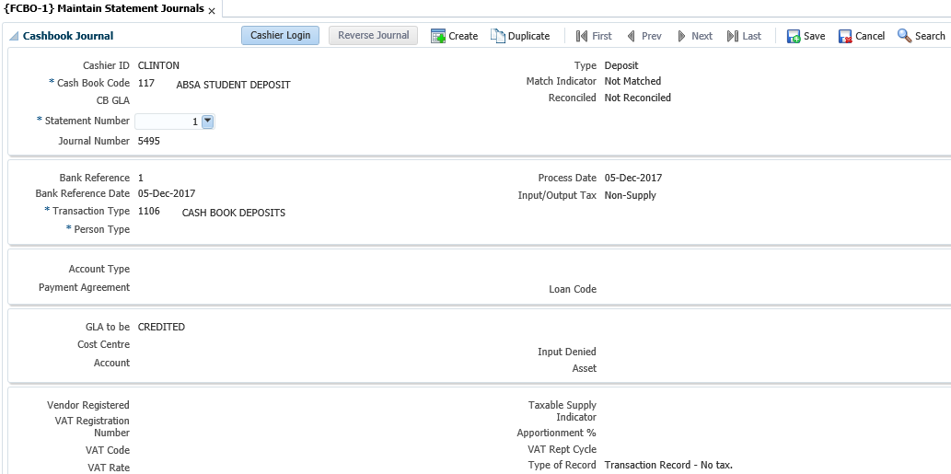

**Duplicate Journal**

Allows the cashier to duplicate a cashbook journal and the journal fields will be pre-filled. (See page 25 for a detailed explanation of the journal fields.)

## Manage Manual Bank Statements {FCBO-2}

This option is used to match transactions on a bank statement (Cheques, Deposits and EFTs) to what exists on the system. If corresponding transactions are found, the normal match indicator is set, and the statement number is stored with the transactions. Items that are not found are stored on a scratch pad table for force-matching. If no transaction appears, it means that the user will have to enter the transactions to link to the statement. Program has been amended by changing the LOV on cash book to show all cash books, not only Manual.

The following screen shows a scenario in which all transactions have been matched.

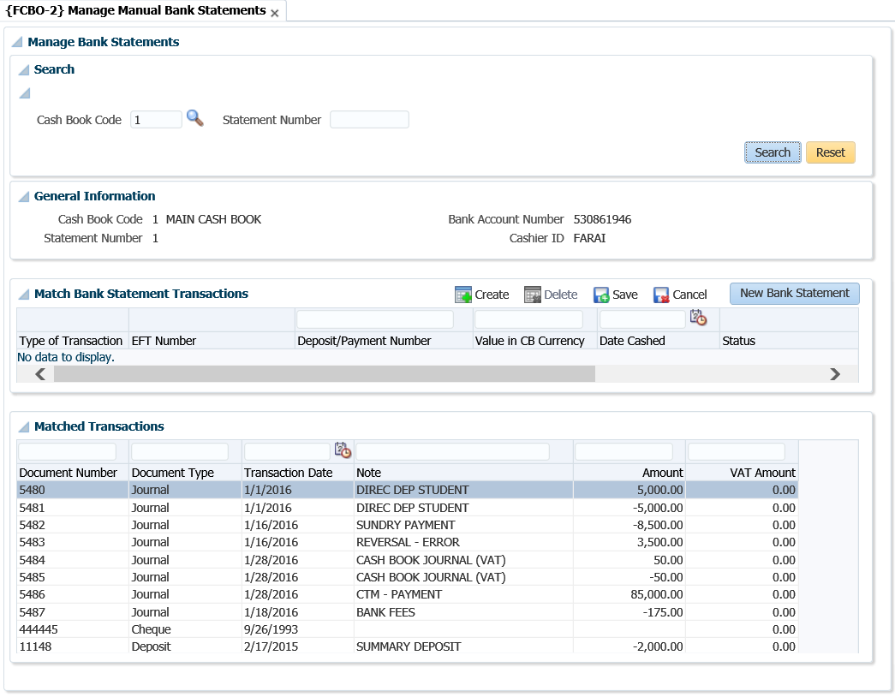

The following screen shows a scenario where some transactions still need to be matched.

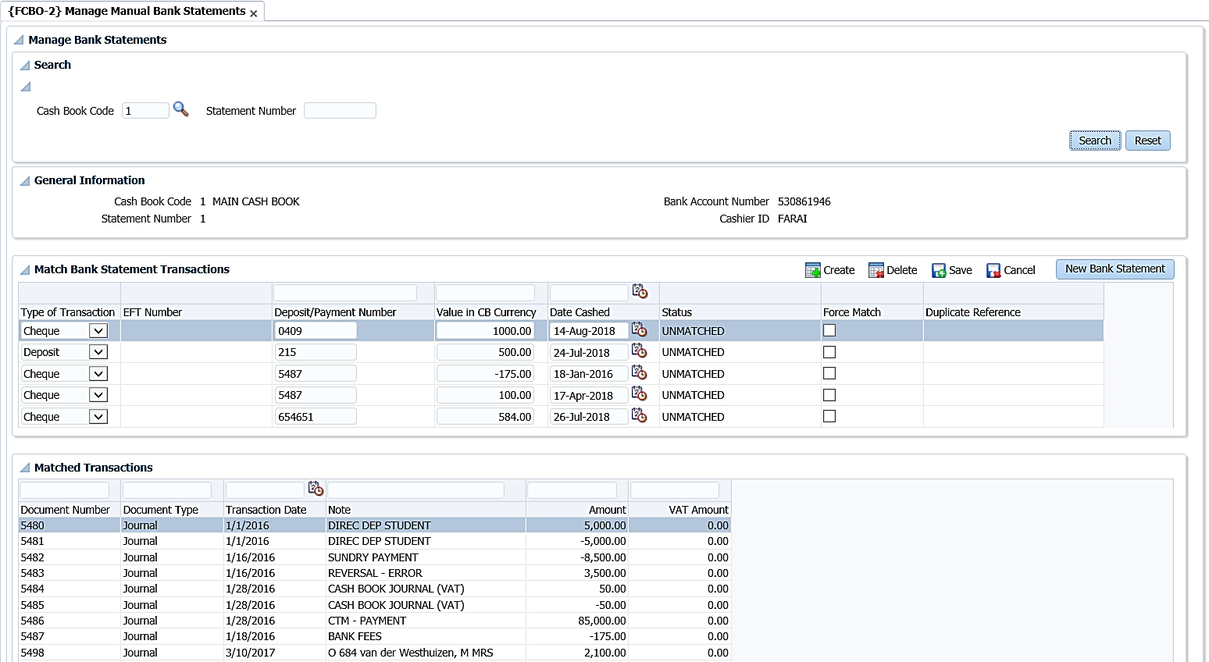

**Search panel box**

Once the user selects the cashbook code and the bank statement number in the 'Search' panel box, all the transactions that have been previously entered for the that cashbook/statement combination will be displayed. These transactions are broken down into 2 panel boxes which are the Match Bank Statement Transactions and Matched Transaction.

**General Information panel box**

The cashbook code, statement number, bank account number and cashier ID will display in form format but are not updatable.

**Match Bank Statement Transactions panel box**

Type of Transaction: The user will have to select the type of transaction that they are capturing. The options valid from the drop-down list are as follows:

* Cheque: Cheque payments that were made.
* Deposits: Deposits made to the bank from money collected at the cashiers.
* EFT: Payments that were generated electronically via tape.

**EFT Number**: This is the journal number of an EFT that exists on the system that the user wishes to link to an EFT on the bank statement. A drop-down list is available, to view all unmatched EFTs that exist in the system.

**Deposit/Payment Number**: The transaction number, as it appears on the bank statement.

**Value in CB Currency**: The transaction amount, as it appears on the bank statement.

**Date Cashed**: The transaction date, as it appears on the bank statement.

**Status**: Read only field that is used to inform the user of the status of the transaction that they have entered. The 5 statuses are as follows:

* Matched: The Deposit/Payment/EFT Number is found, and the amount is correct.
* Incorrect Value: The Deposit/Payment/EFT Number is found but the amount is incorrect.
* Unmatched: Cannot find a match for the Deposit/Payment/EFT Number and amount.
* Cancelled: Cheque was found, but was cancelled.
* Duplicate: More than one transaction found for Deposit/Payment/EFT Number and amount.

**Force Match**: It allows the user to clear the scratch pad table for a specific cashbook. When the user checks the 'Force Match' box and saves, a cashbook journal will be generated for the transaction.

* If the status is 'Unmatched ' or 'Cancelled', the system will use a transaction type linked to event 'C2' for deposits and 'C3' for cheques to process the cashbook journal.
* If the status is 'Incorrect Value', a journal will be created for the difference in the amount. If the amount must be decreased, then the transaction type linked to event 'C3' will be used otherwise the transaction type for event 'C2' will used.

**Duplicate Reference**: This field will display a drop-down list if a payment number is entered and the system finds that the number exists more than once on the system. This will only occur if the cheque that was processed was done outside the system and captured more than once in {FCTO-6} as a manual cheque entry. The user will have to select the correct entry from the drop-down list and save the record.

**Note:** The duplicate cheque will have to be reversed from the system.

**Matched Transactions panel box**

Displays transactions that have been matched to the statement.

## Bank Statement Reconciliation {FCBO-4}

This option serves to verify the correctness of the transactions entered from the bank statement. For this purpose, all the transactions in the journal, cheque and scratch pad table linked to the specific bank statement number will be considered to calculate the closing balance from the opening balance. If the calculated balance is the same with the bank statement balance, all the transactions were entered correctly but all the transactions are not necessarily matched. Once all the transactions in the scratch pad table are updated, force-matched and the calculated closing balance corresponds with the balance on the bank statement, the transactions are flagged to indicate that the reconciliation process was completed successfully.

**See Example below {FCBO-4}**

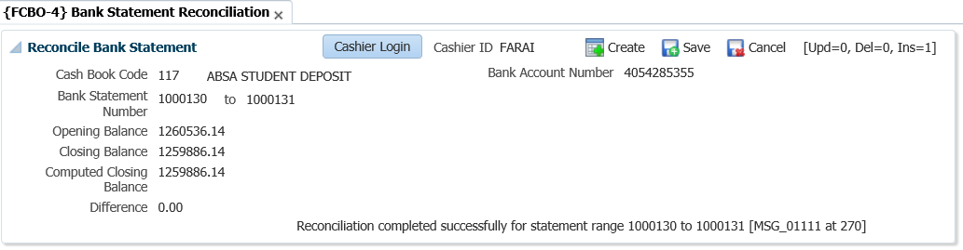

**Cashbook code**: The code of the cashbook that must be reconciled. The cashbook description will be display once entered or selected from the list of values.

**Bank Account Number**: Displays the bank account number of the cashbook.

**Bank statement number from**: The starting bank statement number that must be reconciled

**Bank statement number to**: The end bank statement number that must be reconciled. If a range is specified, the transactions of all the statements in between must have been entered

**Opening balance**: The opening balance as it appears on the first bank statement that must be reconciled.

**Closing balance**: The closing balance as it appears on the last bank statement that must be reconciled.

After the above details have been completed, the user should <SAVE> to reconcile.

**Computed Closing balance**: The system uses the opening balance (as provided) and the transactions linked to the bank code and range of statements (as provided) to calculate a closing balance. This calculated balance is displayed in this field.

**Difference**: The difference between the closing balance as provided and the calculated closing balance is displayed in this field.

## Manage Cheque Matching

The screen-print below shows cheques that are matched.

**See Example below {FCBO-11}**

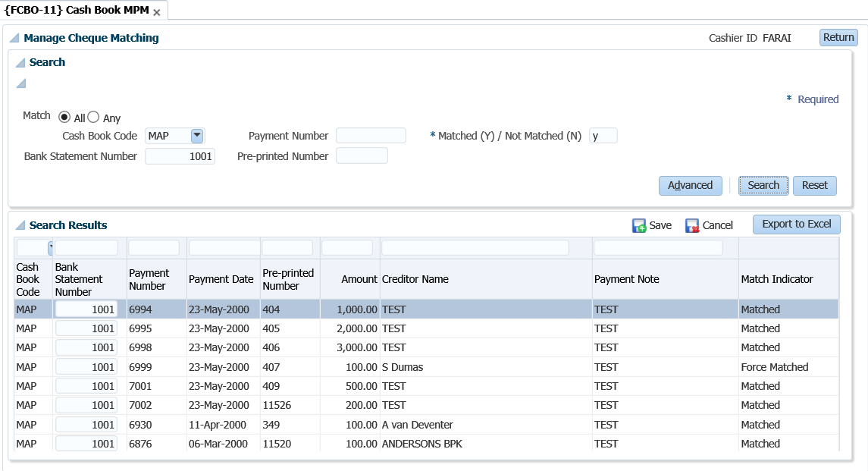

The following screen-print displays unmatched cheques.

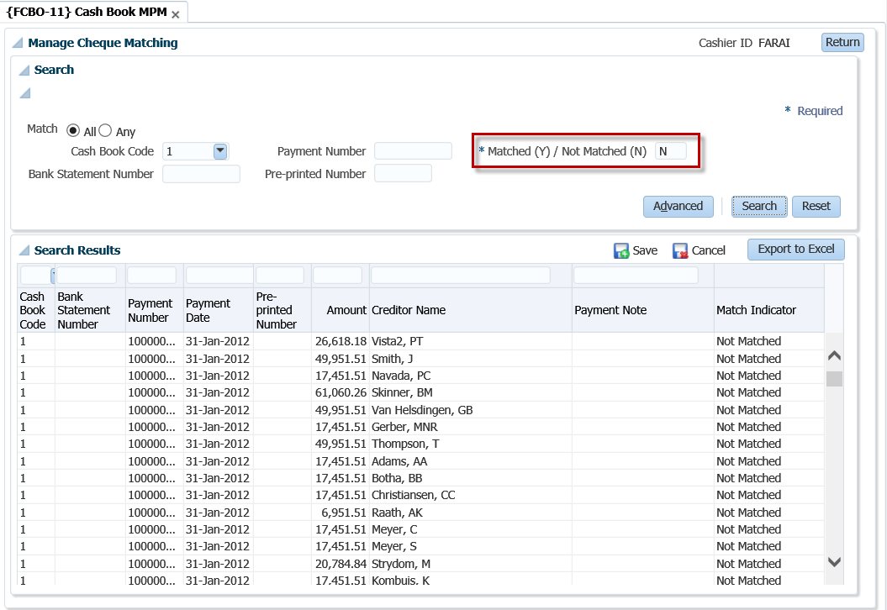

## Cashbook Transfers {FCBO-5}

This option serves the same purpose as option {FCBO-1}, except that two transactions are generated in the journal table, one for each cashbook. These transactions are driven by events “CO: transfers out” and “CI: transfers in”, and transaction types will have to be linked to these events. The two transactions can then be matched individually from the bank statements.

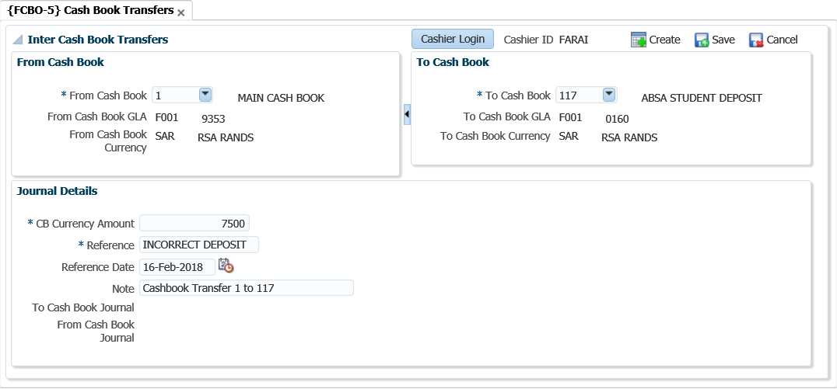

**Cashbook from**: enter the cashbook code from which money must be transferred.

**Cashbook to**: enter the cashbook code to which money must be transferred.

**Amount:** the amount that must be transferred.



**Note** **:**When you save, the system will generate the two transactions linked to events “CO-transfers out” and “CI-transfers in”.

## Maintain Electronic Bank Statement {FCBO-21}

This task on the MPM is a combination of {[FCBO-21](http://wlint4.adaptit.co.za:7700/itshelp/faces/helppages/config.OHW+Servlet+1/topics/navSetId.itshelp/itshelp/documents/fcbo-21.html)} & {[FCBO-22](http://wlint4.adaptit.co.za:7700/itshelp/faces/helppages/config.OHW+Servlet+1/topics/navSetId.itshelp/itshelp/documents/fcbo-22.html)} and is used to maintain and match transactions on an electronic bank statement. Options {FCBO-21}, {[FCBO-22](http://wlint4.adaptit.co.za:7700/itshelp/faces/helppages/config.OHW+Servlet+1/locale.en/topics/navSetId.itshelp/itshelp/documents/fcbo-22.html)}, {[FCBO-23](http://wlint4.adaptit.co.za:7700/itshelp/faces/helppages/config.OHW+Servlet+1/locale.en/topics/navSetId.itshelp/itshelp/documents/fcbo-23.html)} and {[FCBO-24](http://wlint4.adaptit.co.za:7700/itshelp/faces/helppages/config.OHW+Servlet+1/locale.en/topics/navSetId.itshelp/itshelp/documents/fcbo-24.html)} are used to process and  reconcile bank statement downloaded electronically. On converting an electronic bank statement, the system attempts to match all deposits and cheques. Any cheques or deposits that couldn’t be matched and other transactions on the statement are written into a table which can be maintained in this option.

In order to process transactions in the table, the cashier will enter the appropriate transaction type and or cost centre and account or linking the journal number before running the match electronic bank statement program {FCBO-22} which will generate cashbook journals. On reconciliation of a bank statement, the closing statement balance is inserted into the table and all records written to the table for the bank statement excluding the closing balance are deleted.

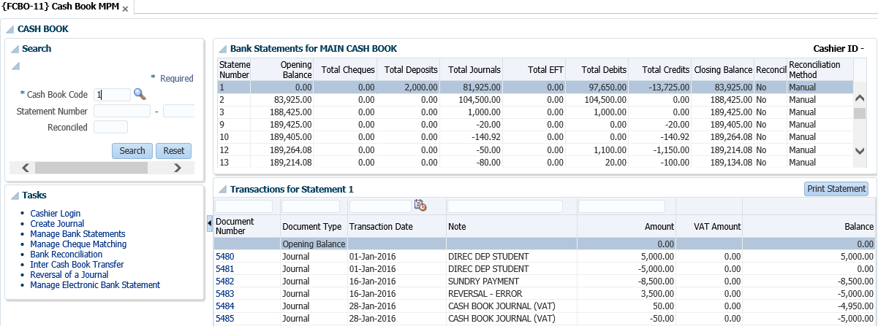

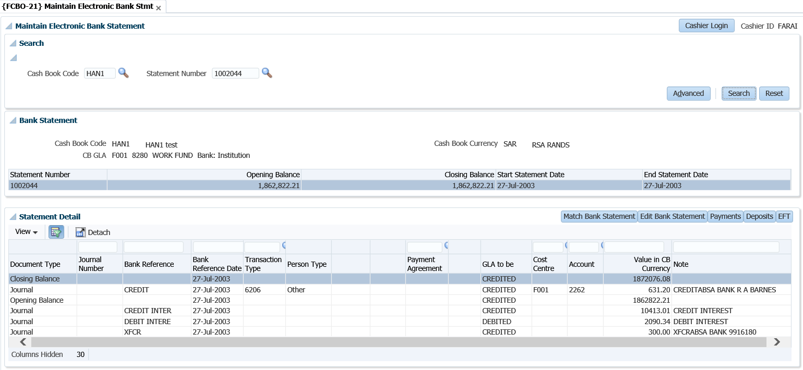

**Search panel box**

**Cashbook Code**: Allows the user to search for a cashbook code. The list of values will display the code, description, CB GLA and CB currency code.

**Bank Statement Number**: Allows the user to search on bank statement number or cashbook and bank statement number. The list of values will display the statement number, maximum reference date and statement closing balance.

**Bank Statement panel box**

The form layout displays cashbook code, cashbook currency and CB GLA returned for the search. The statement number, opening balance, closing balance and statement date range are displayed in a table.

**Statement Detail panel box**

Information cannot be updated in the table; the Edit Bank Statement button must be used to maintain the cashbook journals.

**Document Type**: Indicates if the record related to journal, deposit or payment. Only journals can be maintained in this option

**Journal Number**: The unique transaction number, which is allocated programmatically when a journal is created.

**Bank Reference**: The reference number of the transaction as it appears on the bank statement.

**Bank Reference Date**: The transaction date as it appears on the bank statement.

**Transaction Type**: Journal processing is driven by the transactions type. The transaction type indicates the person type and other subsystem is affected by using the transaction type. The transaction type also determines which of the fields that follow are required and / or updateable and whether the journal relates to input or output for VAT / GST purposes. The transaction types are defined in {FCSO-7}.

**Person Type**: Depending on the transaction type definition, one of the following values will be displayed:

* (S)tudent Debtor
* (P)ersonnel
* (C)reditor
* Normal (D)ebtor
* (A)lumnus
* (O)ther

**Person Number**: The person number field is mandatory if the person type of the transaction is (S)tudent, (D)ebtor, (C)reditor, (P)ersonnel and (A)lumni. For person type (O)ther, this field is not mandatory, but a number can be used if the person was created on the system and has a biographical record.

**Account Type**: The account type will default from the transaction type, but can be updated by the user if so defined on the transaction type definition. The account type field is mandatory if the person type of the transaction is (S)tudent, (D)ebtor or (C)reditor. For (P)ersonnel and (O)ther, this field is also mandatory if the card indicator on the transaction type definition is (Y)es. If this indicator on the transaction type definition is (N)o, an account type is not needed. If person type is (S)tudent, (C)reditor or (D)ebtor, a list of valid account types for that person type will be available. It will also show the balance for the account type / payment agreement combination for (S)tudents. The user will only be able to process a transaction on one of these valid account types or the default account type defined for the student debtor subsystem. The program will validate that the subsystem / account type combination is valid and active.

**Payment Agreement**: When a transaction is processed for person type (S)tudent, the user will have to enter a payment agreement for the transaction. A list of valid values for the specific student will be available from which to choose. This is a mandatory field for person type (S)tudent unless the transaction is processed against the default account type, in which case the field will be null.

**Loan Code**: The staff loan code or student loan code, if applicable, can be entered here. For staff debtors, the cumulative principal repayment and the reducing principal (outstanding amount) {FARPD-2 b2} will then be updated with the amount of the payment. It is essential that the account type used be linked to a category “S” (Staff Loans) otherwise the user will not be allowed to enter a loan code. For student loans, the real payment amount, as indicated on the amortisation schedule {FBLO-22} Tap 4, will be updated with the payment amount when the next amortisation calculation is run. Again, it is essential that the account type used be linked to a category “L” (Student Loans) otherwise the system will not allow the user to enter a loan code.

**GLA to be**: GLA to be Debited / Credited is displayed depending on the transaction type definition.

**Cost Centre**: The cost centre to be debited or credited. The cost centre and account are not updateable if the person type above is Student, Creditor or Debtor or where an account type is used.

**Account**: The account to be debited or credited. The cost centre and account are not updateable if the person type above is Student, Creditor or Debtor or where an account type is used.

**Given Currency Amount**: The value of the transaction, in each currency. Given currency value is the value of the transaction in the currency of the Debtor / Creditor after converting the Cashbook amount received to local currency and the local currency value to the debtor / creditor currency.

**Note:** A note for the subsystem transaction may be entered. If the debtor / creditor is a (S)tudent, the note will default from the transaction type note, but may be updated.

### Match Bank Statement

Selecting the button navigates to the "Maintain Electronic Bank Statement” option {FCBO-21} which allows the user with access to run the option to convert a bank statement.

**See Example below {FCBO-21}**

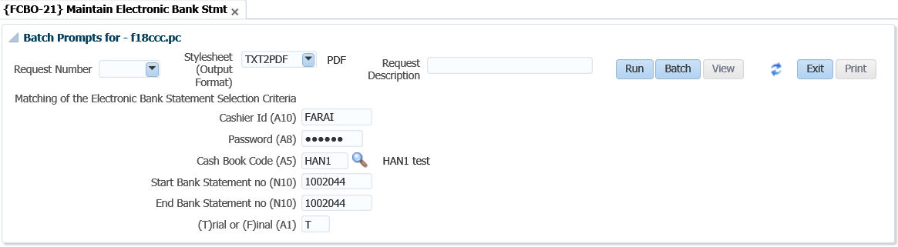

### Edit Bank Statement

Cash book journals cannot be maintained in the Statement Detail panel box. The cashier must use the Edit Bank Statement button to open the edit screen. Clicking the button opens the "Edit Electronic Bank Statements” screen which allows the user to maintain the journals displayed in the table.

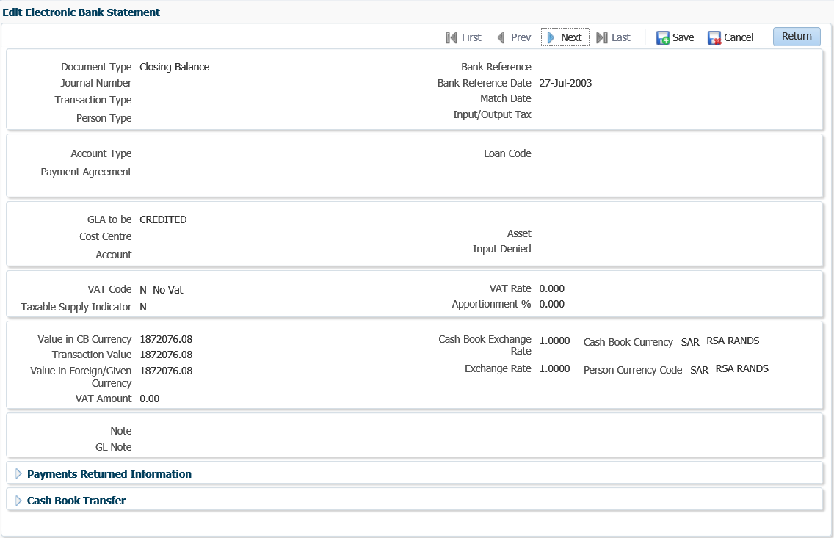

**Payments Returned Information**

**R/D Indicator:** If an R / D cheque is processed this indicator may be set to (Y)es.

**Cheque Number**: If a cheque was returned from the bank, the cheque number of the returned cheque can be entered here.

**Branch**: The branch code of the returned cheque can be entered here.

**Cheque Date**: The date of the returned cheque can be entered

**Cashbook Transfers**

**Transfer Cashbook**: The Cashbook code from / to which money is transferred.

### Payments

When you click on the *Payment* button, the following window pops-up:

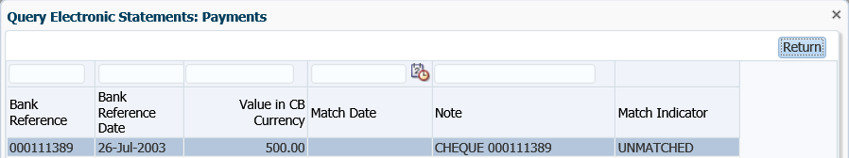

### Deposits

When you click on Deposits, the following window pop-up:

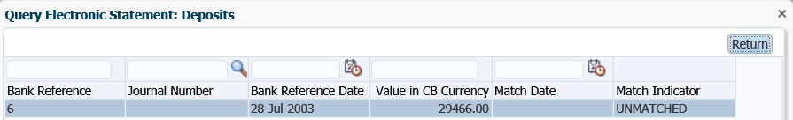

### EFT

When you click on EFT, the following pop-up window appears:

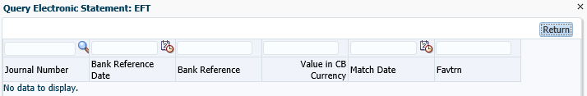

## Process Incoming Bank Files {FACMR1-2}

This Option is used to Process Incoming Bank Files





**None**: This program executes automatically in the background. The program checks all files loaded in the directory for incoming bank files and depending on the file name it knows which program (SSVS, AVS, EFTS, Bank Statement or Transact Alert) to call to process the file and email the output to the user specified.

Example:

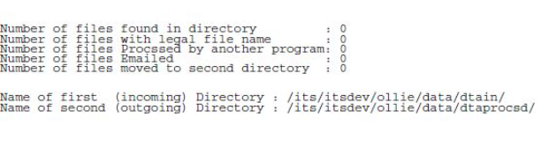

**Processing Rules:** Reports will be generated indicating the errors and the user will be notified automatically that records are verified as correct and will be updated accordingly.

Generating files for Standard Bank:

* ACCV file for Standard Bank - {FACM-6}
* SSVS file for Standard Bank - {FACM-5}
* EFTS file for Standard Bank - {FPRNB-1}
* Error Codes - {FACO-23}.

Processing files from Standard bank:

* Bank Statement files {FEBC-9}
* Transact Alert files

## Maintain Electronic Statement- Standalone {FCBO-28}

This menu option serves the same purpose as {FCBO-21}, except for the Match Bank Statement” functionality. The main difference is the interface, i.e. in {FCBO-21} the user must drill down using the buttons whilst {FCBO-28} has a form layout to maintain the journals.

**See Example below {FCBO-28}**

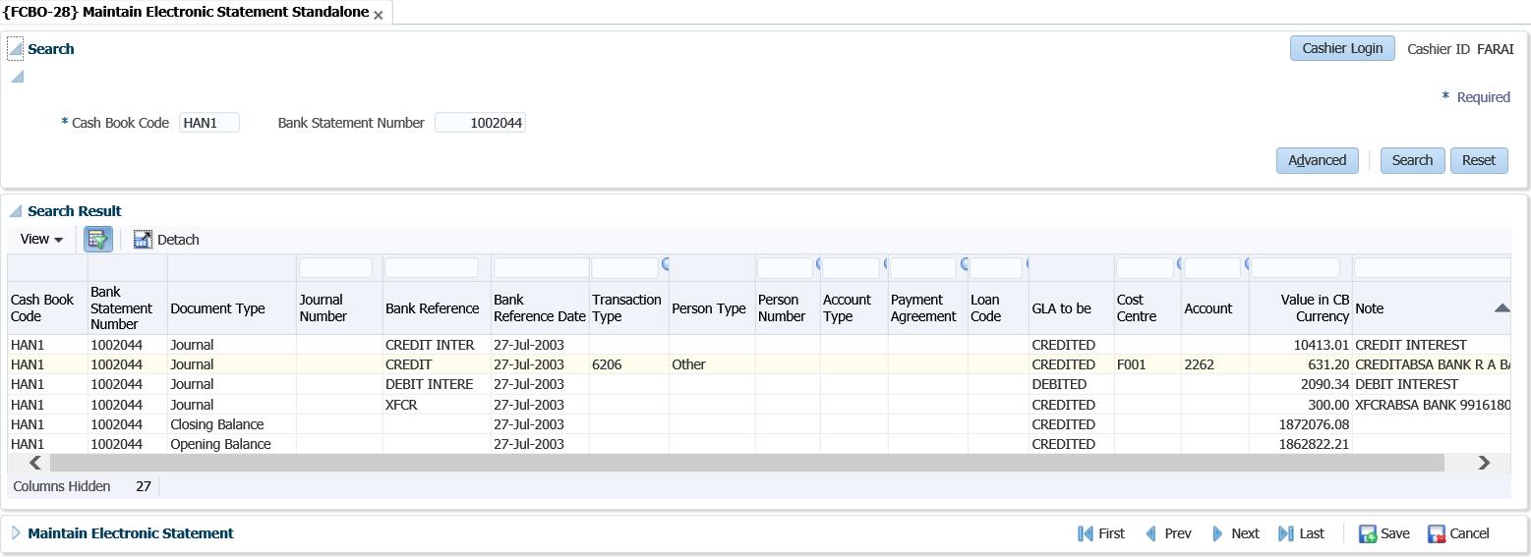  
**Form layout**

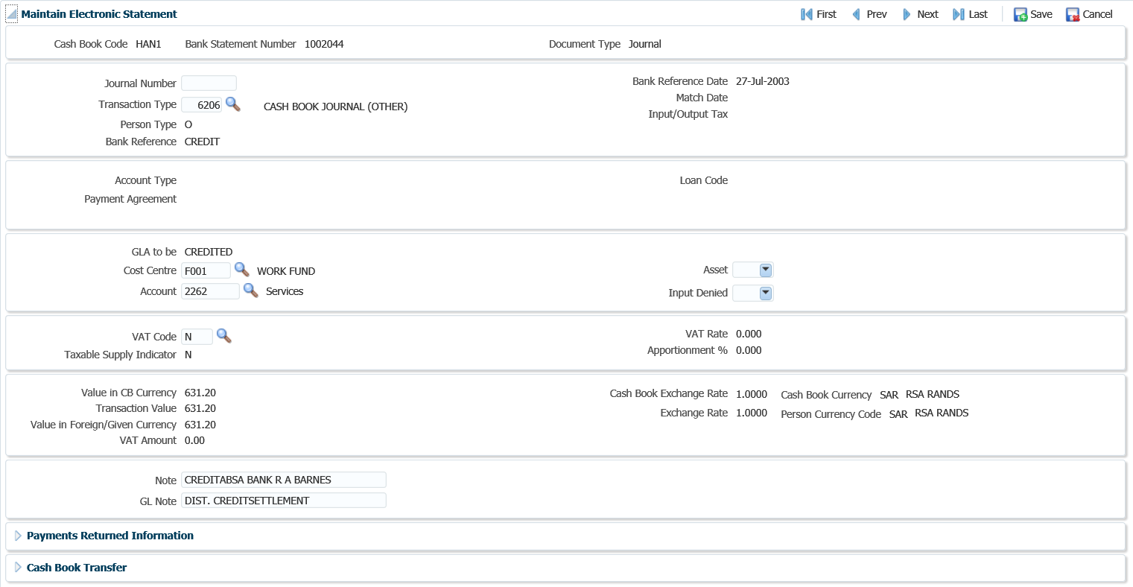

## Query Unreconciled Cheques {FCBO-6}

This option allows the user to update the bank statement on payments where the bank statement has not yet been reconciled.  The screen either lists payments that have not been linked to a bank statement or payments linked to bank statement not yet been reconciled. The user can change the bank statement number on an unreconciled bank statement.

**See Example below {FCBO-11}**

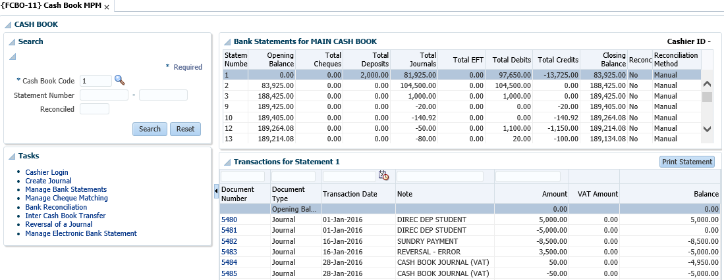

**See Example below {FCBO-6}**

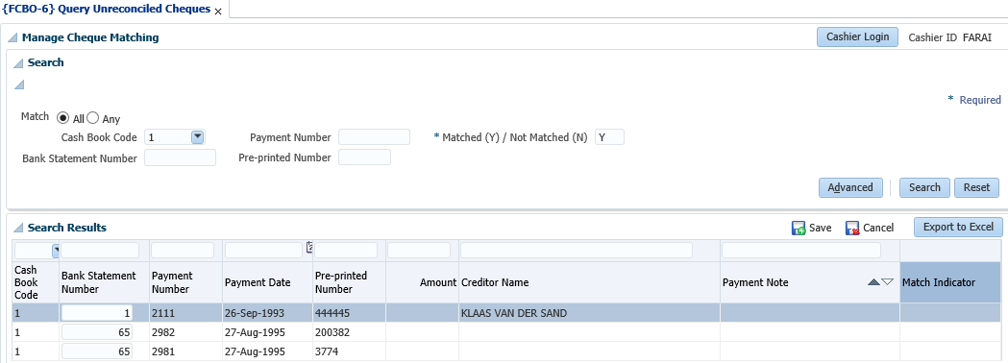

**Search panel box**

The user can search unreconciled payments per cashbook code, payment number, matched Yes / No, bank statement number, pre-printed number or any combination thereof or do an advance search. The Matched (Y) / Not Matched (N) indicator is mandatory.

**Search Results**

**Cashbook Code**: The bank account against which the cheque was issued.

**Bank Statement Number**: The bank statement number on which the cheque was matched.

**Payment Number**: The internal cheque number.

**Payment Date**: The date on the cheque.

**Pre-printed Number**: The external cheque number.

**Amount**: The amount on the cheque.

**Match Indicator**: Whether the cheque was (C)ancelled, (N)ormal or (F)orced matched.

**Name on the Payment**: The Creditors name.

**Note on Payment**: Displays the payment note

**MODULE**

**3**

# **Query Menus (not in MPM)**

Specific outcomes

On completion of this module, you will be able to:

* Query budget general ledger accounts.
* Query statement journals.

## Introduction

This section covers the query functionalities not incorporated in the cashbook MPM.

## Query Budget GLA {FCBO-9}

The user can query budget or actual GLA totals and detail, within the security rules. The form layout is used to capture the query criteria before clicking on the Submit button. Mandatory fields depend on nature of the query i.e. actual or budget. When you click on the “New Query” button, the following screen displays.

**Actual**

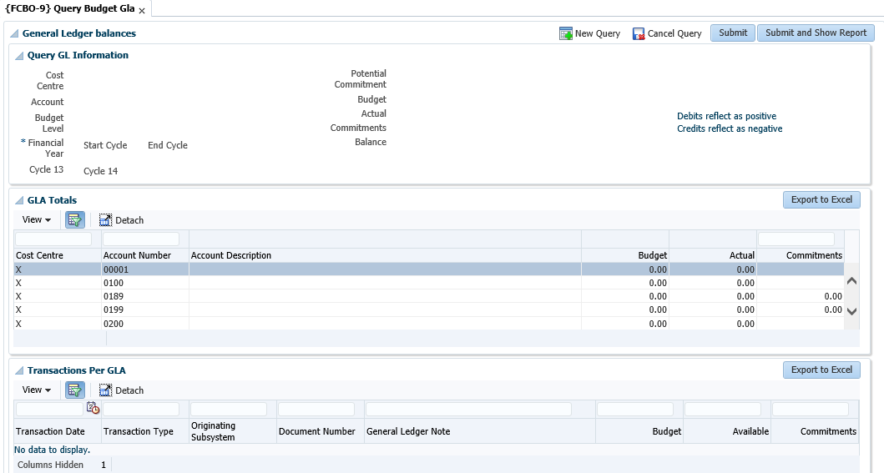

**Budget**

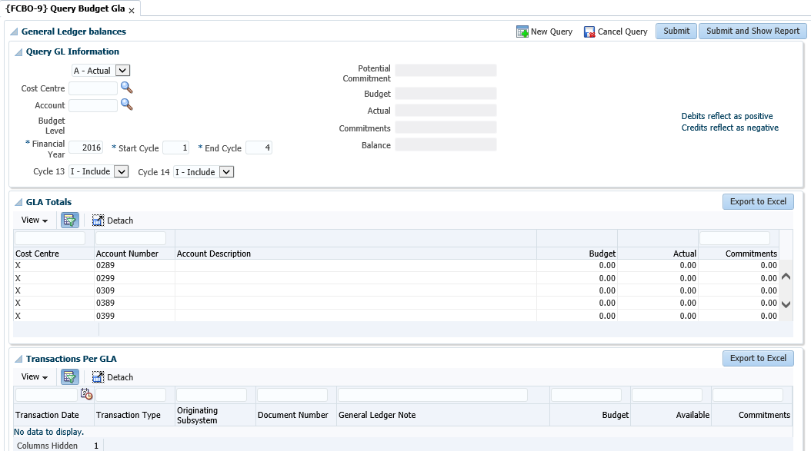

**Submit and Show Report button**

Click the button and a batch prompt that allows you to view or print the report will display.

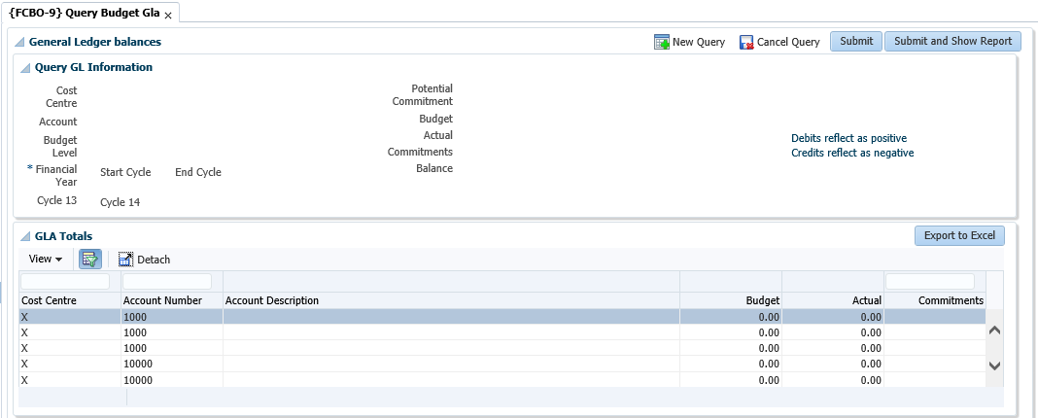

## Query Statement Journals {FCBO-10}

The purpose of this menu option is to enable the user to query transactions processed against a bank statement.

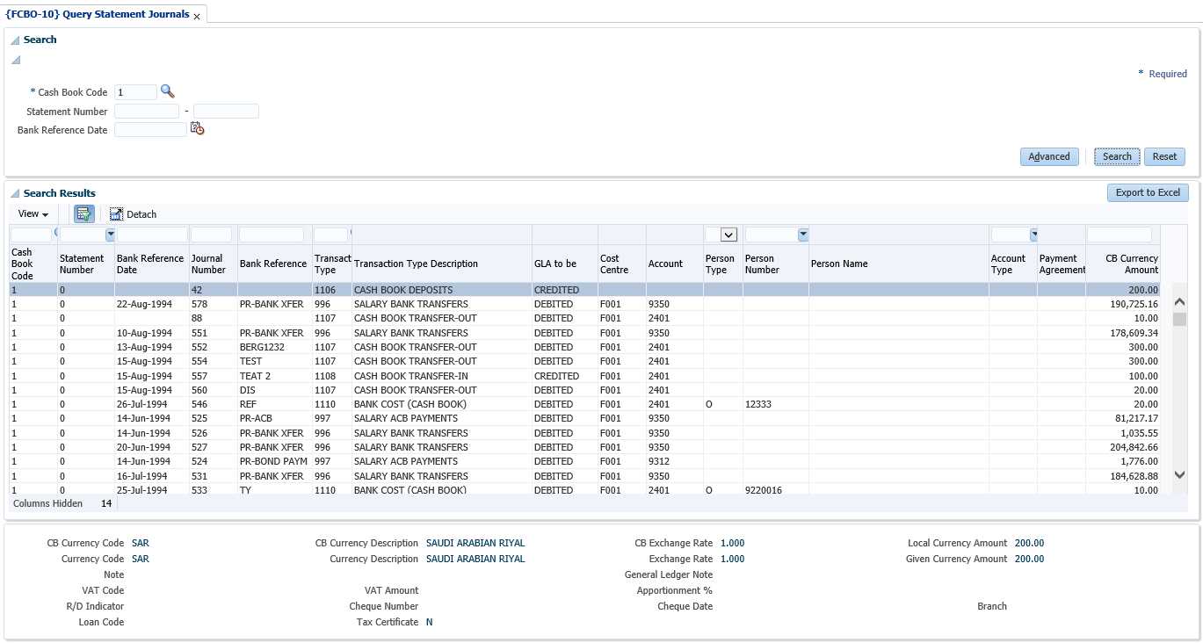

**Search**

Enter the cashbook code. The statement number range and bank reference date are optional. Leaving the statement number fields null will query all transactions for the cashbook.

**Search Results**

All fields in the table are display fields only and display the values as entered when the transaction was processed. Transactions are displayed in the same order that they were entered by the user or downloaded and processed from an electronic bank statement. The form at the bottom of the table shows the financial details of a transaction selected in the table.

**MODULE**

**4**

# **Reports**

Specific outcomes

On completion of this module, you will be able to generate the following reports:

* Bank statement.
* Bank reconciliation statement.
* Bank reconciliation at a specific date.
* Receipts payments not deposited.
* Deposit validation.

## Introduction

All the cashbook transactions are kept in these two sets of tables as indicated. When a bank statement is received, all the transactions must be entered from the bank statement into the system. Matching of the transactions is then performed online. The number of the bank statement is stored with the original transaction if a match is found. In the case where there is no matching transaction for the one on the bank statement, it is stored in a temporary table. Entries in the temporary table can then be force-matched with other groups of transactions. All unmatched transactions in the temporary table can be updated or deleted by the user. To ensure the successful reconciliation of a bank statement, there must be no transactions for that statement in the temporary table

**Reports to use for Cashbook reconciliation are:**

* {FCTOR1-1} Rec/Payments Trans per Type: Transaction per type report from counter system
* {FGLOR1-21} Transactions per Type: Transaction per type report from GL system
* {FCBOR1-1} Bank Statement Report: A report run from one specific bank statement to another
* {FCBOR1-2} Bank Reconciliation: A report which compares the subsystem to the GL. It also provides a list of transactions without bank statement numbers and statements that have not been reconciled
* {FCBOR1-5} Receipt Payments Not Deposited: A report that lists all the undeposited receipts
* {FCBOR1-7} Deposit Validation Report
* {FCBOR1-10} Bank Reconciliation as at a Specific Date

## Receipt / Payment Transactions per Type {FCTOR1-1}

This report reflects detail of transactions for a specified range of types and can be requested in summary or in detail. If all the transaction types for the CT Subsystem is requested the report will first list the receipt transactions and then the cheque transactions.

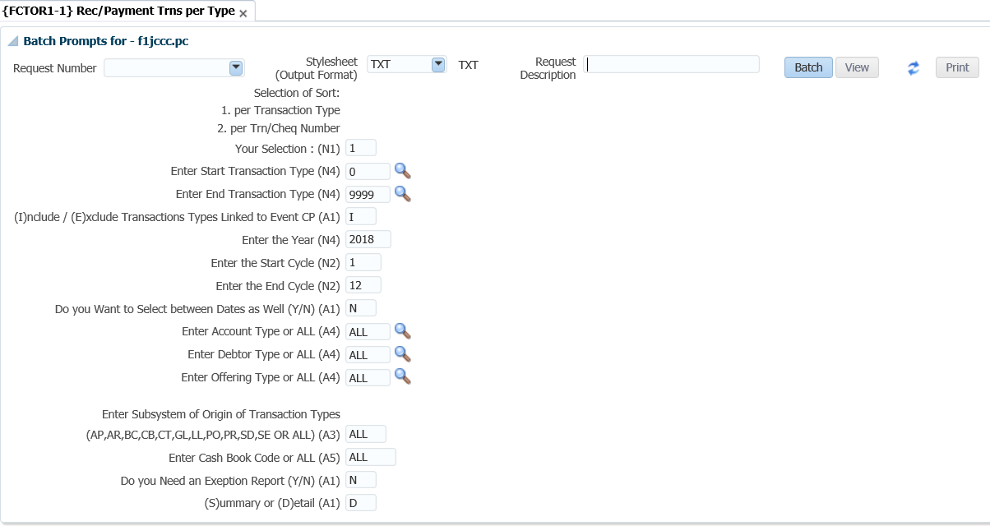

## Bank Statement {FCBOR1-1}

The user will be able to view a bank statement that was created in the cashbook, or view all unmatched transactions. This program will print according to the new transaction sequence. The user will thus be able to print bank statement transactions in the same order as they appear on the physical bank statement; if the transactions were processed in that order.

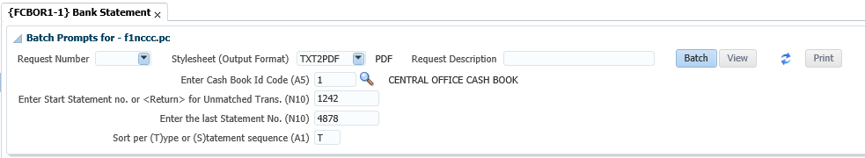

The parameters to be entered are:

* Cashbook ID code
* Enter Start Statement Number or <RETURN> for Unmatched Trans.
* Sort per (T)ype or (S)tatement sequence

Click on the view button and the following report will be generated:

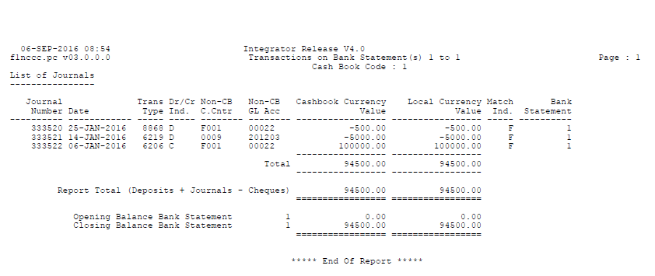

## Bank Reconciliation {FCBOR1-2}

This report is used to reconcile the balance on the bank statement with the balance of the cashbook in the General Ledger.  If the closing balance on the bank statement can be calculated from GL balance and all the outstanding items for that cashbook, no further detail is printed.  If, however it is not in balance, all the detail of unmatched transactions is printed.

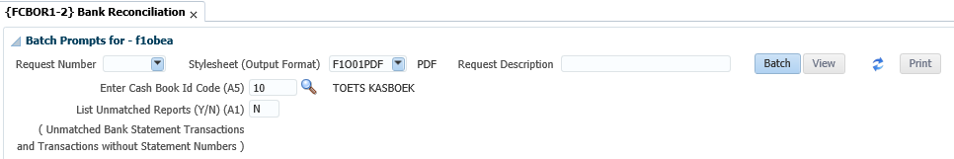

The parameters to be entered are:

* Cashbook ID code
* List Unmatched Reports (Y/N)

Click on the View button the following report will be generated:

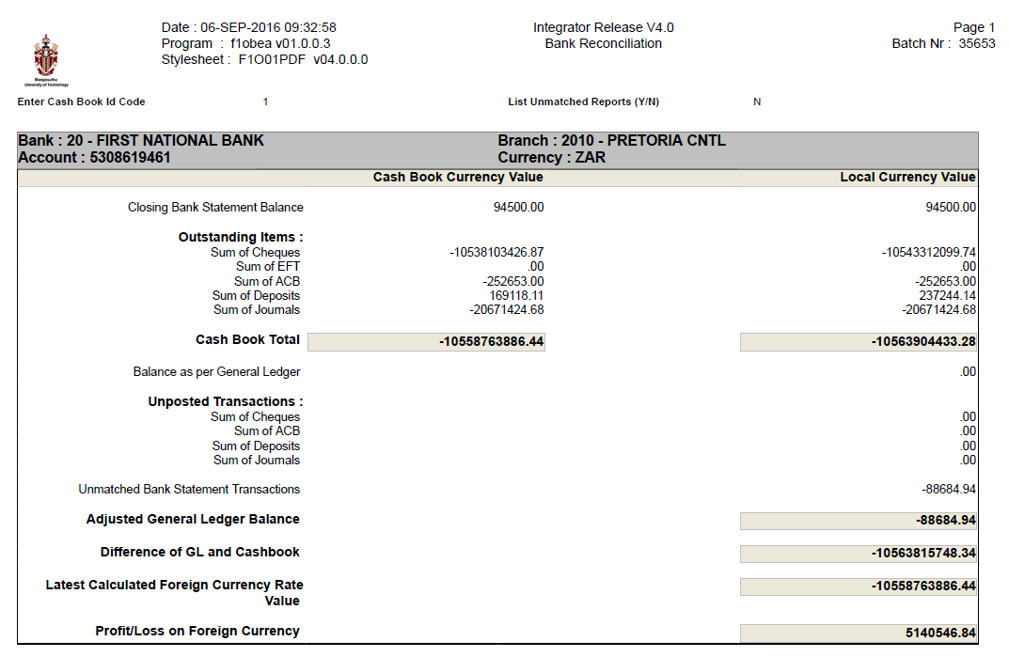

## Receipt Payments Not Deposited {FCBOR1-5}

When run, this report will retrieve a list of all receipts that have been processed in ITS, but have not been deposited to the bank (i.e. A deposit listing has not been run)

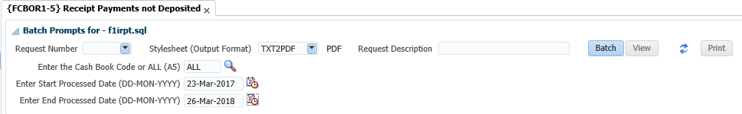

The parameters to be entered are:

* Cashbook Code
* Start Processed Date
* End Processed Date

Click on the View button the following report will be generated:

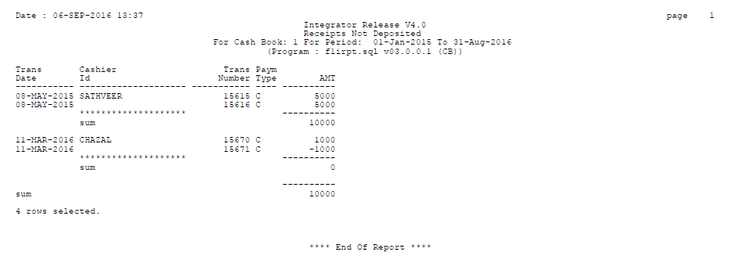

## Deposit Validation Report {FCBOR1-7}

This report lists all the cash-book deposit transactions according to the specified criteria but compares entries made on {FCTO-3} per deposit to deposits created in the cashbook.

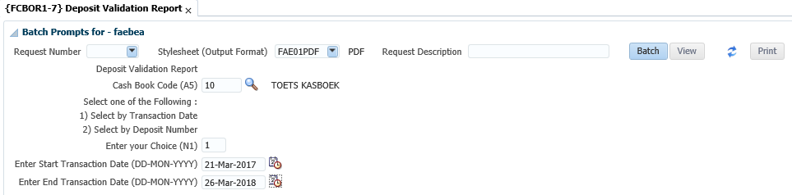

The parameters to be entered are:

* Cashbook Code
* Select 1 for Transaction Date (then enter start and end transaction date) or 2 for deposit number (then enter start and end deposit number)

Click on the View button the following report will be generated:

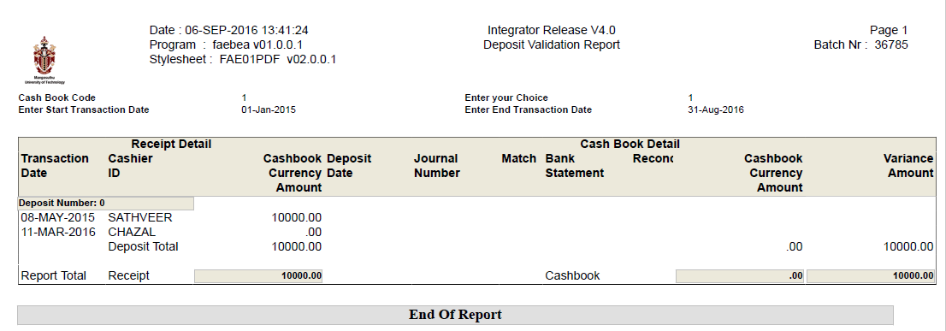

## Bank Reconciliation as at a Specific Date {FCBOR1-10}

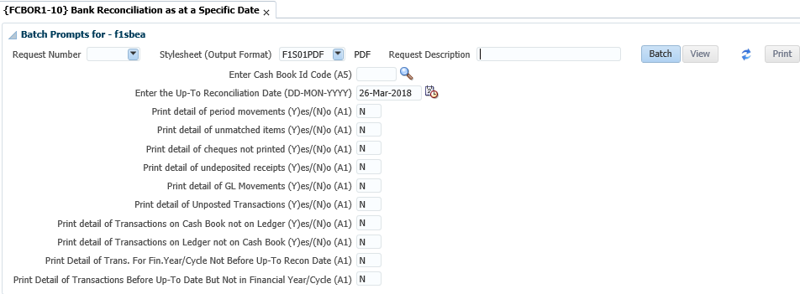

The following report will be generated:

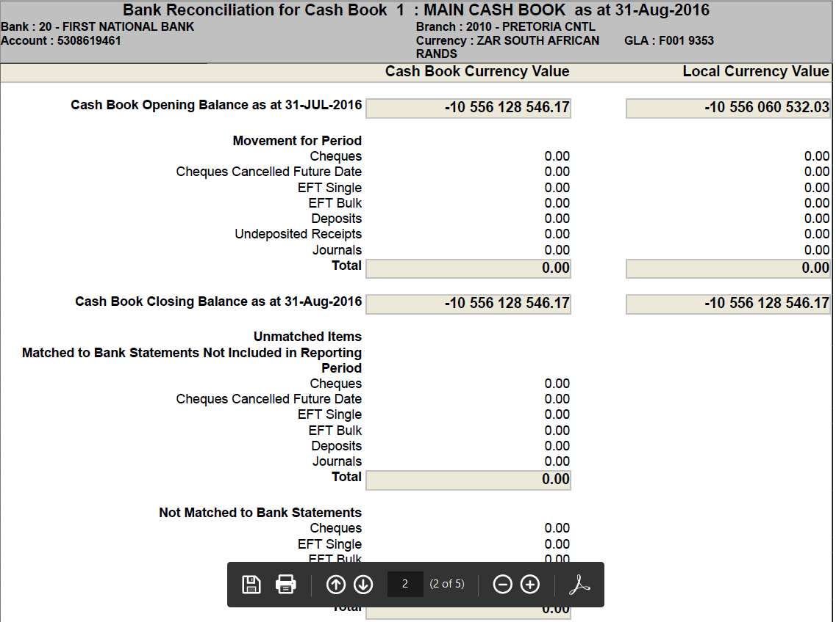

ITS INTEGRATOR 4.1



Interface Manual

Copyright

©All rights reserved

No part of this document may be reproduced or transmitted in any form or by any means, without express written permission from Adapt IT or an authorised representative of Adapt IT. This includes, but not limited to, electronic, electrostatic, magnetic tape or mechanical copying and recording, or use of any information storage and retrieval system.

First edition: February 2018

Disclaimer

Adapt IT makes no representations or warranties with respect to the contents hereof. Although due care and precaution has been taken in the preparation of this manual, Adapt IT assumes no responsibility for errors and omissions or any damages resulting from the use of the information contained in this publication .

i

Contents

Introduction ............................................................................................................................................ 1

Overview ............................................................................................................................................. 1

Layout.................................................................................................................................................. 2

1. System Access ................................................................................................................................. 3
   1. Screen Resolution ................................................................................................................... 3
2. Logging in page ............................................................................................................................... 4
3. Integrator Entry Screen ................................................................................................................... 5
   1. Landing page ........................................................................................................................... 5
   2. Navigation to a menu option .................................................................................................. 7
   3. Adding Favourites ................................................................................................................... 9
4. Accessing online help .................................................................................................................... 10
5. Accessing the Work list and Batch process ................................................................................... 11
   1. Introduction .......................................................................................................................... 11
   2. Running a batch program ..................................................................................................... 11
6. Reports .......................................................................................................................................... 13
   1. Introduction .......................................................................................................................... 13
   2. Jasper Reports ....................................................................................................................... 13
7. Forms ............................................................................................................................................ 15
   1. Introduction .......................................................................................................................... 15
   2. Specific Rules Related to Forms Programs ............................................................................ 16
   3. Specific Rules Related to Forms Programs ............................................................................ 17
8. Screen Patterns ............................................................................................................................. 19
   1. Introduction .......................................................................................................................... 19
   2. Entry Point (EP) ..................................................................................................................... 19
   3. Simple Codes Table (TCS) ...................................................................................................... 20
   4. Table with Search Panel (TCM) ............................................................................................. 20
   5. Multiple tables/Columns with Search Panel (TCL) ................................................................ 21
   6. Search panel with results in query-only table (TQ) .............................................................. 23
   7. Search panel with results in query-only tree table (TT) ........................................................ 23
   8. Search Panel, Search Results Table with CRUD Form at the bottom(FCM) .......................... 24
   9. Search Panel, Search Results Table (one or more) with pop-up CRUD Form (FCM-PC) ....... 25
   10. CRUD Form with Search pop-up or Search Panel (FCL) ........................................................ 26
   11. Search Panel with Search Result Table and CRUD Form on different page (FCL-TSL) .......... 26
   12. Create only Form (FCO) ......................................................................................................... 27

1. The Search Dialogue...................................................................................................................... 28
   1. Search Panel, Search Results Table with Form at the bottom .............................................. 29
      1. Search Panel .................................................................................................................. 30
      2. Results Table ................................................................................................................. 31
   2. Search Panel, Search Results Table, Form on different page ............................................... 32

Glossary ................................................................................................................................................. 33

Need Help ............................................................................................................................................. 34

i

Introduction

# Overview

ITS Integrator 4.1 user interface consists of Oracle forms and ADF task flows. ADF task flows are web based application that makes use of the Model View Controller architecture; this allows for different views of data to be presented, for example, in the form of web pages. The ADF modern technology guarantees our clients long-term benefits from their investment in the system. Our objective is to continuously improve the functionality of the Integrator system based on valuable feedback from clients, recommendations from industry experts and evidence from our research. The system has become more efficient and convenient due to the enriched web based functionalities. For example, the system will interface with more systems that provide functionalities outside the core ITS Integrator scope.

*iEnabler* products are also now accessible on mobile devices. System modules are continuously evaluated therefore irrelevant functional options were discontinued.

***This document gives a short overview of enhancements made to the Integrator interface.***

**1**

# Layout

ITS Integrator 4.1 user interface consists of Oracle forms and ADF task flows. Existing users of the ITS Integrator system should be familiar with Oracle forms. ADF task flows are web based application that makes use of the Model View Controller architecture which allows for different views of data to be presented, such as web pages for humans, and web service interfaces for remote applications.

One of the biggest difference between forms and tasks flows are that forms contain the business logic opposed to task flows that contain little to no business logic. The business logic in the Model View Controller architecture is either carried on the web logic server or data base and promotes modularization and the reuse of code.

The main elements used in the Integrator 4.1 User Interface are:

* ADF Forms
* Tables
* Search areas.

These elements are used in combination or on their own depending on the specific Use Case, keeping usability and performance in mind.

**1**

1System Access

# 1.1Screen Resolution

Optimal screen resolution for Integrator is 1366 x 768 Pixels. 24 Inch or bigger monitors are highly recommended. Other resolutions for smaller monitors we recommend 1366 x 768 Pixels.

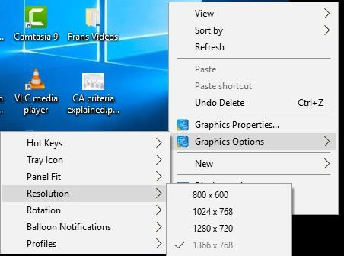

To set/change the screen resolution of a 24 Inch or bigger monitor on Windows XP / -NT or latest release:

1. Right-click anywhere on your Windows Desktop
2. Choose Properties (bottom of pop-up menu)
3. Click Settings Tab (last tab page)
4. Click and drag the bar at Screen Resolution to 1920 x 1080 Pixels
5. Click the OK button

**2**

1. Log in page

To access Integrator you need the use of Internet Explorer and Java 1.8 version 152 and higher (32 bit). Using your browser, use the URL relevant to your institution or link from the institutions’ local Intranet. You will be prompted for your user name and password. Username and passwords are set up in User Access Definitions {USERS-5} and maintained by the institution. A user can have multiple logins with the same user ID. It is dependent on institution rules and policies.

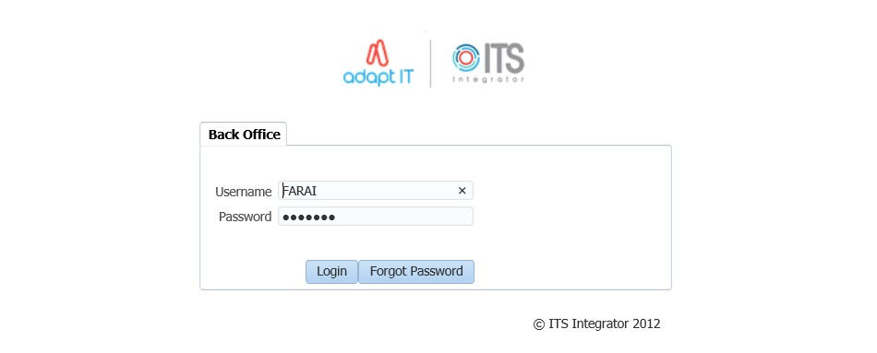

Once the login page has populated; enter your username and password. Select the ‘’login’’ button to gain access into the system.

After logging in, the Integrator Entry Screen will display.

**3**

1. Integrator Entry Screen

# 3.1Landing page

After logging into the Integrator Back Office System the Integrator Entry Screen will display:

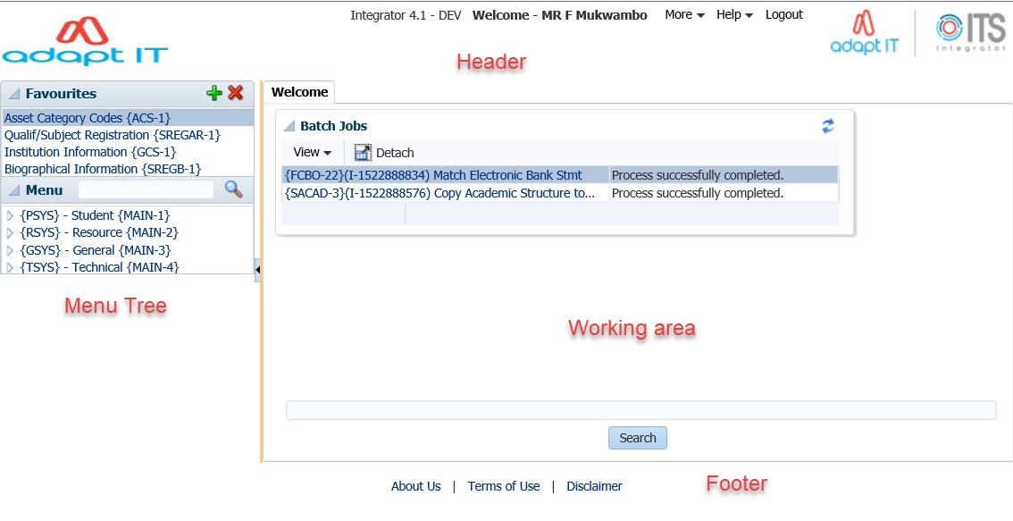

The Integrator Entry Screen is the gateway to the full ITS Integrator Back Office System as is made up of 4 sections: *Header, Main Menu Bar, Work Area, Welcome* and *Footer*.

|  |  |  |
| --- | --- | --- |
| **Display** | **Where on Screen** | **Detail** |
| **Header** | Top | This area contains the following:   * The Institution's Logo. This must be saved in the web/images directory as InsImg.jpg with dimensions of 125x56 * The user who logged in * "Home - Back Office" button which returns the user to the Integrator Entry Screen * "Logout" button which logs the user out of Integrator |

|  |  |  |
| --- | --- | --- |
| **Display** | **Where on Screen** | **Detail** |
|  |  | * "More" button which gives the user access to the following: o Change Password o Favourites o Batch o Worklist o Abort * "Help" button which gives the user access to the following: o Manuals - Gives the user access to the online Integrator help manuals   o Contacts - This will contain information for the  person/department at the institution that is responsible for the Integrator system |
| **Main**  **Menu Bar** | Left Side | The Main Menu Bar consists of two parts:   * Favourites - Will list all of the menus that the user has selected as favourites * Menu - Will allow the user to use the menu tree to get to the required menu. |
| **Welcome** | Middle &  Right side | This part contains a search field that allow the user to search for the relevant menu that they require. The user can either search using the menu code and/or option, or for the name of the option |
| **Footer** | Bottom | This area contains the following links:   * Adapt IT Group. All Rights Reserved - Will redirect the user to an Adapt IT page * About Us - The Institution can link this to their home page * Terms of Use - The Institution can link their terms of use * Disclaimer - The Institution can link their disclaimer |

**Search:**

The searching of a menu/option now works differently to the forms based version of Integrator. The system will return all menus/options that contain the search criteria.

# 3.2Navigation to a menu option

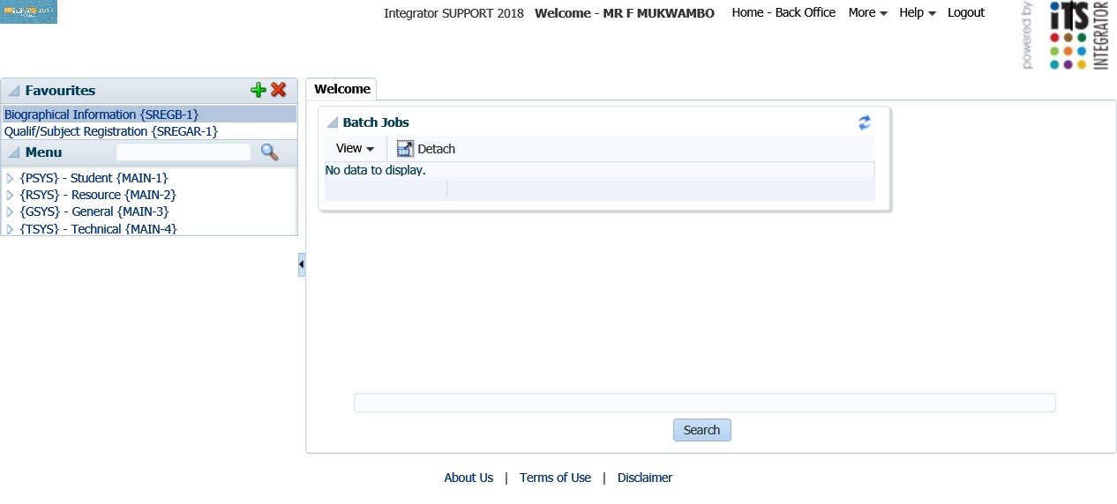

ITS Integrator 4.1 has two ways in which one can navigate to the menu options. The first can be seen on the main menu bar (left hand side) and the ‘’welcome’’ panel box.

Once the menu option has been inserted and the ‘’magnifying glass’’ selected; the menu search panel box will return all menus/options that contain the search criteria.

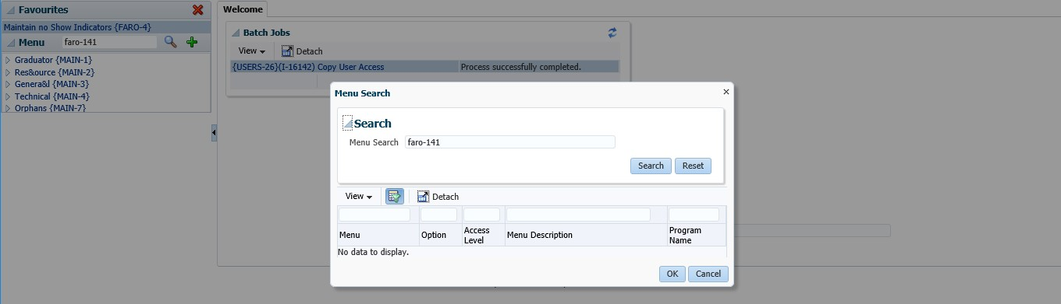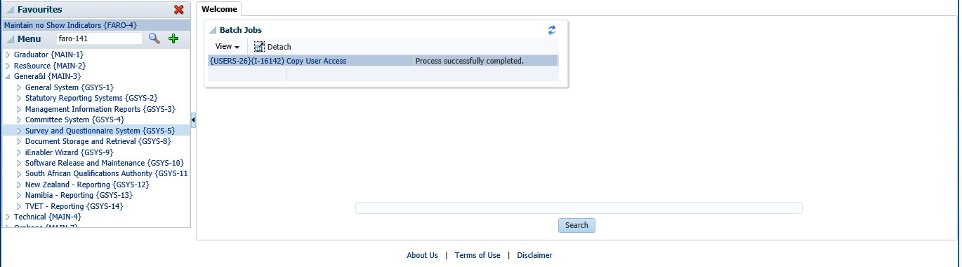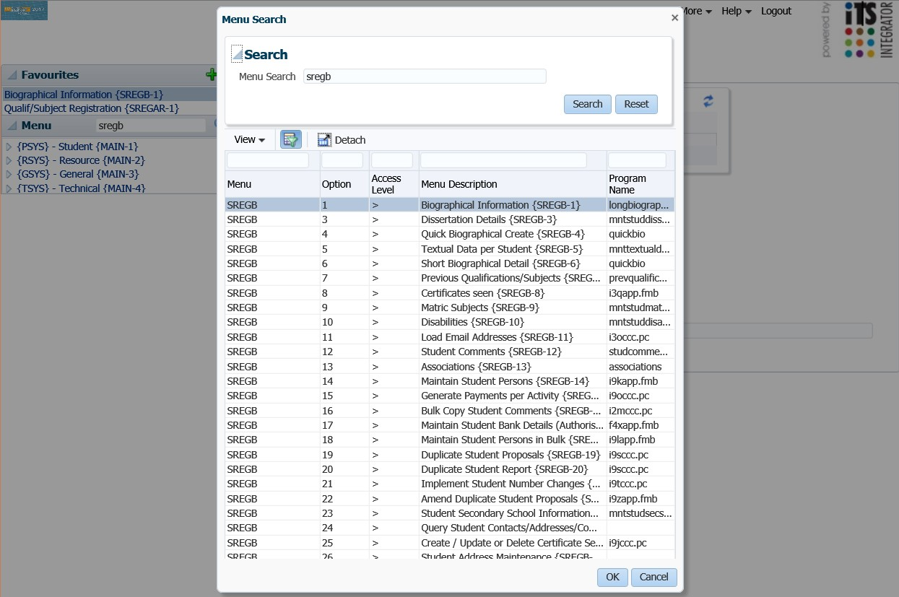

Alternatively, one can also use the tree search functionality to find the menu option desired



# 3.3Adding Favourites

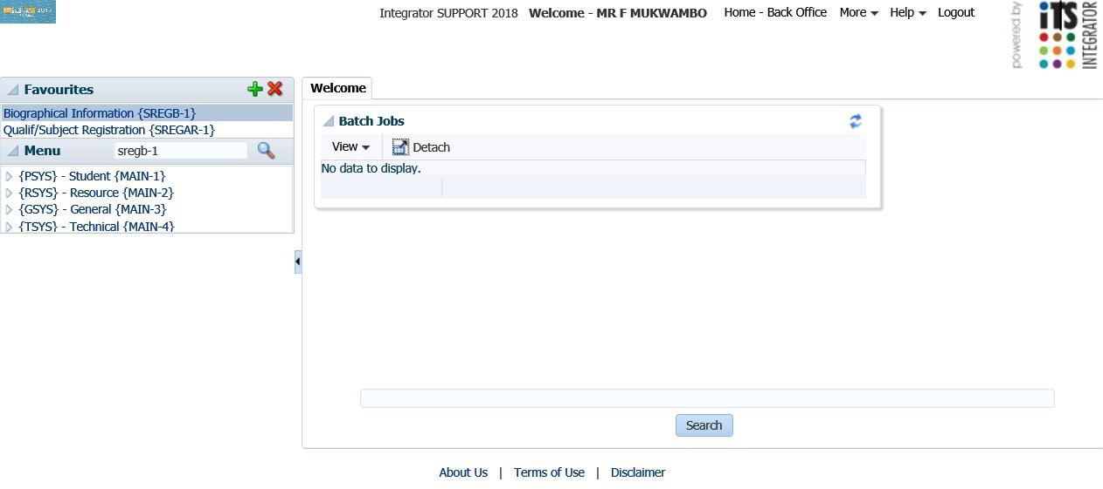

**3**

**1**

**2**

1. Open the desired menu
2. Click on the plus (+) button
3. Once this complete, the menu option will be added under the ‘’favourites’’ panel box

# **MODULE 4**

1. Accessing online help

On the Header; click on ‘’Help’’ and a dropdown with the options ‘’Manuals or About’’ will populate.

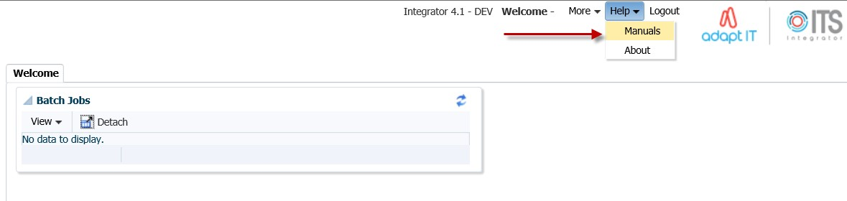

Select the Manuals option and the online help manual will display.

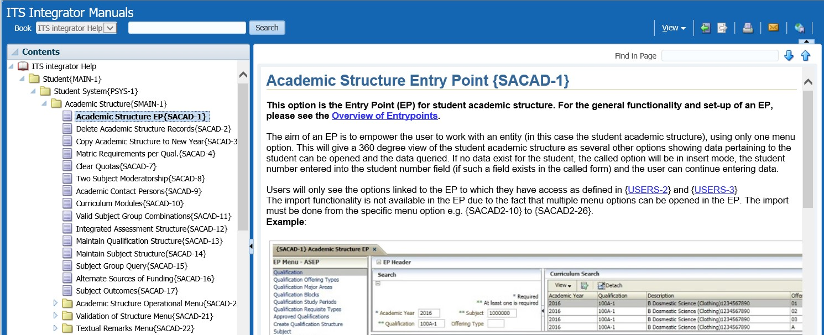

**5**

1. Accessing the Work list and Batch process

## 5.1 Introduction

On the Header; the ‘’More’’ tab can be selected. Once selected a dropdown with the options ‘’change password, favourites, batch, work list and abort option’’ will populate. Select the batch or work list option.

5.2

Running a batch program

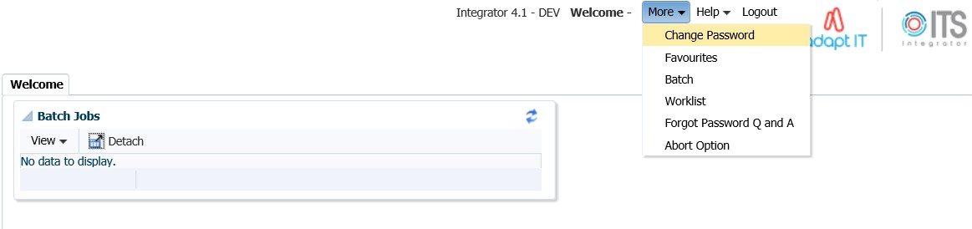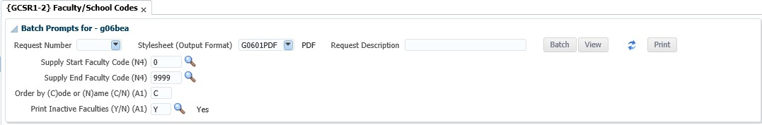

**1**

**2**

**3**

These are steps to follow when running a batch program report:

1. Select the output format
2. Press Tab to see more parameters and activate the batch butoon
3. Click on Batch

This is what the screen looks like once the report has run

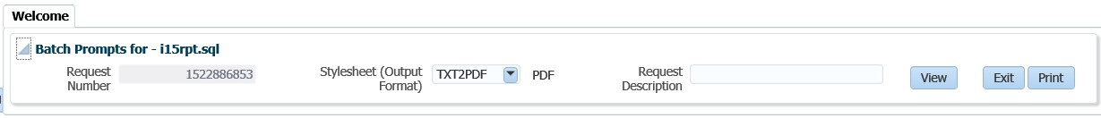

**1**

2

These are the steps to follow when running a batch program report:

1. Click on View to view the output in a browser tab 2. Click on Print to print through the system (unix)

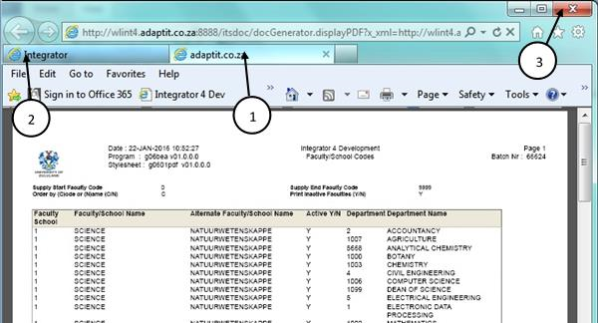

1. The output opens in a separate browser tab
2. Choose the original tab to navigate back to the system
3. Note: Do not close the Browser Window as it will close the whole session

**6**

6Reports

## 6.1 Introduction

The ITS Integrator 4.1 have been converted to Jasper which is a reporting and Business Intelligence tool.

## 6.2 Jasper Reports

The infrastructure for the integration of Jasper reports is now in place on the Integrator 4.1 backoffice application.

* The first set of reports to be converted is based on the use of .RDF Technology
* Soft Transition
* Internal/External reports o Parameter display

o

Headings

•

Report Formats

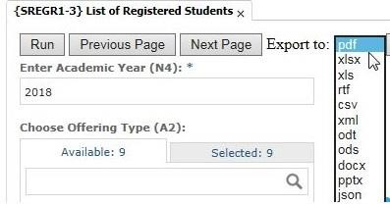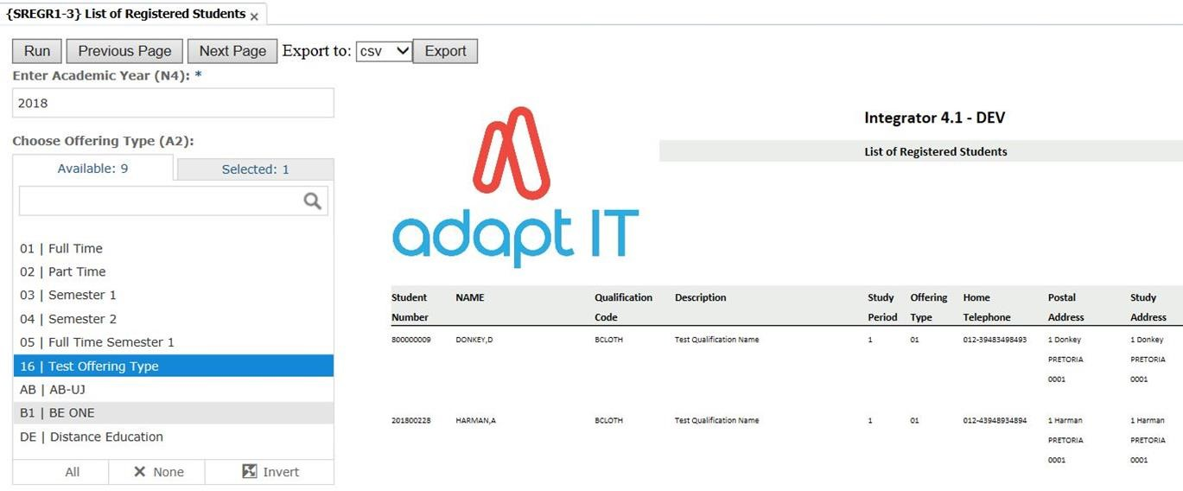

**[1]**

7Forms

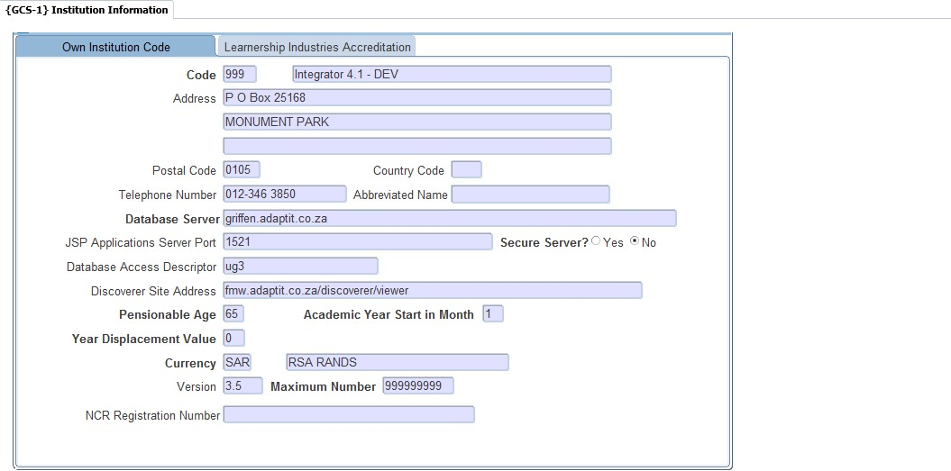

## 7.2 Specific Rules Related to Forms Programs

1. Add the URL to run in Compatibility View

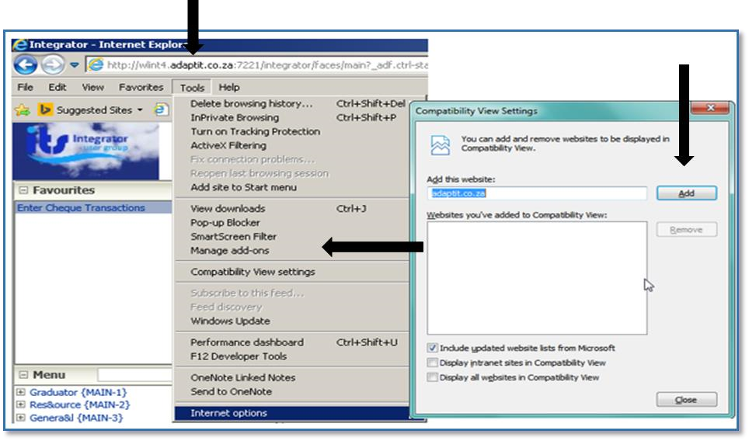

1. Add the Server to the Trusted Sites

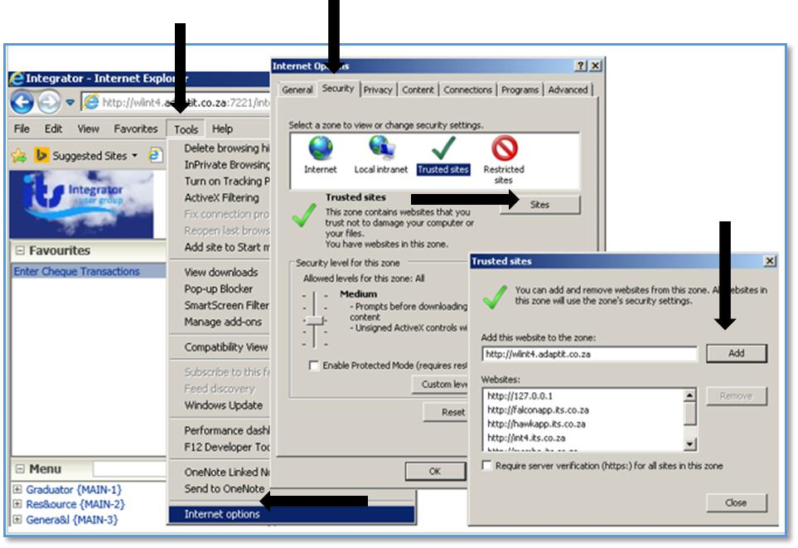

1. Select the Tools options → Internet Options →Security → Trusted Sites → Sites → Entre URL → Add

## 7.3 Specific Rules Related to Forms Programs

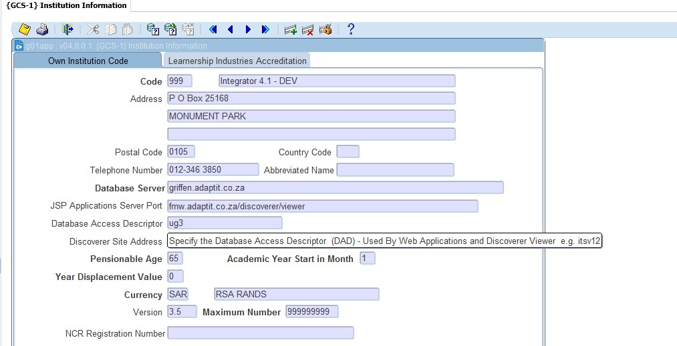

**1**

**2**

1. Always Exit using the “Exit” icon (Green Door iCon).

*Refrain from using the “Home – Back-Office” link in the header, unless the forms program does not open or is stuck due to Java 1.8 not being set-up correctly on the user’s PC or laptop.*

1. Always use the “Enter Query” icon.

**Please note:** The use of the F11 – key for “Enter Query” and other keystrokes is discouraged because browsers have their own ways of handling keys.

# **MODULE 8**

8Screen Patterns

## 8.1 Introduction

Different screen patterns are identified. The screen types used are based on the type of interaction and the number of records accessed.

## 8.2 Entry Point (EP)

The aim of an EP is to empower the user to work with the Academic structure using only one menu option. This is described using the Academic Structure Entry point {SACAD-1} as an example. Users will only see the menu options linked to the EP to which they have access.

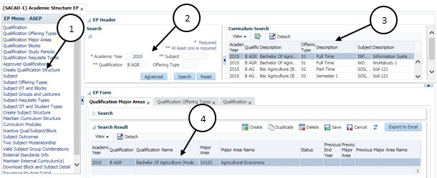

1. The EP Menu controls access to the individual options
2. Search Panel for entry of Search criteria
3. Search Results presented in table format
   * The user should click on the “Detach” icon to see the complete information in table format without scrolling up and down as shown below
   * Click on the “Detach” button to return back to previous Form.

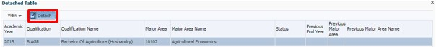

1. EP Form displays Qualification/Subject with focus as per selected EP control

## 8.3 Simple Codes Table (TCS)

Simple codes table without a Search Panel, E.g. Work/Shift Patterns {COOPC-27}.

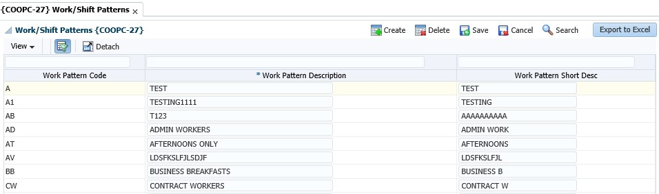

2



3



1



4

1. Create button can be used to create a new record and the empty row will display.
2. Data is presented in an updatable table format.
3. The User can click on the “Detach” icon for better view of data
4. Export to Excel button

* Always allows Read (Query) and at least one of Create, Update or Delete operation
* Information is queried automatically
* Record level validations only, or, simple field level validations
* No cross-field dependencies
* Low volume of records and < 10 fields

## 8.4 Table with Search Panel (TCM)

Simple table with a Search Panel, for small to medium size CRUD, e.g. Certificates Seen {SREGB-8}

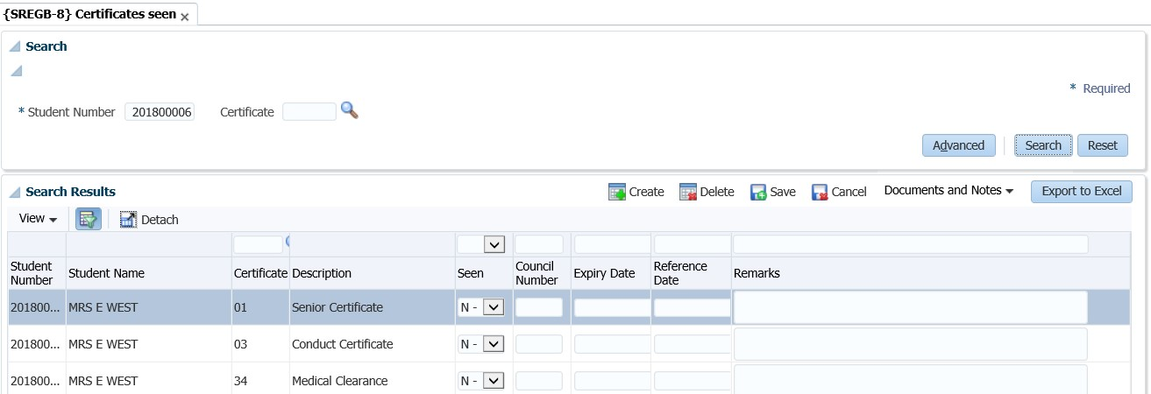

* Always allows Read (Query) and at least one of Create, Update or Delete operation
* No automatic querying
* Possible cross-field dependencies and complex validations
* Less than 30 fields

## 8.5 Multiple tables/Columns with Search Panel (TCL)

CRUD Table (one or more) with collapsible column groups or column hiding and Search Panel for Large size CRUD e.g. Curriculum {SACADO-17}

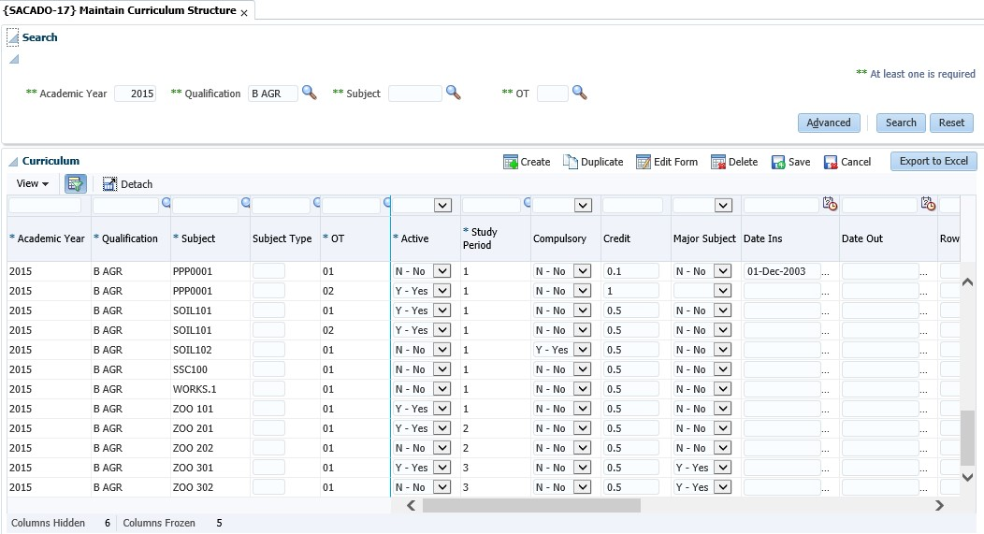

1



4



2



3

1. Search Panel where the user can type in the query criteria
2. Search Results is displayed in the table format
3. Export to Excel button
4. The information on the table can be detached for better viewing of the information presented in the table format

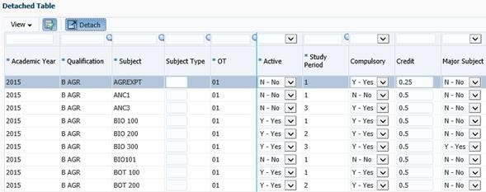

* Always allows Read (Query) and at least one of Create, Update or Delete operation
* No automatic querying
* Possible cross-field dependencies and complex validations
* More than 30 columns.

## 8.6 Search panel with results in query-only table (TQ)

Query

-

only e.g. Query Student Account {FSAO

-

7}

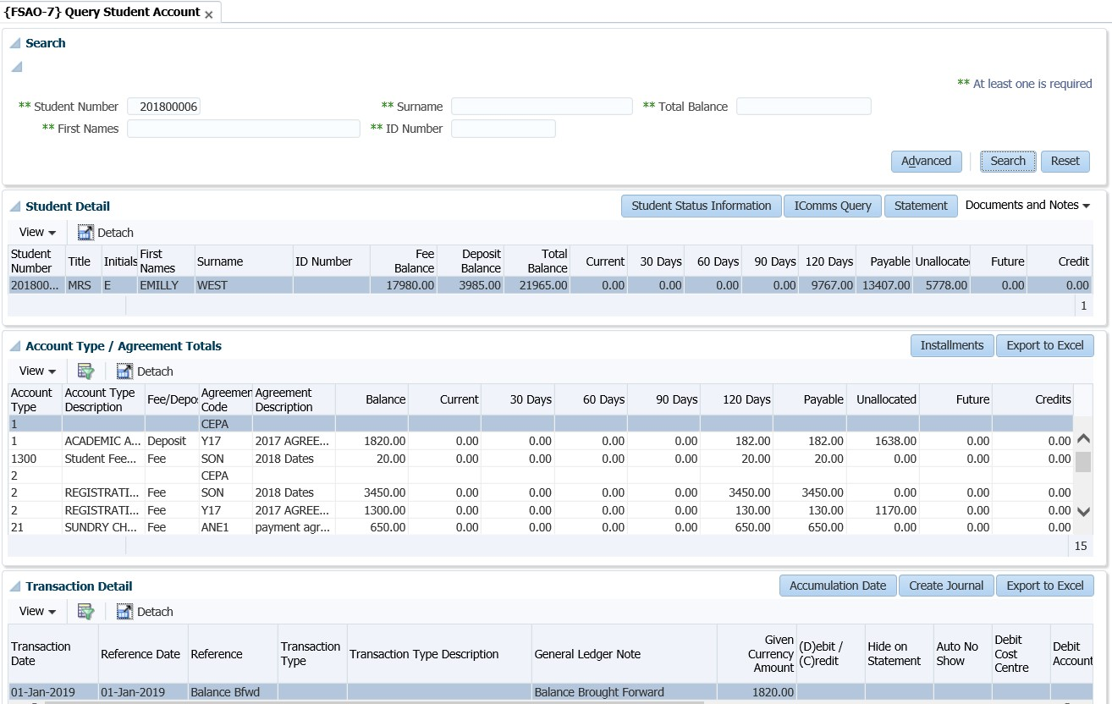

* Always allows Read (Query) and at least one of Create, Update or Delete operation
* No automatic querying
* Possible cross-field dependencies and complex validations
* Less than 30 Columns in table

## 8.7 Search panel with results in query-only tree table (TT)

Query

-

only e.g. Revenue Expense Query {FGLO

-

10}

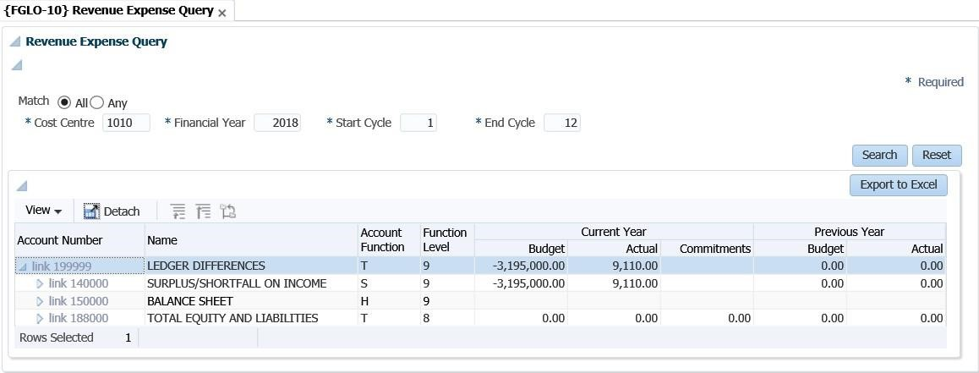

## 8.8 Search Panel, Search Results Table with CRUD Form at the bottom(FCM)

Small to medium size CRUD e.g. Curriculum {PBOP-8}

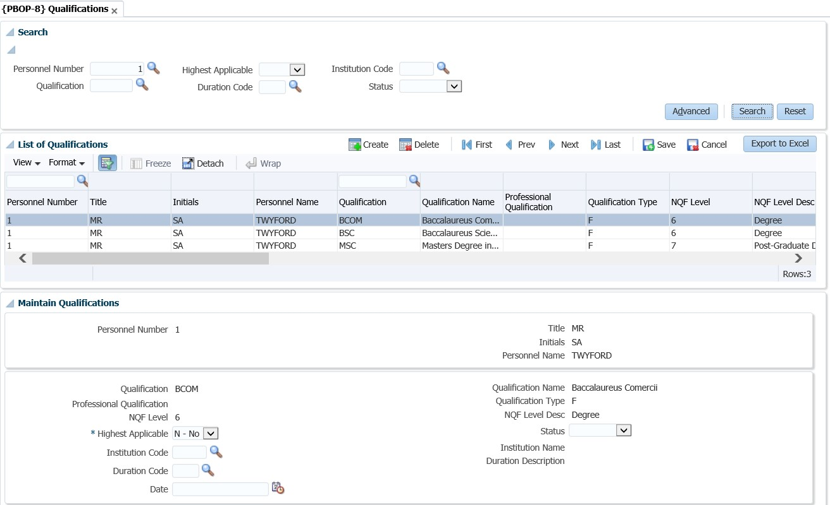

* Always allows Read (Query) and at least one of Create, Update or Delete operation
* No automatic querying
* Possible cross-field dependencies and complex validations
* Less than 30 Columns in table

## 8.9 Search Panel, Search Results Table (one or more) with pop-up CRUD Form (FCM-PC)

Small to medium size CRUD e.g. Query Student Account {FSAO-7}.

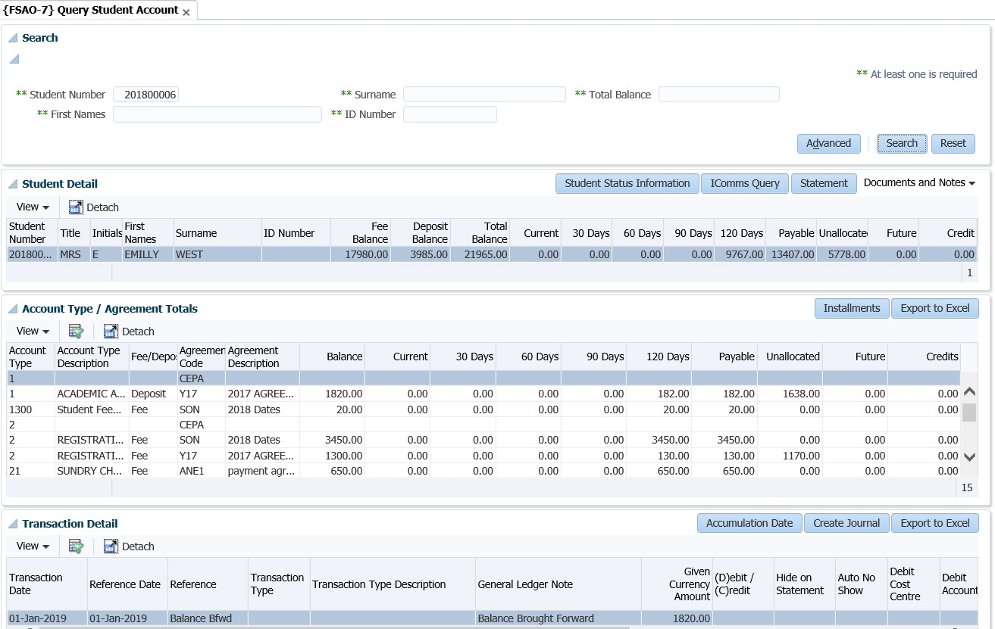

* Always allows Read (Query) and at least one of Create, Update or Delete operation
* No automatic querying
* Possible cross-field dependencies and complex validations
* Less than 30 Columns in table

## 8.10 CRUD Form with Search pop-up or Search Panel (FCL)

Large size CRUD e.g. Query Student Account {FSAO-1} or Define and Maintain Subject {SACADO-10}.

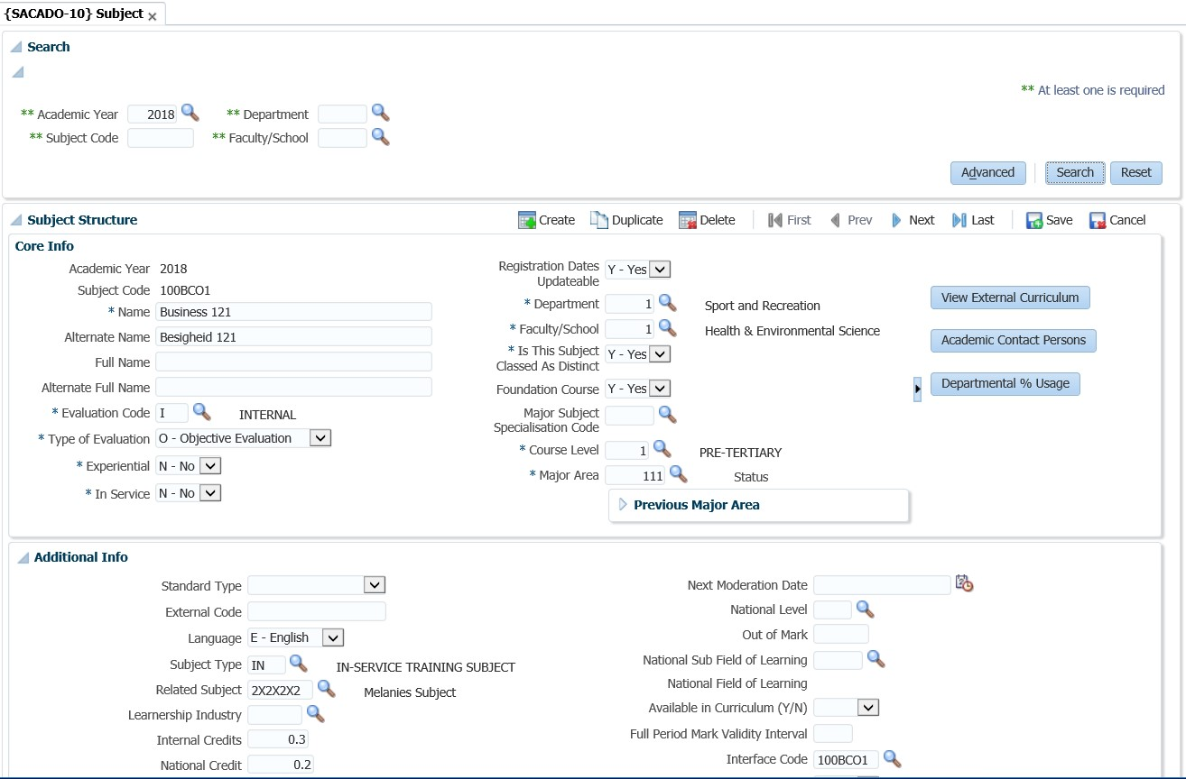

* Always allows Read (Query) and at least one of Create, Update or Delete operation
* No automatic querying
* Possible cross-field dependencies and complex validations
* More than 30 Columns in table

## 8.11 Search Panel with Search Result Table and CRUD Form on different page (FCL-TSL)

Large size CRUD e.g. Post Establishment {PPEO

-

1}

.

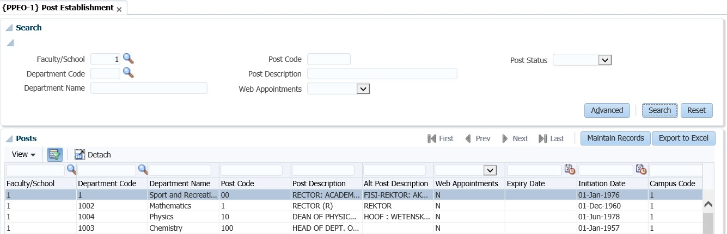

* Always allows Read (Query) and at least one of Create, Update or Delete operation
* No automatic querying
* Possible cross-field dependencies and complex validations
* More than 30 Columns in table

## 8.12 Create only Form (FCO)

Create-Only *e.g. Bank Statement Reconciliation {FCBO-4}*

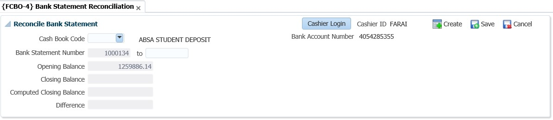

# **MODULE 9**

9The Search Dialogue

To search; select the ‘search’ option on the right hand side of the screen. Once selected, the ‘Search dialog’ box will populate. Various search criteria’s can be supplied to access the data desired.

An advanced search option is also available.

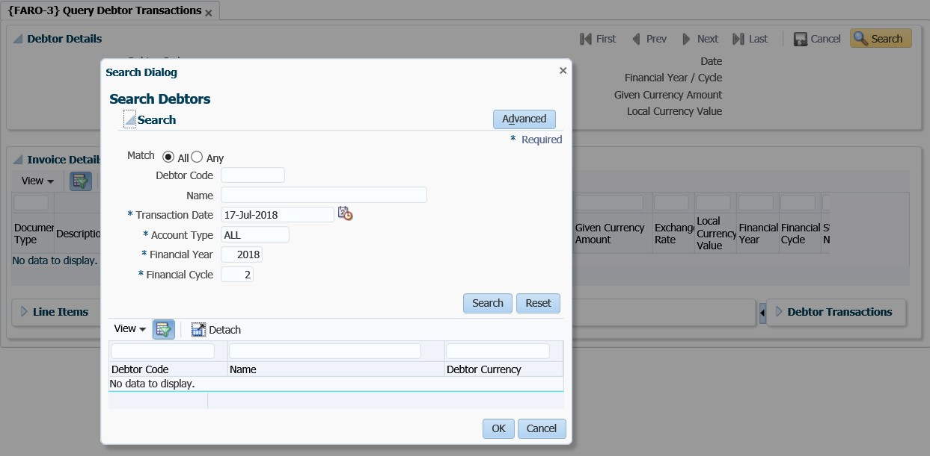

Once the advance search option has been selected; a number of search fields will populate. On the list of fields available, you can choose the field applicable to your Institute or department filter, for future searches.

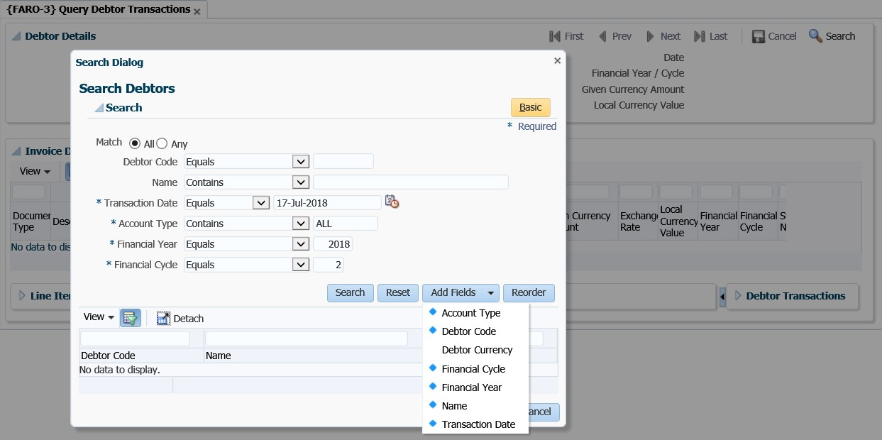

## 9.1 Search Panel, Search Results Table with Form at the bottom

Each menu has got different panel boxes available on one page. Most Panel boxes comprise of the Search panel, the Search results panel and the forms at the bottom of the page.

{

PBOP

-

8

}

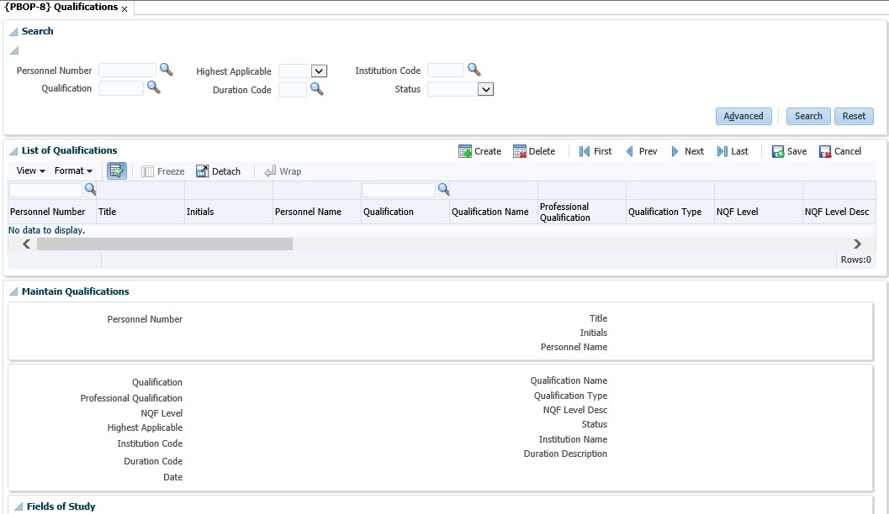

Search Panel

Results Table

Maintenance

Form

### 9.1.1 Search Panel

Fields that appear here are only used to “Search”, in other words, they are “Query Criteria”.

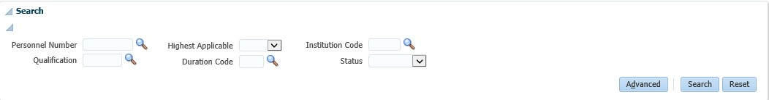

**Search** will search the database for records that match the “Search – Criteria” and display them in the Results Table. Clicking Search when all the fields in the Search Panel is blank (or null), will return all records, otherwise only those that match the fields in the Search Panel. It can be closed by clicking on the Disclose / Close icon

**Advanced** allows the user to “Search” in an advanced way and/or to add fields to the Search Panel

**Reset** will only make the value fields in the Search Panel blank (or empty or null), it will not clear the Results Table or the Form at the bottom.

### 9.1.2 Results Table

In this User Interface Pattern, data in the Results Table cannot be updated. The record selected here will be available in the Form for update purposes

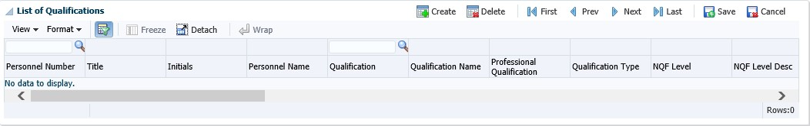

**Delete** will delete the selected record (It only becomes effective in the database after clicking Save)

**Create** will create a new record with blank fields. (It will be available in the Form to complete and it only created in the database after clicking Save)

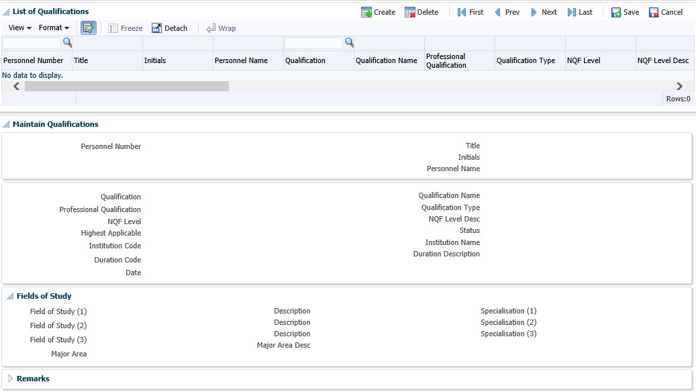

1

**2**

**3**

1. Menu Bar above the Results Table
2. Close / Disclose icon to hide or open Panel Box
3. Combo Box List

## 9.2 Search Panel, Search Results Table, Form on different page

Post Establishment {PPEO-1}

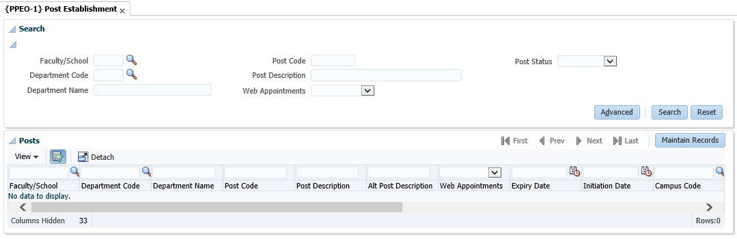

**1**

1. The same as the previous pattern, but use Toolbar Buttons to navigate between the Search Panel / Search Results and the Maintenance Form

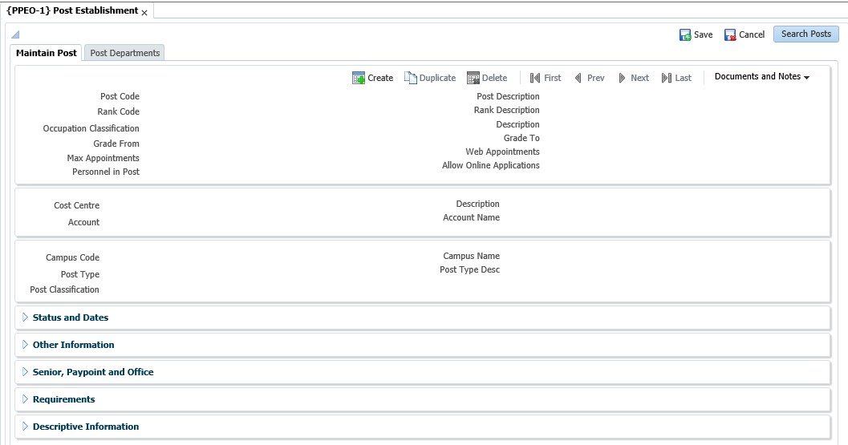

**1**

**2**

1. Navigation back to Search Panel and Results Table
2. These Panel Boxes are closed by default and can be disclosed using the Close / Disclose Buttons

Glossary

|  |  |
| --- | --- |
| **Term** | **Description** |
| CRUD | Create/Read/Update/Delete operations. |
| MPM | Multi-Processing Module |
| Panel Boxes | A Panel Box is used to place ancillary information on a page, offset by a certain colour / border. |
| UI | User Interface |

**Residence iEnabler**

Copyright

©All rights reserved

No part of this document may be reproduced or transmitted in any form or by any means, without express written permission from Adapt IT or an authorised representative of Adapt IT. This includes, but not limited to, electronic, electrostatic, magnetic tape or mechanical copying and recording, or use of any information storage and retrieval system.

Disclaimer

Adapt IT makes no representations or warranties with respect to the contents hereof. Although due care and precaution has been taken in the preparation of this manual, Adapt IT assumes no responsibility for errors and omissions or any damages resulting from the use of the information contained in this publication.

**Contents**

**Course Overview** 1

**Course duration** 1

**Pre-requisite knowledge and skills** 1

**Course content** 1

**Learning outcomes** 1

1.1 Module Structure 2

**System Access** 3

**Logging on to Integrator** 3

**Landing Page** 4

**Navigation** 4

**Exiting a form** 4

**1** **System Overview** 5

1.1 System Requirements 6

1.2 System Overview 6

1.3 System Dependencies 6

1.4 System Setups in the Back Office 7

1.4.1 Maintain System Cycles {SMNT-2} 7

1.4.2 Validation Report/Choice {SMNT-1} 7

1.4.3 Business Functions {STWEBM-1} 9

1.4.4 Business Functions Processes {STWEBM-1} Tab 2: 10

1.4.5 Process Event Code Structure {STWEBM-7} 12

1.4.6 System Operational Definitions (SOD) {SMNT-12} 13

1.4.7 Residence Quotas {SRESIDE-3} 16

1.4.8 Bulk Residence Admission {SRESIDE-16} 16

1.4.9 Excluded students 17

**1.4.10** **Search Criteria** 17

**1.4.11** **Quotas** 19

**1.4.12** **Buttons** 19

**1.4.13** **Detail Fields** 20

1.4.14 Residence Registration Rules {SRESIDE-2} 26

1.4.15 Processing Rules 28

**2** **Residence Application Function** 29

2.1 View/Update Personal Information 30

2.2 Residence Rules and Regulations 30

2.3 Submit Residence Application 31

2.4 Cancel Residence Application 33

**3** **Residence Registration Function** 34

3.1 Residence Registration Rules and Regulations 35

3.2 Submit Residence Registration 36

3.3 Residence Proof of Registration 38

**4** **Student Enquiry Function** 40

4.1 Residence Admission Status 41

**5** **Operational Issues** 42

**6** **Residence iEnabler Implementation – Responsible User** 47

**Acronyms, Glossary & Terminology** 49

**Acronyms** 49

**Glossary** 50

**Terminology** 51

**Help us enhance the course** 53

**Need help?** 54

**Course Overview**

Welcome to the Residence iEnabler course for Integrator 4.1. This course is designed to equip you with the skills and knowledge you need to be able to use Residence Application and Registration iEnabler.

**Course duration**

3 days

**Pre-requisite knowledge and skills**

Before you can register for this course, you must have successfully completed the ITS Integrator Interface Training course or at least be familiar with the Integrator system.

**Course content**

The course is divided into modules and covers the following topics:

|  |  |
| --- | --- |
| **Subsystem** | **Modules** |
| Residence iEnabler Subsystem | * System Overview * System Requirements * Residence Application Function * Residence Registration Function * Student Enquiry Function * Operational Issues |

**Learning outcomes**

On completion of this course, the trainee should be able to:

* Know which setups has to be in place in order to make the Residence Registration iEnabler run smoothly.
* Understand the business function process.
* Know how to capture new records and update existing records on the Residence iEnabler.
* Know about all the options that exist on the Residence iEnabler.

## Module Structure

Each module contains the following parts:

**Specific outcomes**

The specific outcomes are very important because they state what is expected of you.

**Introduction**

Each module starts with a statement of the content and learning outcomes for that module in order to introduce you to the subject matter of the module. Suggested time allocation is also indicated. Bear in mind that the time allocation is only a guide and some people will take longer than others to complete the same task. The timeframe can also be longer if you choose to look up content from other resources.

**Content**

Module content consists of information moving from system pre-requisites to operational and menu management issues. The content is subdivided into topics, tasks, procedures and other information arranged in a logical sequence and broken down into small, connected and understandable units. This content can be supplemented by support materials such as PowerPoint presentations, worksheets, hand-outs, etc.

**Acronyms, Glossary and Terminology**

As far as possible, the workbook uses clear and non-technical language. However, it is inevitable that you will be introduced to new terminology or be faced with the use of acronyms to describe or explain the contents of this manual. All terminology and/or acronyms used will be explained in the content, but you will also find separate structured tables at the end of this manual.

**System Access**

**Logging on to Integrator**

To access Integrator you need the use of Internet Explorer. Using your browser, use the URL relevant to your institution or link from the institutions’ local Intranet. You will be prompted for your user name and password. Username and passwords are set up in User Access Definitions {USERS-5} and maintained by the institution. A user can have multiple logins with the same user ID. It is dependent on institution rules and policies. Additionally, unsuccessful logging attempts might be limited to a specific number depending on the institution’s policy.

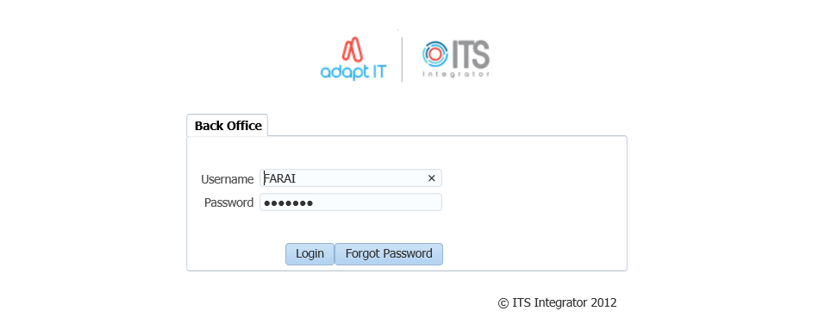

1. Type in your username and password
2. Click on the Login button

**Landing Page**

After logging into the Integrator Back Office System, the Integrator Entry Screen will display. The Integrator Entry Screen is the gateway to the full Integrator Back Office System and consists of four sections: Header, Main Menu Bar, Work Area, Welcome and Footer.



**Navigation**

Integrator 4.1 requires that you use the mouse to move from one field to another. In previous versions, the user could navigate between fields using the Tab and Enter keys. However, the new ADF technology operates in a browser and shortcut keys do not always give the intended output.

**Exiting a form**

Use the Green door  (old forms) or the black cross   (new ADF forms) to exit forms programs in Integrator 4.1.

The Abort Option button is only for emergencies in the event of a menu option hanging.



**MODULE**

**1**

# **System Overview**



Specific outcomes

On completion of this module, you will be able to:

* Maintain System Cycles
* Validate Report/Choice
* Maintain Business Functions
* Setup Business Function Processes
* Process Events Code Structure
* Update the Alpha/Date or Numeric fields

## System Requirements

* Internet Service Provider
* An Oracle Application Server
* A web address

## System Overview

The Residence iEnabler System has been developed to allow prospective and current students to apply and register for hostel accommodation via either the Internet or the Intranet of the institution. Current functionalities include:

* Residence Application
  + View/Update Personal Information
  + Residence Rules and Regulations
  + Submit Residence Application
  + Cancel Residence Application
* Residence Registration
  + Residence Registration Rules and Regulations
  + Submit Residence Registration
  + Residence Proof of Registration
  + Proof of Residence
* Student Enquiry
* Residence Admission Status

## System Dependencies

The residence application/registration process is directly dependent on the following setups in the Back Office:

* Business processes and steps as defined in {STWEBM-1} {STWEBM-2} and {USERS-1}
* Process Event Code structure in {STWEBM-7}
* Several validations that is turned on or off in {SMNT-1} Tab: Validation Control
* System Operational Definitions (SOD’s) in {SMNT-12}
* Definition of Residence Registration Rules in {SRESIDE-2}
* Ensure “W1” batch queue is opened in {BATCH-3}, block 2 – Active Queue Processes
* System Cycles {SMNT-2}
* Census Dates {GOPS-1}
* External Conversion Codes for External Body “INE”, External Code “077” (Rules and Regulations)–{GOPS-21}
* Residence Fee structure in {FSAM-1} and {FSAC-21}
* Accurate and updated information of Asset Register {AOPS-1}
* Document Group for Proof of Registration {GMNT-14}
* Report output for Proof of Registration {USERS-11}
* Bulk residence admission {SRESIDE-16}

The Residence Registration process can only be used by students:

* with an admitted residence application status in {SRESIDE-11}
* that is academically registered for a non-exam only block code on qualification level
* that complies with the rules as set up in {SRESIDE-2} as per the institutions rules and regulations document

System setups dependencies on {SRESIDE-2}:

* Residence buildings must be defined with aggregate code = 9 in {SPCS-4}
* Residence buildings, floors and rooms must be defined in {SPOPS-1} with:
* category 1900 to 1999
* the correct number of stations
* Campus code must be linked to offering type code in {GCS-5}
* Qualification codes must be correctly linked to Approved Qualification codes and Approved Qualification codes must be correctly linked to Qualification Types. Qualification and Approved Qualification codes are defined {SACAD-13} and Qualification Types in {SCODE3-1}

## System Setups in the Back Office

### Maintain System Cycles {SMNT-2}

Control cycles allow the user to limit the use of specific functions within the system to certain time windows during the year, and form an important part of the security of the system.

Even during the time of interval between the specified dates the user will be limited to creating records in respect of the specified years and academic blocks only.

**The following System Cycle types are applicable to the Residence iEnabler System:**

* P – Residence Application
* 1 – iEnabler Residence Registration

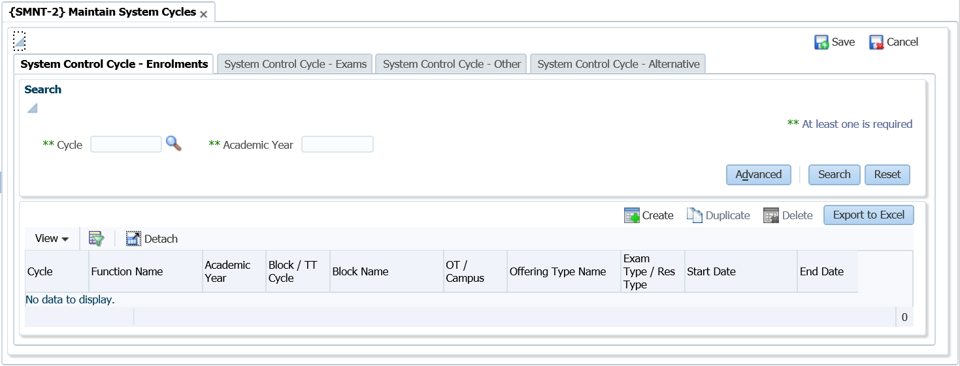

### Validation Report/Choice {SMNT-1}

This option handles two aspects: The control of a number of validations in the system and the control of the printouts that can be produced automatically during registration.

**Note:** Only tab 1 is applicable to the Residence iEnabler

**Validation Control {SMNT-1} Tab 1:**

The available functions are programmed into the system; the user cannot add or delete records but merely activate or de-activate them. The subsystem displayed on the screen is merely there to assist the user in finding the validations applicable to specific subsystems. Any changes to the on/off switches of the validations are written to a log file. The log file can be viewed by using option {SMNTL-5}.

The following validations apply to the Residence iEnabler:

* AH – Residence Application on Academic Application
  + The system will not allow the Residence Application for any students unless they were entered through option {[SNAPPA-1](http://hawkapp.its.co.za:7772/itshelp/help/topics/itshelp/documents/snappa-1.html)}, or admitted to the institution through option {[SNAPPA-3](http://hawkapp.its.co.za:7772/itshelp/help/topics/itshelp/documents/snappa-3.html)}

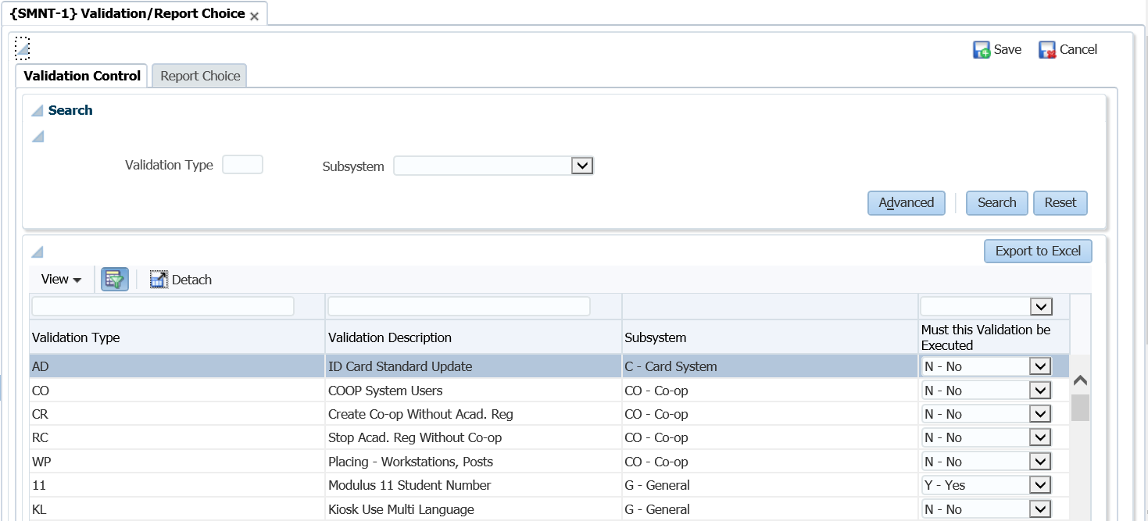

* AR – Academic Registration on Residence Registration
  + If the validation is set to ‘Yes’, no residence registration will be permitted unless the student has been registered academically

**Note:** If the rules in {SRESIDE-2} are activated and any of the rules that are active have requirements that are based on qualification registration information, the student will not be able to register in the residence.

* EE – DE Copy Residence Address to Study Address
  + If the validation is set to ‘Yes’, the study address of the student will be changed to the Residence address as defined in {[SPCS-4](http://hawkapp.its.co.za:7772/itshelp/help/topics/itshelp/documents/spcs-4.html)}
* HA – Residence Admission
  + If this validation is set to ‘Yes’, the system will not allow the registration of students in a residence unless they were admitted through option {[SNAPPA-4](http://hawkapp.its.co.za:7772/itshelp/help/topics/itshelp/documents/snappa-4.html)}
* RA – Copy Residence Address to Study Address
  + If this validation is set to ‘Yes’, the study address of the student will be changed to the Residence address, as defined in {[SPCS-4](http://hawkapp.its.co.za:7772/itshelp/help/topics/itshelp/documents/spcs-4.html)}

### Business Functions {STWEBM-1}

This program is used to maintain Business Functions used in the iEnabler Modules to set up a hierarchical structure of different Business Functions options to be accessed by the end user.

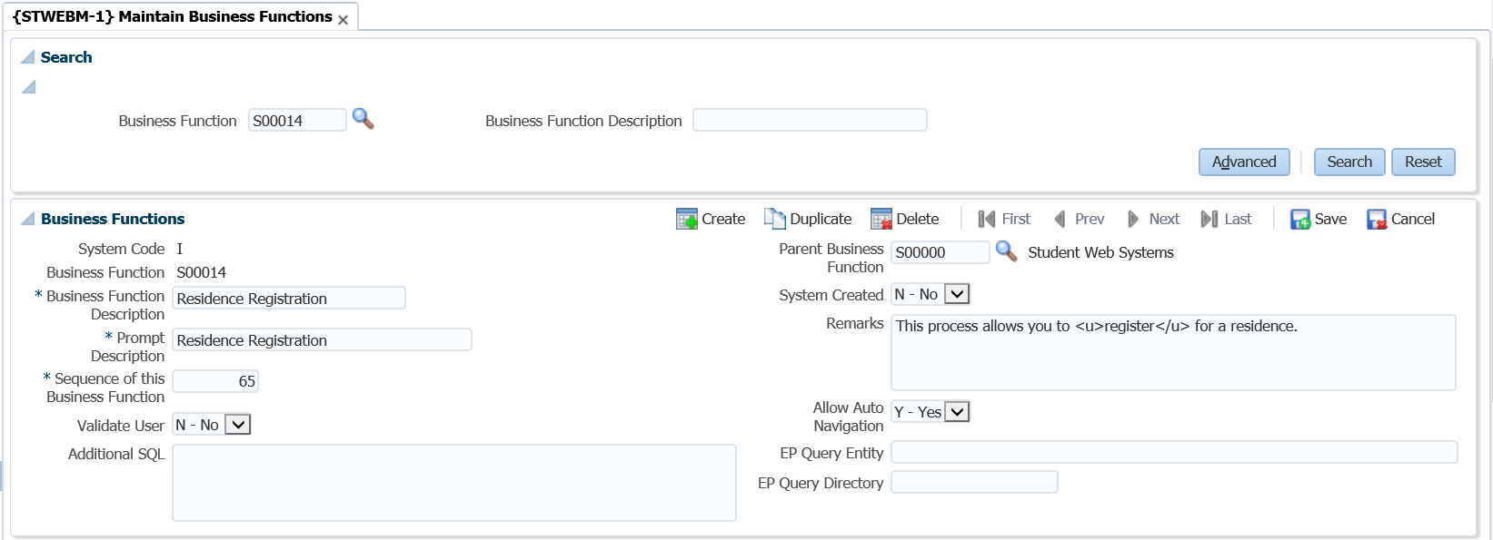

**Field Descriptions:**

**System Code:** The system code for this Business Function will be defaulted into this field. It is dependent on the menu option it is invoked: (I) Student (from STWEBM-1), (P) Personnel (from PWEBM-1).

**Code:** Business Function Code.

**Note:** For Business Functions, that is not "System Created", the Business Function Code should start with "N" or "O".

**Description:** A description for the Business Function.

**Prompt Description:** Enter a description at the prompt for this business function.

* For Business Functions used in the iEnablers, this is the description that will be displayed in the menu frame on the web system for this business function.
* For Business Functions used in Entry Points, this is the description in the left-top frame heading.

**Sequence of this business function:** For the iEnablers, the sequence in which the business function will be displayed within the parent business function supplied, if any. This field does not play a role in Entry Point- and Business Process Driver set-ups

**Validate ITS User:** For the iEnablers, a "Y"es will indicate that the end user should also be defined as a User in the User Access Definitions {USERS-5} before being able to use this Business Function. This field does not play a role in Entry Point- and Business Process Driver set-ups

**Additional SQL:** Not used

**Parent Business Function:** For the iEnablers, this field is used to indicate if the current business function is linked to a parent function, e.g. Application, Residence Application, Registration, etc., linked to S00000-Student Web Systems. This may be used to create the multi-level structure.

**System Created:** If ‘Y’ or ‘M’, the record is part of the standard ITS Software set-ups, may not be deleted and limited fields may be updated, otherwise the user has full control over the record.

**Remarks:** Enter any remarks regarding this Business Process

**Allow Auto Navigation:** For the iEnablers, will Auto Navigation within the Business Process for a particular Business Function be done. This field does not play a role in Entry Point- and Business Process Driver set-ups

**EP Query Entity:** For Entry Points, the name of the EP Query Entity without the extension. This field does not play a role in iEnabler- and Business Process Driver set-ups

**EP Query Directory:** For Entry Points, the directory for the EP Query Entity without the slash. This field does not play a role in iEnabler- and Business Process Driver set-ups

**Note:** Ensure that the following business processes are linked to the parent function S00000 (Student Web Systems):

* S00010 (Residence Application)
* S00014 (Residence Registration)

### Business Functions Processes {STWEBM-1} Tab 2:

This option is used to set up Business Function Processes and link them to the Business Functions as defined in {STWEBM-1}.

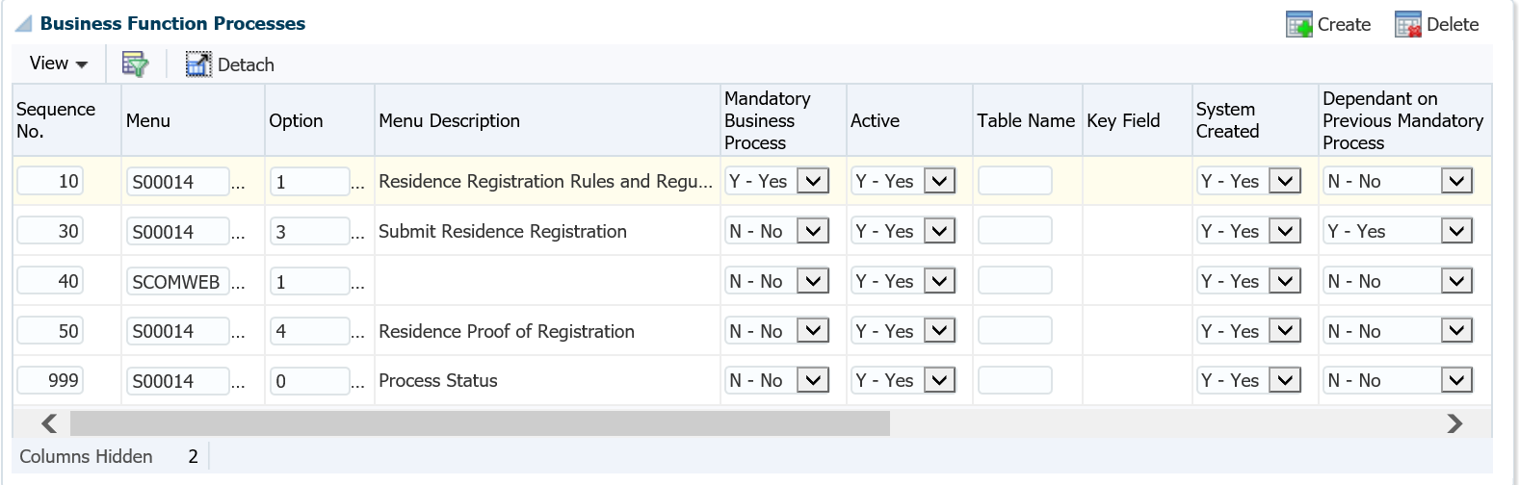

**Field Descriptions:**

**Query a Business Function:** Enter the Business Function to see the detail on the next block – Driver Detail.

**Sequence Nr:** Enter or change the display sequence of this business process in the business function.

**Note:** The number is usually incremented by 10 to leave space for later additions.

**Menu Code:** Enter value for Menu Code, as defined in {USERS-1b1}. This field, together with the Option field, will be used to retrieve the instruction to be executed by this Business Process.

**Option:** Enter value for the Menu Option, as defined in {USERS-1b2}.

**Option Description:** The description linked to the supplied menu code and option, as defined in {USERS-1b2}, will be displayed here.

**Mandatory Business Process:** Is completion of this business process mandatory for the completion of the business Function that it is coupled to?

**Active:** Is this Business Process active? For iEnablers, if this field is "N”, the process will not be available. Processes can be set to Active ="N" for a period and then re-activated when needed. An example of this is exam results that can be made inactive as a rule and only activated when the institution publishes their results.

**Note:** Only non-mandatory Business Processes may be made inactive. To set a mandatory process as inactive, you will first have to change the Business Process to Mandatory "N", before setting the Process Active "N".

**Table Name:** For Business Function Processes used in the Business Process Driver, the table together with the key field may be used to check whether this process has been completed, provided that the process results in the creation of a record in the database. This is only used when the process is defined as Mandatory ‘Y’.

**Key Field:** Enter a Value for key Column Number, as defined in {DMAIN-1b8 (columns)}.

**System Created:** If the system created field = "Y"(for users), then the following fields will not be able to be updated:

* Menu and Option
* Table name and key field.

**Dependant on Previous Mandatory Process:** Is this process dependant on another Mandatory Process?

* If a process is dependent on a previous Mandatory Process, the user will not be allowed to start the process before the dependant process is completed.
* If this field is set to (Y)es, the Dependency Sequence becomes mandatory.

**Dependency Sequence:** The sequence of the mandatory Business Process that must be completed before this option can be utilised.

**Additional SQL:** The Additional SQL Field also plays a role in restricting the count that is done to determine whether a mandatory business process was completed, if necessary. An example of adding Additional SQL would be adding Additional SQL to the "Application" Business Process as follows: Table Name would be "IER" (IERAAD), Key Field would be "1" (IAESTNO) and Additional SQL could be "IERCYR >= to_char(sysdate,'YYYY')". The resultant query will be built as: select count (ierstno) from ieraad where ierstno = v_unum and IERCYR >= to_char(sysdate,'YYYY'); The Additional SQL will make sure that the application records counted are only for the current and future years.

**Validation Rule:** Supply the rule that contains the validation for the step.

**Client Responsibility:**

* + As with all other iEnabler business processes it is the client’s responsibility that the options are linked to the business process in the correct sequence.
  + The user can link any other pages or programs to the business process in the desired sequence.
  + Indicate mandatory steps and dependencies.



**Note:** {STWEBM-2} Ensure that a minimum of the following steps are linked and is active for the business process:

| **Business Step** | **Program Name** | **Default Option** |
| --- | --- | --- |
| Residence Registration Rules and Regulations | w0004lll.w0004res_reg_rules | S00014-1 |
| Submit Residence Registration | ws18pkg.ws18_lst_frm | S00014-3 |
| Process Status | w99pkg.mi_bf_stats?x_busfct=S00014 | S00014-0 |

### Process Event Code Structure {STWEBM-7}

This option is used to define institutional specific parameters for a specific business process accessed via the iEnabler or an option executed via the back office, e.g. to indicate certificate codes to be inserted in the back-office system when the iEnabler user access a business process or to specify the number of unsuccessful login attempts.

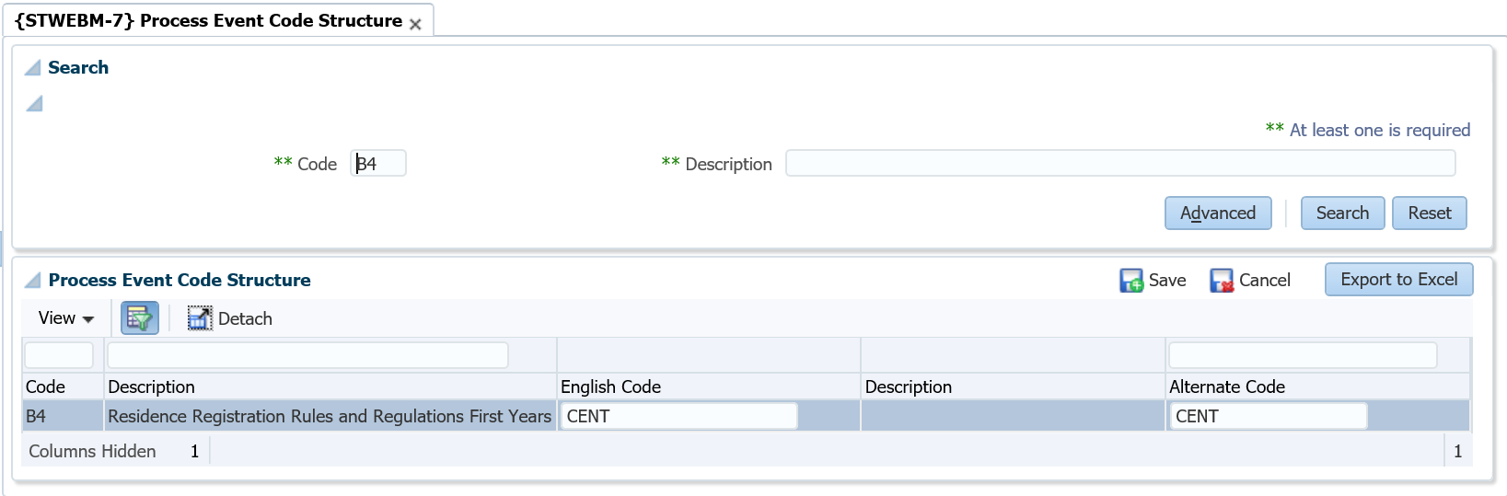

**Field Descriptions:**

**Code:** System created code(s) to be used in the iEnabler

**Code Description:** Description of the system created code

**English Code / Alternate Code:** The English Code and Alternate Code can be from different code structures. Letter codes can be entered in the English Code field or the Alternate Code field. The iEnabler user will be able to view the content of the letter on the iEnabler when the business process is accessed. If an institution prefers detail to be displayed according to the preferred language of the student the Alternate Code must be entered. These Process Event Codes are listed under the heading 'Letters' below.

* Some Process Event Codes are used to link certificate codes or indicators to students and those must be entered in the English Code field. These codes are listed under the heading 'Indicators' below.
* Other Process Event Codes control the display options and specific default values. These Process Event Codes are listed under 'Miscellaneous Events' below.

**Letters**: The letters displayed on the Web will depend on the student's preferred language. If the preferred language is not English but an Alternate Letter Code was not defined, the English letter will be displayed.

**The following codes must be linked to document codes, as defined in {GMNT-14}:**

* B1 – Residence Application Rules and Regulations
* B3 – Residence Application Contract Letter
* B4 – Residence Registration Rules and Regulations
  + Set both the English and Alternate codes to the appropriate document codes as defined in {GMNT-14}
  + When the student clicks on the ‘Rules and Regulations’ link, the system will display the document according to the student’s preferred language
* B6 – Residence Registration Contract Letter

**Indicators:** The following event codes are used to link certificate- or indicator codes from {SCODE-22} to students. These indicator codes must be entered in the English Code column.

* B2 – Residence Application Certificate Indicator
  + A certificate code as defined in {SCODE-22}, must be linked to Event Code ‘B2’. A record will be inserted in {SREGB-8} with an indicator seen set to ‘No’.
* B5 – Residence Registration Certificate Indicator
  + Set the English Code to the certificate indicator code for accepting the Rules and Regulations
  + When the student clicks on the ‘Rules and Regulations’ link and the certificate code is not linked to the student an ‘I Accept’ button will display on the page. When the student clicks the button, this certificate code will be linked to the student with the ‘Seen’ indicator set to ‘Yes’.

**Miscellaneous Events:** These codes control miscellaneous events like specific default values and display options.

* A8 – WR Status End Date
  + To indicate the end date to be linked to the student record on {STWEBM-9} when {STWEBM-3} is run to link statuses to students for iEnabler registrations
* ET – Expiry Time
  + To indicate the expired time for a session with no activity on the iEnabler.
* LA – Number of unsuccessful login attempts
  + Both English and Alternate codes must be entered, with the number of times the student can unsuccessfully try to login. Once this number has been exceeded, the student’s login will be “locked”
* WR – Web Residence Room Type Default

### System Operational Definitions (SOD) {SMNT-12}

This option consists of one block and the user enters the parameters that determine the rules according to which the student systems must operate.

The records in this option are system defined and users cannot create new records via this option. Users can only update the Alpha/Date or Numeric fields with the appropriate value.

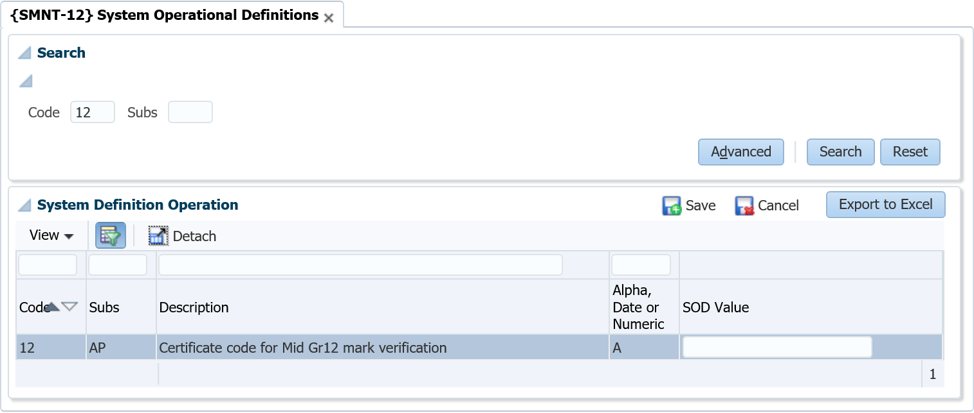

**Field Descriptions:**

**Code:** System pre-defined codes are the rules that are used throughout the student Sub-systems. These cannot be updated or created by users.

**Sub-System:** The rules that are indicated by the code in the "Code” field are valid for various student Sub-systems. The link between the rule and the system is pre-defined and cannot be updated by users.

**Description:** The description of the system pre-defined code defaults and cannot be updated by users.

**Alpha, Date or Numeric:** The value in this field indicates whether the Alpha/Date or Numeric field needs to be completed. If the value is (**A**)lpha or (**D**)ate the Alpha/Date field must be completed by the user. If the value is (**N**)umeric the Numeric field must be completed by the user. These values are pre-defined (per rule) and cannot be updated by users.

**Alpha/Date Field:** Supply the (**A**)lpha or (**D**)ate value for the rule specified. The value to be supplied is determined by the definition and purpose of the SOD.

**Numeric Field:** Supply the (**N**)umeric value for the rule specified. The value to be supplied is determined by the definition and purpose of the SOD.

| **SOD** | **SUB SYSTEM** | **DESCRIPTION** | **ALPHA, DATE or NUMERIC** | **USAGE** |
| --- | --- | --- | --- | --- |
| AP | RR | Allow part time students to register in a Residence | Alpha | If the value is set to 'Y' then a student can register in a residence for any type of offering type.  If the value is set to 'N' then a student can only register for a 'Full Time' offering in a residence.  **Note:** This rule is applied irrespective of the admission status of the student on the residence. |
| FS | RR | Enter the citizenship code that indicates National students | Numeric | The value here will be compared with the student's citizenship code in {SREGB-1}.  If the values are the same, the student will be seen as a "National" Student. If not equal, the student will be seen as a non-National student.  **Note:** This value is used in the application of the Residence Registration Rule "International" in {SRESIDE-2}. |
| FY | RR | Enter the qualification type where a level 1 period of study is considered a first year student | Numeric | This qualification type is used to determine the "first year" status of a student.   Only the period of study of any qualification linked via the approved qualification to this qualification type will be evaluated.   If the period of study is the "start" study period in the hierarchy defined in {SCODE-30}, it will be evaluated to level one of the hierarchy.  **Note:** This is a value that is used in the application of the Residence Registration Rule "Senior Student" in {SRESIDE-2}. |
| NS | RR | Enter number of required subjects for iEnabler Residence Registration in the numeric field | Numeric | This SOD is used on the student iEnabler Residence Registration.  A student will only be able to continue with residence registration if number of subjects entered on this SOD is greater or equals to number of registered subjects where academic year is equals to residence year.  If this SOD is NULL then a student will be able to continue with residence registration, number of registered subjects will not be checked. |

### Residence Quotas {SRESIDE-3}

**Quota information for Residences**.

The Building Code of the Residence will be used here for Quotas per Student Residence Type. Validation regarding the Space Category {SPOPS-1}, will validate for Residences where the Building code is linked to Aggregate Program = 9 on { SPCS-4}, for Space Category Codes between 1910 and 1918; 1920 and 1934; 1950 and 1954 and 1970

**Fields in this option:**

**Block 1: Quota Information For Residences**

**Academic Year:** The Academic Year of the residence registration/application is entered here.

**Residence Building**: Validation regarding the Space Category {SPOPS-1}, will validate for Residences where the Building code is linked to Aggregate Program = 9 on {SPCS-4}, for Space Category Codes between 1910 and 1918; 1920 and 1934; 1950 and 1954 and 1970.

Residence Type A1:

**F - First Year Student**: (First time Academic and Residence Registration/Application)

**S - Senior Student:** (Do have previous Academic and Residence Registration/Application)

**O - Other Student**: (Do have previous Academic Registration/Application but first time Residence Registration/Application)

**A** - All Student Residence Types

When A is entered, no other record for the year, building can be entered

When F, S or O is entered then A is not allowed.

**Quota:** Quota will be tested at Application and Registration not to allow more students in the residence as the quota.

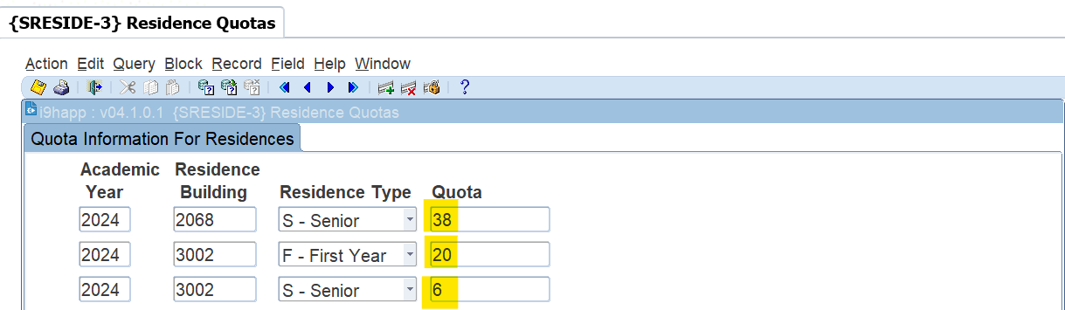

### Bulk Residence Admission {SRESIDE-16}

#### Ordering

Ordering will be done based on

* **Score** – one of the following
  + APS/WRS scores
    - First years. The WRS score can be calculated per academic application.
* **Average mark** 
  + Seniors and Others. Using results of (Application year -1). Excluding cancelled subjects and Exam only registrations.
* **Pass Rate**
  + Seniors and Others. Using results of (Application year -1). Excluding cancelled subjects and Exam only registrations.
* **Application Date**
  + Application Date

Excluded students

* Currently excluding any active Actions **AR, RA, HA, HR,** and **H and R**.
* How do you know funding is available – the absence of financial stop status
* **Clients to provide any other statuses that should be used to identify Funded or non-Funded students.**
* Students will also be removed from the screen if the student balance is more than the ‘**Fee Account Balance**’ entered.
* Exclude Residence Status :
  + Admitted This option will exclude students that has an admission status that leads to ‘Y’
  + Registered This option will exclude students that are already enrolled for this residence
  + None This option will not exclude students

Search Criteria

**Mandatory**

* Academic Year
* Residence Block
* Residence Building Code
* Residence Type.
  + Use A - ALL if ***no quotas have been set on {SRESIDE-3}***

**Then click on the Calc Performance button.**

**Students with statuses as mentioned here above will not display on the screen when you do your selection or bulk updates.**

It will then be depending on which residence code (7000) is selected display the following information as highlighted in yellow in the screen below and the example used:

* Quota (78)
* Mark Limit for Single room (70)
* Residence Type Quota (78)
* Residence Type Quota available (78)
* Registered (0)
* Admitted not yet registered (0)
* Overall bed count in residence (78)
* Students selected (0)

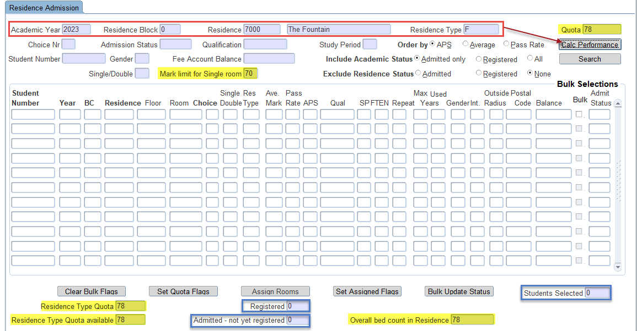

**Please keep in mind that the following fields is additional criteria that can be used to search for more specific or selective information.**

* Application Choice number
* Residence Admission Status
* Qualification Code
* Study Period
* Student Number
* Gender
* Fee Account Balance
* Include Academic status
  + Registered
  + Academic admitted. – These are students admitted but haven’t registered yet.
  + ALL
* Single or Double - Use 1 or 2 as valid values.
* Mark limit for Single room – default of 70. Students with average > this value will be assigned to single rooms. Value can be changed if the single rooms are not being allocated.
* Exclude Residence status
  + Admitted
  + Registered
  + None

Quotas

* We suggest maintaining quotas on {SRESIDE-3} and allocating rooms based on residence types.
* Manually assigning quota values is possible and can be used as alternative if no setup done.
* Note it can be difficult to assign rooms for First years and Seniors at the same time since

the ordering of students cannot cater for both sets of criteria in the last first years do not have averages.

Fields on the Screen

* Residence type quota
  + Value from {SRESIDE-3} for the residence type in search block.
* Residence type quota available
  + Quota minus already admitted students for this building
* Registered
  + Number of residence registrations for this building
* Admitted – not yet registered.
  + Number of admitted students not yet registered.
  + If this value is negative – it means students were registered without having an Admitted application record with a room assigned.
* Overall bed count in Residence
  + Number of beds available in the residence
* Students Selected
  + This is a counter to indicate how many records have been ticked/selected.

Buttons

* Calculate Performance
  + Press this button to calculate the average and pass ratios for all applications.
  + Save changes before continuing with assignment of rooms and admission otherwise you have to do the calculations again next time you work with this building.
  + Cycle P has to be open to allow any changes.
* Search
  + Same as Next Block.
  + Query students based on search criteria and order by selection.
  + The Search action will not pre-select students.
* Clear Bulk Flags
  + Clear all tick boxes.
* Set Quota Flags
  + Use this button after you have queried the students.
  + Selects all tick boxes based on ‘Residence Type Quota available’ value that is determined by the quota predefined per Residence Type on {SRESIDE-3}.
  + Selection will be done from top to bottom – based on the chosen order by
  + Quota can also be set manually if quota is not setup on {SRESIDE-3}
* Assign Rooms
  + Works only with student numbers that has been selected/ticked.
  + Starting from Single rooms – it will match a room with a student number and populate the Floor and Room fields. The Single/Double field will also be updated.
  + No change will be made to students that have been admitted already. The floor and room is required before a student can be admitted.
  + Cycle P has to be open to allow any changes.
  + Single rooms will be assigned to senior students with average > 70%
* Set Assigned Flags
  + Use this button after you have assigned the students.
  + Use this button if you want to auto select all records with a Floor and Room in order to update the admission status in bulk.
* Bulk Update Status
  + Pressing this button will display a popup to allow user to update admission status of all selected students.
  + Cycle P has to be open to allow any changes.

Detail Fields

* Student Number Applicant Student number
* Year - Application Year
* BC - Application Block
* Residence - Application Residence
* Floor - Application Floor
* Room - Application Room
* Choice - Application Choice
* Single/Double - value of 1 or 2
* Res Type - value of S-Senior/O-Other/F-First year
* Ave Mark - calculated from previous year results
* Pass Rate - calculated from previous year results
* APS - calculated based on matric results
* Qual - Qualification student registered for – and if not registered already

then display the application qualification.

* SP - Qualification Study Period
* FTEN - Students FTEN indicator
* Repeat - Y – if student is repeating the Qualification and Study Period
* Max Years - Formal time of qualification. 99 indicates SOD S6/RR is set to N
* Used Years - Number of years student has been academically enrolled
* Gender - Student gender
* Int - Student is Foreign – Y-Yes, N-No or P – Permanent Resident.
* Outside Radius - Y – if student postal code falls outside 50km radius.
  + - * + Please provide all towns/campuses where there are residences. We need to manually determine the postal codes to use to do this calculation.
* Postal Code - The postal code on the students Physical Address. If no Physical Address then the postal

code from the primary postal record.

* Balance - Student Balance
* Bulk - Tick box to select students
* Admit Status - Residence Admission status. Can be updated manually or in bulk.

**Then click on the Search button.**

It will now display the following student information by ordering the **APS**:

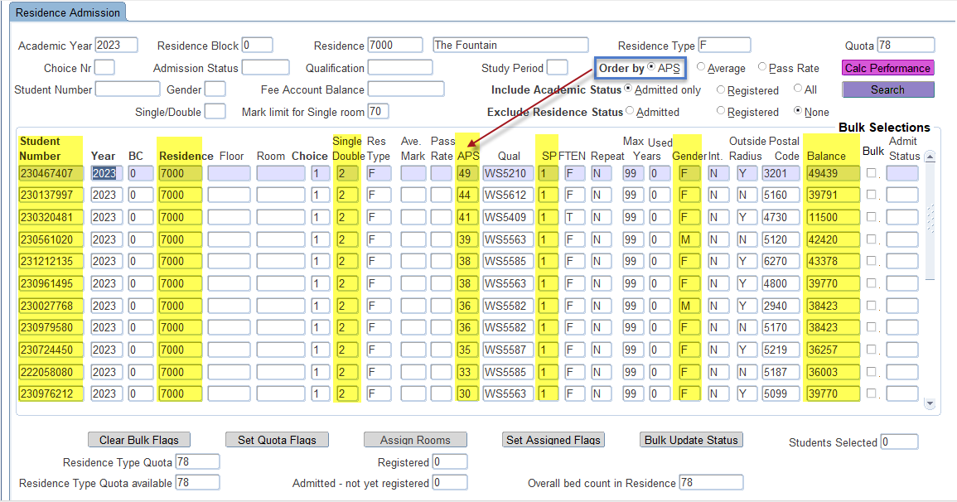

Added criteria = **Gender = F**

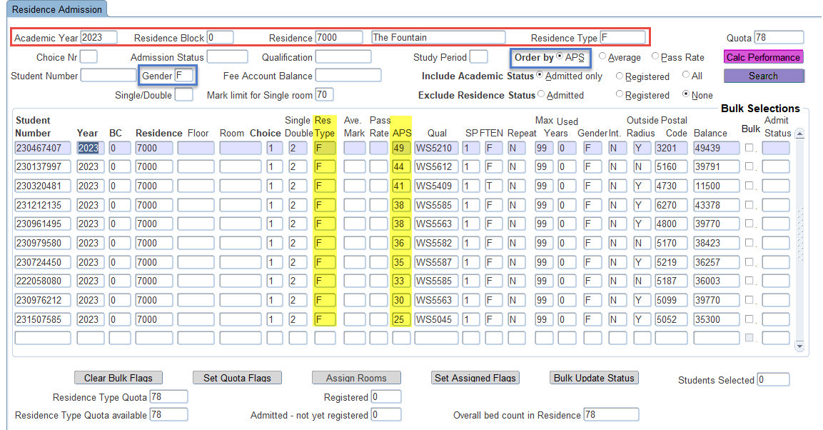

**Click on the Set Quota Flags button.**

In this action the system will tick all the bulk boxes as indicated in green for those students as priority.

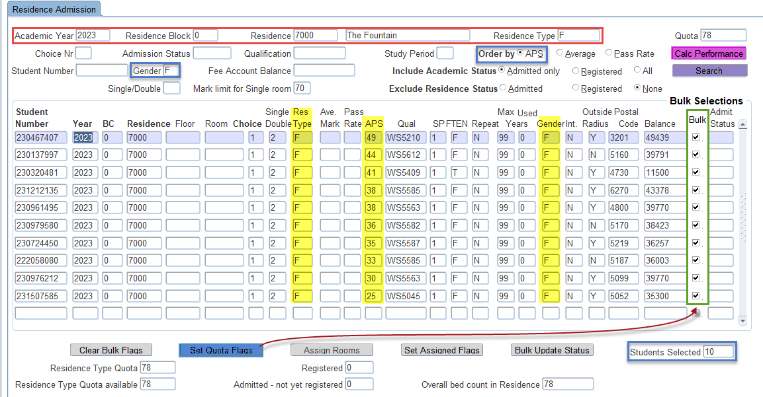

**The next step is to click on the Assign Rooms button**. The system will now assign rooms available to the students that qualify. At this point the user can still make changes or adjust.

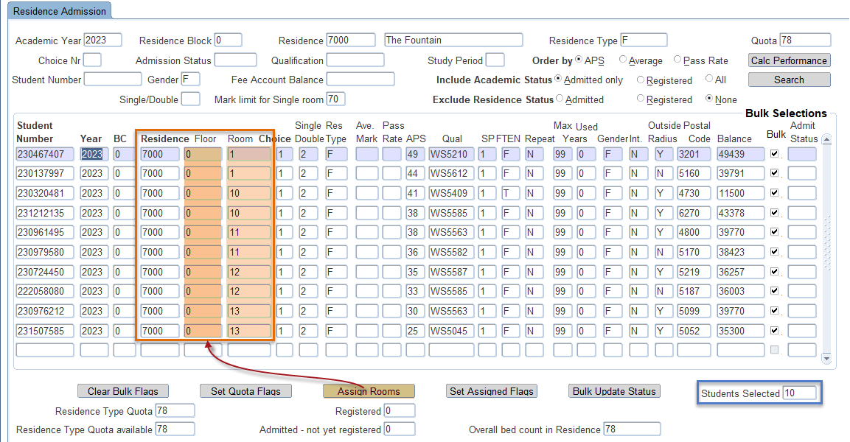

Once the user has accepted the assignments or has adjusted the records, **they can click on the Set Assigned Flags button** to prepare it to be saved. It will also display the number of records that will be selected (9).

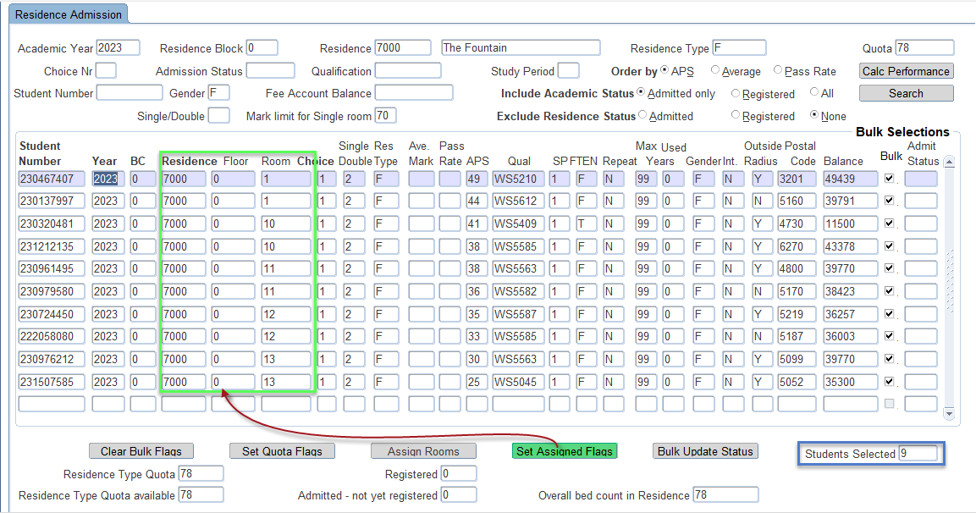

The user or residence officer will now have to **SAVE the records** first before a bulk update of status can be performed. You will notice that it displays 10 records have been saved.

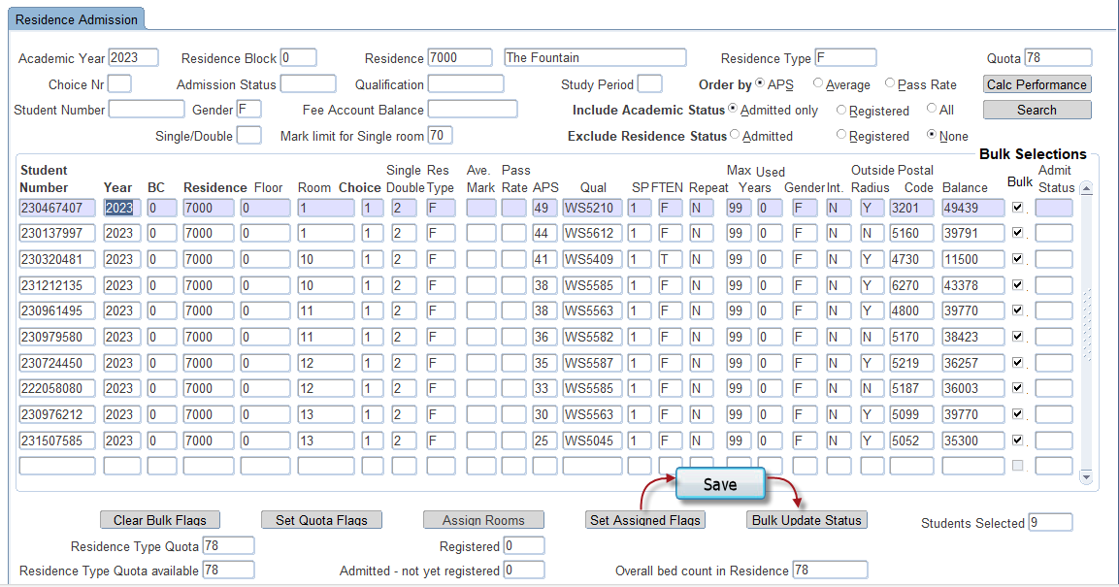



Then the user or residence officer **can click on the Bulk Update Status button**. It will display another pop-up screen where the user needs to enter the **R1** admission status.

**Then click on the Update button.**

If the user does not want to save or update the records he/she can click on the **Exit without Updating** button.

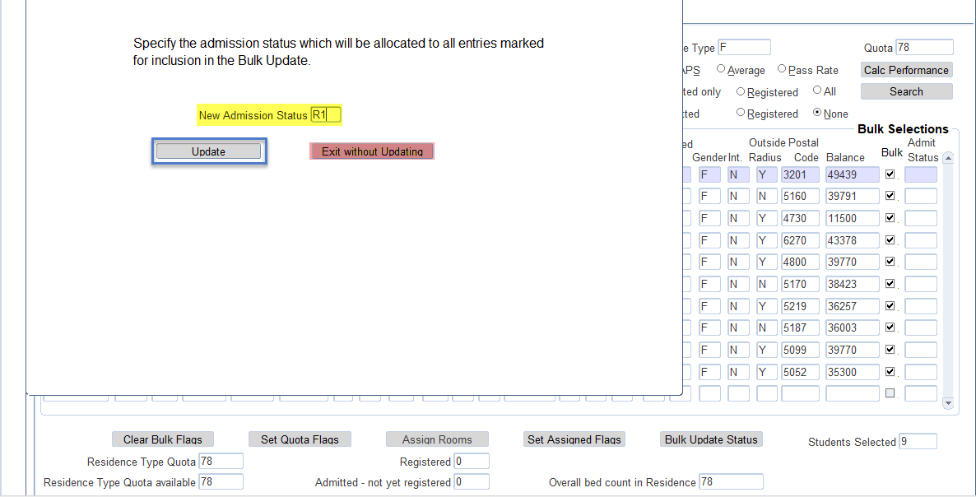

When the user does click on the Update button it will ask you to confirm your update as can be seen here below.

Click on the “**Yes**” and the records have been saved.

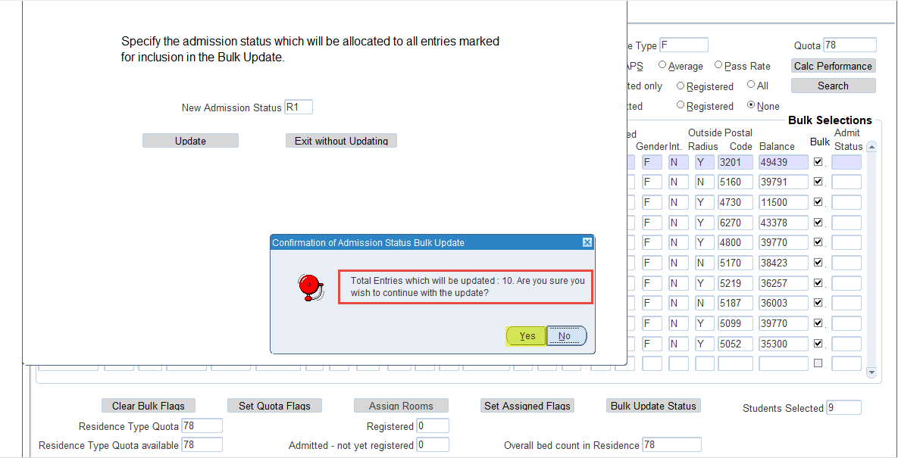

**Below you can see the records saved with the R1 status.**

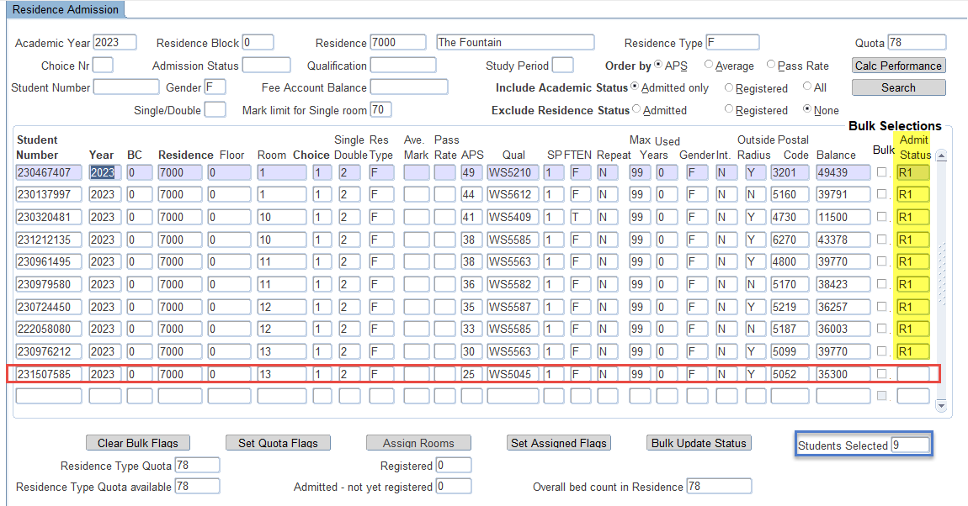

Below is reports that can be used. Please check them out.

The student will also receive a notification once he/she has been admitted.

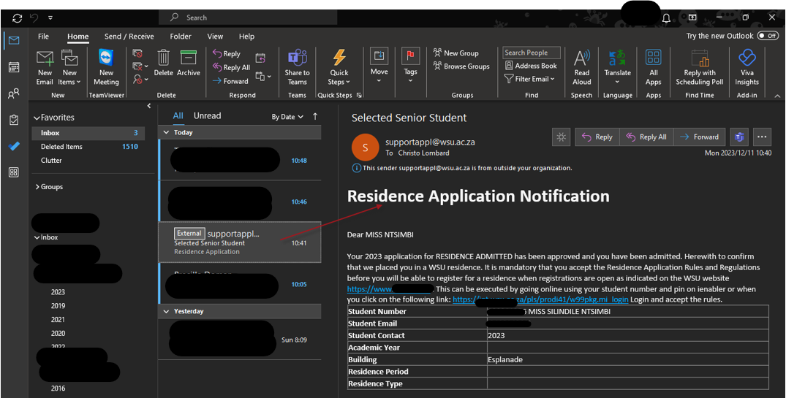

### Residence Registration Rules {SRESIDE-2}

This option is used to define rules against which students will be tested when registering or applying for a place in the residence.

**Note:** Both the Import and Export functionalities are enabled in this option.

**Block 1: Residence Registration and Application Rules**

Before the user defines the content of the rules in Block 1, the user **must** define active rules in Block 2. Most of the fields in Block 1 pertaining to data elements can be left blank. It simply means that the particular data element does not play a role when evaluating the student’s attempt to register.

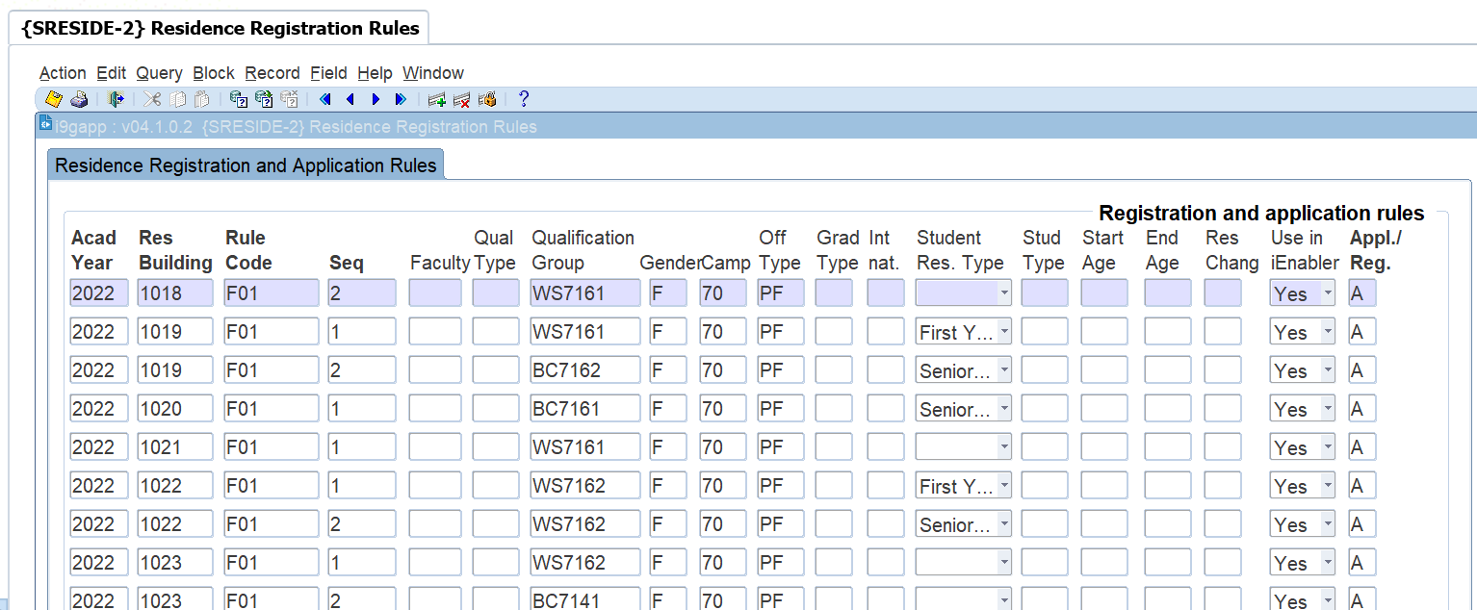

**Field Descriptions:**

**Academic Year:** Enter the Academic Year for which this rule will be valid. The LOV shows a distinct list of years from the Qualification definition in the Academic Structure.

**Residence Building:** Enter the residence building code. The LOV shows all building where the Aggregate Program is 9 and at least one venue in the building is linked to category 1900 to 1999 (excluding category 1919).

**Rule Code:** Enter the rule code for the Residence and year. Only active rule codes can be entered.   
If a record exists for a rule that has become inactive, the program will warn the user when a data element for the record is updated.

**Sequence:** Enter a sequence in which the rules will be applied for this year, residence and rule code. With this feature, it is possible to, for example, to define multiple qualifications that should be grouped in the same residence.

**Quota:** Enter the quota for this rule and sequence. The program will check that the total quota for all rules for a residence does not exceed the total number of places available in the residence.

**Qualification Type:** Enter the Qualification Type that will limit students for this rule. If a qualification code is already entered in the next field, the program will check that the qualification type matches the qualification type linked to the qualification.

**Qualification:** Enter the qualification code that will limit students for this rule. If a qualification type code is entered in the previous field, the program will check that the qualification type linked to the qualification matches the qualification type entered.

**Gender:** Enter an 'F' or 'M'. This determines the gender of students allowed for this rule.

**Campus:** Enter a campus where the student's academic registration will be. If an Offering Type exists in the next field, the program will validate that the offering type is linked to the updated campus.

**Offering Type:** Enter an offering type that will be matched to the student's academic registration. If a campus were entered in the previous field, the program will check that the offering type is linked to the campus entered.

**Grad Type:** Enter the graduate type allowed with this rule. Enter a 'U' for Undergraduate and a 'P' for Post Graduates.

**International:** This field is used to indicate if only International students can comply with this rule or only National students. A 'Y' indicates that International Students are allowed and an 'N' indicates that National Students can register under this rule.  
To determine if a student is national or international, the SOD 'FS' (Enter the citizenship code that indicates National students) for subsystem 'RR' as defined in {SMNT-12} is used. The user must enter a Citizenship code that will be deemed a National student.

**Senior Students:** This field is used to indicate if only Senior Students or only Junior Students may register in the residence.   
A student is considered a junior student if the level of his/her period of study = 1.   
The level of the study period in the hierarchy of the definition of the study periods in {SCODE-30} will be 1 if there is no "Previous Period" in the hierarchy.   
To further refine this test, the user can enter a Qualification Type in SOD 'FY' for subsystem 'RR' in {SMNT-12}.

**Student Type:** Enter the student type that a student must have to register in the residence.

**Block 2: Residence Rule Definition**

This block is used to define the rule codes that are used in the detail of block 1.

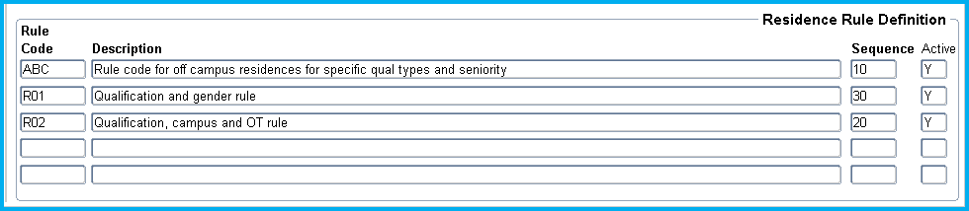

**Field Descriptions:**

**Rule Code:** Enter a code that will identify a Residence Registration Rule.

**Description:** Enter a description for the Rule Code

**Sequence:** Enter a sequence number for this rule. This number determines the sequence in which the rules will be applied to a student's Residence Registration

**Active:** Enter a ‘Y’or ‘N’ to indicate if the Rule Code is active.  
Only active Rule Codes can be used in block one. If, however, a record exists in block one and is made in-active in this block, the rule will not be applied when evaluating a student's registration in the residence.

### Processing Rules

This program does not perform any special processing rules. The following is a high level description of how the rules are applied in the iEnabler Residence Registration. The description is based on the data in the example above.

The Residence Rules in Block 2:

* The rules will be applied in the following sequence: ABC, then R02 and then R01 because of the sequences linked.
* All the rules are active and will be applied for every residence it is linked to.

The Rule details:

* As can be seen in the example, a single residence can be linked to multiple Rule Codes and each can have multiple data elements that should be tested.
* Rule ABC sequence 10 allows
  + One International student to register in residence 1000 for 2012
* Rule R02
  + Sequence 10 allows
    - 3 students that are registered for qualification BCLOTH (the Qualification Type and Grad Type is really redundant in this example),
    - offering type 01 (again the campus code 19 is redundant),
    - is an International student
    - is a Senior student to register in residence 1000 for 2012
  + Sequence 20 allows
    - 2 male senior students irrespective of their qualifications, campus, offering type or student type to register in Residence 1000 for 2012
* Rule R01 allows sequence 20 allows
  + 4 students that are
    - Female
    - registered for the qualification DSPORT
    - to register in residence 1000 for 2012

**MODULE**

**2**

# **Residence Application Function**



Specific outcomes

On completion of this module, you will be able to:

* View/Update Personal Information
* Accept the Residence Rules and Regulations
* Submit Residence Application
* Cancel Residence Application

This option allows prospective students to apply for residence admission via the Student iEnabler. The student may apply for:

* + Year
  + Residence Period
  + Building ({SPCS-4}, Category = 9)
  + Room Type (Single / Double)
  + Choice

If a student should receive a contract from the institution, {STWEBM-7} should be set up to insert a certificate code on the student record on {SREGB-8}. This will be done on clicking on the ‘I Accept’ button. A certificate code as defined in {SCODE-22} must be linked to {STWEBM-7} Event Code ‘B2’. A record will be inserted in {SREGB-8} with an indicator seen set to ‘No’

Financial transactions are raised in {SNAPPA-2}.

**Note:** If a process is mandatory, it must be completed **before** a student’s application can be completed.

# **View/Update Personal Information**

The student can view and/or change his/her Biographical detail via the web. If the Dynamic Biographical process is used, only fields that are marked for update can be updated as defined in {STWEBM-5}.

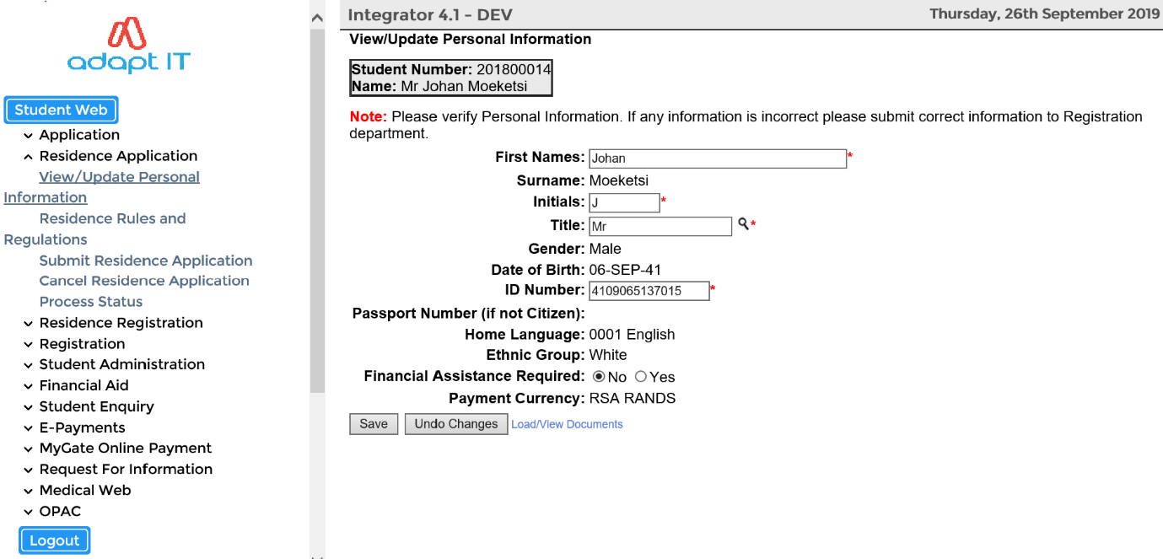

# **Residence Rules and Regulations**

The Process Event code ‘B1’ (Residence Application Rules and Regulations) as defined in {STWEBM-7} is used.

* A document code can be created in {SLLL-1} and linked to Event Code ‘B1’.
* A document can also be added as an HTML or PDF FORMAT {Business Function and Process}

The student can read the criteria/rules for residence application. If the student accepts the rules he/she can click on the “I Accept” button.

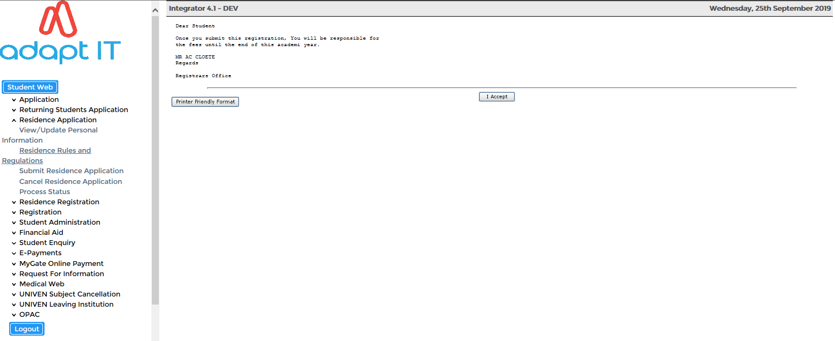

The following screen will appear to inform the student that his acceptance of the application is logged.

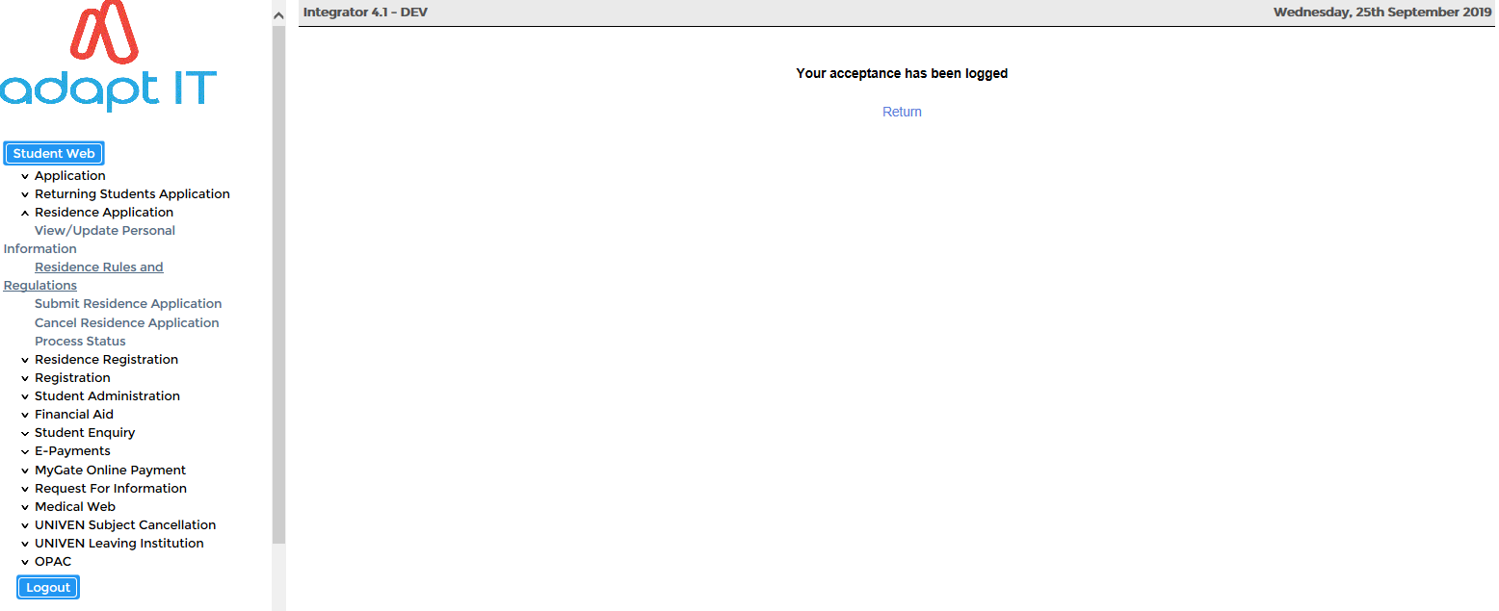

# **Submit Residence Application**

The student will be able to process his/her Residence Application via the Student iEnabler system.

The Process Event code ‘B2’ (Residence Application Certificate Indicator) as defined in {STWEBM-7} is used.

A Certificate code as defined in {SCODE-22} must be linked to Process Event Code ‘B2’. A record will be inserted in {SREGB-8} with an indicator seen set to ‘NO’.

The following information is required:

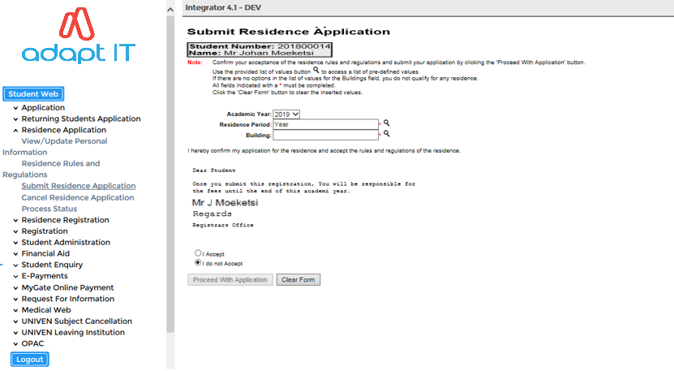

**Field Descriptions:**

**Calendar Year:** The year for which the student is applying

**Residence Period:** The LOV will display all valid Residence Periods

**Building:** The LOV will display all valid Buildings

The student then has the option to either “Proceed with the Application” or “Clear Form”. Once the student proceeds with the process the screen will be displayed.

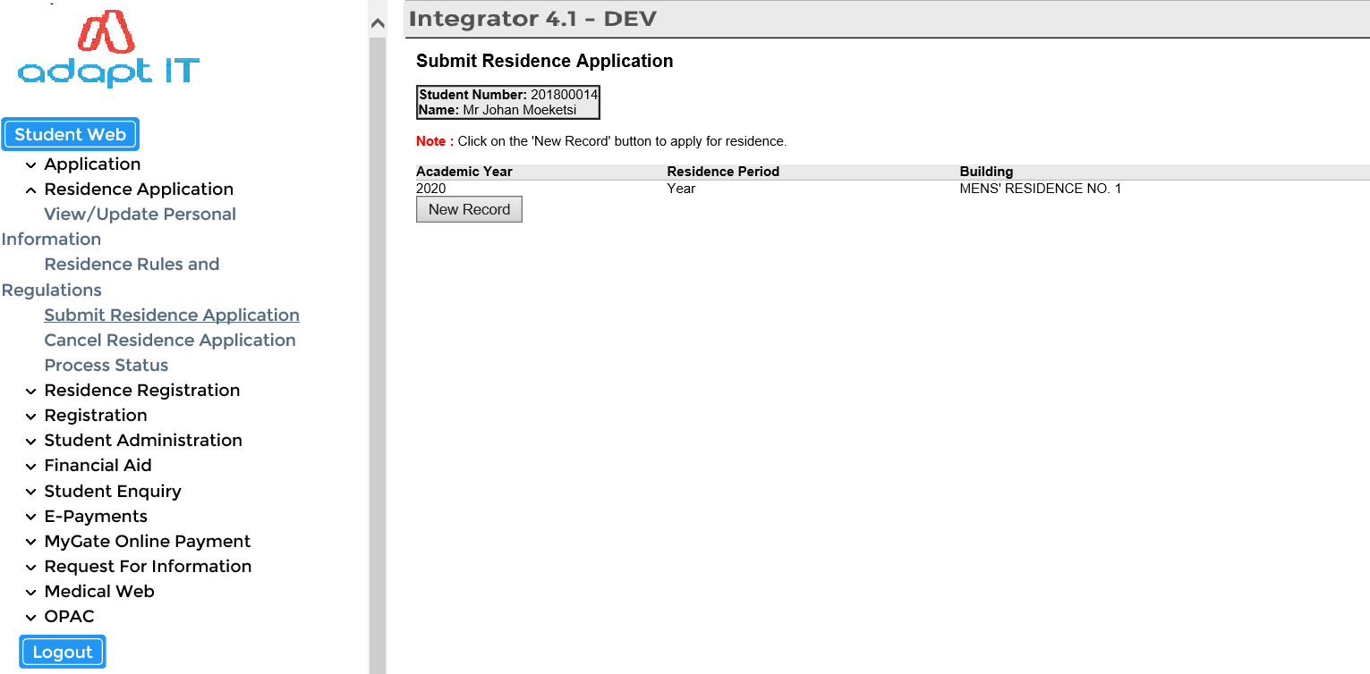

# **Cancel Residence Application**

If the student wants to cancel the residence application, a cancellation reason needs to be selected from the LOV and “Save” the record.

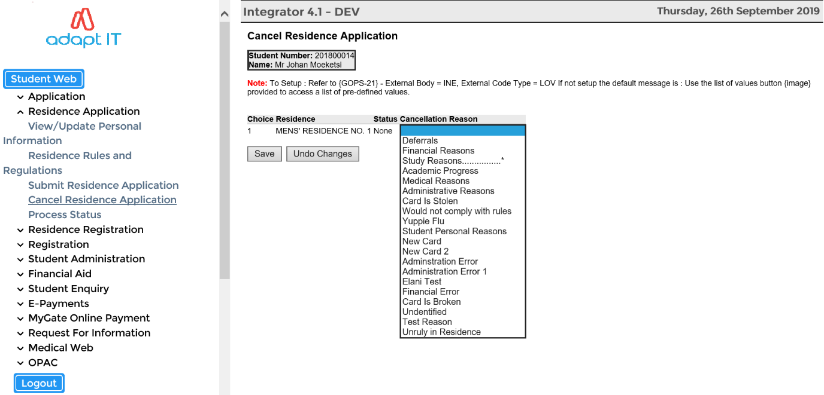

**MODULE**

**3**

# **Residence Registration Function**

Specific outcomes

On completion of this module, you will be able to define the following processes:

* Residence Registration Rules and Regulations
* Submit Residence Registration
* Residence Proof of Registration
* Proof of Residence

* 1. **Residence Registration Rules and Regulations**

The Process Event code ‘B4’ (Residence Registration Rules and Regulations) as defined in {STWEBM-7} is used.

* A document code can be created in {SLLL-1} and linked to Event Code ‘B4’.
* A document can also be added as an HTML or PDF FORMAT {Business Function and Process}

The Residence Registration process for a student will look as follows:

* If required, the student must click on the “I Accept” button for “Residence Registration Rules and Regulations”

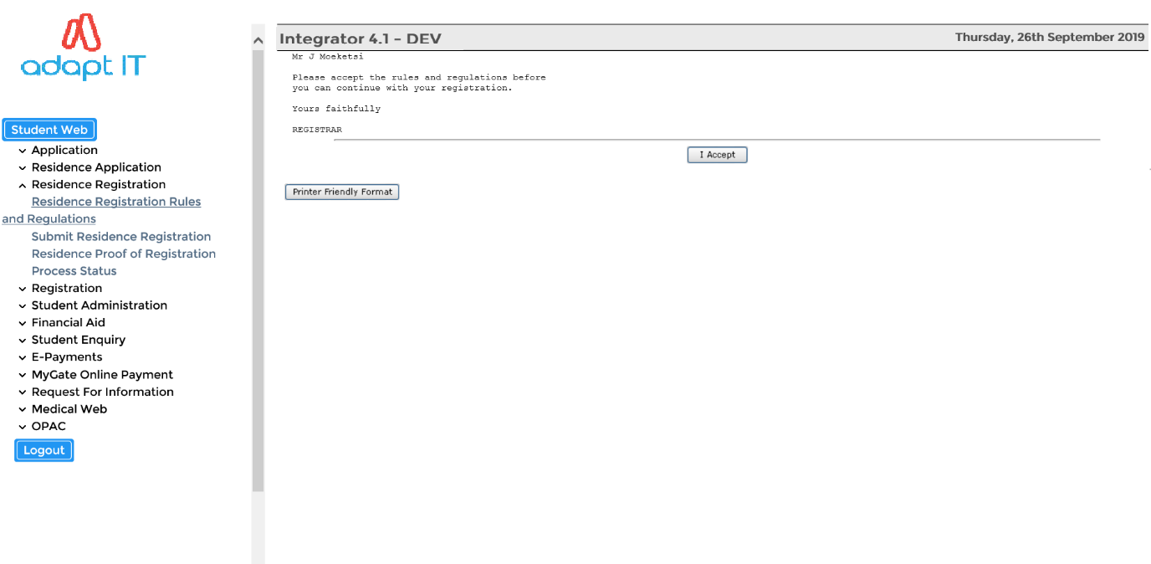

The following screen will appear to inform the student that his acceptance of the application is logged.

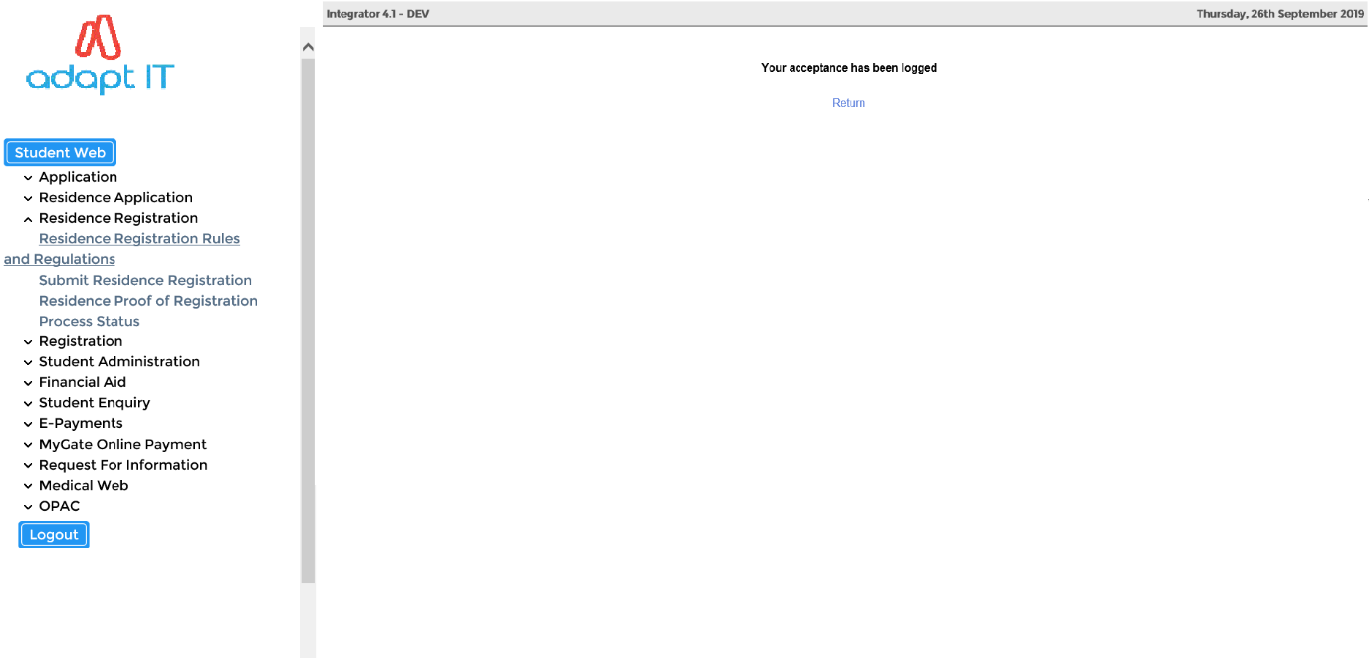

* 1. **Submit Residence Registration**

The student will then click on the "Submit Residence Registration" option and may find any of the following responses;

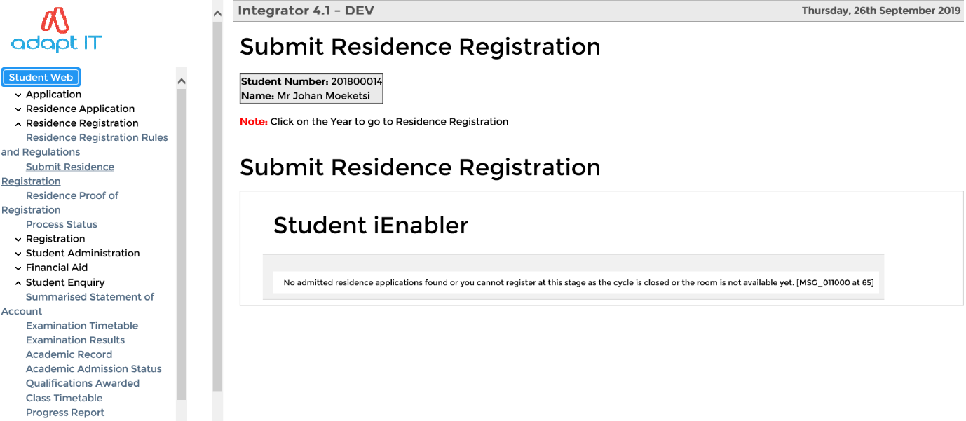

**Error Message:**

*No admitted residence Applications Found, or you cannot register at this stage or the room is not available yet.*

**The cause for this message:**

The student is not admitted to a venue (**building, floor and room**) in a residence in {SNAPPA-4}

* The system cycle '1' is not open in {SMNT-2}
* The room is not set to active in {SPOPS-1}

**Error Message:**

*You no longer comply with the rules of the residence where there is not a hyperlink on the year. You can therefore not register in that residence.*

**The cause for this message:**

* The rules of the residence were changed in {SRESIDE-2} between admission and registration.
* The student no longer complies with any of the rules for the particular residence.

**Error Message:**

All places in the residence have been allocated. You can no longer register in the residence.

**The cause for this message:**

* The available stations (i.e. beds) as defined in {SPOPS-1}, have been allocated after admission of this student and this student is trying to register.
* This means that the quota for the rule (as defined in {SRESIDE-2}), that the student possibly passed, has been reached.

When ALL error messages have been cleared the student can proceed with the residence registration.

**Residence Registration Steps:**

* The student clicks on the year with the hyperlink and is presented with the registration screen
* The only field that the student can update is the ‘Date In’ field
* The cost for the residence registration is displayed (Fees as defined in {FSAM-1})
* The student will click on the "**I Accept this Registration**” button for the record to be processed.

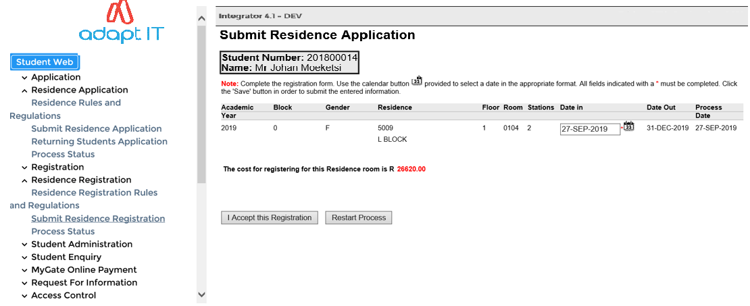

**After accepting the registration:**

* Once the student click on the "I Accept this Registration" button, a confirmation message will be displayed to the student.
* The student will be returned to the start page of Residence Registration function
* All the records will have a year without a hyperlink because the student is now registered.

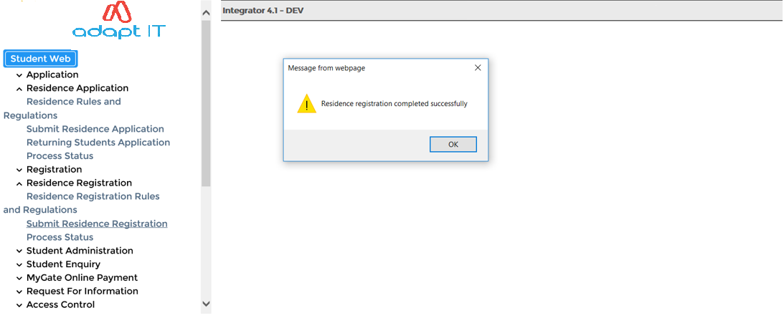

**Note:** It can happen that before the student clicks on the "**I Accept this Registration**" button, the room has been fully occupied i.e. other student(s) has registered in the room (clients do over admit because of students not pitching).

If the room is fully occupied, the student will get the following message:

* *‘This Residence Room is Already Fully Occupied’*

If the student is already registered in the residence and there are no other admitted residences the student will get the following message:

* *‘If the year in the records above does not display with a hyperlink, you are already registered in the residence’*

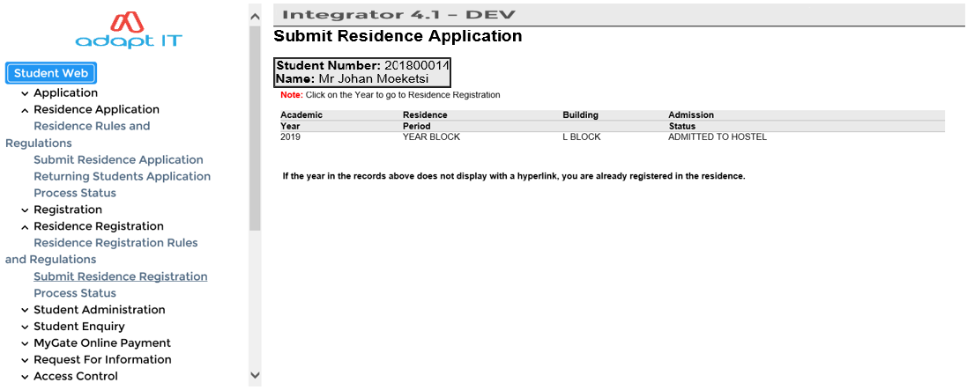

* 1. **Residence Proof of Registration**

The student can now click on the "Residence Proof of Registration" to get a nicely formatted document of a proof of his/her registration

**Very Important**: The batch queue W1 **must be open** for the student to get the document in the iEnabler.

The batch queues are maintained in {BATCH-3}. If the queue was open and the Application Server was restarted, the queue must be closed and reopened.

If the queue is not open, the student will get a message stating the document cannot be produced and the batch request number is displayed.

If the queue is open the student will receive a document that might look like this:

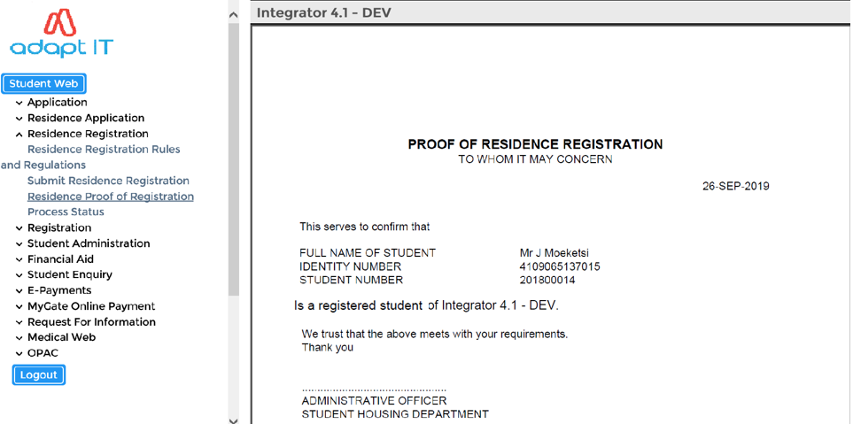

This document is an iComms document and the client can set up their own document and link it to the default group I1801GRP in {GMNT-5} or {GMNT-14}.

**MODULE**

**4**

# **Student Enquiry Function**

Specific outcomes

On completion of this module the following process is defined:

* Residence Admission Status
  1. **Residence Admission Status**

The user may view the progress of Residence Application if the ‘P’ Residence Application cycle is open on {SMNT-2}.

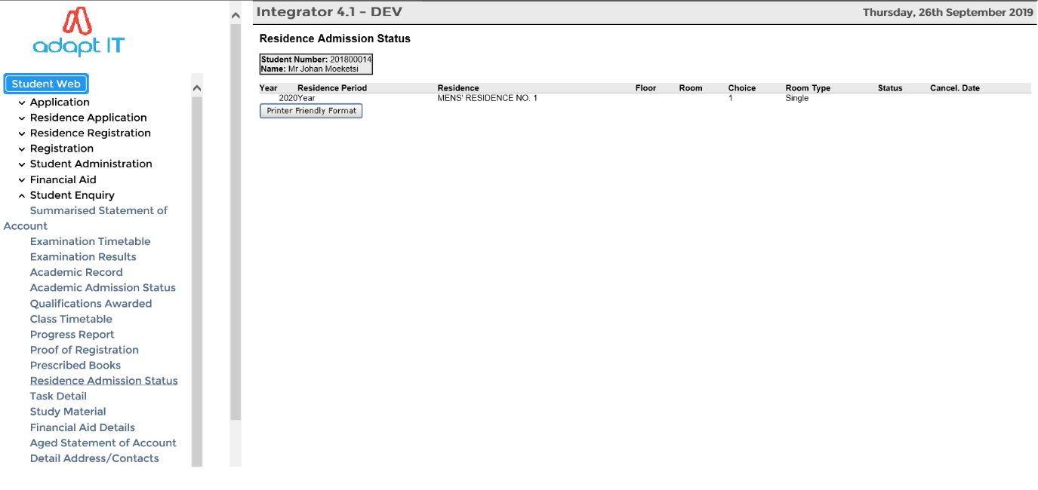

The record of the student residence admission status can be printed.

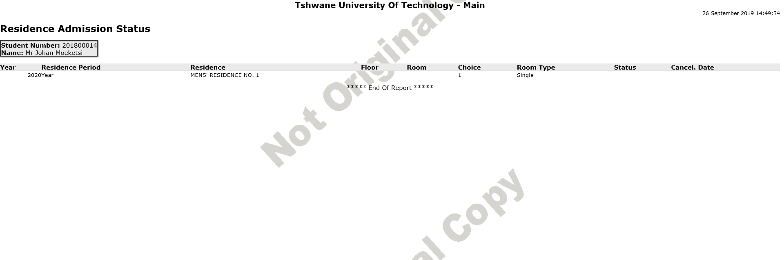

Other business processes can be viewed if the client set it up.

**MODULE**

**5**

# **Operational Issues**



Specific outcomes

On completion of this module, you will be able to:

* Login to the iEnabler
* Change Pin
* Request Pin

**How to log in:**

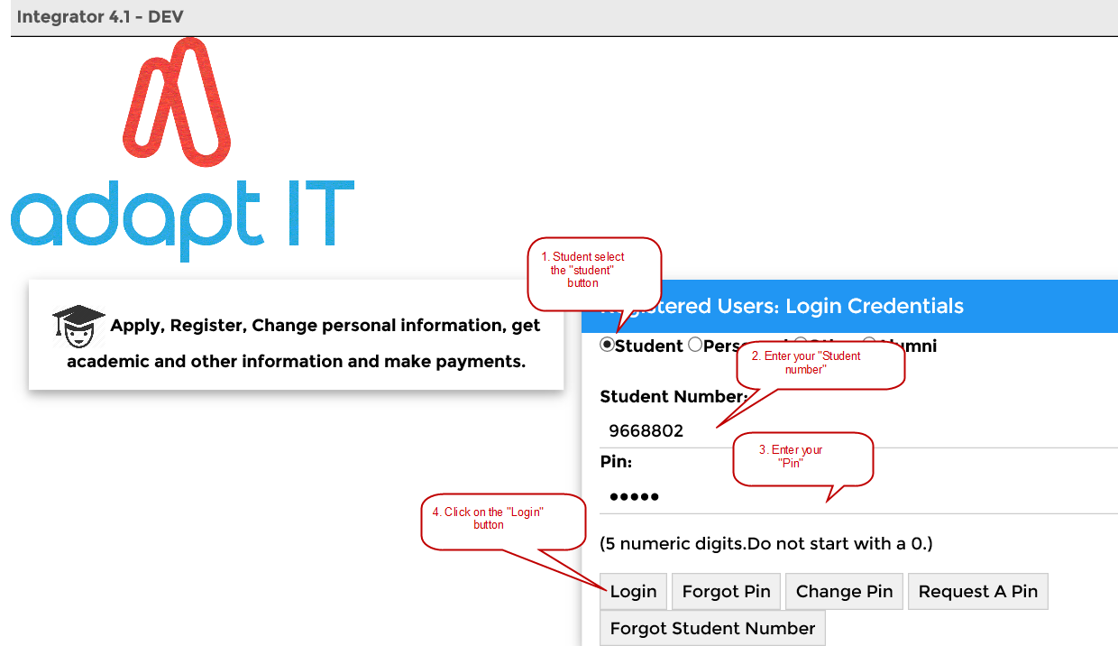

The following basic step can be followed:

* Student selects “Student” button
* Enter your “Student number”
* Enter your “Pin” and
* Click on the “Login” button.

**Forgotten your “Pin”?**

Click on the “Forgot PIN” button and the next screen will confirm that your PIN was successfully requested, and it was sent to your E-mail address.

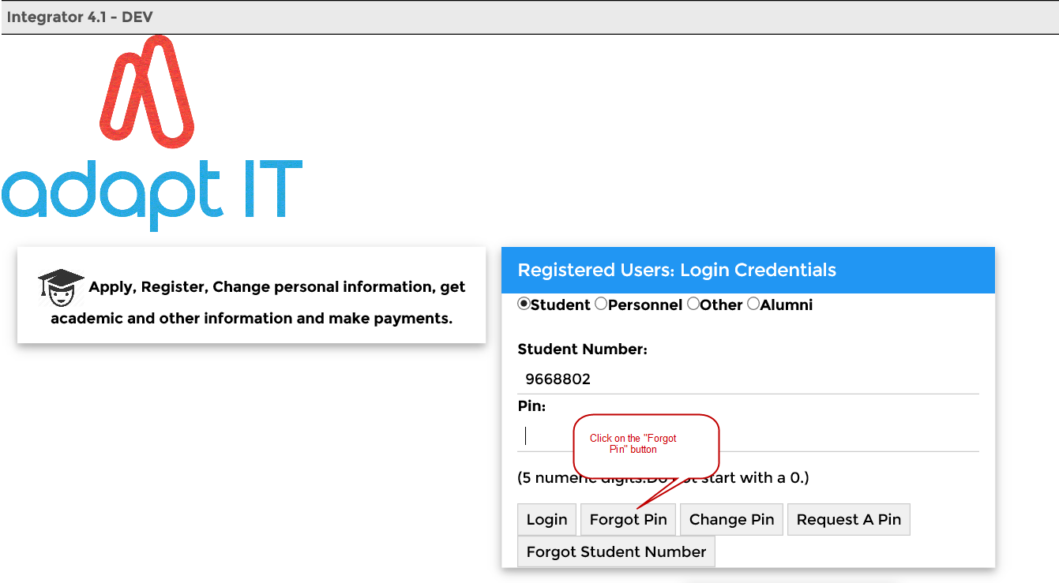

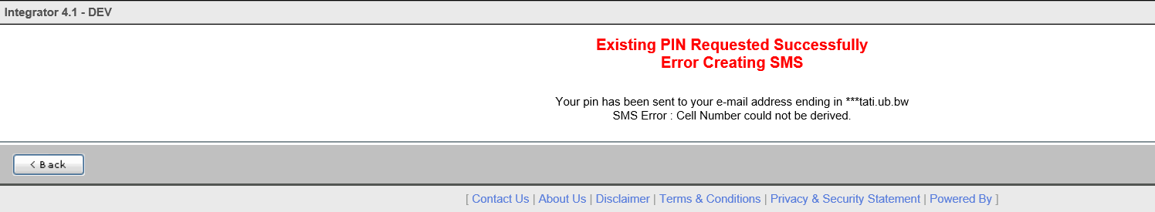

The message as it will appear on your Outlook.

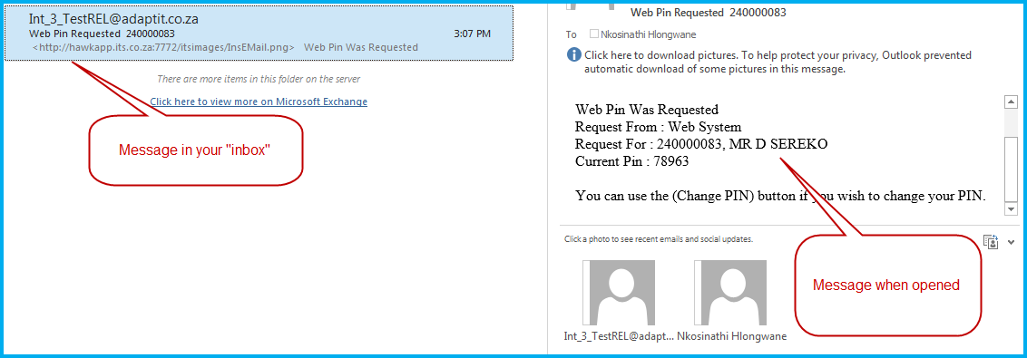

**Change “PIN”**

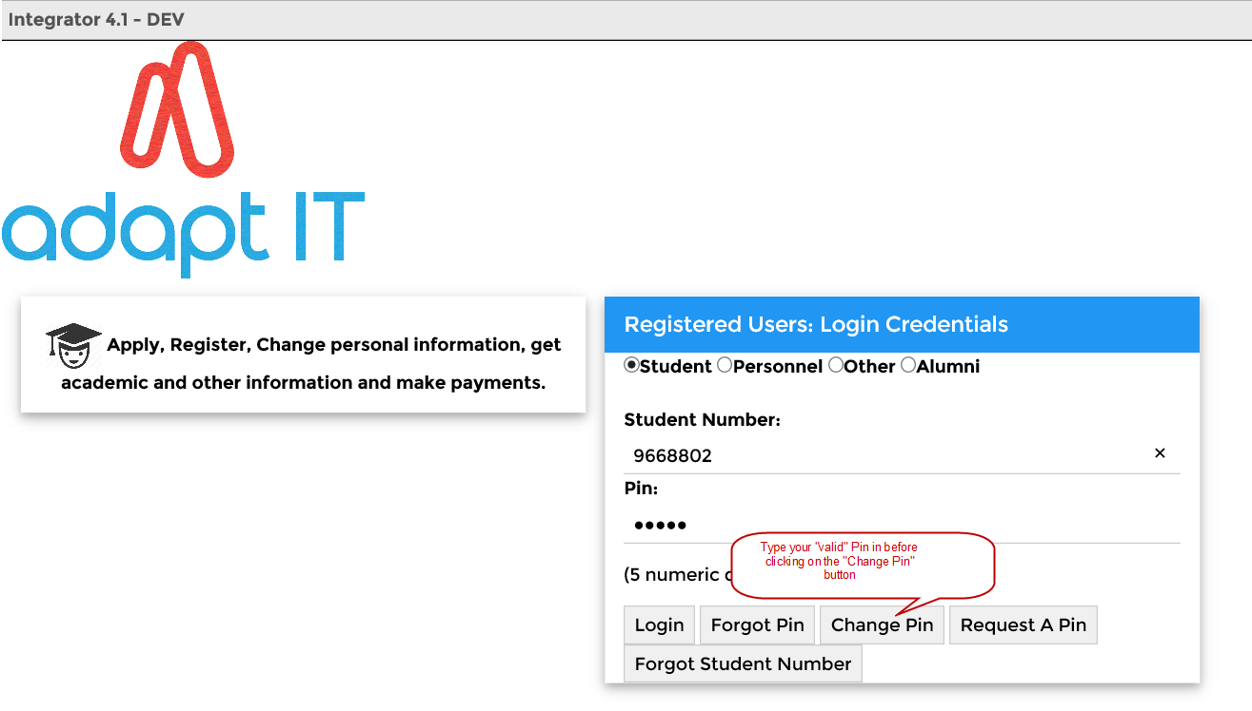

Remember to enter your valid PIN before you change your PIN.

* Then click on the “Change PIN” button. The following screen will appear where the pin is being changed for the person involved.
* The “New Pin” is entered.
* Verify the “New Pin”.
* Now click on the “Change pin” button. (See screen below)

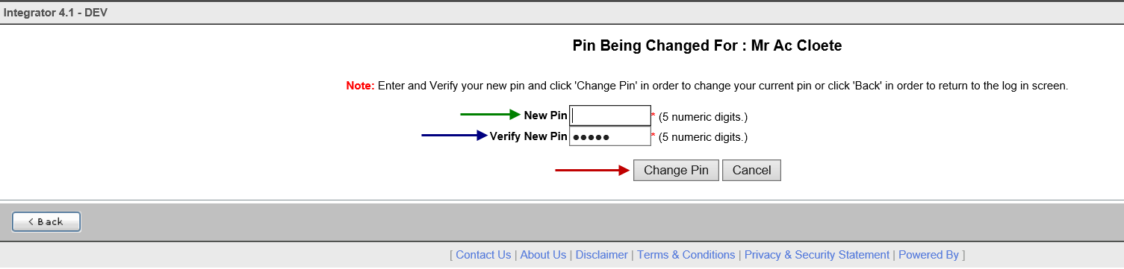

As soon as the “Change Pin” button is clicked on, the system will allow you to continue.

You will also receive an e-mail that your pin was requested. See the print screen below.



**Request a pin**

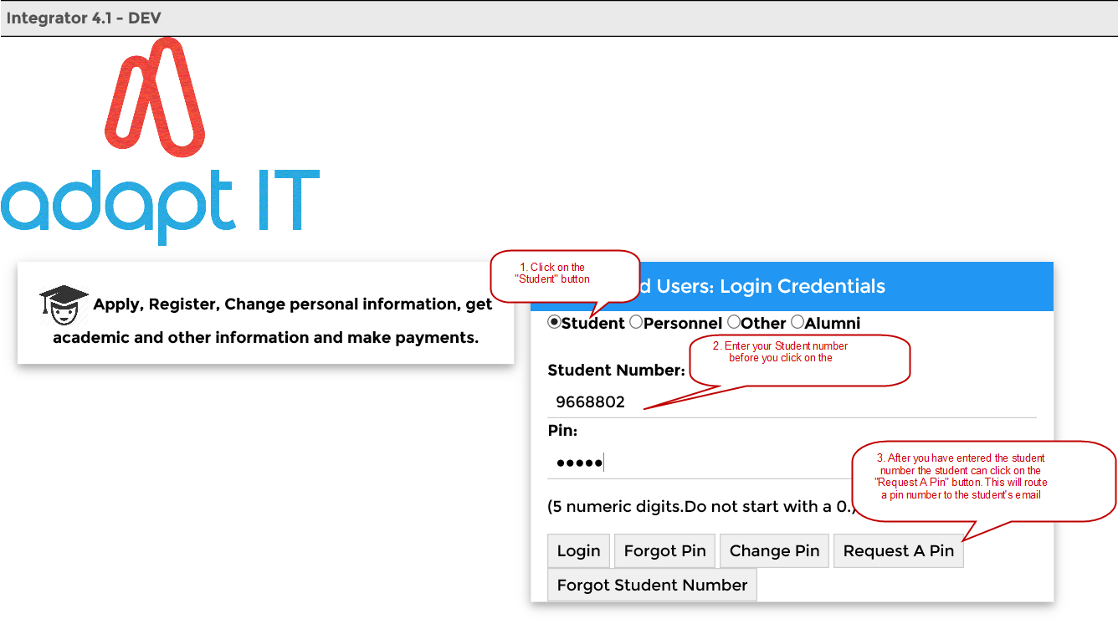

Click on the “Request a PIN” button and the next screen will confirm that your PIN was successfully requested and it was sent to your E-mail address.



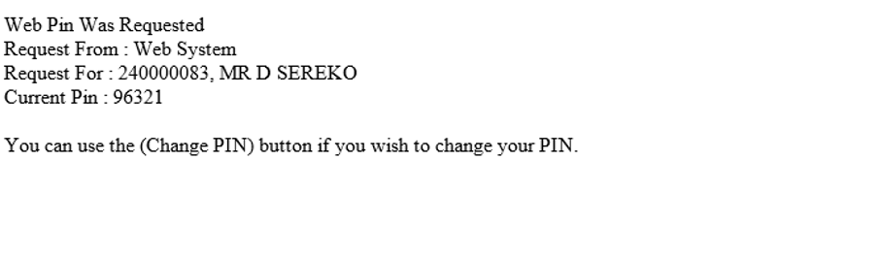

1. .1Introduction

   Some options still open Forms Programs and will be converted to the new ADF technology in the near future.